PIMPRI CHINCHWAD EDUCATION TRUST'S
PIMPRI CHINCHWAD COLLEGE OF ENGINEERING

Department of Applied Science and Humanities
Report of FA-2 activity
Subject: BSH23OE04: Open Elective: Statistical Data Analysis using R
Academic Year 2026-27
Semester I
Submitted by
Sr. No. | Name of the student | PRN number | Branch
1. | Om Khanjodkar | 125B1B283 | B.Tech
2. | Siddhant Verma | 125B1B278 | B.Tech
3. | Parth Ghumade | 125B1B234 | B.Tech
4. | Tanishk Malge | 125B1B247 | B.Tech

Submitted to: Dr. Rajesh G Talekar
Date: ______________ Sign: ______________

Project Title
Statistical Analysis of the Vietnam War Bombing Operations Data using R
Data used
The project uses the THOR Vietnam War bombing operations database (Combat Archives, THOR project), file THOR_Vietnam_Bombing_Operations.csv. It is public research data that lists weapon-delivery records of the air campaign in South-East Asia.
Details of the data
The raw file has 46,70,416 rows and 47 columns and covers missions from 1 June 1965 to 30 June 1975. Each row is one weapon-delivery event as reported by one of four source databases (SEADAB, CACTA6669, CACTA6570 or SACCOACT); the SOURCERECORD column says which one. The columns and the share of missing values in the full file (measured by scanning the whole file with scripts/00_profile_raw.R) are listed below. The analysis itself works with 8 numerical variables (YEAR, WEAPONS_DELIVERED, LOAD_LB, AIRCRAFT_NO, TGT_HOUR, LAT, LON, FLIGHT_HOURS) and 7 categorical ones (COUNTRY, PERIOD, AIRCRAFT_GROUP, SOURCE_DB, WEAPON_CLASS, CLOUD, SERVICE).
No. | Column | Type | Description | Missing
1 | THOR_DATA_VIET_ID | Number | Unique record identifier in the THOR Vietnam database; checked to be unique (46,70,416 distinct values). | 0%
2 | COUNTRYFLYINGMISSION | Category | Country whose air force flew the mission (USA, South Vietnam, Laos, South Korea, Australia). | 0.08%
3 | MILSERVICE | Category | Military service of the flying unit: USAF, USN, VNAF, USMC, RLAF, KAF, RAAF, OTHER, USA. | 0.07%
4 | MSNDATE | Date | Mission date; stored as text in two formats (DD-MMM-YY and YYYYMMDD), parsed in cleaning. | 0%
5 | SOURCEID | Category | Identifier of the source document the record came from. | 0%
6 | SOURCERECORD | Category | Source database of the record: SEADAB, CACTA6669, CACTA6570, SACCOACT. | 0%
7 | VALID_AIRCRAFT_ROOT | Category | Validated aircraft type code (F-4, F-100, A-4, B-52, ...), 129 levels. | 0%
8 | TAKEOFFLOCATION | Category | Air base, carrier or other location the aircraft took off from. | 0.11%
9 | TGTLATDD_DDD_WGS84 | Number | Target latitude, decimal degrees, WGS84. | 24.20%
10 | TGTLONDDD_DDD_WGS84 | Number | Target longitude, decimal degrees, WGS84. | 24.20%
11 | TGTTYPE | Category | Text description of the target type (AREA\DEPOT, BUILDINGS, TRUCKS, ...), 268 levels. | 39.19%
12 | NUMWEAPONSDELIVERED | Number | Number of weapons delivered on the target in the record. | 0%
13 | TIMEONTARGET | Number | Time over target, encoded as HHMM. | 0.57%
14 | WEAPONTYPE | Category | Weapon type designation (e.g. MK-82, 750LB GP). | 51.46%
15 | WEAPONTYPECLASS | Category | Weapon class in the source file: completely empty in this file. | 100%
16 | WEAPONTYPEWEIGHT | Number | Weight of one weapon of this type, pounds. | 0%
17 | AIRCRAFT_ORIGINAL | Category | Aircraft type as written in the source document. | 0.01%
18 | AIRCRAFT_ROOT | Category | Aircraft type code without model suffix (F4, F100, A4, B52, ...). | 0.01%
19 | AIRFORCEGROUP | Category | Air force group code; almost completely missing, not used. | 99.94%
20 | AIRFORCESQDN | Category | Squadron; almost completely missing, not used. | 99.94%
21 | CALLSIGN | Category | Mission callsign. | 70.66%
22 | FLTHOURS | Number | Flight hours logged for the record. | 0%
23 | MFUNC | Category | Mission function code. | 2.16%
24 | MFUNC_DESC | Category | Mission function description (STRIKE, CLOSE AIR SUPPORT, ...), 95 levels. | 2.24%
25 | MISSIONID | Category | Mission identifier. | 0.34%
26 | NUMOFACFT | Number | Number of aircraft taking part in the record. | 0%
27 | OPERATIONSUPPORTED | Category | Name of the operation supported; text is very inconsistent (51,375 levels). | 41.11%
28 | PERIODOFDAY | Category | Period of day of the attack: D (day) or N (night); other codes are data-entry noise. | 4.28%
29 | UNIT | Category | Flying unit name. | 0.01%
30 | TGTCLOUDCOVER | Category | Cloud cover at the target: CLEAR, SCATTERED, BROKEN, OVERCAST, UNDERCAST, NOT OBS, IN CLOUDS, BETWEEN LAYERS. | 52.25%
31 | TGTCONTROL | Category | How the target was controlled/acquired (ABN FWD AIR CNTL, TPQ-10, ...). | 46.05%
32 | TGTCOUNTRY | Category | Country of the target: South Vietnam, Laos, North Vietnam, Cambodia, Thailand, Westpac Waters, UNKNOWN, PHILLIPINES (typo in source). | 4.64%
33 | TGTID | Category | Target identifier; almost completely missing, not used. | 100%
34 | TGTORIGCOORDS | Category | Target coordinates as recorded originally. | 22.87%
35 | TGTORIGCOORDSFORMAT | Category | Format of the original coordinates (7 levels). | 23.40%
36 | TGTWEATHER | Category | Coded weather at the target; free-text style coding, 16,235 levels. | 55.51%
37 | ADDITIONALINFO | Category | Additional free-text information about the record. | 0%
38 | GEOZONE | Category | Target geozone code (84 levels). | 25.01%
39 | ID | Number | Internal record id. | 0%
40 | MFUNC_DESC_CLASS | Category | Mission function class: KINETIC or NONKINETIC. | 0%
41 | NUMWEAPONSJETTISONED | Number | Number of weapons jettisoned; -1 is a missing code. | 0%
42 | NUMWEAPONSRETURNED | Number | Number of weapons returned to base; -1 is a missing code. | 0%
43 | RELEASEALTITUDE | Number | Release altitude; almost completely missing. | 99.93%
44 | RELEASEFLTSPEED | Number | Release flight speed; almost completely missing. | 99.96%
45 | RESULTSBDA | Category | Bomb damage assessment text; almost completely missing. | 93.89%
46 | TIMEOFFTARGET | Number | Time off target, encoded as HHMM. | 0.57%
47 | WEAPONSLOADEDWEIGHT | Number | Total weight of weapons loaded, pounds; -1 is a missing code; only filled in the SEADAB source. | 0%
Table 1: Columns of the raw data file with the share of missing values in the full file.
Flow
• Problem statement - what the question is and why it matters.
• Statistical analysis - the method, its hypotheses and its assumptions.
• Data visualization - the graph that shows the pattern, with its inference.
• Coding - the R script that produces every number and every figure.
• Correlation - where two numerical variables allow it.
• Hypothesis testing with proper sampling - the test, the p-value and the effect size.
Each of the five problem statements below follows this flow, and each one is backed by an R script whose output is quoted in the text.

Data preparation and sampling
The 47-column file mixes four source databases and also holds records that delivered no weapon at all (jettison or return-only sorties, for example). The analysis file was built from it in three steps (script scripts/01_clean.R):
• Step 1 - Population. A full scan of the file kept the 23,46,224 records with NUMWEAPONSDELIVERED > 0 (50.24% of the file) - the records in which a weapon was actually delivered, which is what this study is about.
• Step 2 - Sampling. A simple random sample without replacement of 20,000 records was drawn from those 23,46,224 (set.seed(2026)). A random sample keeps every script fast to run while staying large enough for all the tests in this report.
• Step 3 - Cleaning and derivation. The sample was cleaned and the analysis variables were derived, giving clean_data.csv (20,000 records, 47 raw plus 17 derived columns) and a data-quality log in outputs/01_data_quality.txt.
Cleaning rules applied to the sample
• Mission dates: the 272 records stored in YYYYMMDD format were converted; all 20,000 dates parsed. The sample covers 1 October 1965 to 3 June 1975.
• NUMWEAPONSDELIVERED = 9999 (sentinel value): 2 records set to missing.
• WEAPONSLOADEDWEIGHT = -1 (missing code): 12,394 records set to missing; WEAPONSLOADEDWEIGHT = 0 (records that delivered non-ordnance such as flares or leaflets, so a weapon load does not apply): 1,600 records set to missing; values above 1,000,000 lb (implausible, transport aircraft row): 112 records set to missing.
• NUMOFACFT = 0 (impossible for a delivery record): 13 records set to missing.
• TIMEONTARGET: 8 records with impossible HHMM values set to missing; the valid values were converted to the hour of the day (TGT_HOUR).
• Coordinates outside the study box 0-30N, 90-130E: 2,456 records set to missing.
• TGTCLOUDCOVER 'NOT OBS' treated as missing (396 records); the rare categories 'IN CLOUDS' and 'BETWEEN LAYERS' grouped with 'Other'.
• TGTCOUNTRY 'PHILLIPINES' corrected to PHILIPPINES; 'WESTPAC WATERS' and 'UNKNOWN' grouped as 'Other'; MILSERVICE values OTHER and USA (118 records) grouped as 'Other'.
• Aircraft types were grouped into the six most used types (F-4, F-100, A-4, A-1, A-37, B-52) plus 'Other'; the weapon type was joined with the weapons glossary file to obtain WEAPON_CLASS (BOMB, ROCKET, GUN, MISSILE, SUPPORT); every weapon string matched the glossary.
• Derived variables: YEAR, MONTH from the mission date; PERIOD (Day/Night); COUNTRY, SERVICE, SOURCE_DB, AIRCRAFT_GROUP, CLOUD, WEAPON_CLASS as factors; WEAPONS_DELIVERED, LOAD_LB, AIRCRAFT_NO, TGT_HOUR, LAT, LON, FLIGHT_HOURS as numbers.
Missing values of the analysis variables in the 20,000-record sample
Variable | Missing | Share | Variable | Missing | Share
PERIOD | 834 | 4.17% | LOAD_LB | 14,106 | 70.53%
COUNTRY | 349 | 1.75% | AIRCRAFT_NO | 13 | 0.06%
AIRCRAFT_GROUP | 1 | 0.00% | TGT_HOUR | 8 | 0.04%
CLOUD | 10,729 | 53.65% | LAT / LON | 2,456 | 12.28%
WEAPON_CLASS | 4,250 | 21.25% | WEAPONS_DELIVERED | 2 | 0.01%
SERVICE / SOURCE_DB | 0 | 0.00% | FLIGHT_HOURS | 0 | 0.00%
Table 2: Missing values of the analysis variables after cleaning.
Two gaps matter more than the rest. The weapon load (LOAD_LB) exists only in the SEADAB source, so 70.5% of the sample has no load; every problem that uses the load says so and works only with the records where it is known. Cloud cover is missing for more than half of the records because the ground reports often did not observe it.
Limitations of the data (stated once, valid for every problem)
• A record is one delivery event as reported by one source, not one mission. A mission can produce several records, so the records are not fully independent and the p-values are slightly optimistic; this is why the effect sizes are quoted alongside them.
• The four source databases overlap in time and purpose, and the merged file has no de-duplication flags, so double counting of unusual events cannot be ruled out completely.
• The weapon load is recorded only in SEADAB, so every load result applies to that source only.
• The source data are historical war reports: the numbers of weapons and aircraft are the numbers reported at the time, not later corrections.
Mapping of the course units to the problem statements
Unit | Topics in the syllabus | Covered by
Unit I | Data handling in R, descriptive statistics, data visualization | Problem statement 1
Unit II | Probability, random variables, standard distributions, central limit theorem | Problem statement 2
Unit III | Sampling, estimation, hypothesis testing (t-test, chi-square test), testing of means and proportions | Problem statements 3 and 4
Unit IV | Correlation, simple and multiple linear regression, prediction | Problem statement 5
Table 3: Coverage of the four units of the syllabus by the five problem statements.

Problem statement 1 (Unit I): Descriptive analysis of the weapon-delivery records
Problem statement
Describe how the weapon-delivery activity recorded in the data is distributed over time, target countries, aircraft types and weapon classes, and summarize the number of weapons delivered and the number of aircraft used per record with suitable descriptive statistics and graphs.
Introduction (purpose and approach)
The first job is simple: see what the recorded air campaign actually looks like - when the deliveries happened, where they went, which aircraft flew them and what was dropped. Standard descriptive statistics are enough for this: frequency tables for the categorical variables, and mean, median, quartiles and skewness for the numbers, with one clear graph per question. Everything is produced in R with ggplot2.
Approach / algorithm with explanation
1. Load clean_data.csv (source scripts/common_setup.R).
2. Frequency tables for year, month, target country, aircraft group, period of day, source database and weapon class.
3. Summary statistics of WEAPONS_DELIVERED, AIRCRAFT_NO, LOAD_LB, TGT_HOUR, LAT and LON - median and quartiles next to the mean, plus skewness and kurtosis, because every one of these variables is strongly skewed.
4. Five graphs: records per year, the monthly series by country, the histogram of weapons delivered, boxplots of weapons by country, and a map of the target coordinates.
5. Read every number with the skew in mind and trust the median more than the mean when describing the typical record.
Output with Description
Frequency tables (from outputs/problem1.txt):
Year | 1965 | 1966 | 1967 | 1968 | 1969 | 1970 | 1971 | 1972 | 1973 | 1974 | 1975
Records | 300 | 1,954 | 2,337 | 3,352 | 2,470 | 3,532 | 2,161 | 2,642 | 910 | 256 | 86
Table 4: Number of weapon-delivery records per year in the sample.
Category | Records | Share | Category | Records | Share
South Vietnam | 10,510 | 53.5% | F-4 Phantom | 4,827 | 24.1%
North Vietnam | 2,363 | 12.0% | F-100 Super Sabre | 2,877 | 14.4%
Laos | 5,736 | 29.2% | A-4 Skyhawk | 1,841 | 9.2%
Cambodia | 960 | 4.9% | A-1 Skyraider | 2,067 | 10.3%
Thailand | 82 | 0.4% | A-37 Dragonfly | 1,515 | 7.6%
Day records | 13,786 | 68.8% | B-52 Stratofortress | 836 | 4.2%
Night records | 5,380 | 26.8% | Other types | 6,036 | 30.2%
BOMB class | 12,362 | 61.8% | SEADAB source | 7,606 | 38.0%
GUN class | 535 | 2.7% | CACTA6669 source | 9,944 | 49.7%
Table 5: Headline frequencies of the sample (shares are of the 20,000 records; weapon classes exclude the 4,250 records without a usable weapon type).
Variable | n | Mean | Median | Std. dev. | Q1 | Q3 | Max | Skewness
WEAPONS_DELIVERED | 19,998 | 38.10 | 8 | 268.91 | 4 | 16 | 9,040 | 21.50
AIRCRAFT_NO | 19,987 | 3.06 | 2 | 7.53 | 2 | 2 | 276 | 11.35
LOAD_LB (lb) | 5,894 | 59,795.3 | 34,260 | 94,711.3 | 15,930 | 63,720 | 8,96,480 | 4.55
TGT_HOUR (hour of day) | 19,992 | 8.98 | 8 | 6.23 | 4 | 13 | 23 | 0.52
Table 6: Summary statistics of the main numerical variables.
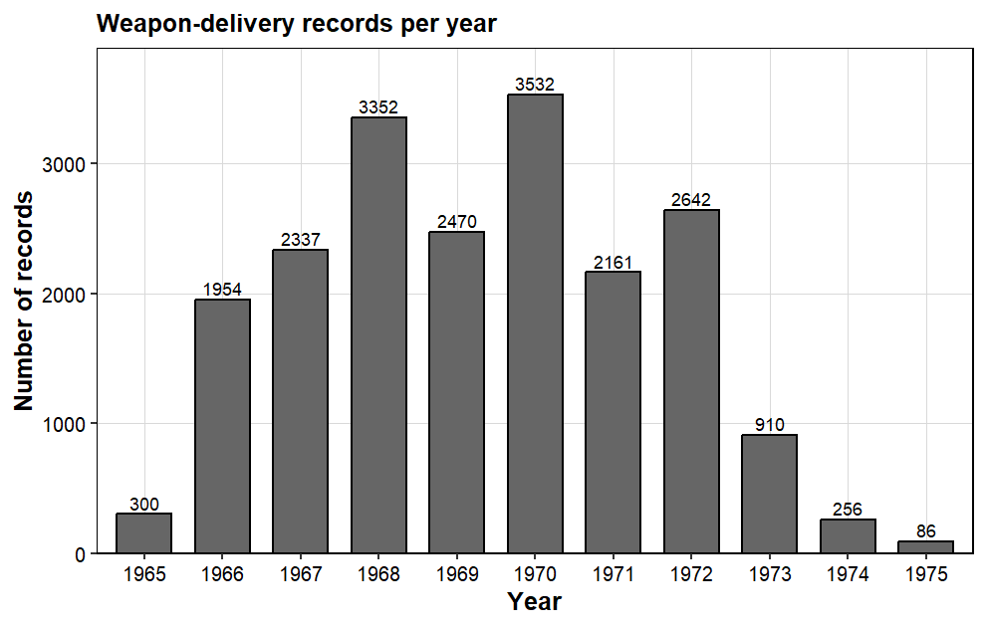
Figure 1.1: Weapon-delivery records per year. Activity builds up 1966-68, peaks in 1970 (3,532 records) and nearly stops after 1972 (86 records in 1975).
The recorded effort builds up from 1966, peaks in 1970 with 3,532 records, and falls away after 1972 (only 86 records in 1975). In total 57.6% of all records fall in 1968-71, the years of the heaviest fighting; the fall after 1972 matches the withdrawal of US forces.
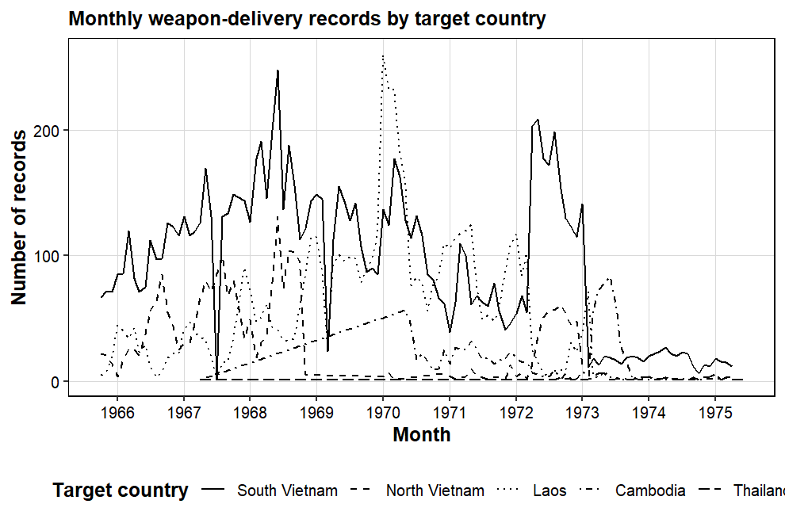
Figure 1.2: Monthly number of records by target country. South Vietnam dominates throughout; Laos is present steadily; the North Vietnam series appears mainly in 1972.
The countries behave differently. South Vietnam is a steady, high-volume theatre almost every month, while North Vietnam appears in concentrated bursts (1967-68 and again in 1972) - the two bombing campaigns against the North.
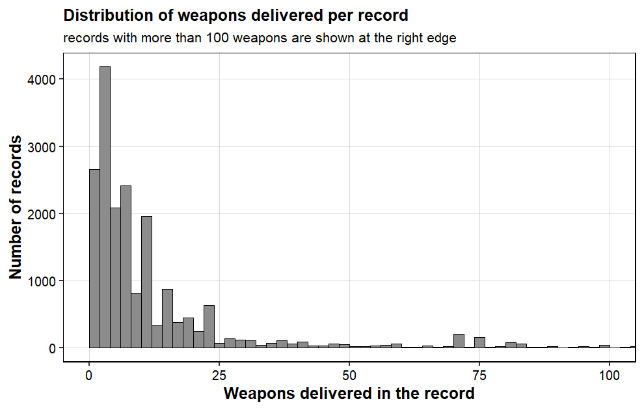
Figure 1.3: Number of weapons delivered per record (records above 100 weapons are shown at the right edge).
Half of all records deliver 8 weapons or fewer, yet 5.74% deliver more than 100 (the largest single record is 9,040 weapons). A tail this heavy is exactly why the median is reported next to the mean everywhere in this report.
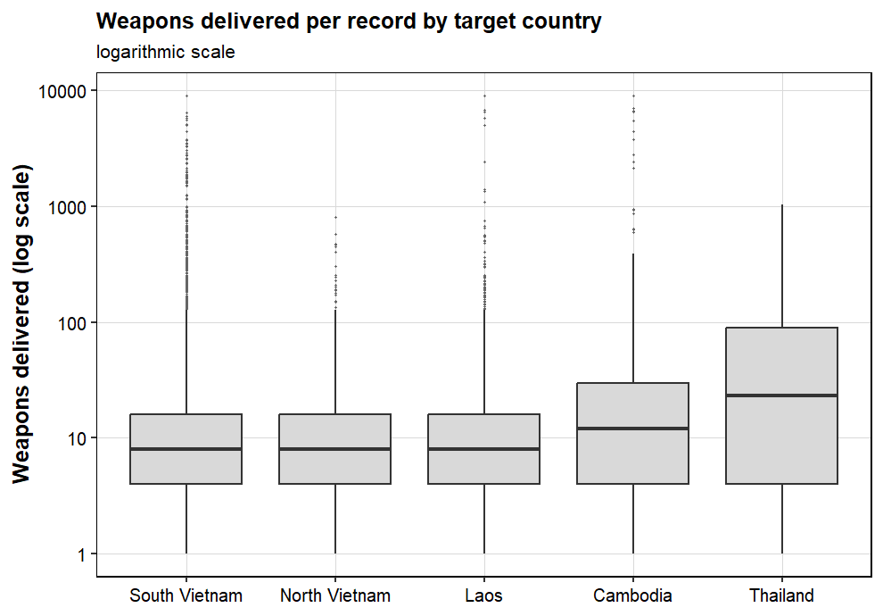
Figure 1.4: Weapons delivered per record by target country (boxplots).
The typical record looks similar everywhere: a median of 8 weapons in South Vietnam, North Vietnam and Laos, and 12 in Cambodia. The means differ much more - they are all inflated by the long right tail, and by different amounts - so the median is the fair basis for comparing countries.
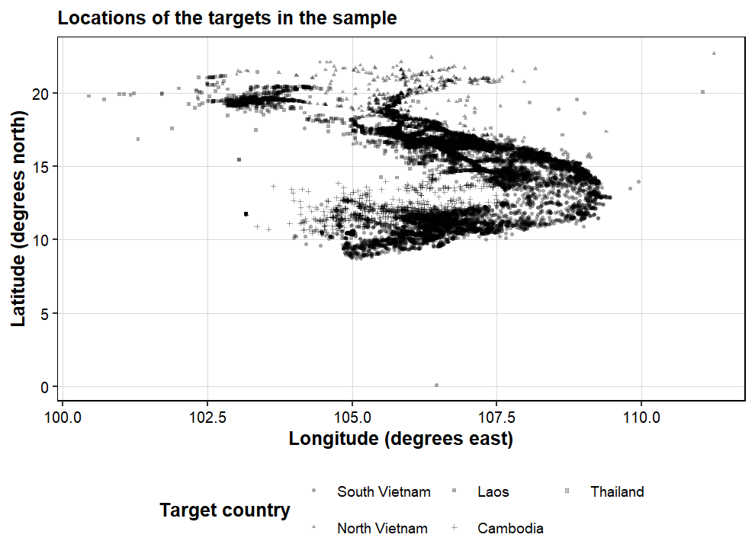
Figure 1.5: Target locations of the sampled records (longitude against latitude).
The plotted targets form the expected map of the war: a dense band along the South Vietnamese coast and the Mekong delta, the Laos panhandle, and clusters in the north. The coordinates agree with the recorded target countries, so the geography in the file is consistent.
Conclusion
• The recorded campaign builds up in 1966-68, peaks in 1970 (3,532 records) and falls away after 1972; 57.6% of all records belong to 1968-71.
• Most deliveries go to South Vietnam (53.5% of records), then Laos (29.2%), North Vietnam (12.0%) and Cambodia (4.9%).
• The F-4 is the most used aircraft (24.1%), followed by the F-100 (14.4%) and the A-1 (10.3%); bombs dominate what is delivered (61.8% of records with a known weapon class).
• Day records outnumber night records roughly 2.5 to 1 (13,786 against 5,380).
• Every numerical variable is heavily right-skewed (weapons: mean 38.1 against median 8), so medians and quartiles describe the typical record, not means.

Problem statement 2 (Unit II): A probability model for the weapon load
Problem statement
Find a probability distribution that describes the recorded weapon load of a delivery record. Compare the normal and the lognormal model, test the quality of the fit, use the model to compute probabilities, and check the central limit theorem for the mean load of 30 records.
Introduction (purpose and approach)
The weapon load (LOAD_LB) is the best continuous measure of how big a single delivery was. It is available for the 5,894 sampled records that come from the SEADAB source (29.5% of the sample). A probability model for this variable lets us answer questions like 'how likely is a delivery above 50,000 lb?'. The plan: estimate the parameters of two candidate models (normal and lognormal) by maximum likelihood, test each fit with a chi-square goodness-of-fit test, and then verify the central limit theorem with a simulation.
Approach / algorithm with explanation
1. Take the 5,894 records that have a load and summarise the variable (mean, median, sd, skewness, kurtosis, quartiles).
2. Fit a normal model, using the sample mean and sd as the maximum-likelihood estimates.
3. Fit a lognormal model: take log10(load), fit a normal distribution to the logs, and report the parameters in natural log units.
4. Test both fits with the chi-square goodness-of-fit test on 8 equally likely bins (df = 7 - 2 estimated parameters = 5).
5. Compare observed and fitted quartiles and probabilities, and use boxplots by aircraft group to see why any misfit happens.
6. Central limit theorem: 20,000 simulated samples of 30 records; compare the mean, sd and skewness of the sample means with theory, and compute the probability that the sample mean exceeds 70,000 lb both ways.
Output with Description
Quantity | Value | Quantity | Value
n (records with load) | 5,894 | Median | 34,260 lb
Mean | 59,795.3 lb | Q1, Q3 | 15,930 / 63,720 lb
Std. deviation | 94,711.3 lb | Minimum, maximum | 60 / 8,96,480 lb
Skewness | 4.554 | Kurtosis | 25.245
Table 7: The recorded weapon load (all 5,894 records come from the SEADAB source).
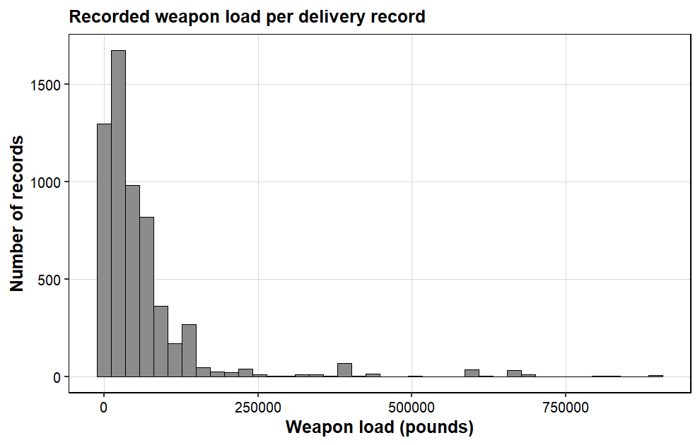
Figure 2.1: Histogram of the recorded weapon load; the strong right skew (skewness 4.55) makes a normal model implausible for the load itself.
Normal model: the fitted parameters are mean 59,795.3 lb and sd 94,703.2 lb, and the chi-square statistic is 7,337.8 on 5 degrees of freedom (p < 2.2e-16) - a clear rejection. One number shows why: the normal model wants 12.5% of the records in the lowest bin, but no delivery load can be negative, so the model's lower tail is impossible.
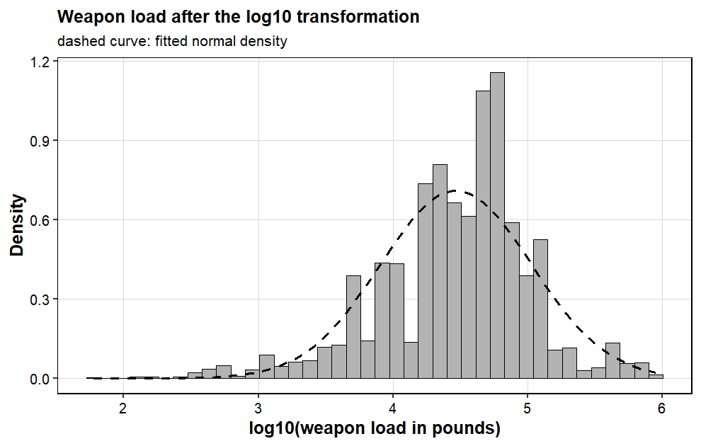
Figure 2.2: log10 of the weapon load with the fitted normal density; on the log scale the data are close to symmetric (skewness -0.64), which is the lognormal idea.
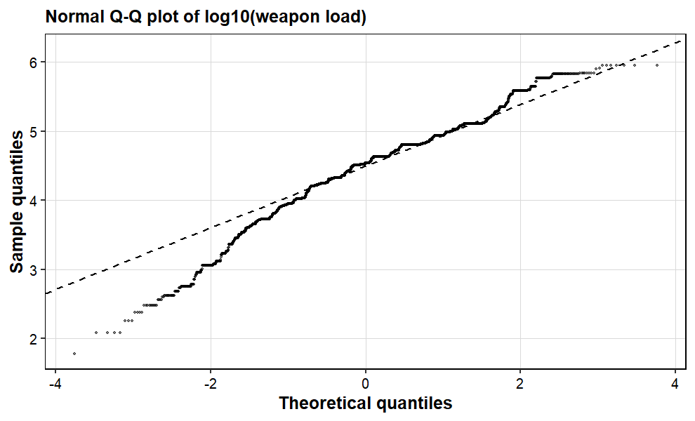
Figure 2.3: Normal Q-Q plot of log10(load): the middle follows the line, but both tails bend away.
The lognormal model does much better. On the log scale the sample has mean 4.4669 and sd 0.5616 (meanlog 10.2854 and sdlog 1.2931 in natural logs). The chi-square statistic drops from 7,338 to 610.2 - still df = 5, and still a formal rejection (p < 2.2e-16), because with n = 5,894 even small imperfections are detectable. The bin counts show the pattern: the middle bins hold more records than expected (1,163 and 1,006 against 736.8 each) and the tails fewer. The quartiles tell the same story: fitted 12,249 / 29,302 / 70,097 against observed 15,930 / 34,260 / 63,720.
Threshold load | Model probability P(load > threshold) | Observed share
25,000 lb | 0.5489 | 0.5976
50,000 lb | 0.3397 | 0.3522
75,000 lb | 0.2337 | 0.1971
1,00,000 lb | 0.1713 | 0.1318
Table 8: Probabilities from the fitted lognormal model against the observed shares. P(20,000 < load < 60,000) is 0.3264 by the model and 0.3453 observed.
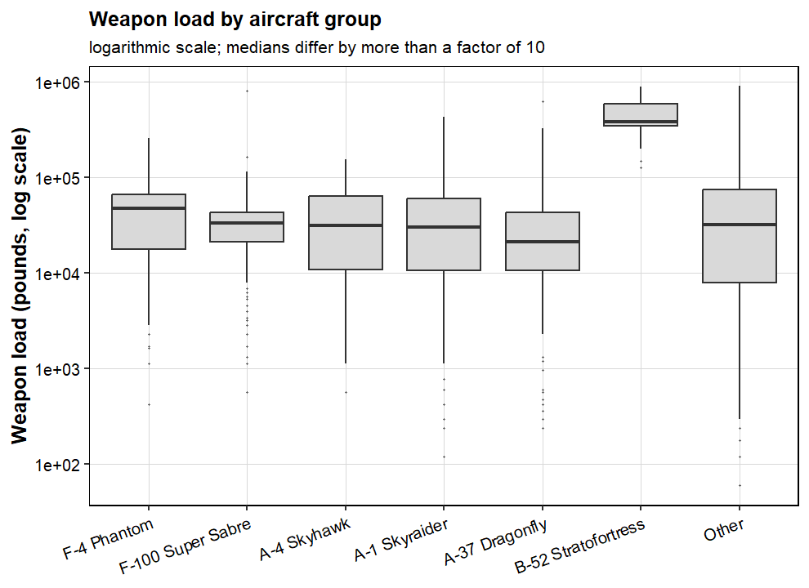
Figure 2.4: Weapon load by aircraft group on the log scale. The B-52 group (median 3,82,320 lb) is an extreme group, more than ten times the median load of the F-4 (47,790 lb) or the A-37 (21,240 lb).
Figure 2.4 explains the rejection: the load is not one population but a mixture of aircraft groups. A B-52 record carries a median of 3,82,320 lb - more than ten times the A-37 median (21,240 lb) and eight times the F-4 median (47,790 lb). No single distribution can fit a mixture this wide. This is a property of the data (very different aircraft pooled together, load recorded in one source only), not a failure of the method.
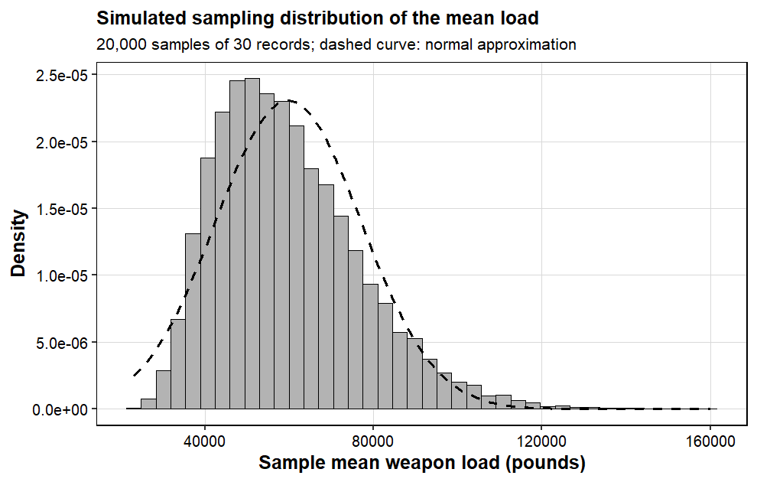
Figure 2.5: Simulated sampling distribution of the mean load of 30 records (20,000 repetitions) against the normal approximation.
For n = 30 the standard error of the mean is 94,711.3 / sqrt(30) = 17,291.8 lb. The simulation matches theory closely: the mean of the sample means is 59,736.9 lb (theory 59,795.3) and their sd is 17,169.1 lb (theory 17,291.8). The one visible imperfection is shape: the normal approximation gives P(sample mean > 70,000) = 0.2775 while the simulation gives 0.2494, because with skewness 0.822 the distribution of the means is still slightly right-skewed at n = 30.
Conclusion
• The normal model is plainly wrong for the load - it needs negative loads and fits twelve times worse than the lognormal (chi-square 7,337.8 against 610.2).
• The lognormal captures the shape well and gives usable probabilities: about 34% of records above 50,000 lb against 35% observed, and all four thresholds in Table 8 within roughly 5 percentage points.
• It is still formally rejected (p < 2.2e-16) because the data are a mixture of very different aircraft groups - a single distribution cannot fit all of them.
• The CLT check succeeded: the mean of 30 records matches theory in both mean and standard error (within about 1%), although the normal approximation is only approximate at n = 30 for such a heavy-tailed variable.

Problem statement 3 (Unit III): Day versus night weapon load (two-sample t-test)
Problem statement
Test, at the 5% level, whether the mean weapon load of a delivery record differs between day and night missions. State the hypotheses, check the assumptions of the test, and cross-check the conclusion with a test that does not assume normality.
Introduction (purpose and approach)
Period of day is one of the few operational factors that is recorded for almost every record (missing for just 4.2%). If day and night deliveries differ in size, that changes how the totals and graphs in this report should be read. Because the load is extremely skewed, the comparison is made on log10(load), which turns the t-test into a test of geometric means, and Welch's version is used so that unequal variances are handled properly.
Approach / algorithm with explanation
• H0: the mean log10(load) is the same for day and night records; H1: the means differ (two-sided), level of significance 5%.
1. Keep the 5,891 records with both a recorded load and a recorded period.
2. Check normality of log10(load) inside each group (skewness, Shapiro-Wilk on a subsample of 2,000) and equality of variances (F test and Levene's test).
3. Carry out Welch's two-sample t-test and report the difference of means on the log scale, its 95% confidence interval and the ratio of geometric means.
4. Measure the size of the effect with Cohen's d on the log scale.
5. Cross-check with the Mann-Whitney test on the raw loads, which assumes neither normality nor equal variances.
6. Investigate the apparent contradiction between the raw means and the medians.
Output with Description
Group | n | Mean (lb) | sd (lb) | Median (lb) | Q1 | Q3 | Geometric mean (lb)
Day | 4,196 | 57,614.7 | 80,064.1 | 42,240 | 17,600 | 65,600 | 32,254
Night | 1,695 | 65,258.9 | 1,23,637.8 | 24,900 | 8,900 | 63,720 | 23,165
Table 9: Weapon load by period of day (5,891 records with both variables recorded; 3 records had a load but no valid period).
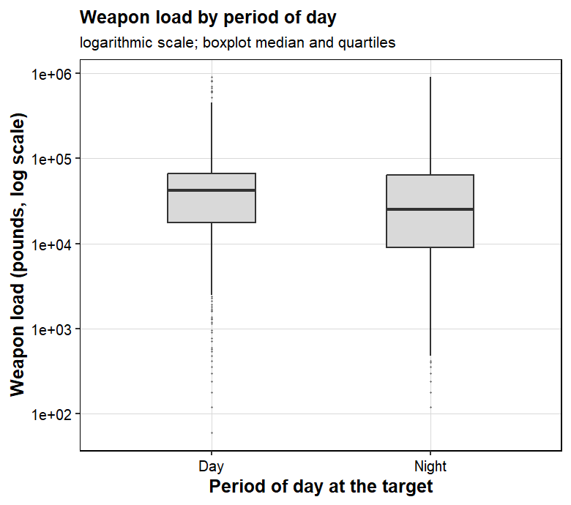
Figure 3.1: Weapon load (raw pounds) by period of day. The night group has a lower median but a longer upper tail.
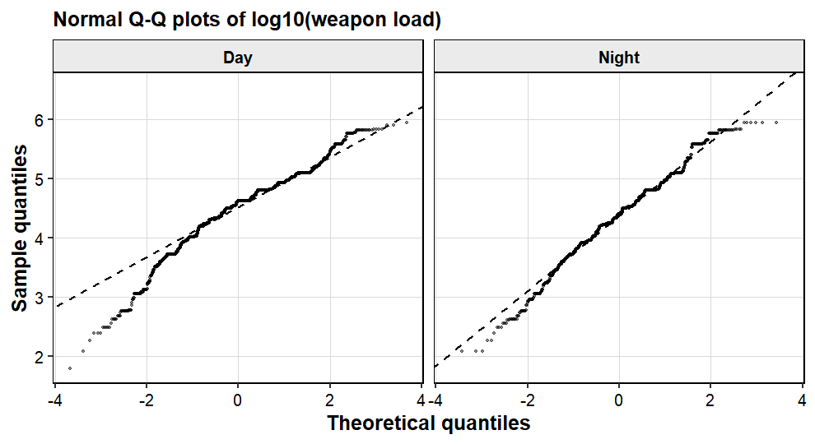
Figure 3.2: Normal Q-Q plots of log10(load) by period; both groups are close to normal on the log scale but the tails deviate.
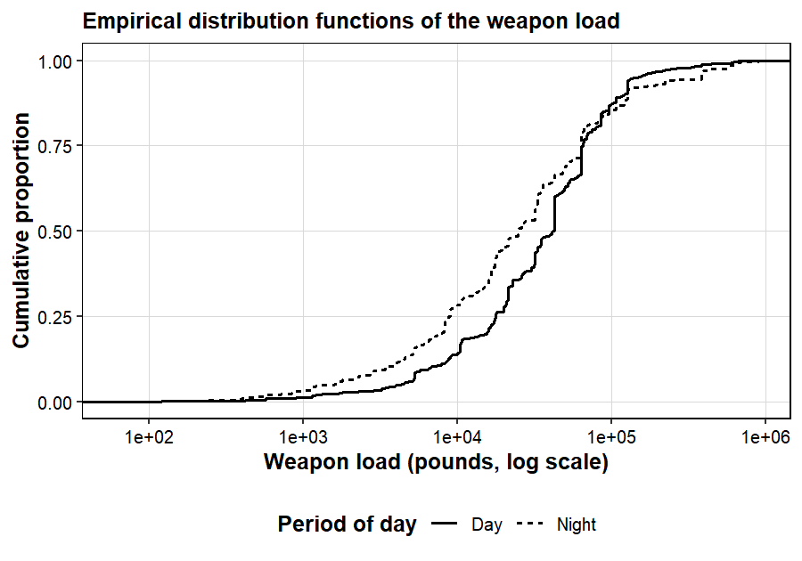
Figure 3.3: Empirical distribution functions of the weapon load (logarithmic axis) by period; the day curve lies to the right for most of the range.
The checks before the test:
• Shape: on the log scale the groups are far better behaved (skewness -0.79 for day and -0.28 for night, against +4.55 for the raw load). Shapiro-Wilk still rejects strict normality (W = 0.9583 and 0.9876, both p < 1e-10), as it does for almost any large sample, so the Mann-Whitney test is added as a safety net.
• Variances: both the F test (0.605) and Levene's test (F = 143.1, p < 2.2e-16) say the variances differ, so Welch's t-test - which does not need equal variances - is the right choice.
Test result: t = 8.069 on 2,561.6 degrees of freedom, p = 1.079e-15, so the null hypothesis is rejected. The mean log10(load) is 4.5086 by day against 4.3648 at night; the difference (day - night) is 0.1438 with 95% confidence interval [0.1088, 0.1787]. Back on the original scale, the day geometric mean is 1.392 times the night value, about 39% higher, and the interval runs from 28.5% to 50.9%. Cohen's d is 0.258 - a small-to-moderate effect.
So why do the raw means say the opposite (night 65,258.9 lb against day 57,614.7 lb)? Because night deliveries are polarised: 27.9% of them are below 10,000 lb (day: 13.8%), but 6.8% are above 2,00,000 lb (day: 3.2%). A handful of very heavy night deliveries drags the mean up, while the median tells the honest story - 42,240 lb by day against 24,900 lb at night, a difference of 17,340 lb in the same direction as the t-test.
The Mann-Whitney test agrees (U = 4,112,513, p < 2.2e-16) on the raw loads, and it assumes neither normality nor equal variances - so the conclusion is not an artefact of the model assumptions.
Conclusion
• Day and night deliveries genuinely differ (Welch p = 1.08e-15): the typical day load is about 39% heavier (geometric means 32,254 against 23,165 lb; medians 42,240 against 24,900 lb).
• The effect is small to moderate (d = 0.26), and the non-parametric Mann-Whitney test agrees with the t-test.
• The raw means disagree only because a few very heavy night deliveries pull the night mean up - a textbook reminder to compare skewed data on the log scale or by medians.
• Limitation: one mission can produce several records, so the p-value is slightly optimistic; the effect size and the confidence interval are the quantities to trust.

Problem statement 4 (Unit III): Aircraft type and target country (chi-square test of independence)
Problem statement
Test whether the mix of aircraft types used in a delivery record is independent of the target country. Use the chi-square test of independence, measure the strength of the association and identify which combinations of aircraft and country occur more or less often than expected.
Introduction (purpose and approach)
Different aircraft have different roles (close air support, interdiction, strategic bombing); the question is whether the recorded aircraft mix actually changes from country to country, or whether the same mix is used everywhere. Both variables are categorical, so the chi-square test of independence is the appropriate test. The strength of the association is measured with Cramer's V and the individual cells are analysed with standardised residuals.
Approach / algorithm with explanation
• H0: aircraft type and target country are independent; H1: they are associated (level of significance 5%).
1. Keep the records with both variables recorded: 19,651 records. The 82 records with targets in Thailand are then excluded from the test because two expected cell counts fall below 5, which would break the chi-square approximation (Thailand is 0.4% of the sample); 19,569 records remain.
2. Build the contingency table (7 aircraft groups x 4 countries) and the row percentages.
3. Check the assumptions: each record is in exactly one cell, the minimum expected count is 40.96 (all above 5), and records are not fully independent (several records per mission - limitation stated once).
4. Chi-square test of independence; Cramer's V for the effect size.
5. Standardised residuals (observed - expected) / sqrt(expected) per cell; |residual| > 3 marks the cells that drive the association.
Output with Description
Aircraft group | South Vietnam | North Vietnam | Laos | Cambodia | Total
F-4 Phantom | 1,743 (36.5%) | 784 (16.4%) | 2,093 (43.9%) | 149 (3.1%) | 4,769
F-100 Super Sabre | 2,516 (90.8%) | 9 (0.3%) | 140 (5.1%) | 107 (3.9%) | 2,772
A-4 Skyhawk | 948 (51.5%) | 542 (29.4%) | 350 (19.0%) | 1 (0.1%) | 1,841
A-1 Skyraider | 1,060 (51.7%) | 94 (4.6%) | 836 (40.8%) | 59 (2.9%) | 2,049
A-37 Dragonfly | 1,222 (85.4%) | 0 (0.0%) | 22 (1.5%) | 187 (13.1%) | 1,431
B-52 Stratofortress | 409 (49.0%) | 67 (8.0%) | 231 (27.7%) | 128 (15.3%) | 835
Other types | 2,612 (44.5%) | 867 (14.8%) | 2,064 (35.1%) | 329 (5.6%) | 5,872
Total | 10,510 | 2,363 | 5,736 | 960 | 19,569
Table 10: Contingency table of aircraft group against target country (row percentages in brackets).
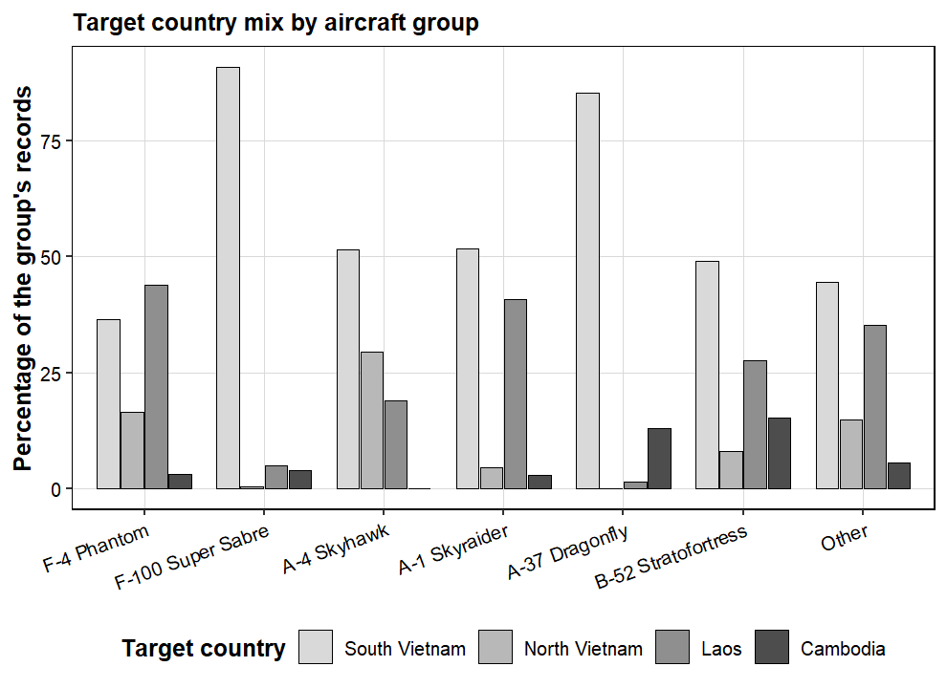
Figure 4.1: Target country mix (row percentages) by aircraft group. Aircraft types clearly differ in where they operate.
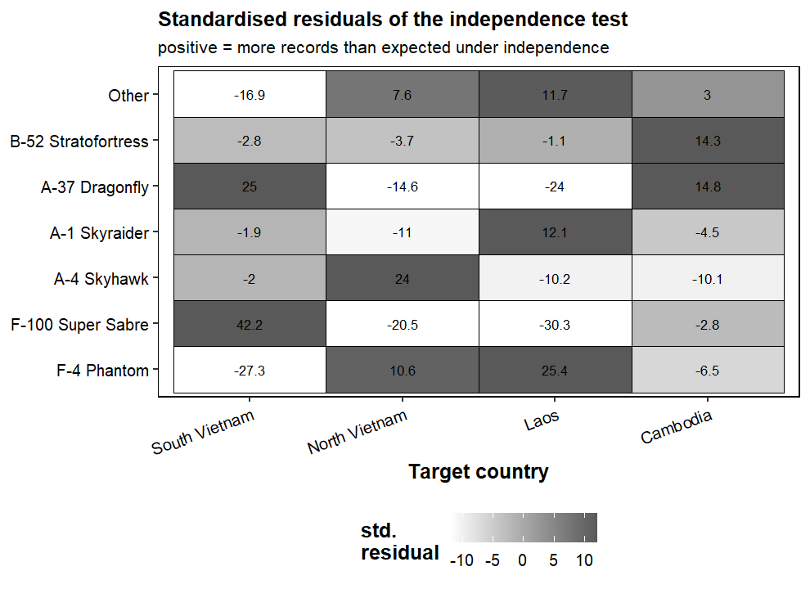
Figure 4.2: Standardised residuals of the test; darker cells deviate more from independence (positive = more records than expected).
Result: chi-square = 4,538.3 on (7-1)(4-1) = 18 degrees of freedom, p < 2.2e-16 - independence is rejected. The aircraft mix clearly depends on where the mission went. Cramer's V = 0.278 says the link is moderate in strength.
The residuals show exactly how the association works:
• F-100 and A-37: almost only South Vietnam (residuals +42.2 and +25.0; 90.8% and 85.4% of their records) - classic close air support.
• A-4 Skyhawk (US Navy): over-represented over North Vietnam (+24.0; 29.4% of its records against 12.1% of the sample).
• F-4 Phantom: over Laos (+25.4; 43.9% of its records) and under over South Vietnam (-27.3).
• B-52: over Cambodia (+14.3; 15.3% of its records against 4.9%) - the well-known pattern of the Cambodian bombing.
• F-100: almost never over North Vietnam (-20.5).
In short, each aircraft family has its own operational home.
Conclusion
• Aircraft type and target country are not independent (chi-square = 4,538.3, df = 18, p < 2.2e-16); the association is moderate (Cramer's V = 0.278).
• The residuals read like the history of the air war: the F-100 and A-37 cover the South, the Navy's A-4 concentrates on the North, the F-4 works over Laos, and the B-52 concentrates on Cambodia.
• Caveats: the 82 Thailand records were excluded (two expected counts below 5), and mission-level dependence makes the p-value optimistic - the residual pattern and Cramer's V are the robust results.

Problem statement 5 (Unit IV): Explaining the size of the attacking formation (correlation and multiple regression)
Problem statement
Study the association between the numerical variables of the data and build a multiple linear regression model for the number of aircraft in a delivery record (log10 of AIRCRAFT_NO) as a function of aircraft type, target country, period of day, year and source database. Evaluate the model, check its assumptions and use it to predict the number of aircraft for a given mission profile.
Introduction (purpose and approach)
The number of aircraft in a record is a direct measure of how big the formation was. This analysis asks three questions: which variables move together (correlation analysis), how much of the formation size the recorded factors explain (multiple regression), and whether the model predicts sensibly for a given mission profile. Because the count is heavily skewed, the regression works on log10(aircraft) and the correlations are read mainly from the Spearman coefficients.
Approach / algorithm with explanation
1. Pearson and Spearman correlations between AIRCRAFT_NO, WEAPONS_DELIVERED, LOAD_LB, TGT_HOUR, LAT and LON on pairwise complete observations.
2. As a baseline, a simple linear regression of log10(AIRCRAFT_NO) on log10(WEAPONS_DELIVERED).
3. Multiple regression log10(AIRCRAFT_NO) ~ AIRCRAFT_GROUP + COUNTRY + PERIOD + YEAR + SOURCE_DB on the 18,811 records with all variables recorded (reference categories: F-4 Phantom, South Vietnam, Day, SEADAB).
4. Report the coefficient table with 95% confidence intervals, R squared, the overall F test and interpret the largest coefficients as percentage changes (factor 10^b).
5. Diagnostics: residual plots, Shapiro-Wilk and moments of the residuals, Cook's distance for influential observations, and the variance inflation of YEAR against all other predictors.
6. Prediction example with a 95% prediction interval and comparison with the observed records of the same profile.
Output with Description
Correlations first (Spearman values; all p < 2.2e-16 unless stated). The strongest pair is weapons delivered and load (rho = 0.648) - heavier loads mean more bombs. Aircraft per record moves with the load (0.288) and with weapons delivered (0.173), and slightly against the hour at target (-0.217). Latitude and longitude correlate negatively (-0.280) simply because the theatre runs from north-west to south-east. Notice how much smaller the Pearson values are for the skewed pairs (0.247 against 0.173 for aircraft and weapons): linear correlation on skewed data understates the relationship.
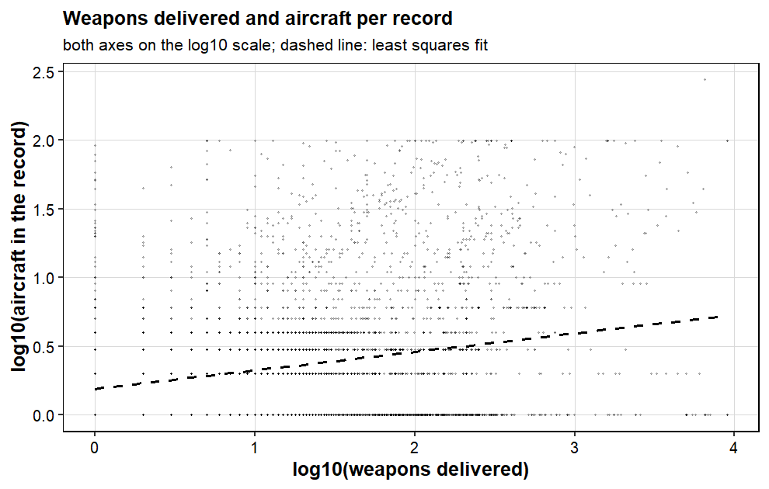
Figure 5.1: log10(weapons delivered) against log10(aircraft per record); the dashed line is the least squares fit of the simple regression, R squared = 0.063.
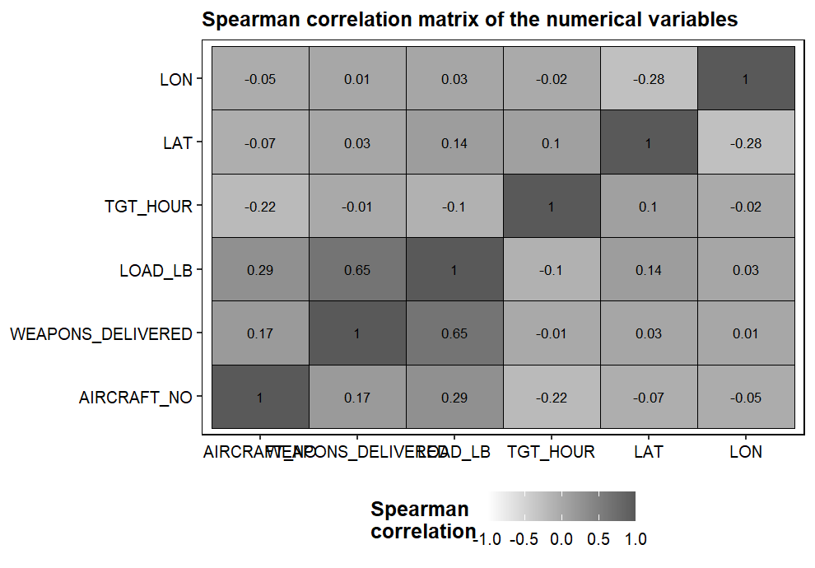
Figure 5.2: Spearman correlation matrix of the numerical variables.
Model | R squared | Adjusted R sq. | F / p | Residual std. error | AIC
Simple: aircraft on weapons | 0.0634 | 0.0633 | 1,273 / < 2.2e-16 | 0.2594 | 2,623.8
Multiple: all five factors | 0.1660 | 0.1654 | 267.2 / < 2.2e-16 | 0.2449 | 467.1
Table 11: Comparison of the simple and the multiple regression (n = 18,811).
Multiple regression: R squared = 0.166 (adjusted 0.1654), with F = 267.2 on (14, 18,796) degrees of freedom, p < 2.2e-16. In words: type, country, period, year and source together explain about 17% of why one record has more aircraft than another. The biggest effects, holding the other factors fixed:
Predictor (against reference) | Estimate (log10) | Effect on aircraft | 95% CI (log10)
B-52 Stratofortress (vs F-4) | +0.193 | +55.9% (x1.56) | [0.164, 0.221]
Period: Night (vs Day) | -0.200 | -36.9% | [-0.208, -0.192]
Source CACTA6669 (vs SEADAB) | -0.189 | -35.3% | [-0.203, -0.175]
Source CACTA6570 (vs SEADAB) | -0.103 | -21.1% | [-0.117, -0.089]
Country: Cambodia (vs South Vietnam) | -0.087 | -18.1% | [-0.105, -0.070]
A-37 Dragonfly (vs F-4) | -0.074 | -15.6% | [-0.089, -0.058]
Year (per year) | -0.033 | -7.3% per year | [-0.036, -0.030]
Table 12: Largest coefficients of the multiple regression (all p < 0.001). The Thailand coefficient (+0.379, +139%) is significant but rests on only 82 records, so it is not interpreted. F-100 and 'Other' are not significantly different from the F-4 at the 5% level once the other factors are held constant; the A-1 and A-4 coefficients are small but significant (-6.1% and -5.2%).
In plain language: a B-52 record carries about 1.56 times the aircraft of an equivalent F-4 record (the big multi-aircraft cells); night operations are about 37% smaller; the two smaller CACTA sources record formations 35% and 21% smaller than SEADAB, which fits with them capturing different kinds of missions; formation sizes shrink by about 7% for each year of the war; and records over Cambodia are about 18% smaller than over South Vietnam.
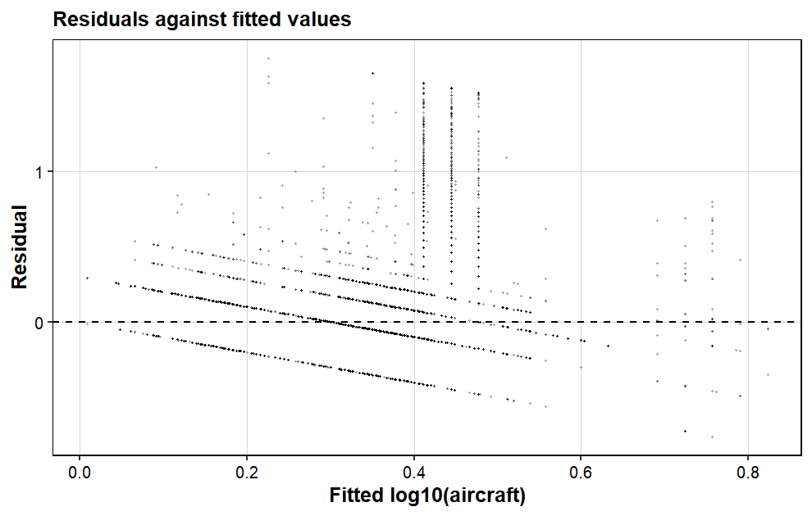
Figure 5.3: Residuals against fitted values. The diagonal stripes come from the discrete response values (log10(1) = 0, log10(2) = 0.30, ...), not from a modelling problem; the points scatter evenly around zero.
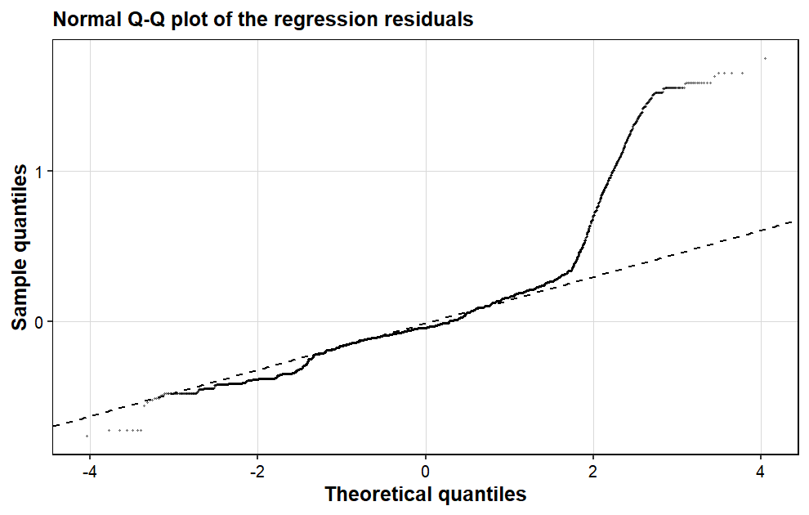
Figure 5.4: Normal Q-Q plot of the residuals; the model is adequate in the middle, the right tail corresponds to a few very large formations (up to 99 aircraft) that the model under predicts.
The diagnostic checks hold up:
• Residuals: mean zero by construction, but skewness 2.45 and kurtosis 11.4 (Shapiro-Wilk W = 0.822 on a subsample of 2,000, p < 2.2e-16). The cause is the right tail - a few giant formations (up to 99 aircraft) that any multiplicative model under-predicts; the middle of the distribution is well behaved.
• Influence: the largest Cook's distance is 0.0089, far below 1, and only 2.81% of records pass the 4/n guideline - no single record is driving the fit.
• Collinearity: the VIF of YEAR is 3.76 - below the usual threshold of 5, but not 1, because the country mix drifts over the war (Thailand appears only late). Read the year effect as an average trend, not a causal effect.
Prediction test: for the profile 'F-4 Phantom, target North Vietnam, night, 1972, SEADAB' the model predicts 1.55 aircraft with a 95% prediction interval of [0.51, 4.69]. The 32 real records matching this profile average 1.75 aircraft - right inside the interval. The interval is wide on the original scale (a factor of about nine), which is honest: the model describes group averages well, a single record only roughly.
Conclusion
• Formation size is dominated by aircraft type and period of day: B-52 records carry about 56% more aircraft than equivalent F-4 records, and night records about 37% fewer.
• The five recorded factors explain about 17% of the record-to-record variation - realistic, since target importance, aircraft availability and weather are not in the data.
• All practical checks pass: no influential records, moderate collinearity, sensible residuals, and the prediction interval covers the observed mean of a real mission profile.
• The correlation analysis adds a caution: on data this skewed, Pearson coefficients understate the links (weapons against load: 0.31, against the Spearman 0.65).

Overall conclusion
• Data: 46.7 lakh raw records reduced to a documented, reproducible 20,000-record random sample; every number in this report is regenerated by the scripts and logged in outputs/.
• Problem 1 - the campaign peaks in 1970, concentrates on South Vietnam and Laos, is flown mainly by the F-4, F-100 and A-1, and delivers mostly bombs.
• Problem 2 - the weapon load follows a lognormal shape (far better than the normal), but the fit is formally rejected because the load is a mixture of aircraft types; model probabilities stay within about 5 percentage points, and the CLT check passed.
• Problem 3 - day deliveries are about 39% heavier than night deliveries in typical value (medians 42,240 against 24,900 lb), with a small-to-moderate effect size.
• Problem 4 - the aircraft mix depends strongly on the target country (chi-square = 4,538.3, V = 0.278): each aircraft family has its own theatre.
• Problem 5 - formation size is explained by type, period, country, year and source (R squared = 0.166); B-52 records carry about 1.56 times the aircraft of an F-4 record, night records about 37% fewer - and the prediction test passed.
• One lesson repeats in all five problems: these data are heavily right-skewed, so medians, geometric means and log-scale tests tell the honest story - raw means can even flip the conclusion.
• Same caveats throughout: records are delivery events, not independent missions; the load is recorded only in SEADAB; several raw columns are unusable.
R packages and software used
• R 4.6.1, run as plain scripts in RStudio.
• readr - reads the large raw file in chunks.
• ggplot2 - produces every figure in a black-and-white theme.
• Base R statistics - lm, t.test, chisq.test, shapiro.test and wilcox.test.
• Base R custom code - Levene's test, the moment-based skewness/kurtosis and the variance inflation factors are written by hand in scripts/common_setup.R, so the project needs no package beyond the two above.
• Scripts - 00_profile_raw.R with 00b/00c profile the raw file, 01_clean.R builds clean_data.csv, and problem1.R to problem5.R each handle one problem statement.
• Outputs - outputs/ holds the text logs quoted in this report, figures/ holds all graphs, and report/ holds this document and its PDF.

