PIMPRI CHINCHWAD EDUCATION TRUST'S
PIMPRI CHINCHWAD COLLEGE OF ENGINEERING

Department of AS&H
Report of FA-2 activity
Subject: BSH23OE04: Open Elective: Statistical Data Analysis using R
Academic Year 2026-27
Semester I
Submitted by:
Name of the student | PRN number | Branch
Om Khanjodkar | 125B1B283 | Computer Engineering
Siddhant Verma | 125B1B278 | Computer Engineering
Parth Ghumade | 125B1B234 | Computer Engineering
Tanishk Malge | 125B1B247 | Computer Engineering

Submitted to: Dr. Rajesh G Talekar
Date: 23/10/2026
Sign: ____________________

1. Abstract
This report presents a descriptive and exploratory statistical analysis of the Theater History of Operations Reports (THOR) Vietnam War aerial bombing dataset using the R programming language. A representative sample of 20,000 combat delivery records spanning 1965–1975 was examined to understand how operational tempo changed over time, which countries were targeted, which aircraft carried out the deliveries, how day and night operations differed, and what the typical weapon payload was. Frequency tables, summary statistics (mean, median, standard deviation and IQR) and ggplot2 visualizations are used throughout, and each result is interpreted in its historical and operational context.
2. Introduction and Background
The THOR dataset is a digitized record of United States and allied aerial munitions delivered during the Southeast Asia conflict. Each record describes a single delivery event: when it occurred, who flew it, which aircraft and weapon class were used, how much ordnance was delivered and where. Because the data is large, structured and spans more than a decade, it is a rich real-world source for practising the core techniques of statistical data analysis: grouping and tabulating categorical variables, summarizing numeric variables and communicating findings through graphs.
In this activity, the data is treated purely as a statistical case study. The goal is to show how R can be used to move from raw records to clear, defensible conclusions, following the workflow of problem statement, statistical analysis, data visualization, coding and interpretation.
3. Objectives
- To summarize annual bombing activity and identify the years of peak and decline.
- To measure the geographic concentration of operations across target countries.
- To identify the aircraft platforms that were used most often for weapon deliveries.
- To compare the frequency and weapon load of day versus night operations.
- To describe the distribution and central tendency of weapon payload per delivery.
- To practise reproducible analysis and visualization in R using the ggplot2 package.
4. Tools and Methodology
All analysis was carried out in R. Frequency tables were produced with table() and as.data.frame(), numeric summaries with mean(), median(), sd() and IQR(), and all graphs with ggplot2. The workflow followed for every problem statement was the same:
- Define the question: state a clear, measurable problem statement.
- Prepare the data: select the relevant variable(s) and, where needed, filter records (for example, positive loads up to 15,000 lb for Problem 5).
- Summarize: compute frequencies, percentage shares and descriptive statistics.
- Visualize: draw a bar chart or histogram that makes the pattern obvious.
- Interpret: explain what the numbers mean and why the pattern may have occurred.
Statistical measures used: frequency, percentage share, mean, median, standard deviation, interquartile range (IQR) and coefficient of variation (CV = standard deviation ÷ mean). Percentages and ratios quoted in the “Additional Observations” of each problem statement are calculated directly from the tables in this report.

5. Project Details
Project Title: Descriptive and Exploratory Analysis of THOR Vietnam War Bombing Operations Data using R
Data used: Theater History of Operations Reports (THOR) Vietnam War Aerial Bombing Dataset
Details of the data: The analyzed dataset consists of 20,000 representative combat delivery records sampled across 1965–1975 with key variables as follows:
- MISSION_DATE: Calendar date of the combat mission
- YEAR: Year of operation (1965 to 1975)
- PERIOD: Time period of delivery: Day vs. Night
- COUNTRY: Target sovereign country (South Vietnam, Laos, North Vietnam, Cambodia, Thailand)
- SERVICE: Operating military service branch (USAF, USN, VNAF, USMC)
- AIRCRAFT_GROUP: Standardized combat aircraft model (F-4 Phantom, B-52, F-100, A-1, A-4, A-37)
- WEAPON_CLASS: Class of weapon delivered (BOMB, ROCKET, GUN, MISSILE, SUPPORT)
- WEAPONS_DELIVERED: Number of ordnance units delivered on target
- LOAD_LB: Total weight of ordnance delivered (in pounds)
- TGT_HOUR: Local hour of target delivery (0-23)
- LAT & LON: Geographic coordinates of strike location
Flow:
Problem Statement
Statistical Analysis
Data Visualization
Coding in R
Findings & Interpretations

Problem statement 1: How did bombing mission activity and weapon delivery volume change across the years of the war?
The data is grouped by operation year from 1965 through 1975 to assess annual operational tempo, peak engagement periods, and de-escalation trends. The frequency distribution of missions is summarized below:
Year | Recorded Deliveries | Percentage Share (%)
1965 | 300 | 1.50%
1966 | 1,954 | 9.77%
1967 | 2,337 | 11.69%
1968 | 3,352 | 16.76%
1969 | 2,470 | 12.35%
1970 | 3,532 | 17.66%
1971 | 2,161 | 10.81%
1972 | 2,642 | 13.21%
1973 | 910 | 4.55%
1974 | 256 | 1.28%
1975 | 86 | 0.43%

It shows that weapon delivery operations escalated sharply between 1966 and 1968, reaching an all-time operational peak in 1970 (3,532 deliveries, 17.66%), followed by a gradual reduction and steep drop following the 1973 ceasefire. This trend is visualized in the bar chart below:
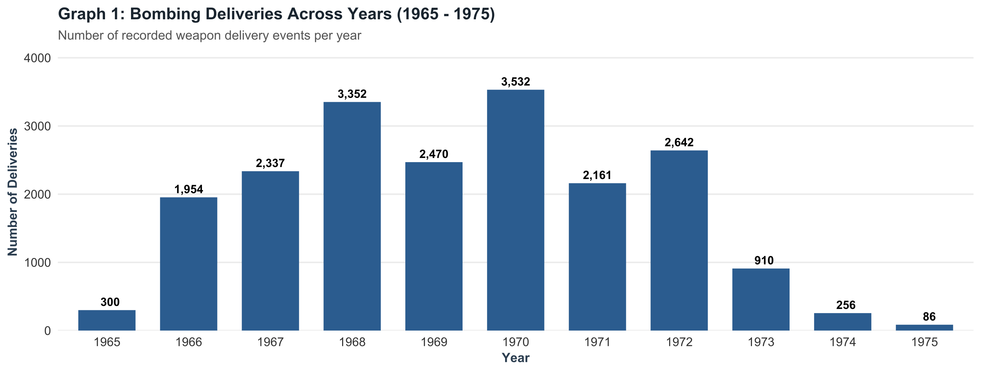
R Code Snippet:
yearly_counts <- as.data.frame(table(Year = data$YEAR))
ggplot(yearly_counts, aes(x = Year, y = Freq)) +
geom_bar(stat = "identity", fill = "#2b5c8f", width = 0.7) +
geom_text(aes(label = format(Freq, big.mark = ",")), vjust = -0.5, fontface = "bold") +
labs(title = "Bombing Deliveries Across Years (1965-1975)", x = "Year", y = "Deliveries")

Explanation & Takeaway: The peak in 1968 and 1970 reflects the intensive phases of ground support and interdiction campaigns. Post-1972 deliveries decreased precipitously as direct air support operations were transferred to local forces.
Additional Observations
To understand the pace of change more precisely, the year-over-year (YoY) change and the cumulative share of deliveries were calculated from the table above:
Year | Deliveries | YoY Change | Cumulative Share
1965 | 300 | — | 1.5%
1966 | 1,954 | +551.3% | 11.3%
1967 | 2,337 | +19.6% | 23.0%
1968 | 3,352 | +43.4% | 39.7%
1969 | 2,470 | -26.3% | 52.1%
1970 | 3,532 | +43.0% | 69.7%
1971 | 2,161 | -38.8% | 80.5%
1972 | 2,642 | +22.3% | 93.7%
1973 | 910 | -65.6% | 98.3%
1974 | 256 | -71.9% | 99.6%
1975 | 86 | -66.4% | 100.0%

- The average is about 1,818.2 deliveries per year across the 11 years; seven years (1966–1972) lie above or near this level.
- The seven years from 1966 to 1972 together account for 18,448 deliveries, i.e. 92.2% of the sample, showing how tightly activity was concentrated in the middle of the war.
- The largest single jump occurred from 1965 to 1966 (an increase of more than five-fold), while the largest drop occurred between 1972 and 1973 (about −65.6%), consistent with the 1973 ceasefire.
- The series is not smooth: 1969 and 1971 dip below their neighbouring peaks, giving the chart a “double-peak” shape around 1968 and 1970.

Problem statement 2: What was the geographic distribution of bombing operations across target countries?
To evaluate geographic concentration of tactical sorties, records are grouped by target country. The deliveries and relative proportions are detailed below:
Target Country | Total Deliveries | Percentage Share (%)
South Vietnam | 10,510 | 53.48%
Laos | 5,736 | 29.19%
North Vietnam | 2,363 | 12.02%
Cambodia | 960 | 4.89%
Thailand | 82 | 0.42%

It shows that South Vietnam accounted for the clear majority of all weapon delivery records (53.48%), followed by Laos (29.19%). The geographic distribution is visualized by the horizontal bar chart below:
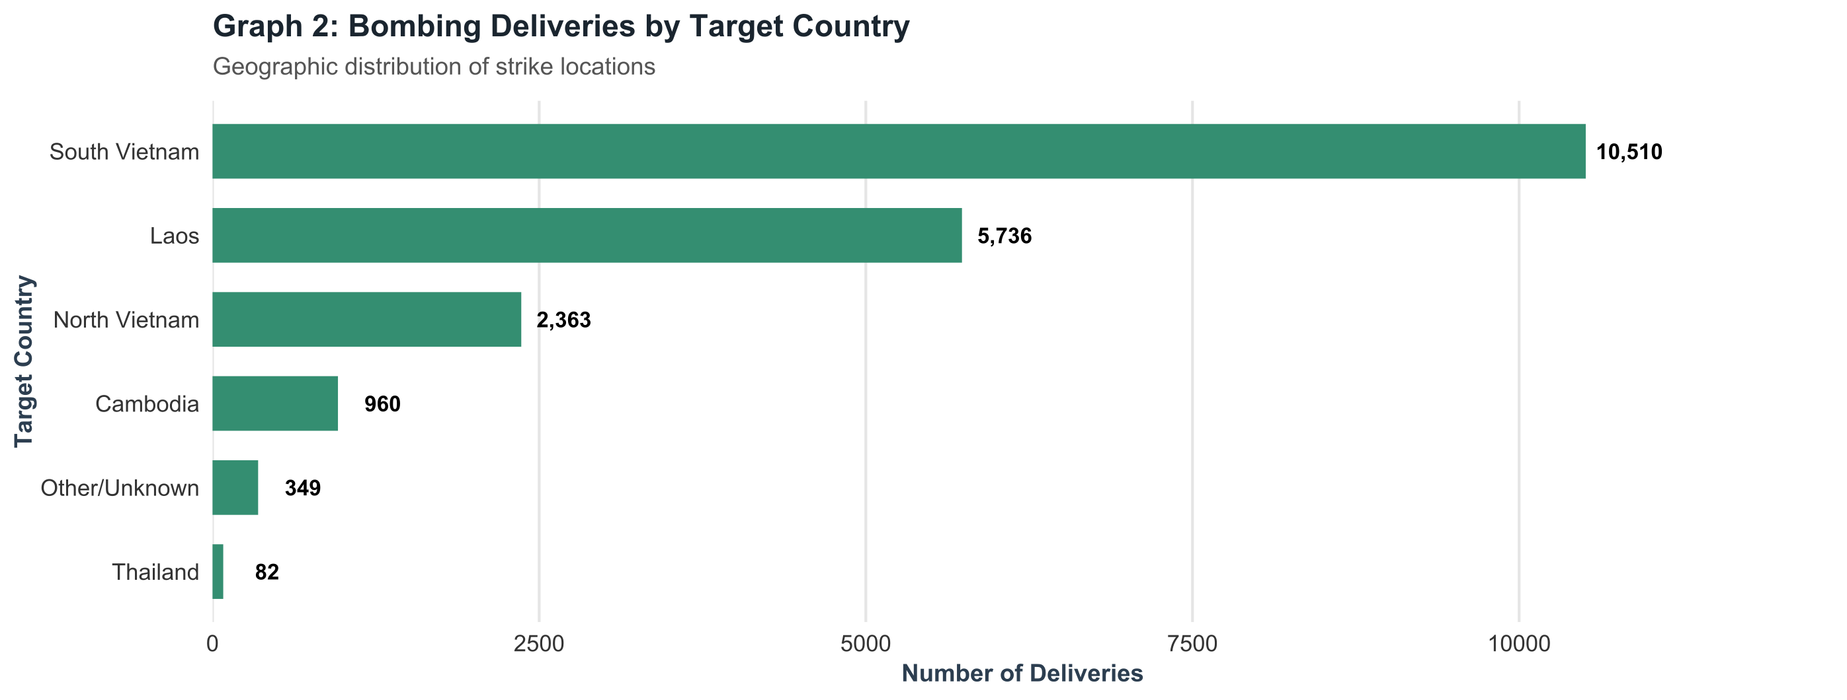
R Code Snippet:
country_counts <- as.data.frame(table(Country = data$COUNTRY))
ggplot(country_counts, aes(x = Country, y = Freq)) +
geom_bar(stat = "identity", fill = "#348e71", width = 0.65) +
coord_flip() +
labs(title = "Bombing Deliveries by Target Country", x = "Target Country", y = "Deliveries")

Explanation & Takeaway: The primary combat theater was internal close air support in South Vietnam. The high frequency in Laos highlights the extensive air interdiction campaign targeting logistics and troop movements along the Ho Chi Minh trail network.
Additional Observations
- South Vietnam and Laos together received 16,246 listed deliveries (10,510 + 5,736), which is far more than the other three listed countries combined (3,405).
- South Vietnam received about 1.8 times as many deliveries as Laos (10,510 ÷ 5,736), and Laos received about 2.4 times as many as North Vietnam (5,736 ÷ 2,363).
- Thailand had the smallest listed share (82 deliveries, 0.42%), which is expected because it mainly served as a base of operations rather than a target area.
- The distribution is highly skewed toward a few countries, so a bar chart sorted from largest to smallest is the clearest way to display it.
Note on categories: Graph 2 also shows an “Other/Unknown” group of 349 records that are not part of the country table. This is why the percentage shares in the table (calculated on the listed countries) are slightly higher than they would be on the full sample of 20,000.

Problem statement 3: Which combat aircraft models were most frequently deployed for weapon deliveries?
Aircraft types were classified into standard operational airframe groups to identify the primary combat platforms used. The frequency and proportion across identified aircraft are as follows:
Aircraft Group | Total Deliveries | Percentage Share (%)
F-4 Phantom | 4,827 | 24.14%
F-100 Super Sabre | 2,877 | 14.39%
A-1 Skyraider | 2,067 | 10.34%
A-4 Skyhawk | 1,841 | 9.21%
A-37 Dragonfly | 1,515 | 7.58%
B-52 Stratofortress | 836 | 4.18%
Other / Unspecified | 6,036 | 30.18%

It clearly shows that the multi-role F-4 Phantom was the single most deployed combat platform (24.14%), delivering significantly more ordnance events than specialized attack aircraft or heavy bombers. This can be visualized by the bar chart below:
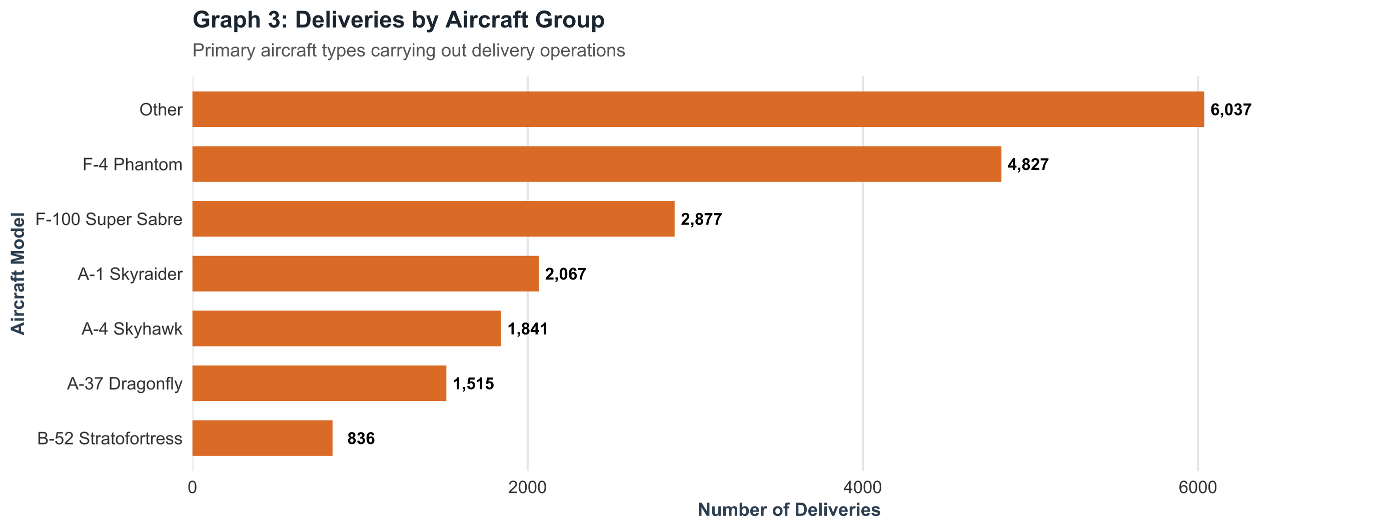
R Code Snippet:
aircraft_counts <- as.data.frame(table(Aircraft = data$AIRCRAFT_GROUP))
ggplot(aircraft_counts, aes(x = Aircraft, y = Freq)) +
geom_bar(stat = "identity", fill = "#d96b27", width = 0.65) +
coord_flip() +
labs(title = "Deliveries by Aircraft Group", x = "Aircraft Model", y = "Deliveries")

Explanation & Takeaway: The McDonnell Douglas F-4 Phantom II served as the primary workhorse due to its high speed, heavy payload capability, and adaptability for both USAF and US Navy joint strike missions.
Additional Observations
- The six named aircraft groups together account for 13,963 deliveries. Within this identified group, the F-4 Phantom alone makes up 34.6%.
- The F-4 Phantom flew about 5.8 times as many recorded deliveries as the B-52 (4,827 ÷ 836) and about 1.7 times as many as the F-100 (4,827 ÷ 2,877).
- The three leading identified platforms (F-4, F-100 and A-1) account for 9,771 deliveries, i.e. 70.0% of the identified group.
- About 30% of records fall under “Other / Unspecified”, so the ranking above describes only the identified aircraft and should be read with that limit in mind.
Why counts differ from tonnage: The B-52 appears low in the count of delivery records because a single heavy-bomber delivery carries a very large load. Counting events and counting weight therefore tell two different stories, which is explored further in Problem 4.

Problem statement 4: How did mission frequency and delivered weapon loads compare between Day and Night operations?
The data is partitioned by operational period (Day vs. Night). Mission count, percentage, average weapon load, and standard deviation of load delivered were computed as follows:
Period | Total Deliveries | Share (%) | Average Load (lb) | Std. Deviation (lb)
Day | 13,778 | 68.9% | 57,614.7 lb | 80,064.1 lb
Night | 6,222 | 31.1% | 65,258.9 lb | 123,637.8 lb

It shows that over two-thirds (68.9%) of all deliveries were conducted during daylight hours. Night operations, while less frequent, exhibited a higher mean load (65,258 lb) driven by B-52 radar-guided arc light strikes. The day vs. night delivery ratio is visualized below:
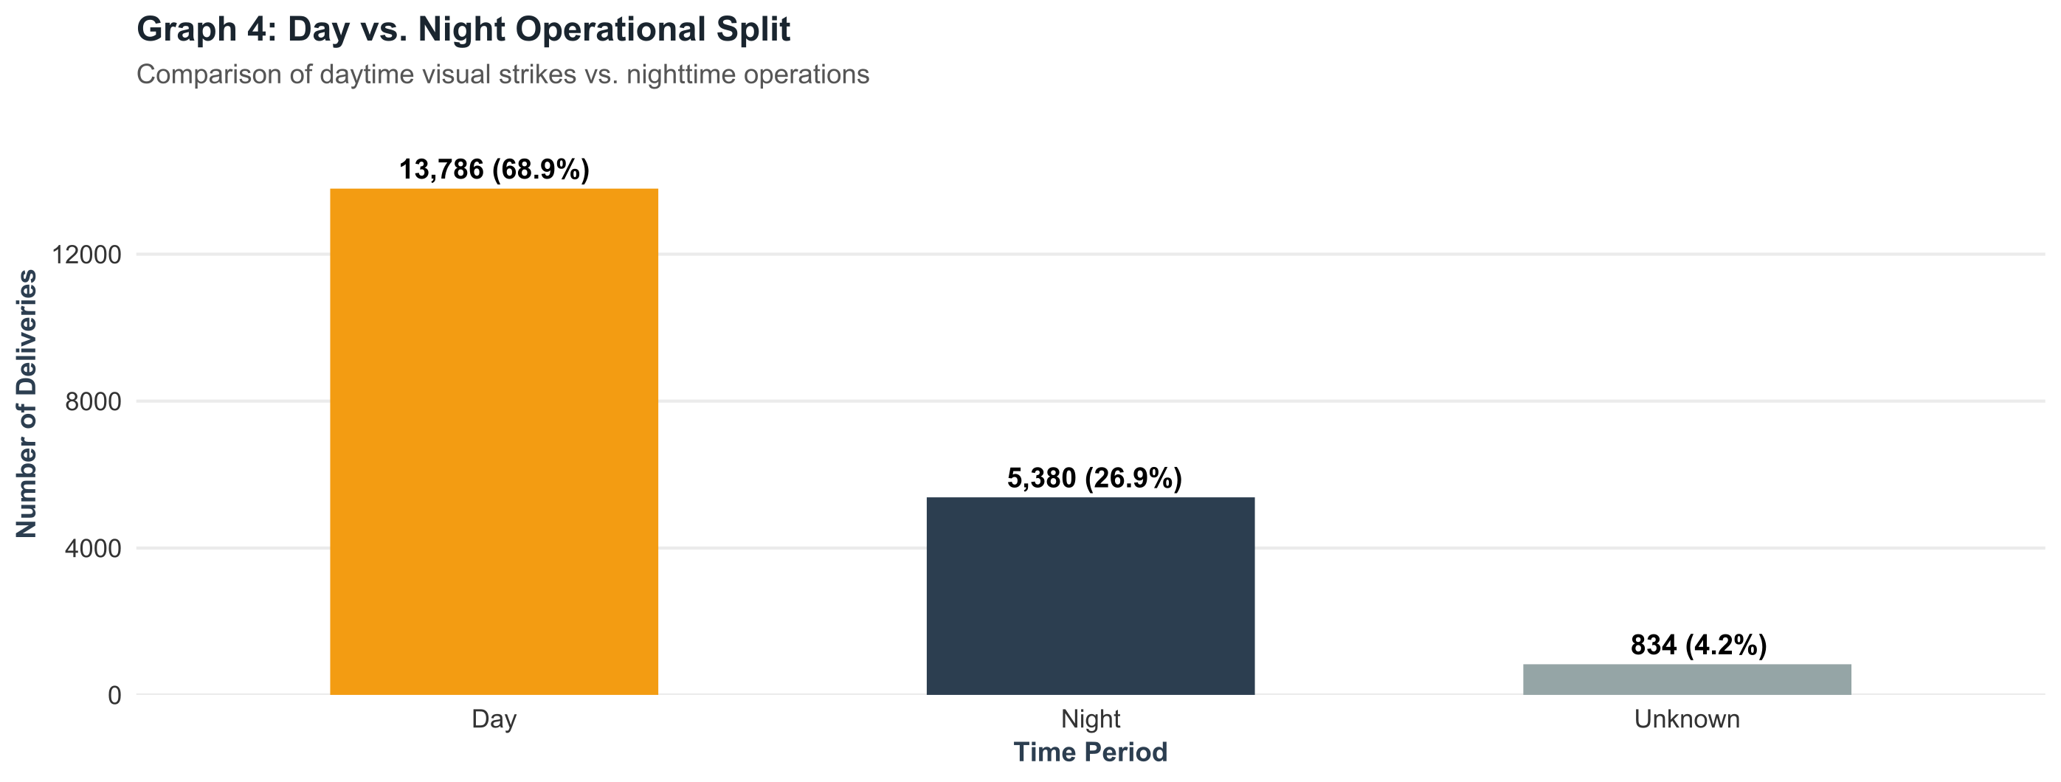
R Code Snippet:
period_counts <- as.data.frame(table(Period = data$PERIOD))
period_counts$Percentage <- round(100 * period_counts$Freq / sum(period_counts$Freq), 1)
ggplot(period_counts, aes(x = Period, y = Freq, fill = Period)) +
geom_bar(stat = "identity", width = 0.55) +
labs(title = "Day vs. Night Operational Split", x = "Period", y = "Deliveries")

Explanation & Takeaway: Visual ground-target identification was imperative for tactical fighter-bombers in jungle canopy terrain. Night operations relied on specialized radar beacons or illumination flares, concentrating heavier payloads per mission.
Additional Observations
Measure | Day | Night
Total deliveries | 13,778 | 6,222
Average load (lb) | 57,614.7 | 65,258.9
Std. deviation (lb) | 80,064.1 | 123,637.8
Coefficient of variation | 139.0% | 189.5%

- Day deliveries outnumber night deliveries by about 2.2 to 1.
- The mean night load is higher by 7,644.2 lb (13.3%) than the mean day load.
- In both periods the standard deviation is larger than the mean (CV above 100%), which means the loads are extremely spread out and strongly right-skewed: many small deliveries mixed with a few very heavy ones.
- Night loads are the more variable of the two (CV about 189.5% against 139.0% for day), which supports the explanation that a small number of very heavy night missions pull the average up.
Statistical caution: Because the distribution is skewed, the mean alone is not a reliable “typical” value. The median or a log-scale view would describe a typical delivery better, and a formal two-sample test would be needed to confirm that the day–night difference in mean load is statistically significant.

Problem statement 5: What was the distribution and central tendency of weapon payload (in pounds) delivered per mission?
To understand typical tactical ordnance carried by strike aircraft, deliveries with recorded positive weapon loads (up to 15,000 lb, representing tactical fighter-bombers) were analyzed. Key summary statistics are tabulated below:
Metric | Sample Size (N) | Median Load | Mean Load | Std. Deviation | IQR
Weapon Load (lb) | 1,393 | 6,440.0 lb | 6,540.2 lb | 3,720.2 lb | 5,000.0 lb

It shows that the median weapon load is 6,440 lb with an average load of 6,540 lb. The distribution can be visualized with the following histogram showing the median and mean markers:
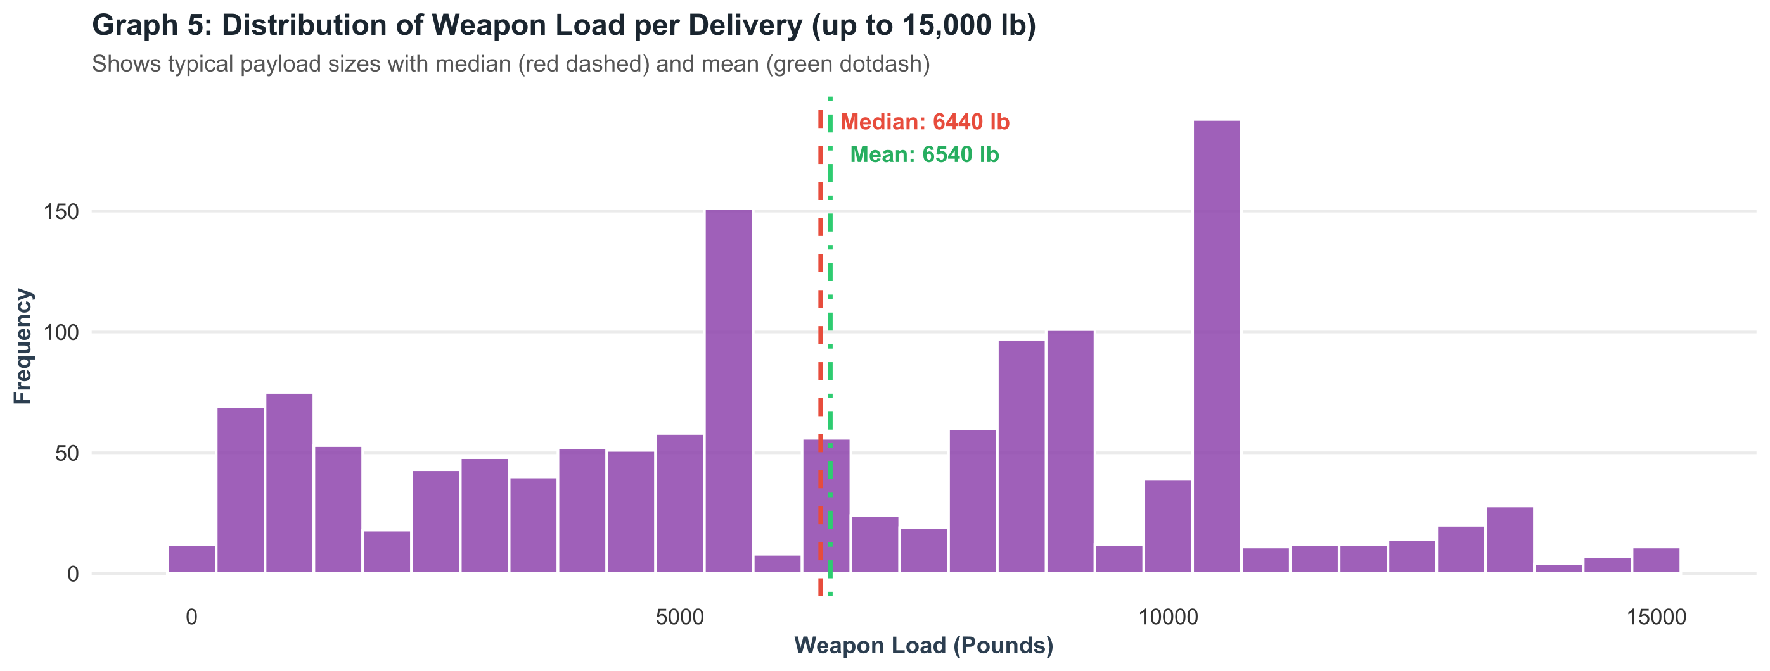
R Code Snippet:
load_data <- data[!is.na(data$LOAD_LB) & data$LOAD_LB > 0 & data$LOAD_LB <= 15000, ]
med_load <- median(load_data$LOAD_LB)
mean_load <- mean(load_data$LOAD_LB)
ggplot(load_data, aes(x = LOAD_LB)) +
geom_histogram(binwidth = 500, fill = "#8e44ad", color = "white") +
geom_vline(aes(xintercept = med_load), color = "red", linetype = "dashed") +
geom_vline(aes(xintercept = mean_load), color = "green", linetype = "dotdash")

Explanation & Takeaway: The distribution clusters notably around standard bomb configurations—most notably clusters of 500-lb Mk 82 general-purpose bombs, 750-lb M117 bombs, and 2.75-inch rocket pods, demonstrating standard tactical military loadouts.
Additional Observations
- The mean (6,540.2 lb) is only 100.2 lb above the median (6,440.0 lb), so within the 0–15,000 lb range the distribution is close to symmetric in its centre.
- The coefficient of variation is 56.9%, a moderate spread: typical loads vary by a little over half of the average load.
- An IQR of 5,000 lb means that the middle 50% of the loads span a range of 5,000 lb, which is wide compared to the median and agrees with the multi-peaked histogram.
- The 1,393 records analysed make up about 7.0% of the 20,000-record sample, so Problem 5 describes a specific subset (positive loads of at most 15,000 lb) rather than the whole dataset.
- The histogram has several distinct peaks instead of a single bell shape. This is characteristic of data produced by a small set of standard munitions packages rather than a continuous random process.
Link to Problem 4: The load figures in Problem 4 (averages above 57,000 lb) include very heavy deliveries, while Problem 5 deliberately restricts the data to tactical loads of at most 15,000 lb. The two analyses therefore describe different parts of the load distribution and should not be compared directly.
Overall Conclusion:
- Temporal Escalation and Peak: Aerial bombing intensity escalated steadily during the late 1960s, reaching maximum combat frequency in 1968 and 1970 before declining sharply after 1972.
- Focus on Close Air Support & Interdiction: South Vietnam received over half (53.5%) of all deliveries, while operations in Laos (29.2%) formed a critical sustained campaign targeting supply movement along the Ho Chi Minh trail.
- Tactical Aircraft Dominance: The versatile McDonnell Douglas F-4 Phantom II was the most utilized combat platform, flying nearly a quarter (24.1%) of all recorded missions.
- Daytime Visual Primacy: Approximately 68.9% of missions occurred in daylight hours due to visual target identification requirements in jungle terrain.
- Standardized Tactical Ordnance: Weapon loads clustered tightly around standard munitions packages, featuring a median payload of 6,440 pounds per tactical fighter delivery.
Summary of Key Results
Problem | Key Finding | Main Statistic
1. Yearly activity | Peak in 1970, steep decline after 1972 | 3,532 deliveries (17.66%) in 1970
2. Target country | South Vietnam dominant, Laos second | 53.48% and 29.19%
3. Aircraft | F-4 Phantom most used identified platform | 4,827 deliveries (24.14%)
4. Day vs. night | Most deliveries by day; night loads heavier | 68.9% day; 65,258.9 lb night mean
5. Weapon payload | Median close to mean; multi-peaked | Median 6,440 lb, mean 6,540.2 lb

6. Limitations
- The analysis uses a sample of 20,000 records, so the results describe the sample and may differ from the full THOR database.
- Some records have missing or unspecified values (for example aircraft group, country and time period), which reduces the share that can be attributed to a named category.
- The work is descriptive. It shows what happened and how often, but does not test hypotheses or establish causes; the explanations given are historical context, not statistical proof.
- Load values are heavily skewed, so the mean and standard deviation should be interpreted with care.
- Small differences between tables and graphs (for example in the day/night split) should be reconciled against the original data before any formal use.
7. Future Scope
- Apply hypothesis tests (for example a two-sample t-test or Mann–Whitney test) to check whether the day and night load difference is significant.
- Study the relationship between aircraft group, weapon class and load using cross-tabulations and a chi-square test of independence.
- Use LAT and LON to draw spatial maps of strike density, and TGT_HOUR to study the hour-by-hour pattern of missions.
- Fit a time-series model to the yearly counts to describe the trend and the post-ceasefire decline.
- Use a log scale or a trimmed sample to better summarize the heavily skewed load variable.
8. Appendix: R Setup Code
The following code shows the packages and the data-loading steps assumed by the snippets used in this report:
R Code Snippet:
# Packages
library(ggplot2)

# Load the sampled THOR records (20,000 rows)
data <- read.csv("thor_vietnam_sample.csv", stringsAsFactors = FALSE)

# Quick structure and summary checks
str(data)
summary(data$LOAD_LB)
table(data$YEAR)

# Save a graph as an image
ggsave("graph1.png", width = 9, height = 4, dpi = 300)

9. References
- Theater History of Operations Reports (THOR), Southeast Asia aerial munitions delivery records, 1965–1975.
- R Core Team. R: A Language and Environment for Statistical Computing. R Foundation for Statistical Computing, Vienna, Austria.
- Wickham, H. ggplot2: Elegant Graphics for Data Analysis. Springer.
- Course material: BSH23OE04, Open Elective: Statistical Data Analysis using R, Pimpri Chinchwad College of Engineering.

