CURSIVE CHARACTER RECOGNITION IN IMAGES USING RESNET

## A PROJECT REPORT

***Submitted by***

# OM PRAKASH K (312419205073)

# MUKESH KOLAPPAN A (3124192065)

***in partial fulfilment for the requirement of award of the degree***

***of***

# BACHELOR OF TECHNOLOGY

in INFORMATION TECHNOLOGY

## St. JOSEPH’S INSTITUTE OF TECHNOLOGY

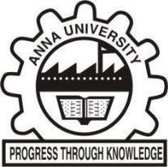

**ANNA UNIVERSITY, CHENNAI 600 025**

**MARCH 2023**