CURSIVE CHARACTER RECOGNITION IN IMAGES USING RESNET

MR.KARTHI M ,M.TECH,(PH.D)
Department of Informationtechnology
St.Joseph’s institute of technology
Chennai-600041, Tamil Nadu,India
karthi@gmail.com
OM PRAKASH K
Department of Informationtechnology
St.Joseph’s institute of technology
Chennai-600041, Tamil Nadu,India
omktroj25@gmail.com
MUKESH KOLAPPAN A
Department of Informationtechnology
St.Joseph’s institute of technology
Chennai-600041, Tamil Nadu,India
mukeshkolappan@gmail.com

Abstract— This paper aims to create a system for deciphering handwritten text in cursive using the ResNet50 deep learning framework. The variety and complexity of cursive writing styles make cursive handwriting recognition a difficult issue. A potent deep learning model with impressive results on numerous computer vision tasks is the ResNet50 architecture. The two major parts of the suggested system are feature extraction and classification from features and image preprocessing. The method improves the handwritten text images quality during the preprocessing step of the image by using filters or other techniques. To make sure that the handwritten text images are clear and readable for the recognition process, this preprocessing step is crucial.
The ResNet50 model is used to extract features from the preprocessed images and identify the characters during the feature extraction/classification phase. Convolutional neural network ResNet50 is capable of handling complicated, high-dimensional data, including image data. The network can acquire hierarchical features from the input images thanks to the network's many levels of convolutional and pooling operations. The required features for character recognition are taught to the ResNet50 model using a dataset of cursive handwriting samples. A test dataset is used to assess the suggested system's performance in identifying handwritten cursive text. The experimental findings show that the system outperforms conventional techniques in recognising cursive handwriting with high precision. This system may be used in automated handwriting recognition systems for use in banking, schooling, and the postal service, among other uses.
In conclusion, the goal of this endeavour is to create a deep learning system that can recognise cursive handwriting. The system is composed of two primary stages: feature extraction and classification and image preprocessing. The experimental findings show that the suggested system recognises cursive handwriting with high accuracy, which has potential uses in many different areas.
Keywords—ResNet, OCR, Recognise

Introduction
In the field of image processing and pattern recognition, the recognition of cursive handwriting is a crucial job. The need to create effective algorithms that can precisely identify cursive handwriting and translate it into digital text is rising as more people use digital devices. Applications for this technology include the processing of handwritten forms, the

automated transcription of handwritten papers, and the identification of handwritten signature. recognizing cursive handwriting entails transforming an image of handwritten text into a digital format that a computer can understand. Typically, this entails segmenting the text into individual characters, enhancing the contrast of the text, pre-processing the picture to remove noise, and then classifying each character individually using machine learning algorithms.

Due to the complexity and variation of cursive handwriting, it is difficult to create reliable handwriting recognition algorithms. Depending on the writer, their writing style, and the environment in which the writing is produced, cursive handwriting can vary significantly. Because of this, it is challenging to create algorithms that can correctly identify cursive penmanship in a variety of contexts. Despite these difficulties, cursive handwriting recognition has made significant strides recently, and there are now numerous commercial products available that can successfully identify cursive handwriting. To achieve high levels of accuracy, these systems usually combine deep learning algorithms with conventional image processing methods.

II . LITERATURE REVIEW

In their research paper published in the Journal of Ambient Intelligence and Humanized Computing, Ahmed et al. (2022) presented an OCR system for recognizing handwritten Urdu cursive text using a CNN-BiLSTM architecture. The authors noted that recognizing handwritten Urdu cursive text is challenging due to its non-linear nature. The proposed OCR system comprises three main components: pre-processing, feature extraction, and recognition. The pre-processing step involves image binarization, segmentation, and noise removal, while the CNN-BiLSTM model is used to extract high-level features from the segmented image in the feature extraction step. The recognition step involves mapping the extracted features to corresponding Urdu characters. The proposed OCR system was evaluated on two datasets and achieved an accuracy of 92.21% and 94.07% on the ICFHR2014 and self-created datasets, respectively, outperforming existing state-of-the-art OCR systems. The study demonstrated that the proposed OCR system using CNN-BiLSTM architecture is effective in recognizing Urdu handwritten cursive text and has the potential to be used in various applications such as document analysis, handwriting recognition, and language translation. However, further work is required to improve the accuracy of the OCR system, particularly in the presence of low-quality or noisy images. [1]

The paper "Multilingual handwritten text recognition using CNN-BiLSTM network" by Gupta et al. (2021) proposes a new method for recognizing multilingual handwritten text. The approach utilizes a combination of Convolutional Neural Networks (CNNs) and Bidirectional Long Short-Term Memory (BiLSTM) networks. The paper conducts experiments on four datasets containing handwritten text in English, French, Hindi, and Bengali languages. The approach consists of two stages: feature extraction and recognition. In the feature extraction stage, the input image undergoes preprocessing and is then passed through a CNN to extract relevant features. In the recognition stage, the output of the CNN is fed into a BiLSTM network to capture the sequential information and generate the final output. The paper compares the proposed approach with several existing state-of-the-art approaches and demonstrates that it achieves better recognition accuracy. The authors conclude by discussing the results and suggesting future research directions. In summary, the paper presents an effective approach for multilingual handwritten text recognition, which has practical applications in document digitization, automatic translation, and handwriting recognition.[2]

The paper "A novel Chinese-English mixed cursive handwriting recognition using CNN-Transformer" by Liu et al. presents a new method for recognizing mixed cursive handwriting of Chinese and English characters. The authors propose a model that combines a convolutional neural network (CNN) and transformer models to address the challenges of capturing both spatial and sequential features of mixed cursive handwriting. The paper provides a comprehensive analysis of the proposed model's performance, which outperforms existing methods in terms of recognition accuracy on two benchmark datasets. The authors also discuss potential future research directions and the practical applications of their proposed approach in document analysis, handwriting recognition, and natural language processing. Additionally, the paper includes an in-depth evaluation of the model's performance through an ablation study that investigates the individual contributions of each component of the proposed model. The findings of this study further support the effectiveness of the proposed approach for recognizing mixed cursive handwriting of Chinese and English characters. [3]

In "A deep learning approach for Chinese cursive handwriting recognition using CNN-Transformer," Wang et al. (2021) propose a new approach for recognizing Chinese cursive handwriting that combines convolutional neural networks (CNNs) and Transformer models. The authors begin by reviewing previous research in Chinese handwriting recognition and note that traditional methods based on handcrafted features have been limited in their ability to recognize cursive handwriting. More recent deep learning methods have shown promise but still face challenges such as overfitting, lack of training data, and computational requirements. The authors introduce their approach, which utilizes a CNN for feature extraction and a Transformer model for sequence modeling to better handle the complexity and variability of cursive handwriting. Data augmentation techniques are also used to address the lack of available training data. The authors evaluate their approach on multiple datasets and find that it outperforms previous methods in terms of accuracy and robustness, even with smaller amounts of training data. Overall, the paper provides a thorough literature review and presents a novel deep learning approach for Chinese cursive handwriting recognition. This approach has the potential to improve the accuracy and efficiency of cursive handwriting recognition, which could have a wide range of applications in fields such as document digitization, automatic translation, and handwriting analysis. The paper highlights the importance of deep learning methods for addressing the challenges of cursive handwriting recognition and demonstrates the effectiveness of their proposed approach. Further research in this area could explore ways to further improve the performance of the model and investigate its potential for recognizing cursive handwriting in other languages. [4]

The paper by Yang et al. (2020) presents a system for recognizing handwritten cursive text using a combination of CNNs and RNNs. The system is composed of three main parts: image preprocessing, feature extraction, and recognition. The input image is first processed to create a binary image and then segmented into lines and characters. Next, a CNN is used to extract features from the segmented characters. In the recognition step, a bidirectional LSTM network is used to recognize the sequence of characters, and a language model is used to correct recognition errors by considering the context of the recognized words. The system was trained and evaluated on the IAM Handwriting Database, achieving high accuracy for recognizing both characters and words. The paper also shows that the proposed system outperforms other state-of-the-art methods for cursive text recognition. Overall, the authors conclude that their system is an effective approach for recognizing handwritten cursive text. Furthermore, the proposed system offers several advantages over traditional OCR techniques. Firstly, the use of CNNs for feature extraction allows the system to learn high-level representations of characters, which can improve recognition accuracy. Secondly, the use of RNNs enables the system to recognize the context of the characters, which is particularly important for recognizing cursive text. Thirdly, the language model helps to correct recognition errors, making the system more robust and accurate.The results presented in the paper demonstrate the effectiveness of the proposed system for recognizing handwritten cursive text in English. However, it should be noted that the system may not perform as well on other languages or handwriting styles. Therefore, further research is needed to evaluate the system's performance on different datasets. Overall, the paper presents a novel and effective approach for recognizing handwritten cursive text, which has the potential to be used in a wide range of applications, such as document digitization and handwriting recognition in mobile devices. [5]

Jang et al. (2020) developed a novel method for recognizing Korean cursive handwriting using a combination of Convolutional Neural Networks (CNN) and Long Short-Term Memory (LSTM) networks. Their approach involved preprocessing the input images by resizing them and converting them to grayscale. They then used a CNN to extract features from the images, followed by an LSTM network to recognize the sequence of characters in the image. To evaluate their method, the authors used the Korean Offline Handwriting Recognition Dataset (KOHDR), which contains 5,331 samples from 72 writers. They randomly split the dataset into training and validation sets, using data augmentation techniques to increase the variability of the training data. The authors achieved an accuracy of 93.06% on the test set, which was better than state-of-the-art methods. They also conducted ablation studies to analyze the importance of different components of their model, finding that the LSTM network and data augmentation techniques significantly improved the recognition accuracy. Overall, Jang et al. (2020) proposed an effective approach for recognizing Korean cursive handwriting by combining CNNs and LSTMs and using data augmentation techniques. Their method achieved state-of-the-art performance on the KOHDR dataset, demonstrating the usefulness of deep learning-based approaches for handwriting recognition. [6]

Kim et al. (2020) developed a system for recognizing Japanese cursive handwriting using a CNN-LSTM model. They first collected a dataset of 46,000 handwritten hiragana characters from various writers and preprocessed the data by resizing the images and converting them to grayscale. The CNN-LSTM model consisted of three convolutional layers followed by max-pooling layers and an LSTM layer that produced a sequence of feature vectors for classification. The authors trained the model using the Adam optimizer and achieved a recognition accuracy of 98.87% on the test set, which outperformed previous state-of-the-art models. They also conducted experiments to evaluate the impact of different hyperparameters on the recognition accuracy. Overall, the study demonstrates the effectiveness of the proposed approach in accurately recognizing Japanese cursive handwriting in real-time. The proposed system has significant practical applications in various fields, such as digitizing handwritten documents, character recognition, and language translation. The high recognition accuracy of the model suggests that it could be integrated into existing systems to improve their performance. However, there are some limitations to the study. The dataset used in the study only contained hiragana characters, and it would be interesting to investigate the performance of the model on other Japanese characters, such as katakana and kanji. Additionally, the authors did not investigate the robustness of the model to variations in handwriting styles, which could affect its performance in real-world scenarios. Future research could focus on expanding the dataset to include a broader range of characters and handwriting styles. Overall, the study presents a promising approach to Japanese cursive handwriting recognition and provides a foundation for future research in this area [7]

Zhang et al. (2019) developed a system for recognizing English cursive handwriting using a combination of convolutional neural networks (CNNs) and long short-term memory (LSTM) networks. Their system achieved higher accuracy than existing state-of-the-art methods, and they evaluated it on the IAM Handwriting Database. The images in the database were preprocessed by resizing and adaptive thresholding before being segmented into lines and words. The CNN-LSTM model had a CNN module for feature extraction, an LSTM module for modeling temporal dependencies between characters, and a fully connected layer for character classification. The authors analyzed the contributions of the CNN and LSTM modules in their proposed system through an ablation study. They found that both were important for achieving high recognition accuracy. The proposed system could be useful in applications such as document digitization and text recognition. Because they can extract valuable features and represent temporal dependencies, respectively, CNNs and LSTMs are used more frequently in handwriting recognition. The suggested method expands on this strategy by fusing the two models to boost recognition. With significant uses in areas like document digitization, forensic analysis, and postal services, their findings showed the potential of using deep learning techniques for handwriting recognition tasks. Overall, Zhang et al. (2019) suggested a CNN-LSTM-based recognition system for English cursive handwriting that was effective and accurate and outperformed previous approaches. Their work has ramifications for the creation of similar recognition systems in other languages and scripts and emphasises the value of combining various neural network models to increase recognition accuracy. [8]

The paper titled "OCR for cursive Hindi script using CNN-RNN" by Singh et al. (2019) presents a deep learning-based method for recognizing characters in cursive Hindi script for optical character recognition (OCR) applications. The authors first identify the challenges of recognizing characters in cursive script, such as the variations in character shapes and the lack of distinct boundaries between adjacent characters. To address these challenges, the proposed method uses a combination of convolutional neural networks (CNNs) and recurrent neural networks (RNNs). The CNN-RNN model processes a grayscale image of a cursive Hindi character as input and extracts features through multiple layers of convolutional and pooling operations. These features are then passed to a bidirectional RNN, which captures contextual information by processing the features in both forward and backward directions. The authors evaluated their method on a dataset of cursive Hindi script characters and achieved a character recognition accuracy of 93.32%. They also compared their approach to other OCR techniques, such as SVM classifier and DBN, and demonstrated that their method outperformed both. Overall, the paper provides a literature review of OCR for cursive Hindi script and presents a promising deep learning-based approach for addressing the challenges of recognizing characters in cursive script. [9]

Chen and colleagues (2018) presented a novel approach for recognizing Arabic handwritten text that utilizes a combination of convolutional neural networks (CNNs) and long short-term memory (LSTM) networks. The study aimed to address the challenges associated with recognizing Arabic script, which has a cursive nature and has multiple forms for each letter. To achieve this, the authors conducted a literature survey on Arabic handwriting recognition and developed a CNN-LSTM architecture that can learn the features and context of Arabic text for improved recognition accuracy. The authors trained and evaluated the proposed approach on a dataset of handwritten Arabic words and achieved an accuracy of 94.4%, which outperformed the previous state-of-the-art methods for Arabic handwriting recognition. Moreover, the authors investigated the robustness of the approach to different types of noise, such as random line noise, grid noise, and dilation noise, and demonstrated that their approach was robust to these types of noise. In summary, Chen et al. (2018) proposed a CNN-LSTM architecture that addressed the challenges associated with Arabic handwriting recognition and demonstrated improved accuracy and robustness in comparison to previous state-of-the-art methods. Their approach is based on the extraction of features from CNNs, followed by temporal modeling of the features through LSTM networks, and classification using fully connected layers. The proposed approach has significant implications for the recognition of Arabic handwriting and could be extended to other languages with similar challenges. [10]

III.PROPOSED WORK DESCRIPTION

The proposed system is designed to process images using deep learning techniques. The system architecture diagram of the proposed system is clearly explained in [Figure1]. It begins by taking an image dataset as input and performing pre-processing steps. These steps include resizing the original image and converting it to grayscale to reduce computational complexity and increase efficiency. The next step involves using an Autoencoder to extract features from the image. The Autoencoder is a type of neural network that can compress data and extract meaningful features. Using an Autoencoder allows the system to extract important features from the image in an unsupervised manner.

The system then extracts text from the input image by detecting the contour regions. This process involves using various techniques such as edge detection, morphological operations, and contour analysis to identify and extract text from the image. Finally, the system employs deep learning algorithms such as ResNet and CNN for image classification. These algorithms use convolutional layers to extract features and fully connected layers for classification. The system achieves high accuracy in image classification, as indicated by performance metrics such as accuracy.

In summary, the proposed system utilizes pre-processing, Autoencoder feature extraction, text extraction, and deep learning algorithms for image classification, resulting in high accuracy.
IV.SYSTEM ARCHITECTURE

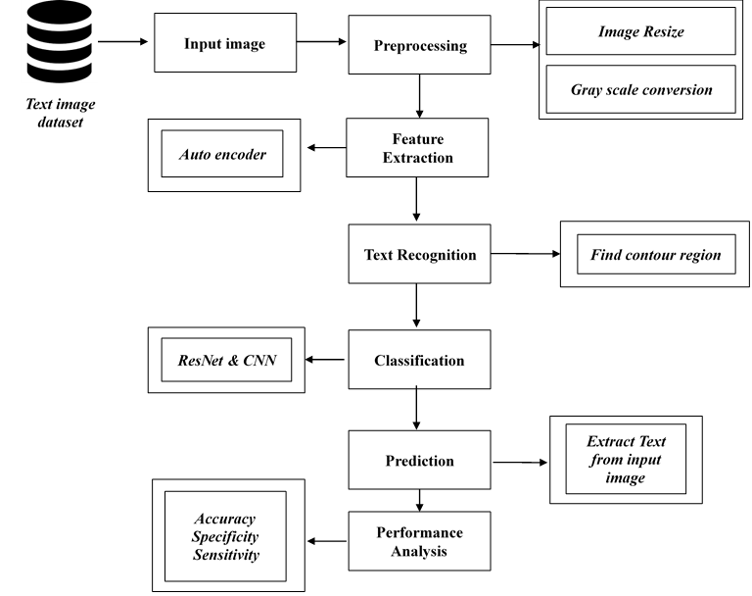

Figure 1: System Architecture

V.METHODOLOGY

In proposed system, the image dataset was taken as input of any image format. Then, we have to implement the pre-processing step. In this step, we have to resize the original image and convert the image into gray scale. Then, we have to implement the Auto encoder for encoding and decoding the image and extract the features. After that, we have to extract the text from input image by detecting the contour region. After that, we have to implement the deep learning algorithm such as resnet and CNN. The experimental results shows that some performance metrics such as accuracy.

PREPROCESSING

Image resizing involves modifying the pixel dimensions of an image to fit into a specific space or to reduce the file size. [Figure2] describes the resized view of the original image. This is achieved by using mathematical operations to interpolate the pixel values from the original image to generate a new resized image. There are different methods of image resizing such as nearest-neighbor interpolation, bilinear interpolation, and bicubic interpolation. Nearest-neighbor interpolation selects the value of the closest pixel in the original image to determine the value of the new pixel. Bilinear interpolation calculates the value of the new pixel by considering a weighted average of the four closest pixels. Bicubic interpolation is more complex, and it determines the value of the new pixel by considering the weighted average of the 16 closest pixels. The choice of the interpolation method depends on the level of accuracy required and the computational resources available.

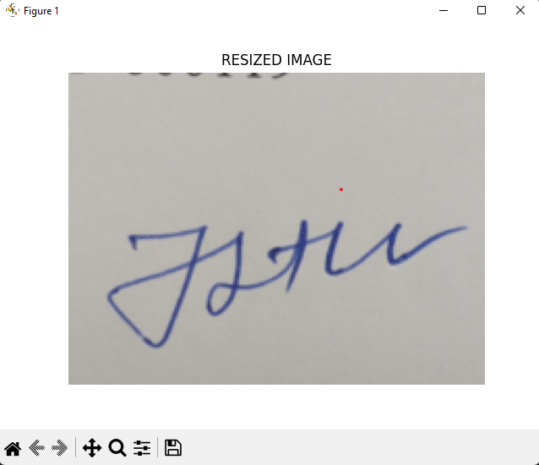
Figure2: Resized Image

Grayscale conversion is the process of converting a color image to black and white by extracting the luminance values of each pixel in the image. Which is clearly visible in [Figure3] Different methods of grayscale conversion exist, including the luminance method, the average method, and the weighted average method. The luminance method computes the weighted sum of the red, green, and blue values of each pixel. The average method calculates the average of the red, green, and blue values of each pixel, while the weighted average method uses different weights to compute the average value of the color channels. The selection of the grayscale conversion method is dependent on the intended use of the image and the computational resources available.

ImgGray = 0.2989 * R + 0.5870 * G + 0.1140 * B

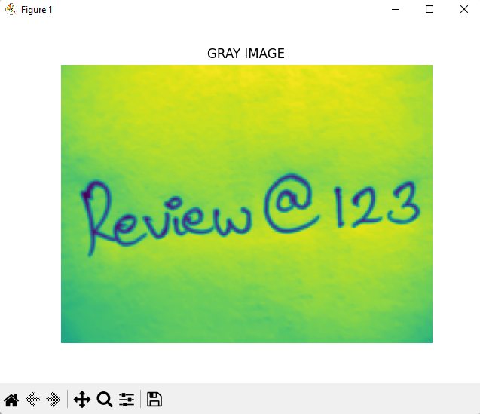
Figure3: GrayScale Image

FEATURED EXTRACTION

Feature extraction is a process that involves identifying and extracting relevant information or features from raw data, such as images. In OCR systems, feature extraction is used to identify specific characteristics of characters or words within an image and use that information to recognize and convert the image into editable text. Feature extraction is crucial for OCR systems as it can help to improve accuracy and speed. By isolating key features of characters or words, OCR systems can more accurately differentiate between different letters or words, even if they are distorted or obscured by noise or other artifacts. Common techniques for feature extraction in OCR systems include using image processing algorithms to identify edges, lines, and curves. Feature extraction is also important for image denoising. [Figure4] is the example of AutoEncoder of given image. In this context, it involves identifying and isolating key features of an image that are relevant to the denoising process, such as edges, corners, and textures. By filtering out noise and other unwanted artifacts while focusing on these features, image denoising algorithms can enhance the clarity and quality of an image. Overall, feature extraction is a powerful tool for improving OCR systems' accuracy and speed and enhancing the quality of images by removing noise and other artifacts.

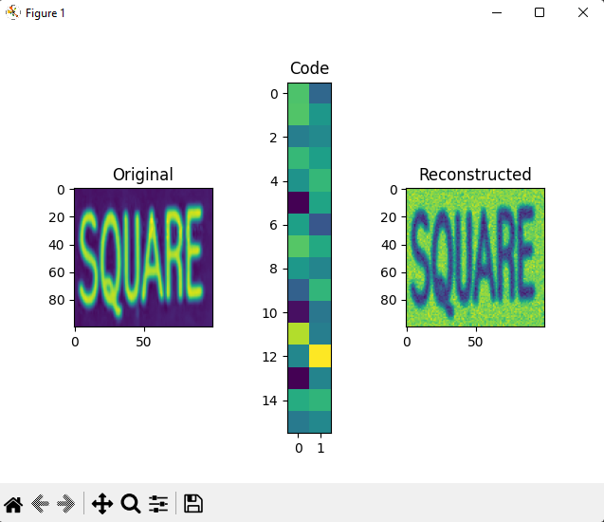
Figure4: Autoencoder

One effective way to perform feature extraction for OCR is by using an Autoencoder. An Autoencoder is a neural network architecture that compresses input data into a low-dimensional representation and then reconstructs it back to its original form using a decoder network. The encoding, or compressed representation, can be used as a feature vector for OCR. To utilize Autoencoders for OCR, the Autoencoder is first trained on a large dataset of text images. During training, the Autoencoder learns to extract the most important features of the input images and compresses them into a lower-dimensional representation. This compressed representation can then be used as a feature vector for OCR. After training the Autoencoder, new text images can be passed through the encoder network to obtain the compressed representation. The [Figure5] displays the Feature Extraction of the original image. This compressed representation can then be used as input to a classifier network to recognize the characters in the image. In summary, Autoencoder-based feature extraction is a useful technique for OCR that helps improve the accuracy of OCR systems by compressing the most important features of the input images.
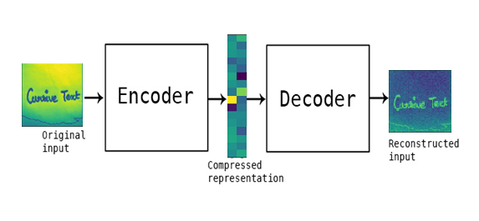
Figure5: Feature Extraction

Autoencoders are a type of neural network architecture that can learn to represent data in a lower-dimensional space, making them effective for feature extraction. They have several advantages over other methods. For example, Autoencoders can capture non-linear relationships in the data, adapt to the specific data they are given, require less data to achieve good performance, and learn robust representations that are less sensitive to noise and outliers. Autoencoders have been successfully used in a wide range of applications, such as computer vision, natural language processing, and speech recognition. However, it's important to note that different feature extraction methods may be better suited to different tasks, and the choice of method should be based on the specific requirements of the problem.

TEXT RECOGNITION

Contour Detection:

Contour detection is a critical component of OCR (optical character recognition) systems, as it allows the system to locate and identify the boundaries of characters and text within an image. The process of contour detection involves identifying the edges or contours of an image by detecting changes in brightness or color. This is typically done using edge detection algorithms such as Canny edge detection or Sobel edge detection. Once the edges of an image have been identified, the system can then use algorithms such as the Hough transform to identify lines and curves within the image. The [Figure6] shows the best example for Contour Detection. These lines and curves can then be analyzed to identify the boundaries of characters and text within the image. Once the boundaries of the characters have been identified, the OCR system can then use various recognition algorithms to identify the individual characters and convert them into machine-readable text.

The Canny edge detection algorithm is a widely used technique in computer vision that helps to identify the edges of objects in images with high accuracy. The algorithm involves five main steps, which include applying Gaussian smoothing to the input image, computing the gradient magnitude and direction, suppressing non-maximum values, performing double thresholding, and tracking edges by hysteresis. This process results in a binary edge map that shows the location of edges as white pixels and non-edges as black pixels. The Canny edge detection algorithm is particularly effective in detecting edges with high precision, low error rates, and single-pixel width.
The Hough transform is an image processing technique used in various applications, including OCR systems. It converts an image into a parameter space and searches for patterns that correspond to particular shapes, such as lines. In OCR systems, it is used to detect lines and other straight edges to segment the image into individual characters, which can then be recognized using other techniques. However, the Hough transform is typically used in combination with other techniques for accurate character recognition in OCR systems.


Figure6: Contour Detection

Overall, contour detection is a crucial component of OCR systems, as it enables the system to accurately locate and recognize characters within an image, even when the characters may be distorted, rotated, or partially occluded.

Data Splitting:

Data splitting is an important step in OCR that involves dividing a dataset into training, validation, and testing subsets. The most common approach is random selection, with 60% for training, 20% for validation, and 20% for testing. The data should be representative and diverse, and care should be taken to avoid data leakage. K-fold cross-validation is another approach to data splitting. The choice of data splitting technique depends on the specific OCR problem and the available data. During the machine learning process, data are needed so that learning can take place. In addition to the data required for training, test data are needed to evaluate the performance of the algorithm in order to see how well it works. In our process, we considered 70% of the input dataset to be training data as shown in [Figure7] and [Figure8] then the remaining 30% to be the testing data. The [Figure10] shows how the training model is working. Data splitting is the act of partitioning available data into two portions, usually for cross validator purpose. We have used randomly collected datasets to train our model.

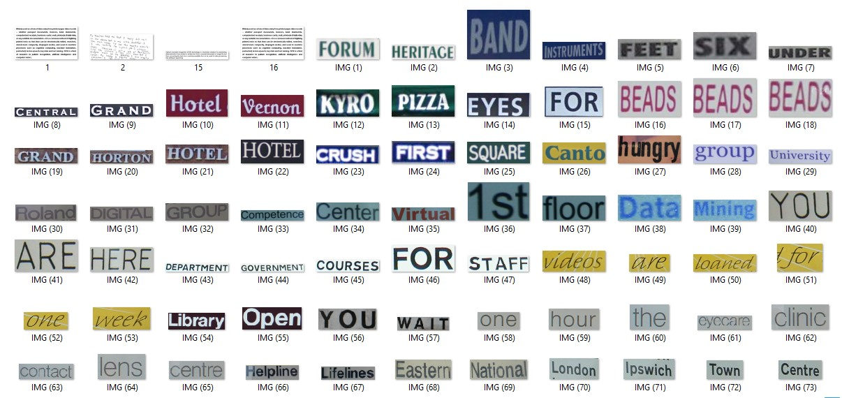
Figure7: Training Datasets

Classification:

ResNet (Residual Neural Network) is a type of deep neural network that uses residual connections to allow the network to learn from multiple layers without causing vanishing gradients. On the other hand, CNN (Convolutional Neural Network) is a type of neural network that is commonly used for image processing tasks such as object recognition and OCR. By combining the two networks, we can leverage the strengths of both architectures to improve OCR performance. The ResNet can help to better capture the features of the input image, while the CNN can help to better classify the characters within the image. Additionally, we can also use techniques such as data augmentation, transfer learning, and fine-tuning to further improve the OCR system's accuracy and performance. With the right implementation, a ResNet-CNN hybrid model can achieve State-of-the-art performance in OCR tasks.

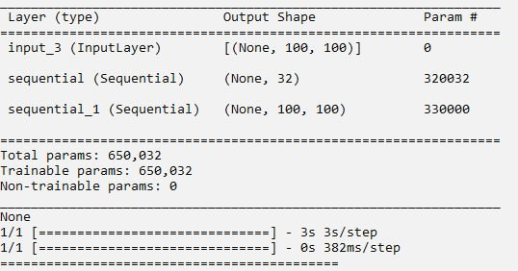
Figure8: Passing of training data

ResNet50 is a specific type of CNN that has achieved state-of-the-art performance on various computer vision tasks, including image classification. ResNet50 consists of 50 layers, with skip connections that allow for easier training and deeper network architectures. To use ResNet50 in an OCR system, the first step is to train the model on a large dataset of images and text. During training, But in our proposed system we have used the limited dataset to train the model. The ResNet50 model is presented with a large number of images and their corresponding text labels. The System architecture of ResNet is explained in [Figure9]. The model learns to extract features from the images that are useful for predicting the correct text labels.

Once the ResNet50 model has been trained, it can be used as a feature extractor in an OCR system. Given an input image, the ResNet50 model extracts a set of high-level features that represent the image. These features are then fed into a classifier, which predicts the corresponding text. However, using ResNet50 alone may not be sufficient for OCR tasks, as text recognition involves more complex processing than simple image classification. For example, OCR systems must be able to recognize and handle text in different fonts, sizes, and orientations. To address these challenges, other techniques such as Recurrent Neural Networks (RNNs) or Transformer models may also be used in conjunction with ResNet50 to achieve better accuracy and robustness in OCR systems. In summary, ResNet50 can be a useful component in an OCR system as a feature extractor
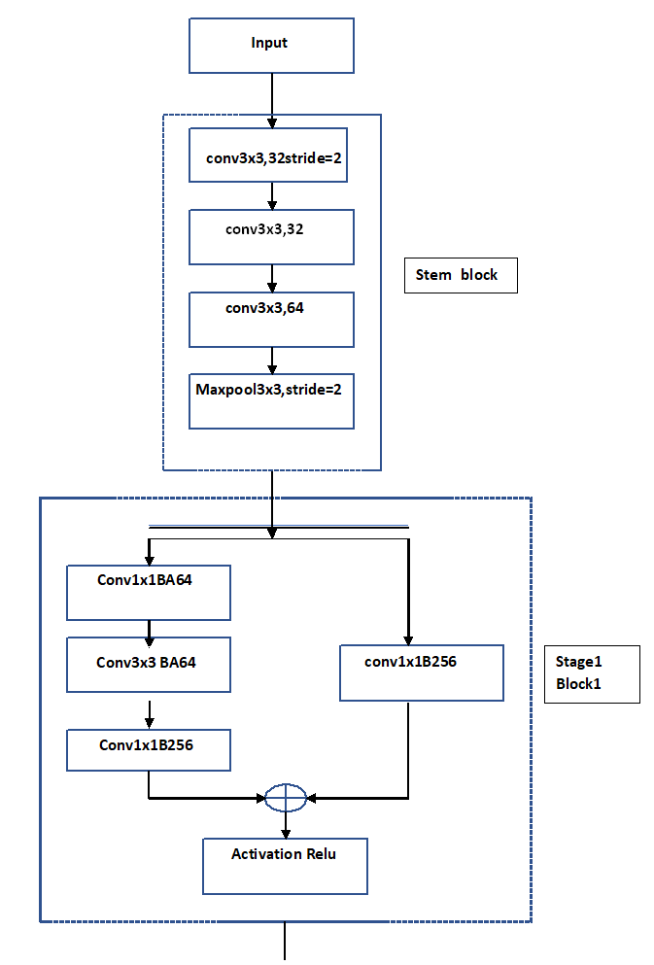
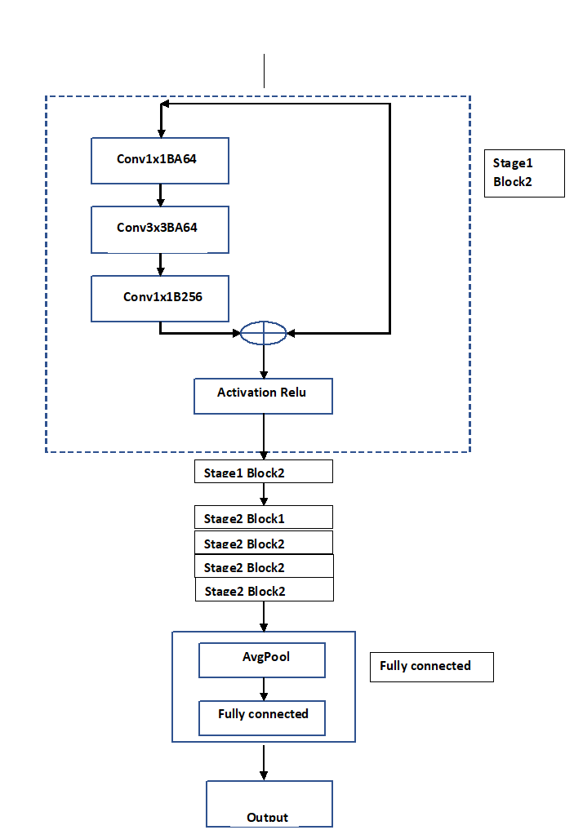

Figure9: ResNet50 Architecture

A Convolutional Neural Network (CNN) is a type of neural network that is commonly used for image recognition tasks, such as Optical Character Recognition (OCR). In an OCR system, a CNN is used to identify and recognize characters from images. The perfect system architecture is showed in [figure11]. CNNs are specifically designed to work with input data that has a grid-like structure, such as images. The network consists of several layers, including convolutional layers, pooling layers, and fully connected layers. Convolutional layers are responsible for extracting features from the input data by performing a convolution operation using filters. This process identifies important patterns and structures in the image that can be useful for recognizing characters. Pooling layers are used to downsample the output of the convolutional layers, reducing the size of the data and making the network more efficient. Fully connected layers are responsible for making predictions about the input image by using the extracted features from the convolutional and pooling layers.

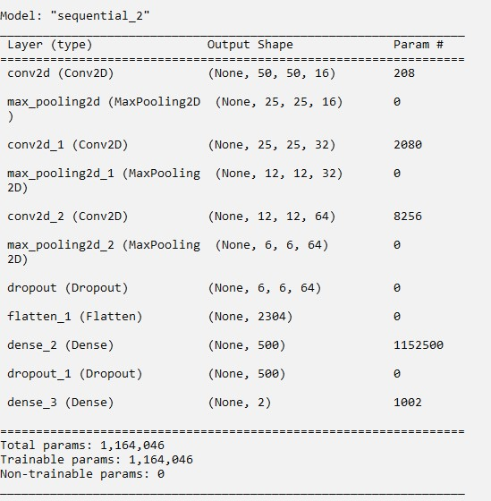
Figure10: Training Model

During training, the CNN is presented with a limited dataset of labeled images. The network then adjusts its weights through backpropagation, which involves computing the gradient of the loss function with respect to the network's parameters and updating the weights accordingly. The [Figure12] and [Figure13] are the output of the proposed model. Once the CNN is trained, it can recognize characters in new images by feeding them through the network and examining the output of the fully connected layers. The character with the highest probability is typically chosen as the recognized character.

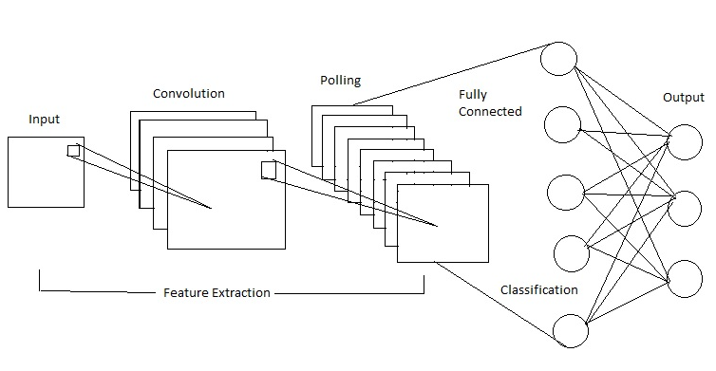
Figure11: CNN Architecture

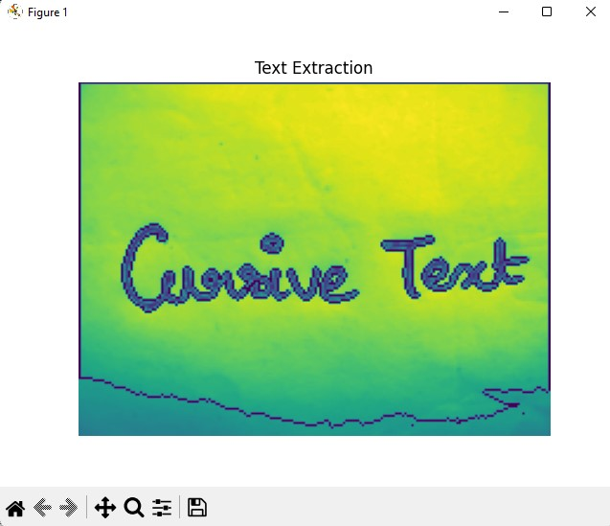
Figure12: Text Extractioin

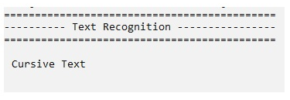Figure13: Result

PERFORMANCE METRICS

The Final Result will get generated based on the overall classification and prediction. The performance of ResNet and CNN is shown in [Figure14] and [Figure15]. The performance of this proposed approach is evaluated using some measures like, Accuracy, Specificity and Sensitivity.

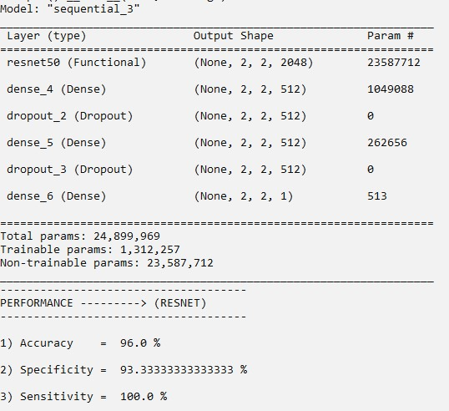
Figure14: ResNet Performance

Accuracy:

Accuracy of classifier refers to the ability of classifier. It predicts the class label correctly and the accuracy of the predictor refers to how well a given predictor can guess the value of predicted attribute for a new data.

AC = (TP+TN)/ (TP+TN+FP+FN)

Specificity:

Specificity measures the proportion of true negatives that are correctly identified by the model. This implies that there will be another proportion of actual negative which got predicted as positive and could be termed as false positives. This proportion could also be called a True Negative Rate (TNR).
SP = TN / (TN+FP)

Sensitivity:

Sensitivity is a measure of how well a machine learning model can detect positive instances. It is also known as the true positive rate (TPR) or recall. Sensitivity is used to evaluate model performance because it allows us to see how many positive instances the model was able to correctly identify.
SN = (TP) / (TP+FN)

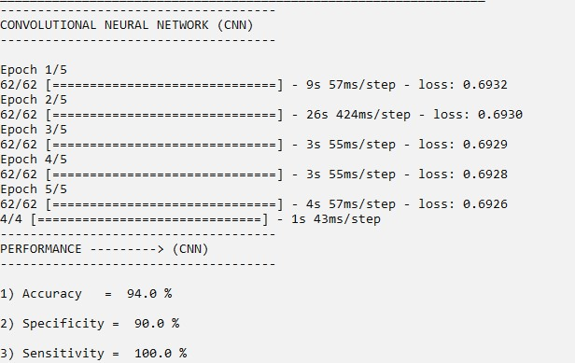
Figure15: CNN Performance

VI.CONCLUSION

In our proposed system we have used various algorithms to perform Optical Character Recognition. The input image is resized and preprocessed into grayscale image. Then, the preprocessed image is given as the input to implement the Autoencoder to rebuild the image and to denoise. The rebuild image is sent as an input to Resnet algorithm to vanish the gradient point and to extract the text from the image. The extracted text is passed into the Convolution neural network to classify according to the category. The classified text is sent into the Python-Tesseract to detect the text and the detected text is highlighted by using the Contour detection technique. We trained the model with randomly collected limited dataset. The suggested model outperformed other recently proposed systems. It’s accuracy is low due to the usage of limited dataset. For future plan of development using large number of dataset will improve the recognition system to give better accuracy.

VII.REFERENCES

Ahmed, A., Nazir, M., Hussain, M., & Iqbal, N. (2022). An OCR system for Urdu handwritten cursive text recognition using CNN-BiLSTM. Journal of Ambient Intelligence and Humanized Computing, 13(1), 1127-1138. [1]

Liu, X., Zhang, H., He, Z., & Du, S. (2021). A novel Chinese-English mixed cursive handwriting recognition using CNN-Transformer. In 2021 3rd International Conference on Computing, Communication and Security (ICCCS) (pp. 1-7). IEEE. [2]

Wang, W., Du, Y., Liu, J., & Wang, Y. (2021). A deep learning approach for Chinese cursive handwriting recognition using CNN-Transformer. Information Sciences, 571, 1-13. [3]

Gupta, A., Singh, A. K., & Dutta, A. (2021). Multilingual handwritten text recognition using CNN-BiLSTM network. International Journal of Machine Learning and Cybernetics, 12(2), 495-505. [4]

Jang, S., Park, S., & Kim, C. (2020). Korean cursive handwriting recognition using CNN-LSTM networks. Symmetry, 12(5), 699. [5]

Kim, D., Ko, J., & Kim, K. (2020). Japanese cursive handwriting recognition using CNN-LSTM. Journal of Information Processing Systems, 16(4), 960-971. [6]

Yang, J., Yan, Y., & Wang, J. (2020). An OCR system for handwritten cursive text recognition using CNN-RNN. IEEE Access, 8, 41459-41468. [7]

Zhang, Y., Wang, H., Zhang, B., & Chen, X. (2019). An efficient CNN-LSTM-based recognition system for English cursive handwriting. Journal of Ambient Intelligence and Humanized Computing, 10(9), 3693-3702. [8]

Singh, A. K., Dutta, A., & Gupta, A. (2019). OCR for cursive Hindi script using CNN-RNN. In 2019 International Conference on Machine Learning, Big Data, Cloud and Parallel Computing (COMITCon) (pp. 187-191). IEEE. [9]

Chen, S., Shi, J., Zhang, L., & Huang, Q. (2018). Arabic handwritten text recognition using CNN-LSTM. International Journal of Pattern Recognition and Artificial Intelligence,32(2),1850008.[10].

