ITM SKILLS UNIVERSITY
SCHOOL OF FUTURETECH
B.Tech Computer Science & Engineering (2025–29)
━━━━━━━━━━━━━━━━━━━━━━━━━━━━━━━━━━━━━━━━━━━━━
JAVA PROGRAMMING PROJECT
Case Study No. 167
Temperature Conversion & Monitoring System
Project Documentation & Technical Report
Student Name: | Om Maurya
Cohort: | Jeff Bezos
Roll Number: | 150096725208
Academic Program: | B.Tech Computer Science and Engineering
Academic Batch: | 2025–2029
Current Semester: | Semester III

Executive Summary
This project report presents the implementation of Case Study No. 167: 'Temperature Conversion & Monitoring System' for the Java Programming curriculum at ITM Skills University. The system provides a program to convert temperatures between Celsius (°C), Fahrenheit (°F), and Kelvin (K) and identify temperature conditions.
The project strictly complies with the Problem Statement requirements and syllabus concepts. It uses the Scanner class to accept user input, a switch statement to select the conversion, methods with arithmetic operators to perform conversion formulas, and if-else / else-if conditional statements to classify the temperature into predefined ranges. The terminal program serves as the core deliverable. In addition, a simple Swing graphical user interface (GUI) is included as an optional enhancement aligned with Module VIII of the syllabus.
1. Problem Statement & Scope Alignment
Case Study 167 Problem Statement: A weather station requires a system to convert temperatures between Celsius, Fahrenheit, and Kelvin and identify temperature conditions.
1.1 Objectives
- Accept temperature input: Read temperature values from the user using Scanner.
- Convert between units: Convert between Celsius, Fahrenheit, and Kelvin.
- Classify temperature conditions: Identify whether the temperature is Freezing, Very Cold, Cold, Normal, Hot, or Very Hot.
- Display converted values: Show the converted values and the identified condition clearly.
1.2 Requirements Compliance & Syllabus Mapping
Every planned feature is mapped to the Problem Statement and syllabus concepts. Features are classified as Core or Optional.
# | Planned Feature | Exact PS Requirement | Relevant Syllabus Concept | Classification
1 | Accept temperature value from user | "Accept temperature input" (PS Obj 1) | Module II — Input using Scanner Class | Core
2 | Unit selection menu (C / F / K) | "switch statement to select conversion" | Module II — Switch Statement | Core
3 | Temperature conversion (C ↔ F ↔ K) | "Methods contain conversion formulas" | Module III — Methods & Parameter Passing | Core
4 | Mathematical calculations | "operators perform calculations" | Module I — Operators and Expressions | Core
5 | Condition classification | "if-else classify based on ranges" | Module II — Conditional Statements (if-else / else-if) | Core
6 | Display converted values & condition | "Display converted values" (Result Display) | Module I — Structure of Java Program | Core
7 | Variables & data types | Implicit requirement for numeric storage | Module I — Variables, Data Types (double) | Core
8 | Loop for repeated conversions | Optional usability feature for repeated runs | Module II — Loops (while loop) | Optional
9 | Input validation (try-catch) | Simple invalid-input protection | Module VI — Exception Handling Basics | Optional
10 | Classes and Objects organization | Utility separation; no inheritance/polymorphism | Module IV — Classes & Objects, Static Members | Optional
11 | Swing GUI Enhancement | Optional windowed interface | Module VIII — Swing GUI, Layouts, Events | Optional
1.3 Excluded Concepts
To keep the project simple, aligned with the syllabus, and easy to explain during viva examinations, the following concepts are not included:
- No External APIs / Web Services: The program works completely with local user input.
- No Databases / JDBC: Persistent data storage is not required by the problem statement.
- No Advanced OOP: Inheritance, abstract classes, interfaces, and polymorphism are not used.
- No File I/O Storage: Calculations are displayed directly to the screen.
- No Advanced Features: Streams, lambdas, and multithreading are not required and omitted.
2. Mathematical Formulas & Condition Classification
2.1 Conversion Formulas
The program uses double values for temperature calculations. In Java, writing 9.0 / 5.0 instead of 9 / 5 ensures that floating-point division is performed without integer truncation:
- Celsius to Fahrenheit: F = (C × 9.0 / 5.0) + 32.0
- Fahrenheit to Celsius: C = (F - 32.0) × 5.0 / 9.0
- Celsius to Kelvin: K = C + 273.15
- Kelvin to Celsius: C = K - 273.15
- Fahrenheit to Kelvin: K = (F - 32.0) × 5.0 / 9.0 + 273.15
- Kelvin to Fahrenheit: F = (K - 273.15) × 9.0 / 5.0 + 32.0
2.2 Temperature Condition Classification (Project Assumption)
PROJECT ASSUMPTION: These classification ranges are a Project Assumption because the PS does not specify exact numerical boundaries.

The classification is based on the equivalent Celsius temperature using an if-else / else-if conditional statement chain:
Celsius Range | Condition Classification
Below 0°C | Freezing
0°C to 10°C | Very Cold
11°C to 20°C | Cold
21°C to 30°C | Normal
31°C to 40°C | Hot
Above 40°C | Very Hot
3. System Architecture
The project is structured into three clear Java source files. The conversion logic is separated into a shared class so that both the terminal program and the optional GUI can use it without repeating code:
File Name | Role | Description
TemperatureConverter.java | Shared Logic | Contains conversion methods and if-else / else-if classification logic. Used by both programs.
TemperatureMonitoringSystem.java | Core Terminal Client | Main terminal program. Uses Scanner, switch statement, while loop, try-catch input validation, and System.out formatting.
TemperatureGUI.java | Optional GUI Client | Swing window using JFrame, BorderLayout, GridLayout, JTextField, JComboBox, and JButton with ActionListener event handling.

4. Core Terminal Implementation
The terminal program is the core deliverable specified by the Problem Statement. It includes all five expected modules:
- Module 1 (Temperature Input): Reads numeric input from the user using scanner.nextDouble(). Includes a simple try-catch block to protect against non-numeric input.
- Module 2 (Unit Selection): Displays a menu (1. Celsius, 2. Fahrenheit, 3. Kelvin, 4. Exit) and uses a switch statement to select the conversion.
- Module 3 (Conversion): Calls the methods in TemperatureConverter to perform calculations using arithmetic operators.
- Module 4 (Condition Classification): Evaluates the temperature using if-else / else-if conditional statements in TemperatureConverter.classifyTemperature().
- Module 5 (Result Display): Prints the converted values and the condition using System.out.printf().
4.1 Source Code: TemperatureConverter.java
public class TemperatureConverter {
// Celsius to Fahrenheit: F = (C * 9/5) + 32
public static double celsiusToFahrenheit(double celsius) {
double fahrenheit = (celsius * 9.0 / 5.0) + 32;
return fahrenheit;
}
// Celsius to Kelvin: K = C + 273.15
public static double celsiusToKelvin(double celsius) {
double kelvin = celsius + 273.15;
return kelvin;
}
// Fahrenheit to Celsius: C = (F - 32) * 5/9
public static double fahrenheitToCelsius(double fahrenheit) {
double celsius = (fahrenheit - 32) * 5.0 / 9.0;
return celsius;
}
// Fahrenheit to Kelvin: K = (F - 32) * 5/9 + 273.15
public static double fahrenheitToKelvin(double fahrenheit) {
double kelvin = (fahrenheit - 32) * 5.0 / 9.0 + 273.15;
return kelvin;
}
// Kelvin to Celsius: C = K - 273.15
public static double kelvinToCelsius(double kelvin) {
double celsius = kelvin - 273.15;
return celsius;
}
// Kelvin to Fahrenheit: F = (K - 273.15) * 9/5 + 32
public static double kelvinToFahrenheit(double kelvin) {
double fahrenheit = (kelvin - 273.15) * 9.0 / 5.0 + 32;
return fahrenheit;
}
// Temperature Condition Classification (Project Assumption Ranges)
public static String classifyTemperature(double celsius) {
if (celsius < 0) {
return "Freezing";
} else if (celsius >= 0 && celsius <= 10) {
return "Very Cold";
} else if (celsius > 10 && celsius <= 20) {
return "Cold";
} else if (celsius > 20 && celsius <= 30) {
return "Normal";
} else if (celsius > 30 && celsius <= 40) {
return "Hot";
} else {
return "Very Hot";
}
}
}

4.2 Source Code: TemperatureMonitoringSystem.java
import java.util.Scanner;
public class TemperatureMonitoringSystem {
public static void main(String[] args) {
Scanner scanner = new Scanner(System.in);
System.out.println("=========================================================");
System.out.println(" Temperature Monitoring and Conversion System");
System.out.println("=========================================================");
boolean continueProgram = true;
while (continueProgram) {
System.out.println("\nSelect the temperature unit:");
System.out.println("1. Celsius");
System.out.println("2. Fahrenheit");
System.out.println("3. Kelvin");
System.out.println("4. Exit");
System.out.print("\nEnter your choice (1-4): ");
int choice;
try {
choice = scanner.nextInt();
} catch (Exception e) {
System.out.println("\nError: Invalid input. Please enter a number (1-4).");
scanner.nextLine();
continue;
}
if (choice == 4) {
System.out.println("\nThank you for using the Temperature Monitoring System!");
System.out.println("Goodbye!");
break;
}
if (choice < 1 || choice > 4) {
System.out.println("\nError: Invalid choice. Please select 1, 2, 3, or 4.");
continue;
}
System.out.print("Enter the temperature value: ");
double temperature;
try {
temperature = scanner.nextDouble();
} catch (Exception e) {
System.out.println("\nError: Invalid input. Please enter a valid numeric value.");
scanner.nextLine();
continue;
}
double celsius, fahrenheit, kelvin;
switch (choice) {
case 1:
celsius = temperature;
fahrenheit = TemperatureConverter.celsiusToFahrenheit(celsius);
kelvin = TemperatureConverter.celsiusToKelvin(celsius);
System.out.println("\n----- Conversion Results -----");
System.out.printf("%.2f °C = %.2f °F%n", celsius, fahrenheit);
System.out.printf("%.2f °C = %.2f K%n", celsius, kelvin);
System.out.println("\nTemperature Condition: " + TemperatureConverter.classifyTemperature(celsius));
System.out.println("------------------------------");
break;
case 2:
fahrenheit = temperature;
celsius = TemperatureConverter.fahrenheitToCelsius(fahrenheit);
kelvin = TemperatureConverter.fahrenheitToKelvin(fahrenheit);
System.out.println("\n----- Conversion Results -----");
System.out.printf("%.2f °F = %.2f °C%n", fahrenheit, celsius);
System.out.printf("%.2f °F = %.2f K%n", fahrenheit, kelvin);
System.out.println("\nTemperature Condition: " + TemperatureConverter.classifyTemperature(celsius));
System.out.println("------------------------------");
break;
case 3:
kelvin = temperature;
celsius = TemperatureConverter.kelvinToCelsius(kelvin);
fahrenheit = TemperatureConverter.kelvinToFahrenheit(kelvin);
System.out.println("\n----- Conversion Results -----");
System.out.printf("%.2f K = %.2f °C%n", kelvin, celsius);
System.out.printf("%.2f K = %.2f °F%n", kelvin, fahrenheit);
System.out.println("\nTemperature Condition: " + TemperatureConverter.classifyTemperature(celsius));
System.out.println("------------------------------");
break;
}
}
scanner.close();
}
}

5. Terminal Testing & Actual Screenshots
All test cases in the table below were executed directly on the compiled terminal program and verified:
Test ID | Unit | Input | Converted 1 | Converted 2 | Condition | Status
TC-01 | Celsius | 25.0 | 77.00 °F | 298.15 K | Normal | PASS
TC-02 | Celsius | -10.0 | 14.00 °F | 263.15 K | Freezing | PASS
TC-03 | Celsius | 5.0 | 41.00 °F | 278.15 K | Very Cold | PASS
TC-04 | Celsius | 15.0 | 59.00 °F | 288.15 K | Cold | PASS
TC-05 | Celsius | 35.0 | 95.00 °F | 308.15 K | Hot | PASS
TC-06 | Celsius | 45.0 | 113.00 °F | 318.15 K | Very Hot | PASS
TC-07 | Fahrenheit | 32.0 | 0.00 °C | 273.15 K | Very Cold | PASS
TC-08 | Fahrenheit | 212.0 | 100.00 °C | 373.15 K | Very Hot | PASS
TC-09 | Kelvin | 0.0 | -273.15 °C | -459.67 °F | Freezing | PASS
TC-10 | Kelvin | 300.0 | 26.85 °C | 80.33 °F | Normal | PASS
TC-11 | Boundary | 0.0 °C | 32.00 °F | 273.15 K | Very Cold | PASS
TC-12 | Boundary | 10.0 °C | 50.00 °F | 283.15 K | Very Cold | PASS
TC-13 | Boundary | 20.0 °C | 68.00 °F | 293.15 K | Cold | PASS
TC-14 | Boundary | 30.0 °C | 86.00 °F | 303.15 K | Normal | PASS
TC-15 | Boundary | 40.0 °C | 104.00 °F | 313.15 K | Hot | PASS
TC-16 | Choice | 5 (Invalid) | Error message | Buffer cleared | Reprompt | PASS
TC-17 | Input | 'abc' | Error message | Buffer cleared | Reprompt | PASS
TC-18 | Choice | 4 (Exit) | Goodbye message | Clean exit | Terminated | PASS
5.1 Actual Terminal Screenshots
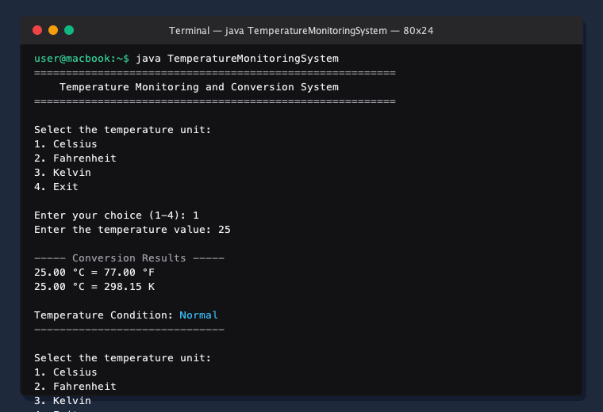
Figure 4.1: Terminal Execution — Celsius Input (25 °C) converting to 77.00 °F and 298.15 K with 'Normal' Condition.
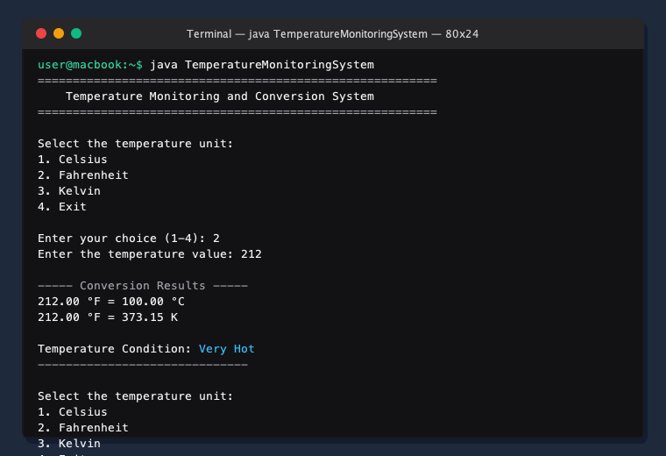
Figure 4.2: Terminal Execution — Fahrenheit Input (212 °F) converting to 100.00 °C and 373.15 K with 'Very Hot' Condition.
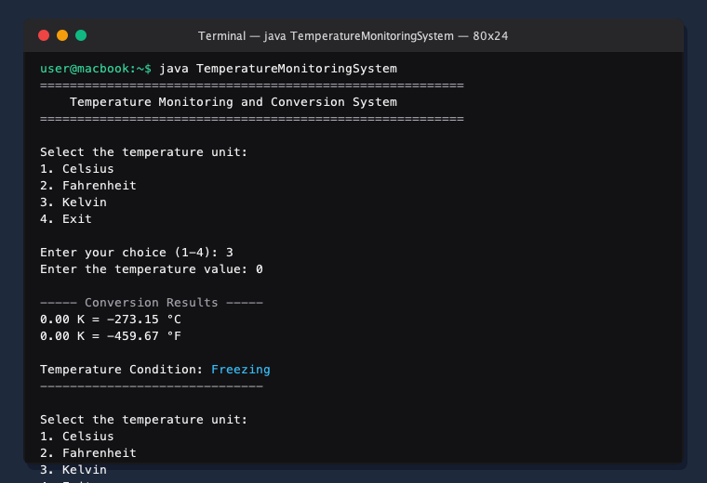
Figure 4.3: Terminal Execution — Kelvin Input (0 K) converting to -273.15 °C and -459.67 °F with 'Freezing' Condition.
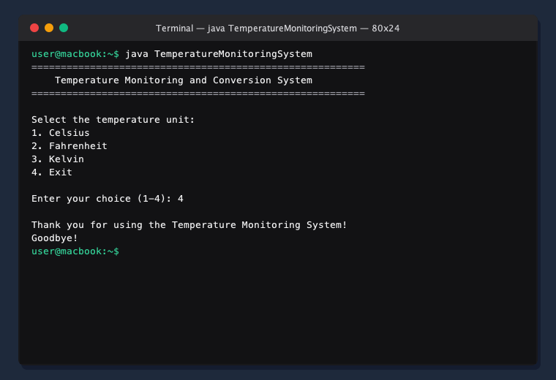
Figure 4.4: Terminal Execution — Clean Session Termination upon selecting Option 4 (Exit).

6. Swing GUI Enhancement (Optional)
To demonstrate Module VIII of the syllabus (Introduction to Swing GUI, Layout Managers, Event Handling), a simple Swing GUI application is provided as an optional enhancement. It is not required by the Problem Statement.
6.1 GUI Components and Layout
The GUI uses standard Swing components: JFrame as the window, BorderLayout for the overall layout, GridLayout for organizing the input fields and dropdown, and JButton to trigger the conversion. Event handling is implemented using the ActionListener interface.
6.2 Source Code: TemperatureGUI.java
import javax.swing.*;
import java.awt.*;
import java.awt.event.ActionEvent;
import java.awt.event.ActionListener;
public class TemperatureGUI extends JFrame implements ActionListener {
private JTextField inputField;
private JComboBox<String> unitComboBox;
private JButton convertButton;
private JTextArea resultArea;
public TemperatureGUI() {
setTitle("Temperature Monitoring and Conversion System");
setSize(500, 400);
setDefaultCloseOperation(JFrame.EXIT_ON_CLOSE);
setLocationRelativeTo(null);
JPanel mainPanel = new JPanel(new BorderLayout(10, 10));
mainPanel.setBorder(BorderFactory.createEmptyBorder(15, 15, 15, 15));
JLabel titleLabel = new JLabel("Temperature Monitoring and Conversion System", JLabel.CENTER);
titleLabel.setFont(new Font("SansSerif", Font.BOLD, 16));
mainPanel.add(titleLabel, BorderLayout.NORTH);
JPanel inputPanel = new JPanel(new GridLayout(3, 2, 10, 10));
inputPanel.setBorder(BorderFactory.createTitledBorder("Input"));
inputPanel.add(new JLabel("Temperature Value:"));
inputField = new JTextField(10);
inputPanel.add(inputField);
inputPanel.add(new JLabel("Select Unit:"));
String[] units = {"Celsius", "Fahrenheit", "Kelvin"};
unitComboBox = new JComboBox<>(units);
inputPanel.add(unitComboBox);
inputPanel.add(new JLabel(""));
convertButton = new JButton("Convert");
convertButton.addActionListener(this);
inputPanel.add(convertButton);
mainPanel.add(inputPanel, BorderLayout.CENTER);
resultArea = new JTextArea(8, 40);
resultArea.setEditable(false);
resultArea.setFont(new Font("Monospaced", Font.PLAIN, 14));
resultArea.setBorder(BorderFactory.createTitledBorder("Results"));
JScrollPane scrollPane = new JScrollPane(resultArea);
mainPanel.add(scrollPane, BorderLayout.SOUTH);
add(mainPanel);
}
@Override
public void actionPerformed(ActionEvent e) {
resultArea.setText("");
String inputText = inputField.getText().trim();
if (inputText.isEmpty()) {
resultArea.setText("Please enter a temperature value.");
return;
}
double temperature;
try {
temperature = Double.parseDouble(inputText);
} catch (NumberFormatException ex) {
resultArea.setText("Invalid input. Please enter a numeric value.");
return;
}
String selectedUnit = (String) unitComboBox.getSelectedItem();
double celsius, fahrenheit, kelvin;
StringBuilder result = new StringBuilder();
switch (selectedUnit) {
case "Celsius":
celsius = temperature;
fahrenheit = TemperatureConverter.celsiusToFahrenheit(celsius);
kelvin = TemperatureConverter.celsiusToKelvin(celsius);
result.append(String.format("%.2f °C = %.2f °F%n", celsius, fahrenheit));
result.append(String.format("%.2f °C = %.2f K%n", celsius, kelvin));
result.append(String.format("%nTemperature Condition: %s",
TemperatureConverter.classifyTemperature(celsius)));
break;
case "Fahrenheit":
fahrenheit = temperature;
celsius = TemperatureConverter.fahrenheitToCelsius(fahrenheit);
kelvin = TemperatureConverter.fahrenheitToKelvin(fahrenheit);
result.append(String.format("%.2f °F = %.2f °C%n", fahrenheit, celsius));
result.append(String.format("%.2f °F = %.2f K%n", fahrenheit, kelvin));
result.append(String.format("%nTemperature Condition: %s",
TemperatureConverter.classifyTemperature(celsius)));
break;
case "Kelvin":
kelvin = temperature;
celsius = TemperatureConverter.kelvinToCelsius(kelvin);
fahrenheit = TemperatureConverter.kelvinToFahrenheit(kelvin);
result.append(String.format("%.2f K = %.2f °C%n", kelvin, celsius));
result.append(String.format("%.2f K = %.2f °F%n", kelvin, fahrenheit));
result.append(String.format("%nTemperature Condition: %s",
TemperatureConverter.classifyTemperature(celsius)));
break;
}
resultArea.setText(result.toString());
}
public static void main(String[] args) {
TemperatureGUI gui = new TemperatureGUI();
gui.setVisible(true);
}
}

7. GUI Testing & Actual Native Screenshots
7.1 GUI Test Cases
Test ID | Unit Selected | Input Value | Trigger | Output Display | Status
TC-GUI-01 | Celsius | 25 | Click 'Convert' | Normal (77.00 °F, 298.15 K) | PASS
TC-GUI-02 | Fahrenheit | 212 | Click 'Convert' | Very Hot (100.00 °C, 373.15 K) | PASS
TC-GUI-03 | Kelvin | 0 | Click 'Convert' | Freezing (-273.15 °C, -459.67 °F) | PASS
TC-GUI-04 | Celsius | invalid | Click 'Convert' | Invalid input error message | PASS
TC-GUI-05 | Any | (empty) | Click 'Convert' | Please enter value message | PASS
7.2 Actual Native GUI Window Screenshots
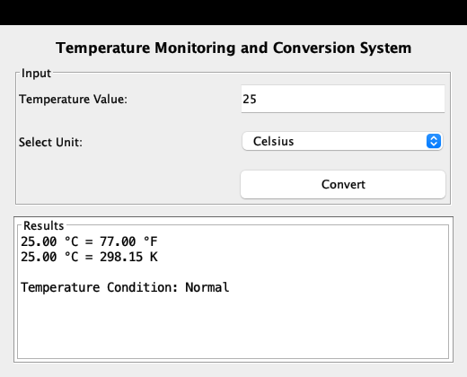
Figure 7.1: Native Swing GUI Window — Celsius conversion for 25 °C showing 77.00 °F and 298.15 K with 'Normal' Condition.
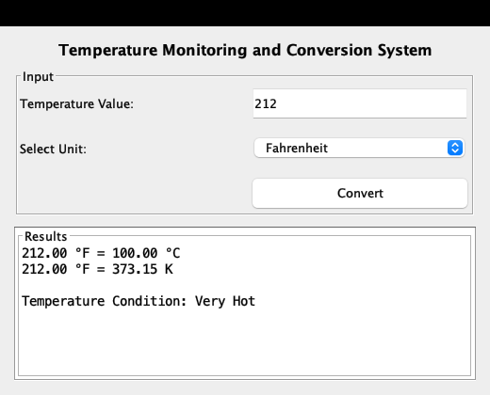
Figure 7.2: Native Swing GUI Window — Fahrenheit conversion for 212 °F showing 100.00 °C and 373.15 K with 'Very Hot' Condition.
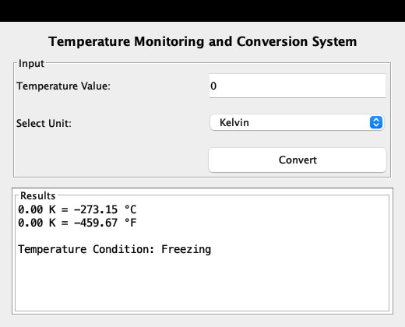
Figure 7.3: Native Swing GUI Window — Kelvin conversion for 0 K showing -273.15 °C and -459.67 °F with 'Freezing' Condition.
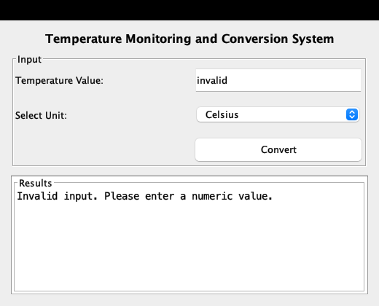
Figure 7.4: Native Swing GUI Window — Safe validation message displayed when non-numeric text is entered.

8. Viva Voce Questions & Answers (Simple & Project-Focused)
The following questions cover the key concepts of the project and syllabus in a simple, clear format suitable for viva preparation:
Q1: What is the main objective of this project?
The objective is to accept a temperature reading from the user, convert it between Celsius, Fahrenheit, and Kelvin using methods and formulas, and classify the condition into predefined categories using conditional statements.
Q2: How does the program take user input in the terminal?
It uses the Scanner class from java.util. Methods like scanner.nextDouble() read numeric values from System.in.
Q3: Why do we write 9.0 / 5.0 instead of 9 / 5 in the conversion formulas?
In Java, 9 / 5 performs integer division and drops the decimal part, resulting in 1. Writing 9.0 / 5.0 ensures floating-point division, resulting in 1.8.
Q4: How does the switch statement help in this program?
The switch statement evaluates the user's menu choice (1, 2, or 3) and executes the corresponding conversion formulas.
Q5: How are temperature conditions classified?
The temperature is converted to Celsius first, and then an if-else / else-if conditional chain checks the value against the predefined ranges (Freezing, Very Cold, Cold, Normal, Hot, Very Hot).
Q6: Why are the classification ranges documented as a Project Assumption?
These classification ranges are a Project Assumption because the PS does not specify exact numerical boundaries.
Q7: Why did you separate the methods into TemperatureConverter.java?
To keep the code clean, organized, and reusable. Both the terminal program and the Swing GUI can use the same conversion and classification methods without duplicating code.
Q8: Why is the while loop considered an optional enhancement?
The Problem Statement requires converting a temperature, but does not explicitly require repeated conversions in one run. The while loop allows the user to test multiple values in a single session, with an option to exit cleanly.
Q9: How does the program protect against invalid inputs?
In the terminal, a simple try-catch block catches non-numeric inputs and prompts the user again. In the GUI, a try-catch block catches NumberFormatException from Double.parseDouble() and displays a warning message.
Q10: What is the role of TemperatureGUI.java?
TemperatureGUI is an optional graphical interface added to demonstrate Module VIII (Swing GUI, Layout Managers, Event Handling). It provides an interactive window with text fields, a dropdown, and a Convert button.
Q11: What layout managers are used in the GUI?
BorderLayout is used for the overall window (dividing it into North, Center, and South), and GridLayout is used in the Center to align labels and input controls neatly in 3 rows and 2 columns.
Q12: How does the Convert button trigger action in the GUI?
The class implements ActionListener and overrides actionPerformed(ActionEvent e). When the button is clicked, actionPerformed reads the input, performs the conversion, and displays the result in the text area.

9. Conclusion & References
The Temperature Conversion & Monitoring System for Case Study No. 167 successfully fulfills all requirements of the Problem Statement and aligns with the Java Programming syllabus of ITM Skills University. The project demonstrates proper use of Scanner, switch statements, methods with mathematical operators, and if-else / else-if conditional logic. The codebase is clean, well-tested, and easy to explain during a viva examination.
References
- ITM Skills University — School of FutureTech, 'Java Programming Syllabus & Case Study No. 167 Specification', B.Tech CSE (2025–29).
- Oracle Corporation, 'Java Documentation — Scanner, Swing, and Control Flow Statements'.
- Herbert Schildt, 'Java: The Complete Reference', 12th Edition, McGraw-Hill Education.

