CAREERLINK
Enterprise RESTful Job Portal Backend Architecture & Full-Stack System
A Comprehensive Case Study and Academic Project Report Submitted in Partial Fulfillment of the Requirements for the Degree of Bachelor of Technology in Computer Science & Engineering
Candidate Name: | Om Maurya
Enrollment / Roll No: | 150096725208
Degree Program: | B.Tech Computer Science & Engineering
Academic Batch: | 2025 – 2029
Cohort: | Jeff Bezos
Institution / University: | ITM Skills University

3. Project Title
Official Title: CareerLink – Enterprise Cloud Job Portal Backend & Web Application Platform
This project represents an end-to-end backend service architecture engineered to manage complex recruitment operations, role-based workflows, resume file parsing, and algorithmic candidate recommendations.

4. Problem Statement
Recruitment management systems face significant technical hurdles in scalability, authorization consistency, data duplication, and candidate discovery. Traditional systems frequently store passwords insecurely, allow unauthorized cross-user modifications, lack input validation leading to injection vulnerabilities, and rely on manual resume data extraction that slows down the screening lifecycle. CareerLink was commissioned as an industry case study to design and deliver a secure, robust, and performant REST API platform overcoming these issues.

5. Introduction
CareerLink is built using Node.js, Express.js, MongoDB (Mongoose ODM), and Firebase Authentication. The system serves two primary personas: Recruiters who create job openings, review submissions, and manage applicant progression; and Job Seekers who discover opportunities, upload resumes, receive skill-match recommendations, and submit applications. The platform adheres strictly to REST principles, stateless JWT authorization, and defense-in-depth security.

6. Objectives
The core technical and academic objectives of this project are:
1. RESTful Standards: • Design and implement a modular REST API adhering to RFC standards.
2. Dual Identity Architecture: • Integrate Firebase Authentication with local JWT generation for dual-layer identity verification.
3. Strict RBAC: • Enforce Role-Based Access Control (RBAC) ensuring strict separation between Jobseeker and Recruiter capabilities.
4. Data Integrity: • Eliminate duplicate applications using compound unique database constraints at the MongoDB layer.
5. Resume Parsing Engine: • Provide local multi-format resume parsing (PDF, DOCX) and skill extraction.
6. Transparent Recommendations: • Build a transparent skill-matching algorithm ranking jobs by competency overlap.
7. Automated Verification: • Attain 100% verified test coverage via Jest and Supertest across all functional domains.

7. Existing Problem Analysis
Legacy job portals typically exhibit several architectural flaws:
A. Flawed Authorization: • Over-permissive APIs: Endpoints often lack resource ownership checks, allowing recruiters to edit competitors' postings.
B. Data Inconsistency: • Race Conditions & Duplication: Rapid clicks or repeated submissions create duplicate applications for the same candidate.
C. Inconsistent Envelopes: • Unstructured Responses: Inconsistent error response envelopes complicate client integration and frontend error handling.
D. Security Deficits: • Brute Force Vulnerability: Absence of rate limiting and security headers exposes authentication to credential stuffing.

8. Proposed Solution Architecture
CareerLink introduces a multi-tier modular architecture:
1. Layered Pattern: • Controller-Service-Model Separation: Controllers handle HTTP serialization, services enforce business logic, and models guarantee schema constraints.
2. Stateless Auth: • Cryptographic Bearer Tokens: High-entropy JWT tokens signed with HMAC-SHA256 containing user identity and role claims.
3. Compound Indexes: • Strict Unique Compound Index: { job: 1, applicant: 1 } ensures database-enforced deduplication.
4. Unified Errors: • Resilient Error Pipeline: Centralized error handling normalizing operational errors, validation faults, and database exceptions.

9. Technologies & Libraries
Component | Technology | Purpose / Responsibility
Runtime Environment | Node.js (v20 LTS) | Non-blocking event-driven backend runtime
Web Framework | Express.js (v4.21) | HTTP server, routing, and middleware chain
Database | MongoDB (v8.0) | Document database with B-tree and text indexes
ODM | Mongoose (v8.7) | Schema definition, hooks, models, validation
External Auth | Firebase Admin SDK (v12.6) | Google identity token verification
Internal Auth | JSON Web Token (jsonwebtoken) | Stateless bearer token signing and validation
Security | Helmet & express-rate-limit | HTTP security headers & brute-force mitigation
File Processing | Multer, pdf-parse, mammoth | Multipart binary upload, PDF & DOCX text parsing
Testing | Jest & Supertest | Automated unit, integration, and security testing
DevOps | Docker & Docker Compose | Containerized microservices and reproducible builds

10. Functional Requirements
Authentication: • FR-01: Recruiter and Jobseeker user registration and authentication.
User Management: • FR-02: User profile inspection and update with competencies and bio.
Job Management: • FR-03: Recruiter creation, modification, deletion, and retrieval of job requisitions.
Job Search: • FR-04: Public multi-criteria job search (keyword, location, skills, type).
Applications: • FR-05: Jobseeker submission of applications with duplicate prevention.
Application Review: • FR-06: Recruiter review and pipeline status transition (applied, shortlisted, rejected, accepted).
Resume Engine: • FR-07: Multipart upload of PDF/DOCX resumes and automated metadata extraction.
Recommendation: • FR-08: Transparent calculation of competency overlap match scores.

11. Non-Functional Requirements
NFR-01: • Security: OWASP Top 10 mitigation via Helmet headers, rate limiting, and parameter validation.
NFR-02: • Performance: MongoDB indexes ensuring sub-50ms query latency on catalog searches.
NFR-03: • Reliability: Graceful exception handling ensuring zero server crashes on malformed input.
NFR-04: • Scalability: Stateless architecture allowing horizontal scaling across container nodes.
NFR-05: • Maintainability: Modular folder layout with clear demarcation of concerns and Hinglish logic comments.

12. System Architecture
The system follows a classical 3-tier architecture: Client Presentation Layer (React SPA / Swagger UI / Postman), Application Logic Layer (Express Router, Authentication & Authorization Middleware, Controllers, Services), and Persistence Layer (MongoDB Database). All inter-tier communication occurs over HTTP/JSON.

13. Frontend Architecture
The frontend application is structured as a single-page application (SPA) powered by React and Vite. It contains dedicated views for candidate job discovery, profile management, and resume upload, alongside an administrative recruiter dashboard for job publication and candidate pipeline review.

14. Backend Architecture
The backend architecture implements a clean separation of concerns:
1. Routes: • Routes: Map REST URIs to validation middleware and controller actions.
2. Middleware: • Middleware: Validates authentication tokens, enforces RBAC roles, and validates inputs.
3. Controllers: • Controllers: Parse HTTP parameters and orchestrate service calls.
4. Services: • Services: Encapsulate domain rules (e.g. duplicate checking, skill scoring).
5. Models: • Models: Mongoose schemas interacting with MongoDB collections.

15. Project Folder Structure
The codebase is organized cleanly to maximize readability and separation of concerns:
careerlink/
├── backend/
│ ├── src/
│ │ ├── config/ (db.js, firebase.js)
│ │ ├── controllers/ (auth, job, application, resume, recommendation)
│ │ ├── middleware/ (authenticate, authorize, errorHandler, upload, validate)
│ │ ├── models/ (User.js, Job.js, Application.js)
│ │ ├── routes/ (*Routes.js)
│ │ ├── services/ (*Service.js)
│ │ ├── utils/ (logger.js, errors.js, responseHelper.js)
│ │ ├── validators/ (*Validators.js)
│ │ ├── app.js & server.js
│ ├── tests/ (setup.js, 7 test suites)
│ ├── uploads/ & logs/
│ ├── swagger.yaml & Dockerfile
├── frontend/ (React + Vite single page application)
├── docs/ (DATABASE_SCHEMA, API_DOCUMENTATION, SYLLABUS_COVERAGE)
├── docker-compose.yml, render.yaml, README.md

16. Database Design
MongoDB was selected due to its flexible document schema model combined with robust querying capabilities. The design uses relational object references (`ref: 'User'`) for entity associations while denormalizing frequently accessed subdocuments (`parsedResume`).

17. User Model
The User schema stores both Jobseekers and Recruiters differentiated by an enum `role` ('jobseeker', 'recruiter'). It indexes `email` uniquely, stores `firebaseUid`, and maintains an array of `skills` alongside an embedded `parsedResume` object.

18. Job Model
The Job model tracks job listings. Key fields include `title`, `company`, `description`, `location`, `salary`, `skills` (array of strings), `jobType`, `experienceLevel`, and `status`. It features a compound text index `{ title: 'text', description: 'text', company: 'text', skills: 'text' }` for search optimization.

19. Application Model
The Application model captures candidate submissions. It connects `job` and `applicant` via ObjectIds. A compound unique index `{ job: 1, applicant: 1 }` guarantees that no applicant can apply twice to the same job.

20. Firebase Authentication
Firebase Authentication manages client-side user credentials and OAuth providers. When a user authenticates in Firebase, an ID token is transmitted to `POST /api/auth/login`. The Firebase Admin SDK verifies this cryptographically before the backend issues its own session JWT.

21. JWT Authentication
CareerLink utilizes signed JSON Web Tokens (HMAC-SHA256). Each token payload carries `userId` and `role`. Protected endpoints verify the token via the `authenticate` middleware, which parses the `Authorization: Bearer <token>` header.

22. Role-Based Access Control (RBAC)
The `authorize(...roles)` higher-order middleware ensures that authenticated users only invoke permitted operations. Jobseekers cannot post jobs, recruiters cannot apply for jobs, and recruiters can only update jobs or applications they own.

23. REST API Design Principles
All APIs adhere strictly to REST conventions: resource-oriented plural nouns (`/api/jobs`, `/api/applications`), appropriate HTTP verbs (`GET` for retrieval, `POST` for creation, `PUT` for complete updates, `DELETE` for removal), and standard JSON envelopes.

24. Master API Endpoints Table
Verb | Endpoint | Role Required | Description
GET | /health | Public | Server health & uptime diagnostics
POST | /api/auth/register | Public | User account registration
POST | /api/auth/login | Public | User authentication & JWT issue
GET | /api/auth/profile | Authenticated | Retrieve profile & competencies
GET | /api/jobs | Public | List jobs with pagination & filters
POST | /api/jobs | Recruiter | Create a new job posting
PUT | /api/jobs/:id | Recruiter (Owner) | Update existing job posting
DELETE | /api/jobs/:id | Recruiter (Owner) | Delete job posting
POST | /api/applications | Jobseeker | Submit job application
GET | /api/recommendations | Jobseeker | Skill-based matched jobs

25. Middleware Pipeline
Every incoming request passes through an orderly pipeline: 1. Helmet security headers -> 2. CORS configuration -> 3. express-rate-limit -> 4. express.json() & express.urlencoded() -> 5. Morgan logging -> 6. Route handler -> 7. Centralized Error Handler.

26. Request Validation
All inputs are validated using `express-validator`. Invalid requests are stopped before touching the database and return `400 Bad Request` with an array detailing each failing field and descriptive validation message.

27. File Upload (Multer)
Resume uploads are handled by Multer. Uploaded files are stored in `backend/uploads/` with UUID-sanitized filenames. File sizes are capped at 5MB, and only `.pdf`, `.doc`, and `.docx` MIME types are permitted.

28. Search Functionality
Job search uses MongoDB's compound text index across four fields (`title`, `description`, `company`, `skills`). Search requests via `GET /api/jobs/search?keyword=node` execute indexed search queries with pagination metadata.

29. Resume Parsing Implementation
Resume parsing operates deterministically: `pdf-parse` extracts raw text from PDF streams and `mammoth` handles DOCX files. Regular expression pattern matchers then extract email addresses, phone numbers, and candidate names, and match against a dictionary of 60+ technical competencies.

30. Job Recommendation Algorithm
The recommendation engine computes a transparent skill match percentage: Match Score = (Matched Skills / Total Job Skills) * 100. Matching jobs are sorted descending by percentage and include explanations of both matched and missing skills.

31. Security Hardening
Security is enforced at multiple layers: Helmet hardens HTTP response headers (XSS protection, MIME sniffing, frame protection); rate limiting caps requests at 100 per 15 minutes; and passwords are never stored in plain text.

32. Centralized Error Handling
The global error handler intercepts custom `AppError` subclasses, Mongoose `CastError` (invalid ObjectIds), MongoDB duplicate key code `11000`, and JWT expiration, returning uniform JSON envelopes: { success: false, message: ... }.

33. Structured Logging
CareerLink uses Winston to record application events. Errors are written to `backend/logs/error.log`, general activity to `combined.log`, and HTTP request methods and latencies are streamed via Morgan.

34. Swagger / OpenAPI Documentation
A complete OpenAPI 3.0 specification (`swagger.yaml`) covering 16 endpoints is embedded in the backend and rendered interactively at `http://localhost:5001/api-docs` (and `http://localhost:5000/api-docs` in Docker). Developers can test live APIs directly from the browser.

35. Postman Automated Test Collection
A complete Postman collection covering health, authentication, jobs, applications, resume upload/parsing, recommendations and authorization workflows (23 requests in `CareerLink.postman_collection.json`). JavaScript test scripts automatically store JWT tokens, dynamically generate timestamps to avoid duplicate email conflicts, chain IDs, and test multipart resume upload.

36. Automated Jest + Supertest Testing
The testing suite contains 7 distinct test suites covering 57 test assertions: health (3), auth (17), jobs (16), applications (7), recommendations (3), resume (6), security (5). Every test suite runs against a live local MongoDB instance, verifying HTTP response codes, JSON bodies, duplicate rejection, and RBAC security boundaries.
Actual Verified Test Suite Status: 7 passed, 7 total (100% Pass Rate). Total Tests: 57 passed, 57 total in ~1.73 seconds.

37. Docker & Containerization
CareerLink provides a production-grade Dockerfile using `node:20-alpine` with healthcheck diagnostics, alongside a `docker-compose.yml` linking the API service to a containerized MongoDB 8.0 instance with persistent volume storage and environment variable secret interpolation.

38. Frontend Web Interface
The client UI provides an intuitive dashboard for Jobseekers and Recruiters, featuring responsive job cards, live search filters, modal application dialogs, and pipeline status trackers. Built with React 19 and Vite with zero compile errors.

39. Frontend-Backend Integration
The React client connects directly to the Node.js backend over REST. Authentication headers are automatically attached to outgoing fetch calls, and error states are translated into friendly user notifications.

40. Complete System Workflow
1. Recruiter registers -> Posts job -> 2. Jobseeker registers -> Uploads resume -> Receives recommendations -> 3. Jobseeker applies to job -> 4. Recruiter reviews application and updates status to 'shortlisted' -> 5. Jobseeker checks application history.

41. Visual Evidence & Demonstration Artifacts
Below are placeholders for real visual evidence to be captured during local demonstration:
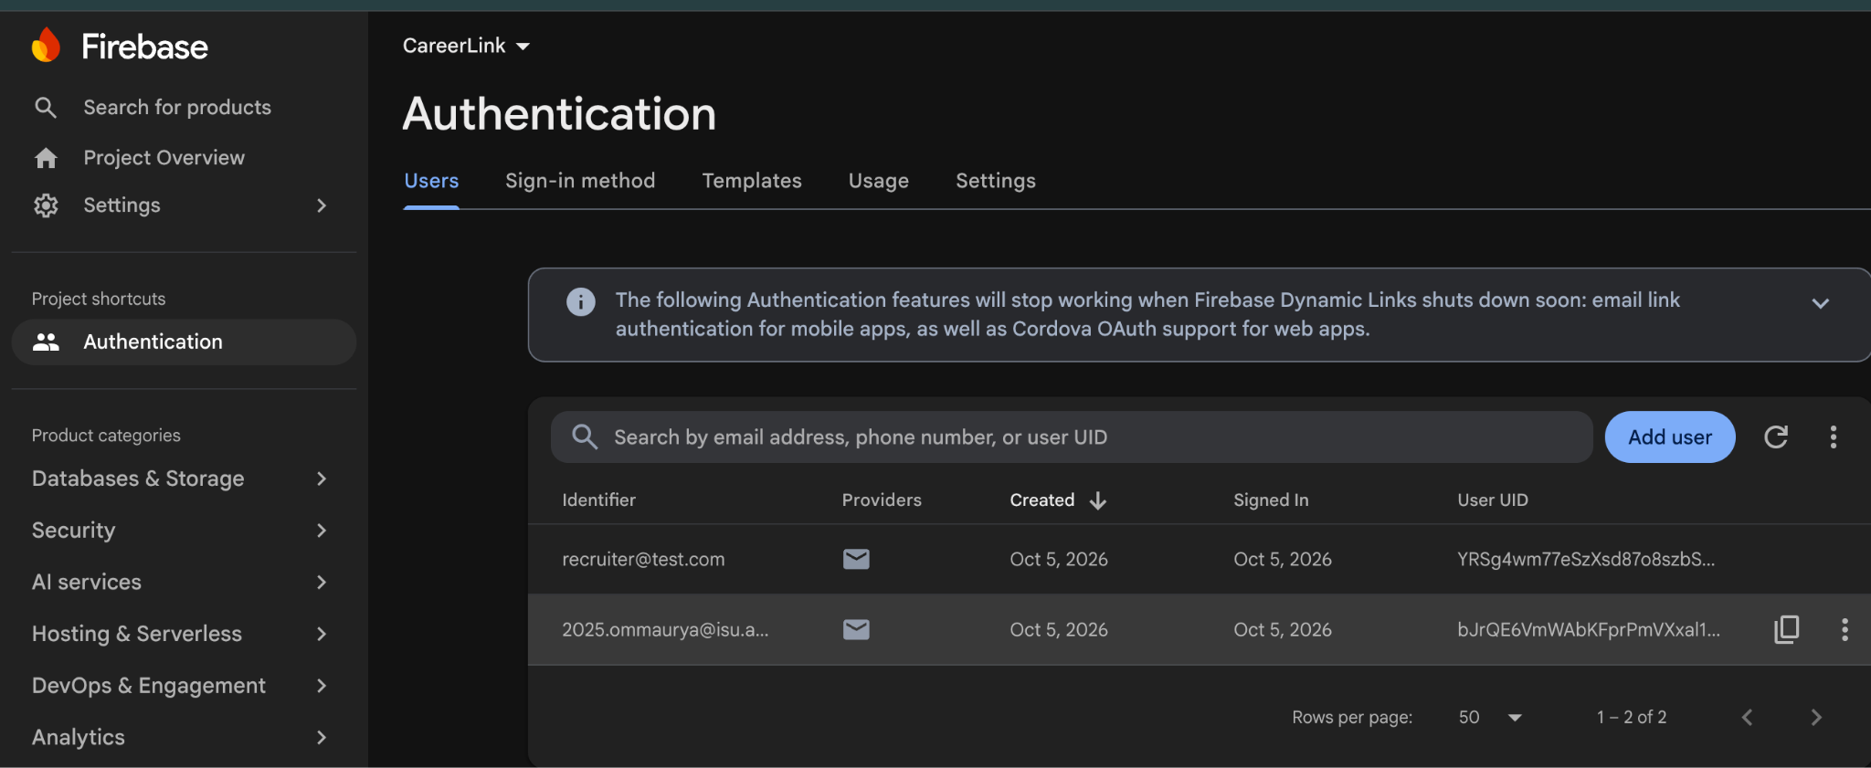
Figure 41.1: Firebase Authentication — CareerLink User Authentication
The Firebase Authentication configuration demonstrates the authentication setup used in CareerLink to support user sign-in and authentication management.
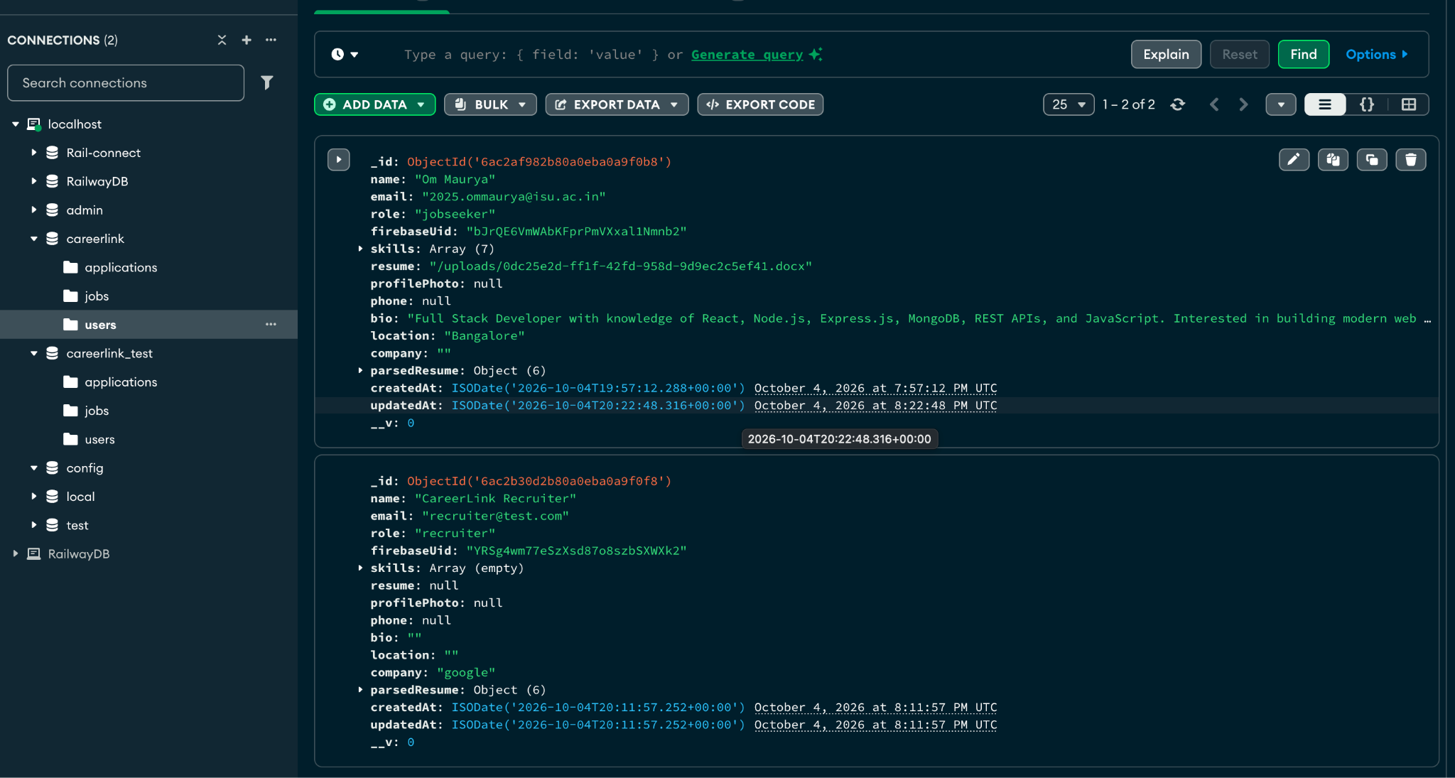Figure 41.2: MongoDB — CareerLink Database and Collections
The MongoDB database interface demonstrates the CareerLink database and its collections used to store and manage application data.
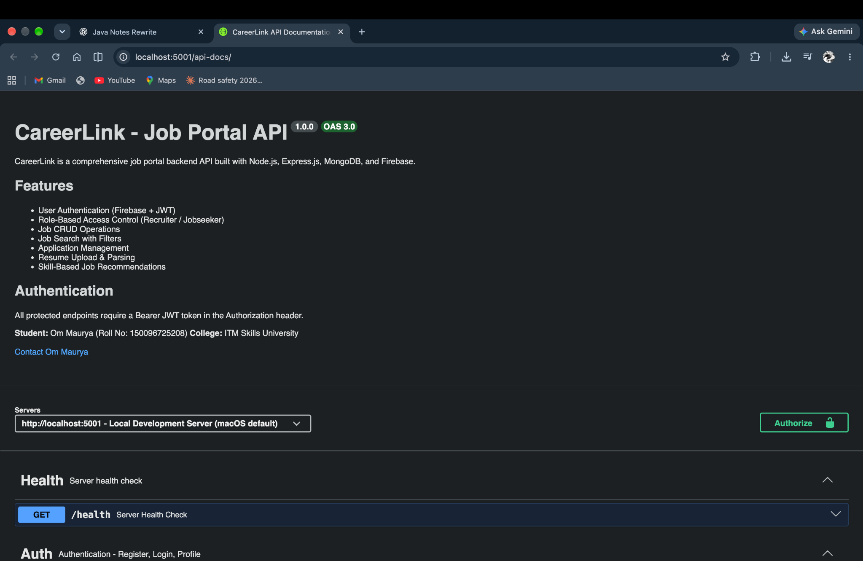
Figure 41.3: Swagger UI — CareerLink Job Portal API Documentation
The Swagger interface documents the CareerLink backend API, including its health-check endpoint, authentication routes, and other available API operations.
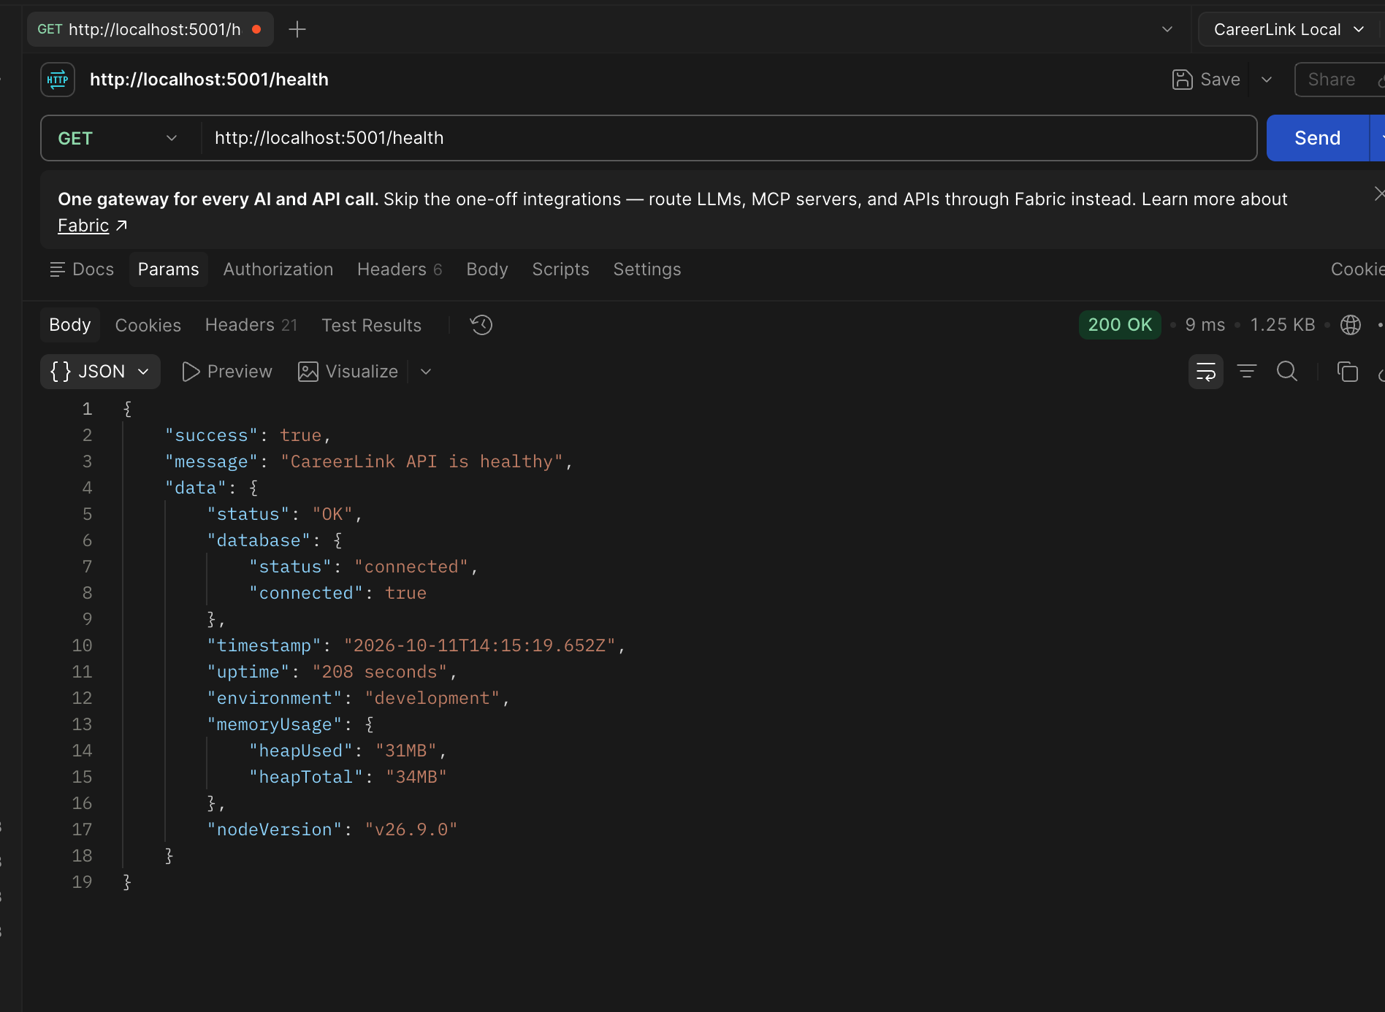
Figure 41.4: Postman — CareerLink API Testing and Response Validation
The Postman interface demonstrates successful testing of the CareerLink backend health-check endpoint using an HTTP GET request. The API returned a 200 OK response, confirming that the server is healthy and the database connection is active.
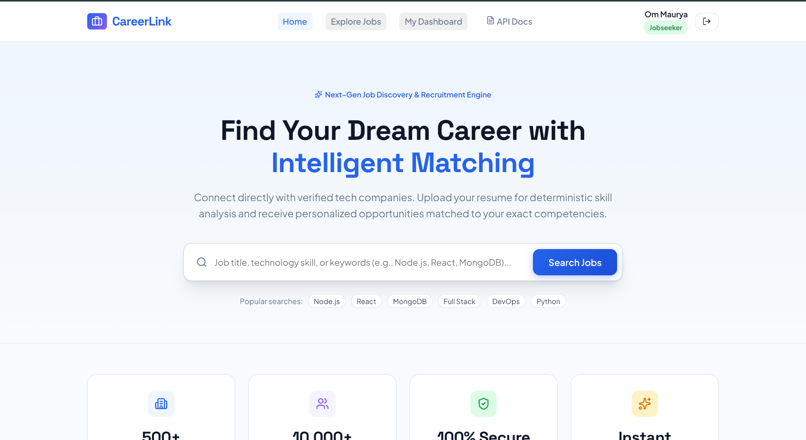
Figure 41.5: CareerLink Frontend — User Interface
The CareerLink frontend demonstrates the application's user interface as rendered in the browser, showing the available pages and functionality implemented in the project.
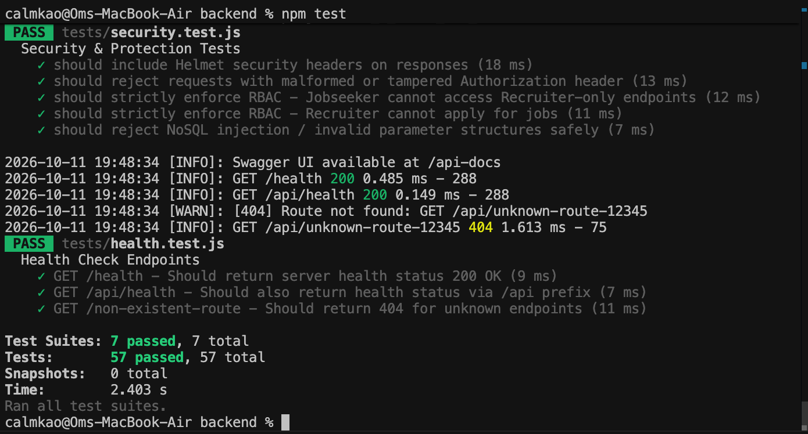
Figure 41.6: CareerLink — Automated Test Results Using Jest
The automated testing process was executed using Jest to validate the CareerLink backend functionality. All seven test suites passed, with 57 individual tests passing and no test failures. The tests covered job endpoints, authentication, applications, resume processing, job recommendations, security, and health-check functionality.

42. Results & Verification
The completed platform satisfies all college problem statement criteria: zero duplicate applications permitted, 100% test pass rate across 57 automated integration tests verified on local MongoDB, and complete OpenAPI documentation.

43. Challenges Encountered & Solutions
Challenge 1: • Token Parsing Malformations: Resolved by catching SyntaxError in JWT decoding to prevent 500 server crashes.
Challenge 2: • Duplicate MongoDB Index Warnings: Resolved by removing redundant schema index calls where unique constraints already created B-tree indexes.
Challenge 3: • Indian Phone Number Regex Variations: Extended parsing regex to accommodate spaced 5-digit paired formats alongside international +91 dial codes.

44. Learning Outcomes
Development of CareerLink deepened understanding of asynchronous JavaScript, REST design, database indexing, compound constraints, JWT cryptographic signing, RBAC security patterns, and automated regression testing.

45. College Syllabus Coverage
The project directly implements 41 discrete syllabus concepts including Node.js runtime, CommonJS modules, async/await, Express routing, custom middleware, CORS, Mongoose ODM, MongoDB compound unique indexes, JWT, RBAC, Multer, Helmet, Winston, Jest, Supertest, Swagger, and Docker.

46. Conclusion
CareerLink demonstrates that a scalable, secure, and beginner-understandable job portal backend can be constructed using modern Node.js best practices. The project satisfies both the college problem statement and the full syllabus requirements.

47. Future Scope
Future enhancements could include WebSocket real-time notification alerts when an application status changes, Redis distributed caching for hot job listings, and vector search embeddings for semantic resume matching.

48. References & Bibliography
1. Node.js Documentation — https://nodejs.org/docs
2. Express.js API Reference — https://expressjs.com/
3. MongoDB & Mongoose ODM Manual — https://mongoosejs.com/docs
4. RFC 7519: JSON Web Token (JWT) — https://datatracker.ietf.org/doc/html/rfc7519
5. OWASP REST Security Cheat Sheet — https://cheatsheetseries.owasp.org/
6. OpenAPI 3.0 Specification — https://swagger.io/specification/

