Time Series Forecasting for Vehicle Sales
Automotive Data Science Analyst Internship - Week 3 Task Report

1. Objective
This report documents a time series analysis of monthly vehicle sales. The goals are to prepare the data for time series modelling, decompose it into trend, seasonality and noise, build and validate forecasting models in Python, and forecast the next twelve months so that inventory and market strategy decisions can be supported by data.

2. Approach Overview
- Simulate seven years (84 months) of monthly vehicle sales with trend, seasonality and an irregular shock.
- Prepare the data: fix the monthly index, fill missing months, detect and replace outliers, apply a log transform.
- Decompose the series with STL and test stationarity with the Augmented Dickey-Fuller (ADF) test.
- Compare three models on a 12-month hold-out: a seasonal naive baseline, Holt-Winters and SARIMA.
- Check residual diagnostics, refit the best model on all data and forecast 2026 with 95% intervals.

3. Data
A self-simulated dataset covering January 2019 to December 2025 was generated with a fixed random seed. Sales are built from a linear upward trend, a repeating yearly seasonal pattern (a spring peak around fiscal year-end and a festive-season peak in September to November), a multiplicative noise term, and an irregular shock that mimics a lockdown-style dip between April and August 2020. Because the data is simulated, the patterns reflect the assumptions built in; the workflow applies directly to real registration or dealer sales data.
Data-quality problems were injected on purpose: 2 missing months, one inflated value (a data-entry spike) and one deflated value (a reporting error).

4. Data Preparation
- Monthly frequency: the index was set to month-start so that every month exists exactly once.
- Missing values: 2 missing months were filled by time-based linear interpolation, which keeps the local level of the series.
- Outliers: the log series was decomposed with STL and points whose residual was more than 4 standard deviations from the mean were flagged. 2 values were flagged (Sep 2022, Jul 2024) and replaced by interpolation. The genuine 2020 dip is not flagged, because the STL trend component adapts to a multi-month shock; it is real behaviour of the market and is kept in the data.
- Log transform: seasonal swings grow with the level of sales (multiplicative seasonality), so modelling log(sales) turns them into a constant additive pattern and stabilises the variance.
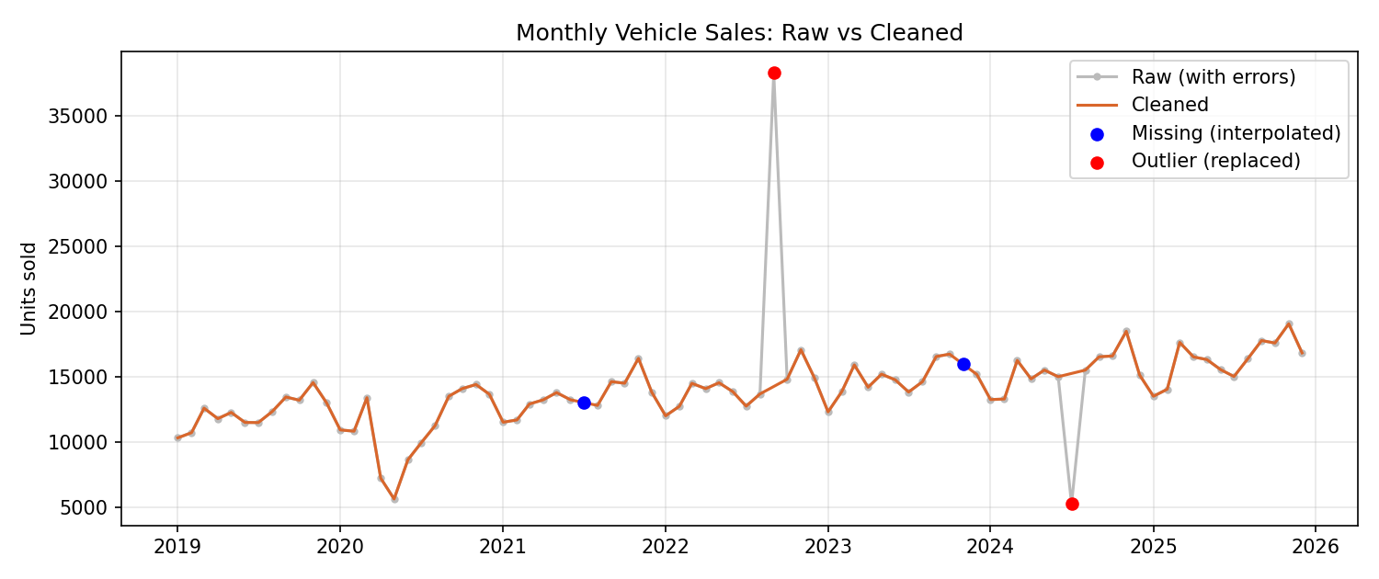
Figure 1: Raw versus cleaned monthly sales

5. Decomposition: Trend, Seasonality and Noise
STL decomposition with a 12-month period splits the log series into three parts. The trend is clearly upward (about 5.2% growth over the last year of data), the seasonal component repeats every year, and the remainder is small noise apart from the 2020 shock. The strength of trend is 0.50 and the strength of seasonality is 0.31 (both on a 0 to 1 scale, where values near 1 mean a very strong component).
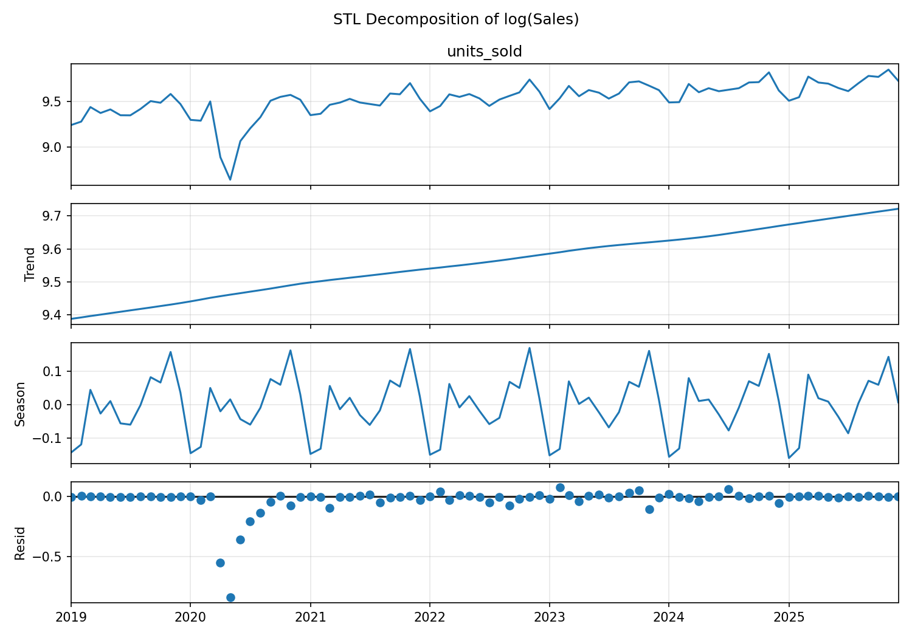
Figure 2: STL decomposition of log(sales)
The seasonal effect by month shows that sales are highest in November at 17.2% above trend and lowest in January at -13.9% below trend.
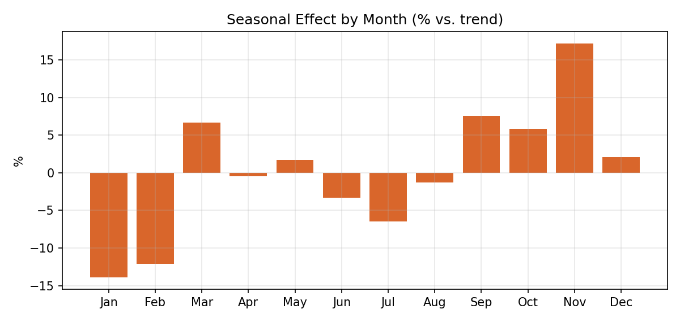
Figure 3: Average seasonal effect by calendar month

6. Stationarity Analysis
Classical models such as ARIMA require a stationary series. The ADF test has the null hypothesis that the series has a unit root (is non-stationary); a p-value below 0.05 rejects it.
Series | ADF p-value | Stationary at 5%?
Raw sales | 0.9188 | No
log(sales) | 0.1466 | No
log, first difference | 0.0 | Yes
log, seasonal difference (12) | 0.0174 | Yes
log, first + seasonal difference | 0.0081 | Yes

The original series is not stationary because of the trend and seasonality. Applying one regular difference and one seasonal difference (lag 12) to the log series removes both, which motivates d = 1 and D = 1 in the SARIMA model. The ACF and PACF of the differenced series (Figure 4) guide the choice of the moving-average and autoregressive orders.
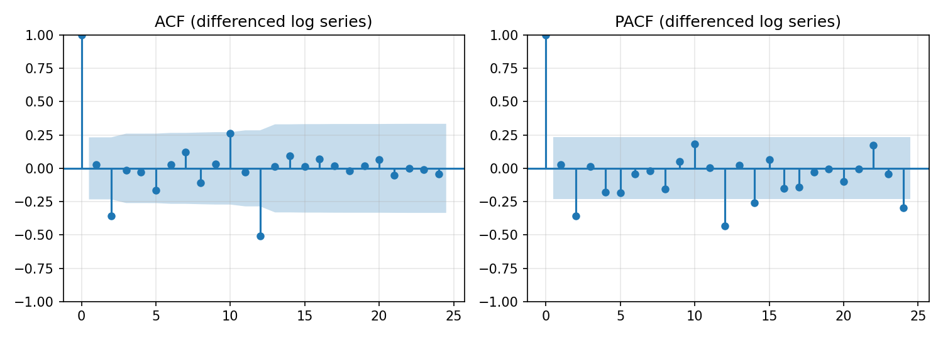
Figure 4: ACF and PACF of the differenced log series

7. Model Selection
Three candidates were compared. The last 12 months (2025) were held out as a test set and never used for fitting.
- Seasonal naive: predicts each month with the value from the same month one year earlier. It is the benchmark any model must beat.
- Holt-Winters (exponential smoothing): additive trend and additive seasonality on the log series.
- SARIMA(p,1,q)(P,1,Q)12: a grid search over p, q in {0,1,2} and P, Q in {0,1} (36 models), choosing the lowest AIC on the training data.
The five best SARIMA candidates by AIC were:
Rank | Order (p,d,q) | Seasonal order | AIC
1 | (2, 1, 2) | (0, 1, 1, 12) | -106.0
2 | (1, 1, 2) | (0, 1, 1, 12) | -102.6
3 | (0, 1, 2) | (0, 1, 1, 12) | -102.4
4 | (0, 1, 2) | (1, 1, 1, 12) | -96.9
5 | (1, 1, 2) | (1, 1, 1, 12) | -95.1

8. Validation Results
Forecasts for the 12 hold-out months were compared with the actual values using MAE (mean absolute error), RMSE (root mean squared error) and MAPE (mean absolute percentage error).
Model | MAE (units) | RMSE (units) | MAPE (%)
Seasonal Naive (baseline) | 917.9 | 1034.3 | 5.52
Holt-Winters | 1591.0 | 1752.2 | 9.65
SARIMA (2, 1, 2)(0, 1, 1, 12) | 474.8 | 633.1 | 3.01

SARIMA gave the lowest RMSE of the two fitted models and also beat the seasonal naive baseline, so it was selected as the final model. Its MAPE of 3.01% means forecasts were on average about that percentage away from actual monthly sales.
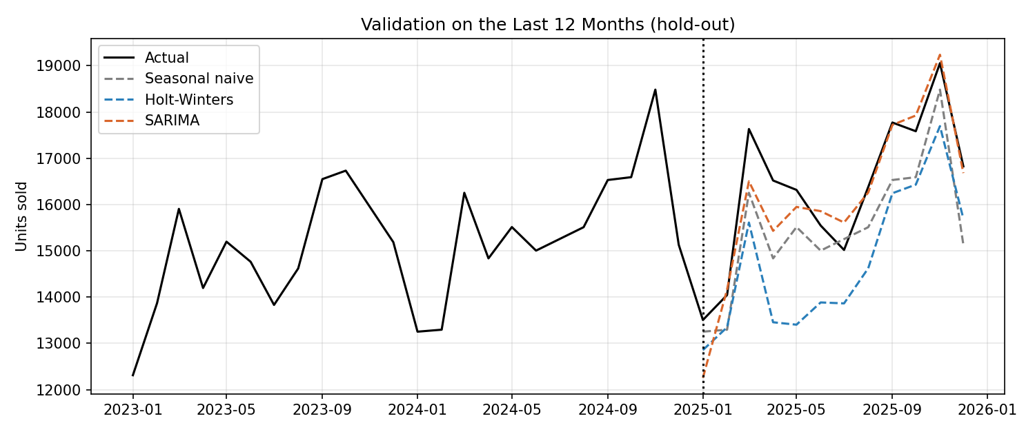
Figure 5: Model forecasts versus actual sales on the hold-out year

8.1 Residual diagnostics
For the SARIMA model, the residuals should look like white noise. The Ljung-Box test at lag 12 gives a p-value of 0.699; a value above 0.05 means no significant leftover autocorrelation, so the model has captured the structure of the data.
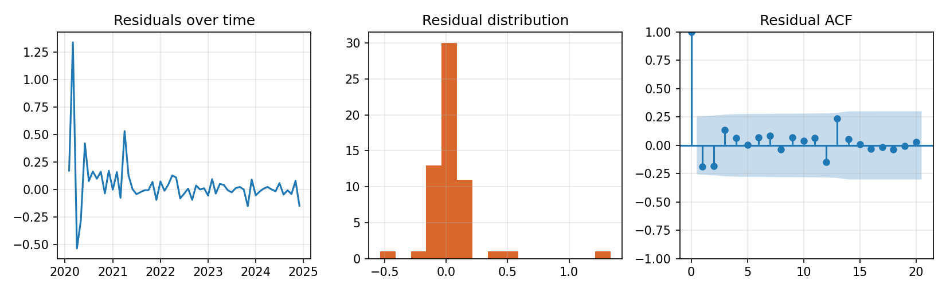
Figure 6: SARIMA residual diagnostics

9. Forecast for 2026
The selected model (SARIMA) was refitted on all 84 months and used to forecast January to December 2026 with 95% prediction intervals.
Month | Forecast | Lower 95% | Upper 95%
Jan 2026 | 14,684 | 13,076 | 16,488
Feb 2026 | 15,297 | 13,071 | 17,903
Mar 2026 | 18,549 | 15,738 | 21,862
Apr 2026 | 16,984 | 14,345 | 20,109
May 2026 | 17,211 | 14,518 | 20,405
Jun 2026 | 16,754 | 14,120 | 19,878
Jul 2026 | 16,371 | 13,793 | 19,430
Aug 2026 | 17,375 | 14,637 | 20,626
Sep 2026 | 18,930 | 15,945 | 22,474
Oct 2026 | 18,959 | 15,968 | 22,510
Nov 2026 | 20,430 | 17,207 | 24,257
Dec 2026 | 17,888 | 15,066 | 21,239

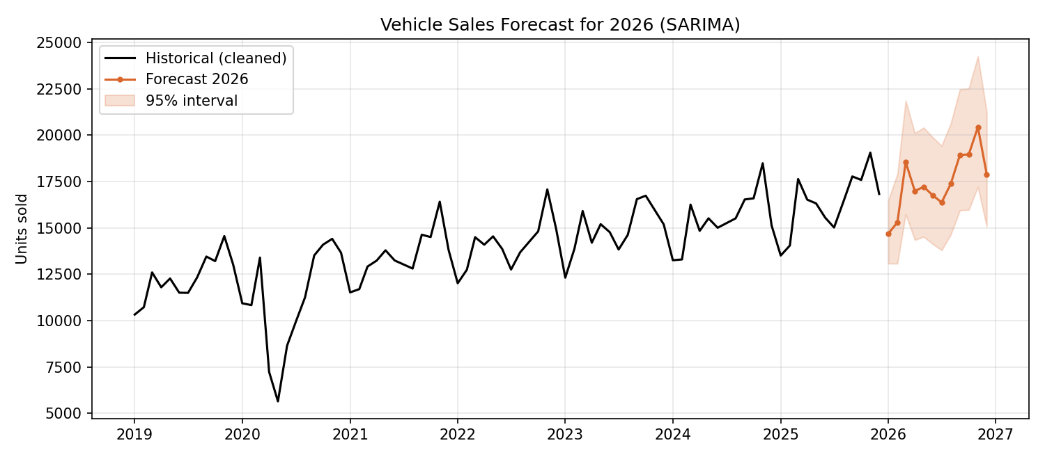
Figure 7: Historical sales and the 2026 forecast with 95% interval

10. Interpretation of the Forecast
- Total forecast sales for 2026 are about 209,432 units, which is +6.7% compared with 196,195 units in 2025.
- The forecast peaks in Nov 2026 and is lowest in Jan 2026, following the seasonal pattern found in the decomposition.
- The prediction interval widens as the horizon grows, which is expected: uncertainty accumulates the further ahead we forecast.
- Business use: stock levels and dealer orders can be planned ahead of the spring and festive peaks, and marketing spend can be timed around the low months.

11. Model Effectiveness and Limitations
- Effectiveness: the model reproduces trend and seasonality well and its hold-out error is small relative to the monthly sales level.
- Simulated data: the series follows the assumptions built into the simulation, so real data would be noisier and the errors larger.
- Short hold-out: only one year was used for validation; rolling-origin cross-validation would give a more reliable error estimate.
- Irregular events: SARIMA cannot anticipate shocks such as lockdowns, supply shortages or price changes. Such events need external variables or scenario analysis.
- No external drivers: interest rates, fuel prices, promotions and model launches were not included. SARIMAX or Prophet with regressors would be a natural next step.
- Interval coverage: the intervals assume normally distributed residuals on the log scale.

12. Code Snippets
Data preparation:
s = raw.asfreq("MS") # fixed monthly index
s_interp = s.interpolate(method="time") # fill missing months
log_s = np.log(s_interp)
res = STL(log_s, period=12).fit().resid
z = (res - res.mean()) / res.std() # z-score of the residual
clean = s.copy(); clean[z.abs() > 4.0] = np.nan
clean = clean.interpolate(method="time")
y = np.log(clean) # log transform

Decomposition and stationarity test:
stl = STL(y, period=12, robust=True).fit() # trend, seasonal, resid
adfuller(y.diff().diff(12).dropna())[1] # ADF p-value

SARIMA grid search and validation:
train, test = y.iloc[:-12], y.iloc[-12:]
for p, q, P, Q in itertools.product([0,1,2], [0,1,2], [0,1], [0,1]):
m = SARIMAX(train, order=(p,1,q), seasonal_order=(P,1,Q,12)).fit(disp=False)
rows.append({"order": (p,1,q), "seasonal": (P,1,Q,12), "aic": m.aic})
pred = np.exp(best_model.get_forecast(12).predicted_mean)
mape = np.mean(np.abs((actual - pred) / actual)) * 100

Final forecast:
final = SARIMAX(y, order=best_order, seasonal_order=best_seasonal).fit(disp=False)
fc = final.get_forecast(12)
mean = np.exp(fc.predicted_mean)
lo, hi = np.exp(fc.conf_int(alpha=0.05)).T.values

13. Conclusion
Monthly vehicle sales show a clear upward trend and a stable yearly seasonal pattern. After cleaning and a log transform, SARIMA produced a hold-out MAPE of 3.01% and a 2026 forecast of about 209,432 units. The analysis is reproducible from the Python script in the GitHub repository, and the main next step is to repeat it on real sales data and add external drivers.

