Meeting Guide
Statistics, figures, and how to explain them
June 2026 | Sabiha Tahsin Soha

0. Foundations — say this before anything else

What is throughput?
Throughput (TP) is the single number that captures how efficiently someone can point. It combines speed and accuracy together.
TP = Effective Difficulty / Movement Time (bits per second)
Effective difficulty (IDe) is how hard the pointing task was — measured by how small and far the target was. Movement time (MT) is how long the trial took in seconds. Higher TP means better performance.
Say it like this: Imagine typing speed — but for pointing at things on screen. A fast typist who also makes no errors has high throughput. Someone slow who also misses a lot has low throughput. With a mouse you might get 4-5 bits/s. Head pointing is much harder so these pilots show 0.3 to 1.0 bits/s. Higher is always better.

What is the One Euro advantage and how is it computed?
For every participant, at every variance level, the experiment records two TP values: one when using One Euro filter, one when using Exponential filter. The advantage is just the subtraction:
One Euro advantage = TP(One Euro) - TP(Exponential)
Positive number = One Euro was faster. Negative number = Exponential was faster.

Example from Pilot 2, Tareq:
Variance level | One Euro TP | Exponential TP | Advantage (OE - Exp)
Low | TP_OE_low | TP_Exp_low | +0.08 bits/s (OE wins)
Medium | TP_OE_med | TP_Exp_med | +0.17 bits/s (OE wins)
High | TP_OE_high | TP_Exp_high | -0.26 bits/s (Exp wins)

The bar chart averages these numbers across all participants. So the Low bar height = average of all participants' Low advantage. If that average is positive, One Euro wins at Low. If negative, Exponential wins.
Say it like this: For every person, at every jitter level, we ran them with both filters and timed them. Then we just subtracted: One Euro time minus Exponential time. Positive means One Euro was faster for that person at that level. Negative means Exponential was faster. Then we averaged those across all people to get one bar per level.

Pilot 1 — 4 participants, uncapped conditions

What the three tests actually compute
Test 1: Bootstrap confidence interval
What question it answers: Given only 4 participants, what is the plausible range for the true filter difference?

Mathematical steps:
- For each participant, compute their overall mean TP for One Euro and for Exponential. Subtract: d_i = TP(OE) - TP(Exp). You get 4 differences.
- Compute the mean of those 4 differences. That is your observed effect.
- Resample: randomly pick 4 participants from your 4, with replacement (so some appear twice, some not at all). Compute the mean difference for this fake sample. Record it.
- Repeat step 3 ten thousand times. You get 10,000 fake means.
- Sort those 10,000 values. The 2.5th percentile and 97.5th percentile give you the 95% confidence interval.

Pilot 1 result: CI = [-0.107, +0.081] bits/s
Zero is inside this range. This means we cannot rule out that the true difference is zero.

Say it like this: We only have 4 people. We cannot be sure if our 4 people gave us a lucky or unlucky sample. So we simulate: pretend we ran the study 10,000 times by randomly picking 4 people from our 4 (some might appear twice). Each time we get a slightly different answer. The range of those answers is our confidence interval. If zero is inside that range, we cannot say which filter is better.
Why this test: it makes no assumptions about the shape of the data. It is the most honest method for tiny samples.
Limitation: with n=4, the interval is wide. You are resampling from a very small pool. The uncertainty is real and the wide interval correctly reflects that.

Test 2: Per-participant t-test
What question it answers: Do the 4 participants consistently prefer one filter, treating each person as one data point?

Mathematical steps:
- For each participant, compute d_i = mean TP(OE) - mean TP(Exp). You get 4 numbers.
- Compute the mean of those 4 differences: d_bar.
- Compute the standard deviation of those 4 differences: s.
- Compute: t = d_bar / (s / sqrt(n)). With n=4, df=3.
- Look up the p-value from the t-distribution with 3 degrees of freedom.

Pilot 1 result: t = -0.16, p = 0.88
A t-value this close to zero with p=0.88 means the four differences pointed in no consistent direction.

Say it like this: Collapse every person down to one number — their average score with One Euro minus their average with Exponential. Then ask: do those four differences all point in the same direction? Two pointed toward One Euro, two toward Exponential. They cancelled out. That is p = 0.88 — like asking four friends if they prefer coffee or tea and getting a 2-2 split.
Why this test: most conservative. Each person counts exactly once. No pseudo-replication.
Limitation: throws away all within-person trial variation. With 4 people you need a huge effect to reach significance. p=0.88 does NOT mean the filters are identical — it means we cannot tell with 4 people.

Test 3: Linear Mixed Model (LMM)
What question it answers: After accounting for target difficulty and condition latency, does filter type predict throughput? Uses all individual trials.

Mathematical model:
TP ~ filter_OE + MeasuredLatency + IDe + (1 | Participant)
Each term means:
- filter_OE: 1 if One Euro, 0 if Exponential. Its coefficient = how much TP changes when you switch to One Euro, holding everything else constant.
- MeasuredLatency: controls for the fact that high-variance conditions are also slower. Keeps the filter comparison fair.
- IDe: controls for target difficulty. Some target combinations are harder.
- (1 | Participant): the random intercept. Each participant gets their own baseline level. This is why Soha being fast overall does not contaminate the filter comparison.

How the p-value is computed: The model is fit twice — once with filter_OE included, once without. The improvement in model fit (likelihood ratio test) gives a chi-squared statistic, which is converted to a p-value.

Pilot 1 result: filter_OE coefficient = -0.05 bits/s, p = 0.38
The negative sign means One Euro is 0.05 bits/s slower on average — but p=0.38 means this is not significant. After accounting for difficulty and latency, filter type does not predict throughput.

Say it like this: Use all the trial data — every single target, not just averages. But be fair about it: some targets are harder than others, and some conditions are slower. So we account for those first, then ask: after all that, does switching the filter make a difference? We also account for the fact that some people are just faster overall, so one fast participant does not drag the result. After all that accounting, the filter made a 0.05 bits/s difference — which could easily be noise. p = 0.38.
Why this test: uses every single trial. Accounts for covariates. Standard for repeated-measures HCI studies. Most statistically powerful of the three.
Limitation: harder to explain. Random effect variance estimates are unreliable with only 4 participants (though fixed effect estimates are still valid).

Pilot 1 — Figure 1: Crossover bar chart
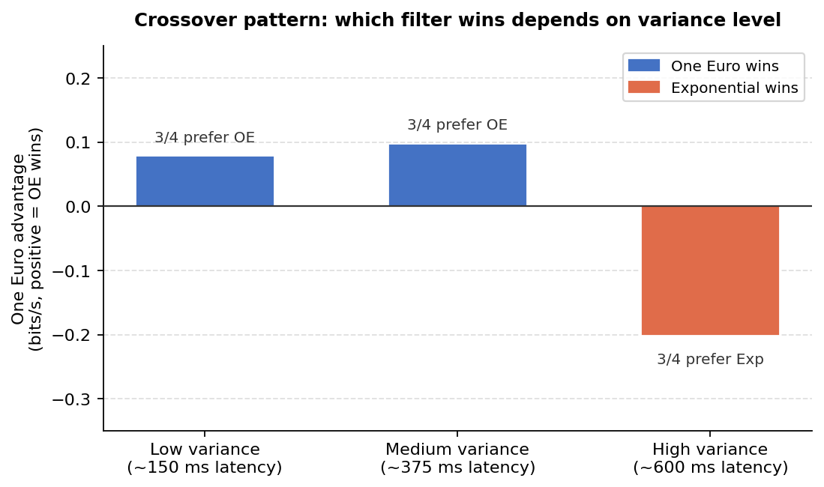
Pilot 1 Figure 1: One Euro advantage at each variance level

How the bars are computed:
- For each participant, compute One Euro advantage at each variance level (OE TP minus Exp TP at Low, at Medium, at High).
- Average across 4 participants to get three numbers: Low average, Medium average, High average.
- Each bar height = that average. Positive = One Euro wins on average. Negative = Exponential wins.
- The annotation '3/4 prefer OE' counts how many individual participants (not the average) showed that direction.

Say it like this: Look at the first bar — it is blue and above zero. That means on average, when the cursor was smooth (Low variance), One Euro was faster. Middle bar — still blue, still positive, One Euro still wins. Now look at the last bar — it flipped to orange and below zero. At high jitter, Exponential became faster. That flip from positive to negative is the crossover. The winner literally changes depending on which condition you are in.

Pilot 1 — Figure 2: Between-participant jitter spread
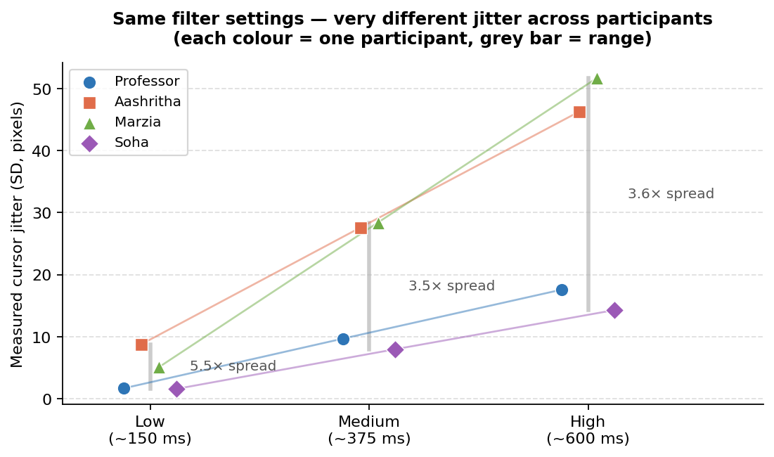
Pilot 1 Figure 2: Cursor jitter per participant at identical settings

How the figure is computed:
- For each participant at each variance level, record the measured cursor jitter in pixels (standard deviation of cursor position during a calibration measurement).
- Each coloured dot is one participant's measured jitter at one variance level.
- The grey bar spans from the minimum to the maximum across participants at that level.

Say it like this: These four people used the exact same filter settings. Same numbers, same everything. But look at the left side — one person's cursor had 1.6 px of jitter, another person's had 8.8 px. That is a 5x difference from the same settings. Imagine giving two people the exact same glasses prescription and one sees perfectly and the other still sees blurry. That is what this shows. This is why you cannot use one shared calibration — you have to tune it per person.

Pilot 2 — 3 participants, capped conditions

What changed from Pilot 1
- Both caps now active: 600 ms latency cap and 12 px jitter cap enforced during calibration.
- The Pilot 1 concern was: the crossover was seen at extreme conditions (up to 52 px jitter). Does it survive when conditions are more moderate? Pilot 2 tests this directly.
- The LMM is updated to include an interaction term (filter x SD) to formally test the crossover.

Updated LMM — now with interaction term
What question it answers: Does the One Euro advantage change depending on how noisy the signal is? This directly tests the crossover.

Mathematical model:
log(MT) ~ filter_OE * SD + IDe + (1 | Participant)
The * expands to: filter_OE + SD + filter_OE:SD (main effects plus their interaction).
- filter_OE: main effect of filter at the reference (low) SD level.
- SD: main effect of cursor jitter. More jitter = slower movement time.
- filter_OE:SD (the interaction): how much does the filter advantage CHANGE for each additional px of jitter? Positive coefficient means One Euro's advantage shrinks as jitter increases.

Why log(MT) instead of TP? Movement time is log-normally distributed — a few very slow trials can skew the mean. Taking log makes the distribution more symmetric and the model assumptions more valid.

Pilot 2 result: filter_OE main effect: coef = -0.38 on log(MT), p = 0.018
filter_OE:SD interaction: coef = +0.039 per px, p = 0.033

The main effect (p=0.018) says One Euro produces shorter movement times at the reference (low) jitter level. The interaction (p=0.033) says that advantage shrinks as jitter increases — and at high jitter the sign flips, meaning Exponential becomes faster. That is the crossover, now statistically confirmed.

Important: the LMM main effect p=0.018 sounds like One Euro wins overall, but the bootstrap CI and per-participant t-test still straddle zero. These are not contradictory. The LMM main effect is One Euro's advantage at the LOW end of jitter only. Averaged across all jitter levels (which the bootstrap and t-test do), the effect cancels out.

Say it like this: In Pilot 1 we saw the crossover but could not prove it statistically — too few people. In Pilot 2 we added a new question to the model: does One Euro's advantage change depending on how noisy the cursor is? The answer is yes, p = 0.033. Specifically, for every extra pixel of jitter, One Euro's advantage shrinks a little bit. At high jitter it shrinks so much it flips — Exponential becomes faster. That is the crossover confirmed mathematically. And this time it is under capped conditions, so the Pilot 1 concern is gone.
The interaction p=0.033 is the most important number in Pilot 2. It is the first time the crossover has been statistically confirmed, and it was measured under the actual capped conditions the full study will use.

Pilot 2 — Figure 1: Crossover bar chart (capped)
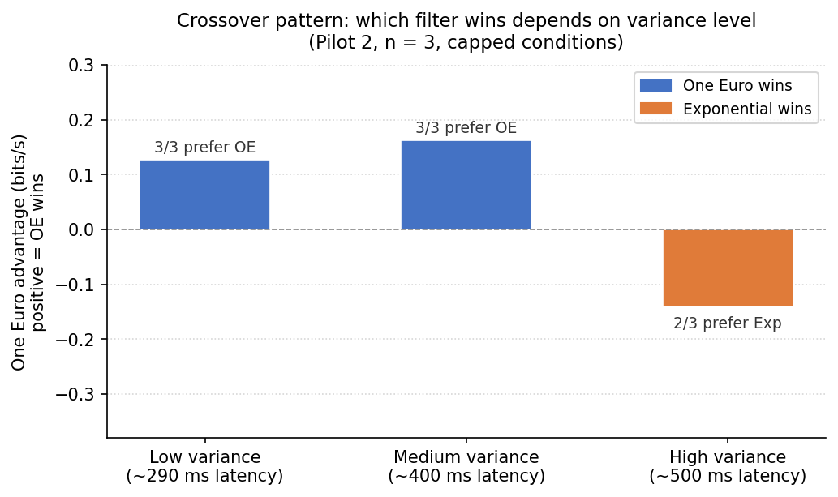
Pilot 2 Figure 1: One Euro advantage at each variance level, capped conditions

Same computation as Pilot 1 Figure 1. Average of (OE TP minus Exp TP) across 3 participants at each variance level. The key comparison to Pilot 1:
- The pattern is the same: positive at Low and Medium, negative at High.
- The High bar is -0.14 bits/s here vs -0.20 in Pilot 1. The Exponential advantage at High is slightly weaker under capped conditions.
- At High, it is 2 of 3 participants who flipped (not 3 of 3). Nowshad showed +0.07 — nearly zero.
Say it like this: The big question after Pilot 1 was: we saw the crossover but conditions were extreme — up to 52 px jitter. Does it still happen when conditions are more moderate? This figure says yes. Same pattern: blue positive bars on the left, orange negative bar on the right. The Exponential advantage at High is a bit smaller now (-0.14 vs -0.20) because the cap means High is less extreme, but the direction is the same.

Pilot 2 — Figure 2: Per-participant lines
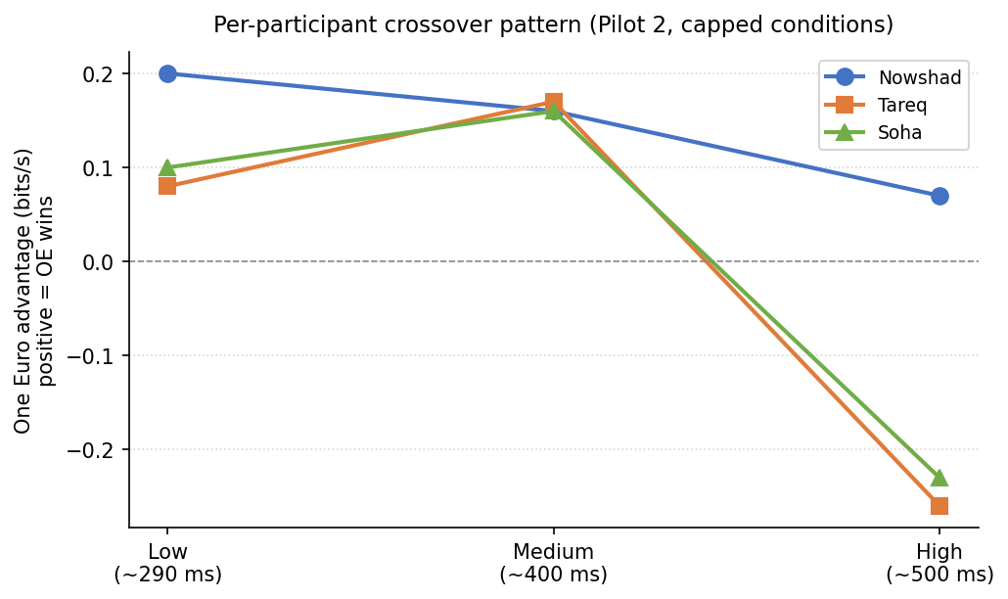
Pilot 2 Figure 2: Per-participant One Euro advantage across variance levels

How to read this:
- Each coloured line is one participant.
- Y-axis: One Euro advantage at each variance level (same numbers as the crossover table).
- X-axis: Low, Medium, High variance.
- A line going downward from left to right means: One Euro's advantage shrinks as jitter increases.

Say it like this: Each line is one person. All three lines start in positive territory on the left — everyone had better throughput with One Euro when jitter was low. All three lines slope downward as you move right — everyone's One Euro advantage shrank as jitter increased. Two lines crossed zero and went negative — for those two people, Exponential became better at high jitter. The third line just barely stayed positive. This consistent downward slope in all three lines is exactly what the interaction p = 0.033 is detecting. If lines went in random directions, no significance. Same direction in everyone — significant.

Quick reference: if Roberto asks...

Question | Answer
How did you get the advantage numbers? | For each person at each variance level: TP(One Euro) minus TP(Exponential). Positive means OE was faster. Average across people to get the bar height.
Why three different tests? | Each test treats the data differently. Bootstrap uses all trial data but makes no assumptions. t-test is most conservative (one number per person). LMM uses all trials and controls for covariates. If all three agree, the conclusion is much stronger than relying on one.
p = 0.88 — does that mean they are equal? | No. It means: with only 4 people we cannot detect a difference even if one exists. It is an underpowered test. The confidence interval tells the honest story: the true difference could be anywhere from -0.11 to +0.08 bits/s.
p = 0.018 but also no overall winner — how? | The p = 0.018 is One Euro's advantage at the low-jitter end only. Because the crossover flips things at high jitter, the overall average cancels out. The LMM and the bootstrap are measuring different things.
What does the interaction p = 0.033 mean? | It means: the filter advantage is not constant across jitter levels. Specifically, for each extra pixel of jitter, One Euro's advantage decreases by 0.039 log-MT units. At high jitter this flips sign. The crossover is real.
Why is Soha's throughput so high? | She built the system and has completed the full task at least 4 times plus development runs. Her Pilot 1 mean TP was 0.93 bits/s and Pilot 2 was 0.95 bits/s — essentially identical across two pilots with different conditions. That consistency across conditions proves it is a person-level skill effect, not an artifact. The LMM random intercept accounts for her higher baseline when estimating filter effects.

