Head-Pointing Filter Study
Pilot Update: 4 Participants
May 2026 | Sabiha Tahsin Soha | UC Santa Cruz

1. Changes since May 15
- Latency capped at 600 ms and jitter capped at 12 px (roughly 1% of the screen's limiting dimension): above these levels, pilot participants struggled to complete trials accurately. Both caps were added after the pilot to keep all conditions within a usable range.
- Three variance levels spaced by latency (~150 / 375 / 600 ms) so conditions feel distinct
- Calibration edge-check before each part : catches a bad calibration before trials start
- Practice block before real task so participants understand dwell-to-select
- 20-second per-trial timeout so a stuck trial cannot freeze the session
- Revised questionnaire with alternating positive/negative wording (scale: 1 = Completely Disagree, 5 = Completely Agree):

# | Statement | Polarity
1 | I felt it was very natural to move the cursor with my head | Positive
2 | I had to put a lot of effort to put the cursor into the target | Negative
3 | I think the cursor was following my head very accurately | Positive
4 | I think there was a lot of delay | Negative

Open-ended questions: "What is more important to you: a faster cursor or one with less jitter?" and "Any other thoughts or comments?"

2. Calibration bug (fixed)
Part B was not switching to the standard calibration file. All four pilot participants ran both parts with their own personal calibration, so the personal-vs-standard comparison could not be measured. The swap is now automatic. No experimenter action needed. The full study will produce real data for this comparison.

3. Pilot findings
4 participants is too small for firm conclusions. The pilot confirms the pipeline works, gives effect-size estimates, and shows two patterns worth testing at full scale.

3.1 No overall winner between the two filters
Three statistical tests were run on the same data. Each asks the same question in a different way: is there a meaningful throughput difference between One Euro and Exponential? All three say no.

Test | What it actually checks | Result | Says
Bootstrap  confidence interval | Re-sample the 4 participants 10,000 times. What range of filter differences is consistent with the data? If zero is inside the range, there is no clear winner. | [−0.107, +0.081]  bits/s | Zero is inside
Per-participant  t-test | Average each person to one number (most conservative, treats each person as one data point). Do those 4 averages point one way? | t = −0.16  p = 0.88 | No difference
Mixed model  (LMM) | After accounting for how hard the targets were and the latency of each condition, does filter type predict throughput? | −0.05 bits/s  p = 0.38 | No difference

The reason all three agree: the four participants split two-to-two. Professor and Aashritha averaged higher throughput with Exponential; Marzia and Soha averaged higher with One Euro. Their preferences cancel at the group level.

The confidence interval tells us where the true filter difference probably sits. With 4 participants it is wide: somewhere between One Euro being 0.11 bits/s worse and 0.08 bits/s better than Exponential. We cannot say which filter is ahead. At n = 24 this range should narrow to about ±0.04 bits/s, roughly 2% of typical task throughput. If zero is still inside that range, we can say the two filters are effectively equivalent overall, and the crossover by variance level becomes the more interesting finding.

3.2 Crossover: the winner changes with variance level
When split by variance level, a consistent pattern appears across 3 of 4 participants:

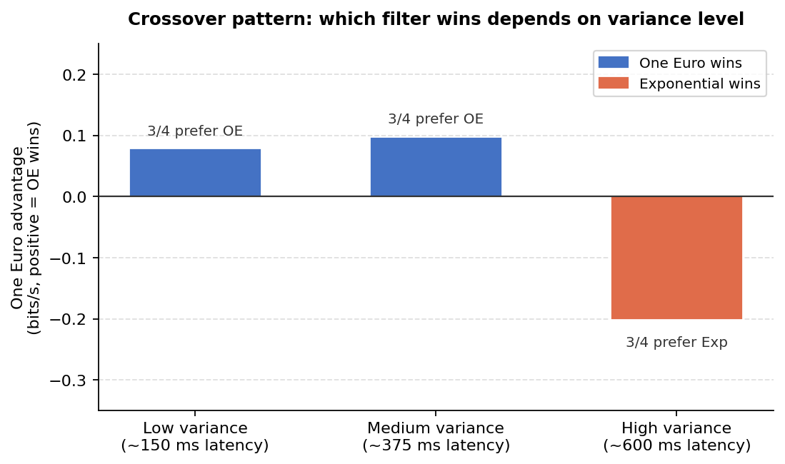
Figure 1. One Euro advantage (bits/s) at each variance level. Positive = One Euro wins; negative = Exponential wins. 3 of 4 participants follow this pattern.
Variance level | Winner | 3 of 4 participants? | Average gap
Low (~150 ms latency) | One Euro | Yes | +0.08 bits/s
Medium (~375 ms latency) | One Euro | Yes | +0.10 bits/s
High (~600 ms latency) | Exponential | Yes | −0.20 bits/s

One Euro works better at low jitter. Exponential works better at high jitter. The likely reason: One Euro's adaptive cutoff can over-correct when the signal is very noisy, adding unwanted lag on top of the original noise.

This crossover is the main pattern to investigate at n = 24. Effect size from the pilot = 0.81 (large). A power analysis based on this estimate suggests ~96% chance of detecting the crossover if it holds, but with only 4 participants as the basis this is a rough estimate, not a guarantee.

3.3 Same settings, very different jitter across people
The same filter settings produce very different cursor jitter depending on the participant:

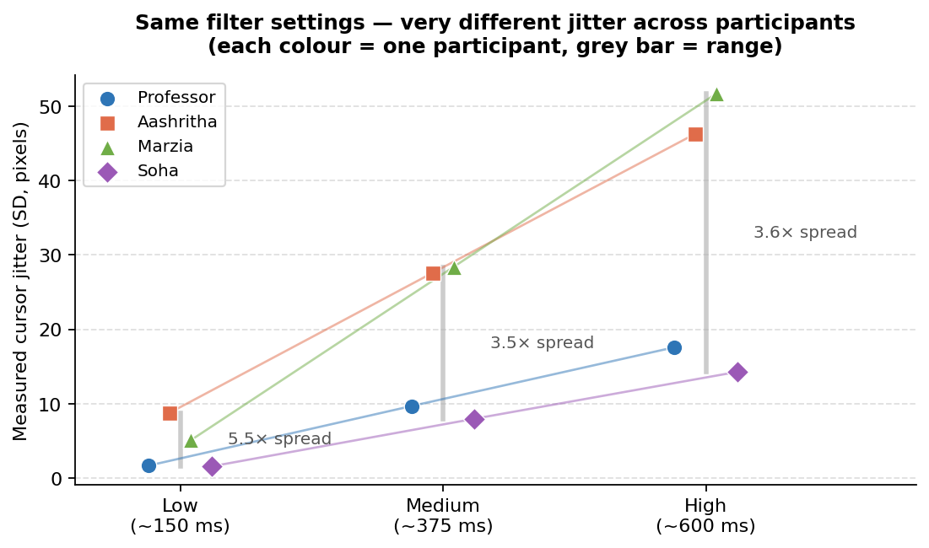
Figure 2. Cursor jitter (SD in pixels) per participant at identical filter settings. Each colour is one participant. At the Low condition, jitter ranges from 1.6 px to 8.8 px across four people using the exact same parameters.
Condition | Jitter range across 4 people | Spread
Low (~150 ms) | 1.6 px to 8.8 px | 5.4×
Medium (~375 ms) | 8 px to 28 px | 3.5×
High (~600 ms) | 14 px to 52 px | 3.6×

Note: the pilot was run before the jitter and latency caps were put in place, so the Medium and High numbers above will look different in the full study. The Low condition (1.6-8.8 px) is under the new cap and is the most reliable part of this data.

A single shared calibration gives one participant a clean signal and another a noisy one, from the same settings. This is why individual calibration matters. At n = 24, this will be visible as 24 Pareto curves spread across the variance-latency plane.

