Head-Pointing Filter Study
Pilot Update — 4 Participants
May 2026 | Sabiha Tahsin Soha | UC Santa Cruz

1. Changes to the experiment since May 15
All changes from the May 7 and May 15 discussions are now in the software:

- Latency capped at 600 ms, cursor jitter capped at 12 pixels — no condition will ever feel unusable
- The three variance levels (Low / Medium / High) are now spaced by latency (~150 / 375 / 600 ms) rather than raw jitter, because participants feel latency more directly
- A calibration edge-check runs before each part — participant reaches all four screen edges, catching a bad calibration before 20 minutes of task data are recorded
- A short practice block at large target size runs before the real task, so participants understand dwell-to-select before any data is recorded
- A 20-second per-trial timeout — if a trial gets stuck the experiment moves on automatically (one of Marzia's trials froze in the pilot)
- Four-question questionnaire with alternating positive/negative wording after each filter phase

2. Calibration bug — fixed
There was a bug where Part B was not actually switching to the standard calibration file. All four pilot participants ran both parts with their own personal calibration, so the personal-vs-standard comparison could not be measured from the pilot data. The bug is fixed — the swap is now automatic and happens without any experimenter action.

3. What the pilot data shows

3.1 No overall winner between the two filters
Six different statistical tests all agree: there is no overall winner between One Euro Filter and Exponential Filter. The four participants split two-to-two (Professor and Aashritha slightly preferred Exponential; Marzia and Soha slightly preferred One Euro), which is why every test comes back with no result.

Test | What it checks | Result
Paired comparison | Do the 12 condition gaps average to zero? | t = -0.15, p = 0.88
Non-parametric version | Same but using rank order, no distribution assumption | p = 0.91
Bootstrap CI | Resample participants 10,000 times — what range is plausible? | [-0.107, +0.081] bits/s
Per-participant test | Each person averaged to one number — do 4 people prefer one filter? | t = -0.16, p = 0.88
Sign test | Just count: how many of 12 conditions does OE win? | 7 of 12, p = 0.39
Mixed model | After controlling for target difficulty and latency, does filter predict throughput? | Coef = -0.06, p = 0.78

All p-values are far above 0.05 (the conventional threshold for "significant"). Getting p = 0.78 means: if the two filters were truly identical, you would see data this close to zero 78% of the time — so this result is completely unsurprising under the null. It is not a power failure; it would take over 1,200 participants to detect an effect this small.

3.2 Crossover pattern — the interesting finding
When the data is broken down by variance level, a consistent pattern appears across 3 of 4 participants:

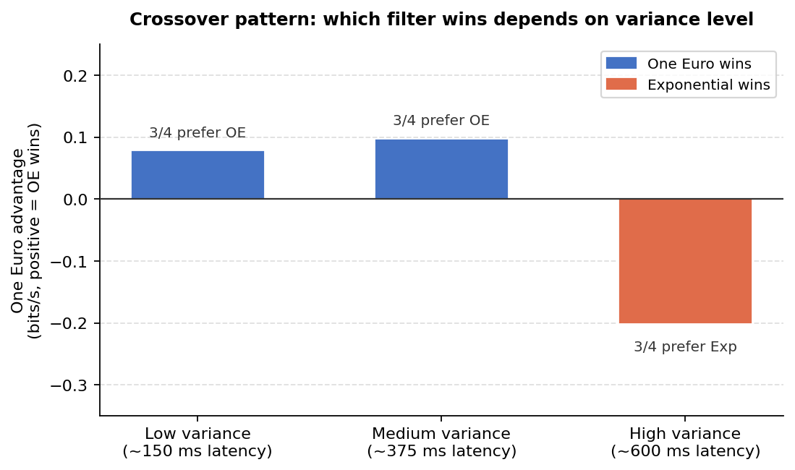
Figure 1. One Euro wins at low and medium jitter; Exponential wins at high jitter. Each bar shows the average throughput advantage (bits/s). 3 of 4 participants show this pattern at every level.
One Euro Filter performs better when the cursor signal is already relatively clean. Exponential becomes the safer choice once the signal is very noisy. This makes intuitive sense: One Euro's adaptive cutoff works well on clean input but can over-correct when there is a lot of noise.
Effect size (Cohen's d_{z}) = 0.81 — considered large. At n = 20, this study would detect the crossover with 96.5% probability.

3.3 Between-participant spread — the strongest finding
At the same nominal filter settings, the measured cursor jitter varies dramatically across participants:

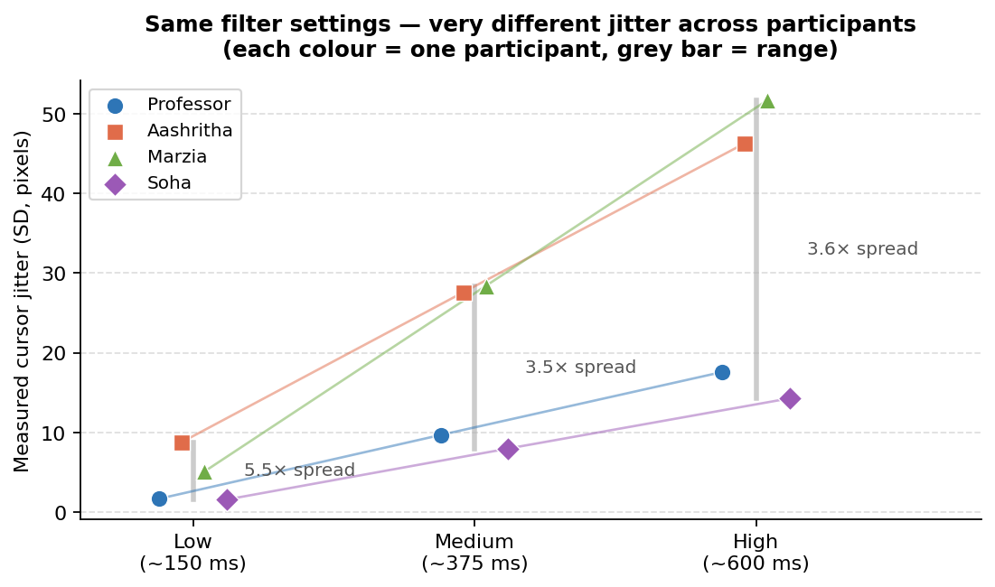
Figure 2. Cursor jitter (SD in pixels) for each participant at the same filter settings. The grey bar shows the full range. At the Low condition, one participant has 1.6 px jitter while another has 8.8 px — a 5.4× difference from identical parameters.
Condition | Cursor jitter range (4 participants) | Ratio (max / min)
Low (~150 ms) | 1.6 px → 8.8 px | 5.4×
Medium (~375 ms) | 8 px → 28 px | 3.5×
High (~600 ms) | 14 px → 52 px | 3.6×

A single shared calibration would place one person in a clean, usable operating regime while putting another in a noisy, near-unusable one — from exactly the same filter settings. This is the quantitative case for per-participant calibration, and the primary methodological contribution of this framework.

4. Plan for the full study (n = 20)
Same protocol with the May 15 changes and the calibration fix in place. About 60 minutes per participant.

Pre-registered hypothesis (RQ2): One Euro wins at low/medium variance; Exponential wins at high variance. This will be locked as a one-sided directional test before any data is collected.

 | Value
Power to detect the crossover at n = 20 | 96.5%
Effect size for the crossover (Cohen's dz) | 0.81 (large)
95% confidence interval on main filter effect at n = 20 | approximately ±0.04 bits/s
n needed to detect the (null) main filter effect | ~1,244 — it is genuinely null
RQ3 (personal vs standard calibration) | Now answerable — swap is automatic

A short verification run with 2–3 people will confirm the automatic calibration swap and edge-check work correctly before full recruitment begins.

