Head-Pointing Filter Study
Pilot Update — 4 Participants
May 2026 | Sabiha Tahsin Soha | UC Santa Cruz

1. Changes to the experiment since May 15
All changes from the May 7 and May 15 discussions are now in the software:

- Latency capped at 600 ms and cursor jitter at 12 pixels — no condition will ever feel unusable
- The three variance levels (Low / Medium / High) are now spaced by latency (~150 / 375 / 600 ms) rather than raw pixel jitter, because participants feel latency more directly
- Calibration edge-check before each part — participant reaches all four screen edges; catches a bad calibration before 20 minutes of task data are recorded
- Short practice block at large target size before the real task, so participants understand dwell-to-select before any data is recorded
- 20-second per-trial timeout — if a trial gets stuck the experiment moves on automatically (one of Marzia's trials froze in the pilot)
- Four-question questionnaire with alternating positive/negative wording after each filter phase

2. Calibration bug — fixed
There was a bug where Part B was not switching to the standard calibration file. All four pilot participants ended up running both parts with their own personal calibration, so the personal-vs-standard comparison could not be measured from the pilot data. The swap is now automatic — it happens without any experimenter action — and will produce real data in the full study.

3. What the pilot data shows
This is a 4-person pilot, so the numbers are not definitive. The goal was to confirm the pipeline runs end-to-end, get effect-size estimates for powering the full study, and spot any patterns worth testing at larger scale. Three things came out clearly.

3.1 No overall winner between the two filters
The central question is whether One Euro Filter or Exponential Filter produces higher pointing throughput (bits per second) for head-pointer users. The short answer from the pilot: neither filter is consistently better overall.

To make sure this conclusion is robust and not an artefact of any single statistical method, six completely different tests were run on the same data. They all ask the same question in different ways — does switching between filters change throughput? — and they all come back with the same answer: no.

Test | What it actually checks (plain English) | Result | Conclusion
Paired comparison | For each of the 12 conditions, subtract Exponential from One Euro. Do those 12 gaps average to something other than zero? | t = -0.15, p = 0.88 | No
Non-parametric version | Same question but using rank order instead of raw numbers — makes no assumption about how data are distributed | p = 0.91 | No
Bootstrap confidence interval | Re-sample the 4 participants 10,000 times. What range of filter differences is consistent with the data? | [-0.107, +0.081] bits/s | Zero is inside the range
Per-participant test | Reduce each person to a single average. Do 4 people consistently prefer one filter? | t = -0.16, p = 0.88 | No
Sign test | Just count: how many of the 12 conditions does One Euro win? (no maths, just counting) | 7 of 12, p = 0.39 | Not more than chance
Mixed model | After accounting for how hard the targets were and the latency of each condition, does filter type predict throughput? | Coefficient = -0.06 bits/s, p = 0.78 | No

The reason all six agree is simple: the four participants split two-to-two. Professor and Aashritha averaged slightly higher throughput with Exponential; Marzia and Soha averaged slightly higher with One Euro. Those preferences cancel each other out when you look at the group average.

This is not a failure to find a result — it is a result. It says filter choice alone does not determine performance. What matters is the operating point: which variance level you are in. That is where the more interesting pattern appears.
At n = 20, the 95% confidence interval on the filter gap will narrow to roughly ±0.04 bits/s. That is tight enough to say with confidence: even if one filter has an advantage, it is smaller than 5% of typical head-pointer throughput — practically irrelevant for real use.

3.2 Crossover pattern — the candidate finding for n = 20
When the data is broken down by variance level rather than averaged across all conditions, a consistent pattern appears in 3 of 4 participants:

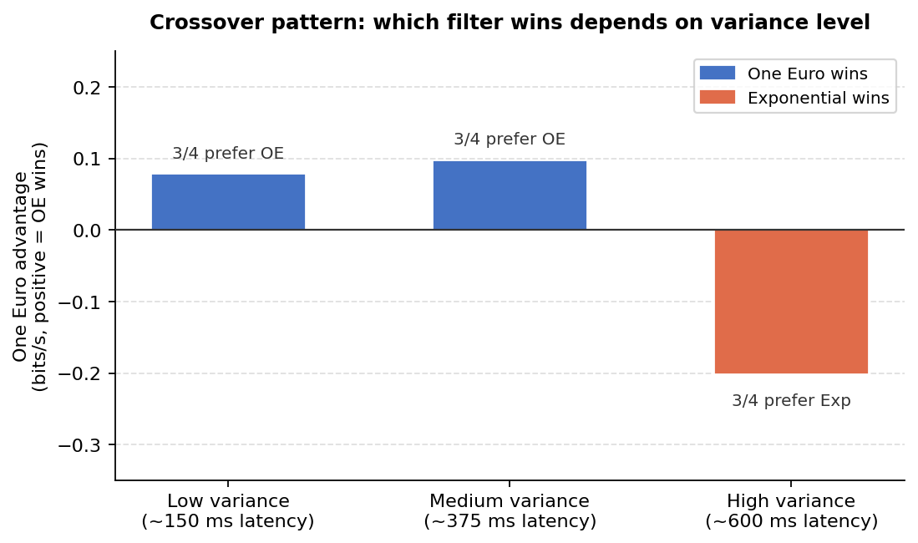
Figure 1. Average throughput advantage of One Euro over Exponential (bits/s) at each variance level. Positive = One Euro wins; negative = Exponential wins. 3 of 4 participants show this crossover direction at every level.
Variance level | Who wins? | How many of 4 participants? | Average gap | Effect size
Low (~150 ms latency) | One Euro Filter | 3 of 4 | +0.08 bits/s | dₑ = 0.79
Medium (~375 ms latency) | One Euro Filter | 3 of 4 | +0.10 bits/s | dₑ = 0.87
High (~600 ms latency) | Exponential Filter | 3 of 4 | -0.20 bits/s | dₑ = 0.81

One Euro Filter performs better when the cursor signal is relatively clean. Exponential Filter becomes the safer choice once the signal is very noisy. The likely reason is how One Euro works: its adaptive cutoff responds well to clean input but can over-correct when the signal contains a lot of noise, adding unwanted lag or jitter on top of the original signal.

The effect size for the High-variance crossover is 0.81, which is considered large by conventional standards (anything above 0.8 is large). Translated into a practical question: at n = 20, a study would detect this crossover with 96.5% probability if it is real. That is well above the 80% threshold conventionally required.

The crossover is the pre-registered hypothesis for the full study. Before recruiting, the exact prediction — One Euro wins at Low/Medium, Exponential wins at High — will be locked in an OSF pre-registration document. If the crossover replicates at n = 20, it tells practitioners: choose your filter based on where your personal calibration places you on the variance-latency curve, not on a group average.

3.3 Between-participant spread — the headline finding
Separate from the filter comparison, the analysis measured the cursor jitter each participant actually produced at each operating point. The result is the strongest finding in the pilot, and the primary argument for the calibration framework:

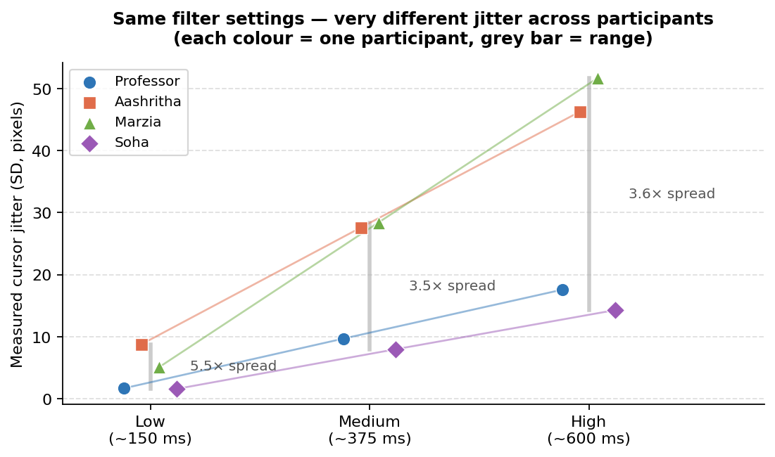
Figure 2. Measured cursor jitter (SD in pixels) per participant at each variance level, using identical filter settings. Each colour is one participant. The grey bar spans the full range across participants. The spread is 3.5–5.4× at every level.
Condition | Cursor jitter — range across 4 people | Ratio (max / min)
Low (~150 ms) | 1.6 px to 8.8 px | 5.4×
Medium (~375 ms) | 8 px to 28 px | 3.5×
High (~600 ms) | 14 px to 52 px | 3.6×

At the Low condition, one participant has 1.6 pixels of cursor jitter and another has 8.8 pixels — from exactly the same filter parameters. That is a 5.4× difference. The same filter setting that gives one person a clean, usable operating point puts another person in a noticeably noisy regime.

This matters because it means a single shared calibration — one set of filter parameters applied to every participant — will work well for some people and poorly for others, not because the filter is wrong, but because people's head-movement profiles differ in ways that interact strongly with filter parameters. The only way to give every participant a comparable experience is to calibrate individually.

This between-participant spread is the quantitative, empirical backbone of the personal-calibration methodology. It will be even more striking with 20 participants: 20 Pareto curves overlaid in a single figure, each person in a different position on the variance-latency plane despite using identical filter settings. That image is the paper's lead figure.

3.4 Other observations
Two smaller findings worth noting:

- Subjective ratings partly track objective performance. After each filter phase, participants rated comfort and control. Spearman correlation between subjective rating and objective throughput averaged +0.35 across the eight participant-filter pairs, and was positive in 6 of 8. People can partially feel which filter is helping them, but the relationship is inconsistent enough that questionnaire data cannot replace the objective measure.
- Vertical targets take about 21% longer than horizontal ones. Up and down movements are slower than left/right for all four participants. This is consistent with neck biomechanics and is part of why the calibration edge-check is now mandatory — under-calibrated vertical range penalises every upward and downward trial.

4. Plan for the full study (n = 20)
Same protocol with all the changes above in place. Approximately 60 minutes per participant. A short verification run with 2–3 people will confirm the automatic calibration swap and edge-check work correctly before full recruitment.

 | Value
Power to detect the crossover at n = 20 | 96.5% (one-tailed, α = 0.05)
Effect size for crossover (Cohen’s dz) | 0.81 (large)
95% CI on filter main effect at n = 20 | ±0.04 bits/s (precise null)
Main filter effect at n = 20 | CI will be ±0.04 bits/s — tight enough to confirm negligible difference
RQ1 (main filter effect) | Expected: confirm the null with tight CI
RQ2 (filter × variance crossover) | Pre-registered one-sided test — high power
RQ3 (personal vs standard calibration) | Now answerable with the automatic swap fix

Before recruiting, the model formula, crossover hypothesis, exclusion criteria, and stopping rule (n = 20, max 25) will be locked in an OSF pre-registration.

