Om Makwana

om.makwana@einfochip.com

ommakwana07@gmail.com

**Assignment 2**

Created repository in GitHub.

1. Pushed a text file to a master branch(default branch) & initialized a local repository to the created repo at GitHub.

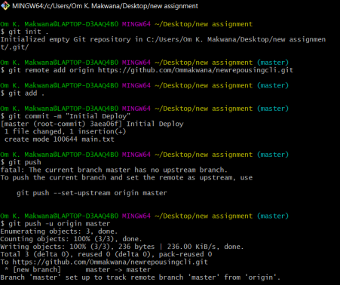

2. Pushed the local repository to remote one and checked the status.

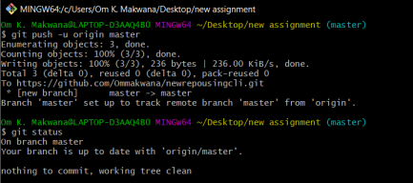

3. Created a new branch called **feature-one** and checked out to that new created branch. 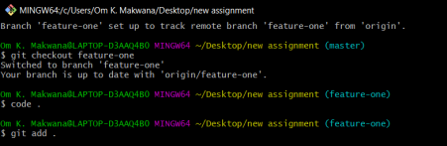

4. Edited the file & pushed the **master** branch code to the new created branch **feature-one.**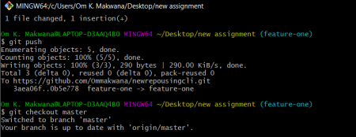

5. Checkout to **master** branch and pulled the code from new branch called **feature-one** & pushed the code(merging of the branches **master** & **feature-one**).

