Author – om makwana
Linux Internals – Process Assignment
PES – Shift 1, Track 2

// 1.Test whether the process(exec() system call) that replaces old program data , will inherit the fds or not.

#include<stdio.h>
#include<unistd.h>

int main(){
printf("I'm going to print the process tree on terminal\n");
int ret = execl("/home/axay/LINUX-INTERNALS/10-3-2022/prob3", "", 0);
if(ret == -1){
printf("execl returned error %d\n", ret);
}
return 0;
}

//to check that FD is inherited or not…
#include <sys/types.h>
#include <sys/stat.h>
#include <fcntl.h>
#include <unistd.h>
#include <stdlib.h>
#include <stdio.h>

int main(){
int fd;
fd = open("/home/axay/LINUX-INTERNALS/10-3-2022/prob2", O_RDONLY, 777);
printf("file descriptor of a open system call is %d\n", fd);
return 0;
}

Output:
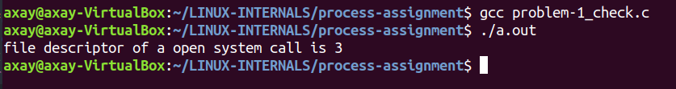

// 2.Write a program such that parent process create two child processes,such that
// each child executes a separate task.

#include <stdio.h>
#include <fcntl.h>
#include <sys/types.h>
#include <sys/stat.h>
#include <unistd.h>
#include <stdlib.h>

int main()
{
int pid1, pid2, pid3;
printf("\nparent process is:%d\n", getpid());
pid1 = fork();
if (pid1 == 0)
{
printf("\n1st child is:%d\n", getpid());
}
else
{
printf("\n2nd child is:%d\n", getpid());
pid2 = fork();
if (pid2 == 0)
{
// execl("/usr/bin/pstree","pstree",NULL);
printf("successfully run execl() for child process 1\n");
}
else
{
// wait(0);
printf("failed to run execl() for child process 1\n");
}
wait(0);
pid3 = fork();
if (pid3 == 0)
{
// execl("/usr/bin/vim","vim","txt3.txt",NULL);
printf("successfully run execl() for child process 2\n");
}
else
{
// wait(0);
printf("failed to run execl() for child process 2\n");
}
}
exit(0);
return 0;
}
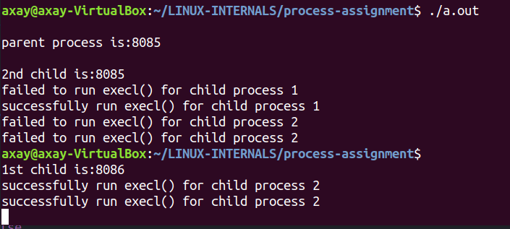

// 3. A program that replaces old program with new program data and is expected to display
// the currently running processes in a hierarchical tree format.

#include<stdio.h>
#include<unistd.h>

int main(){
printf("I'm going to display a process tree\n");
// int ret = execl("/usr/bin/vim", "vim","info1.txt", 0);
int ret = execl("/usr/bin/pstree", "pstree", 0, 0);
if(ret == -1){
printf("execl returned error %d\n", ret);
}
return 0;
}

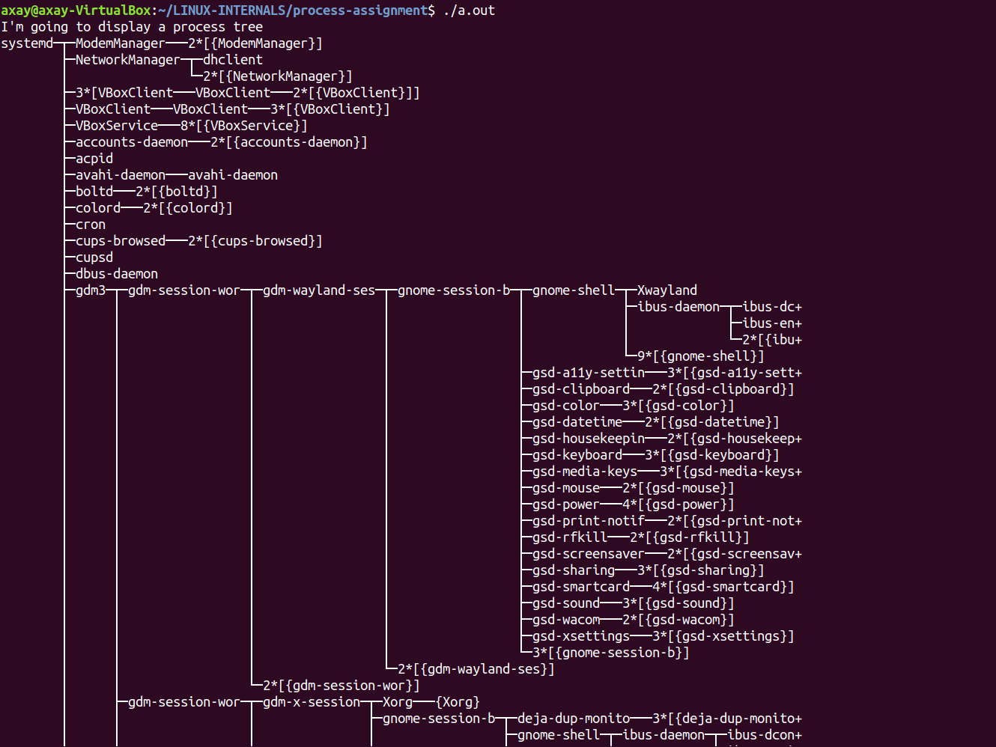

// 4.A processs using execl() system call should replace a new command line program.

#include<stdio.h>
#include<stdlib.h>
#include<unistd.h>

int main(int argc, char* argv[]){
// int ret = execl("/usr/bin/vim", "vim","info1.txt", 0);
int ret = execl(argv[1], argv[2],argv[3], 0);
if(ret == -1){
printf("execl returned error %d\n", ret);
}
return(0);
}

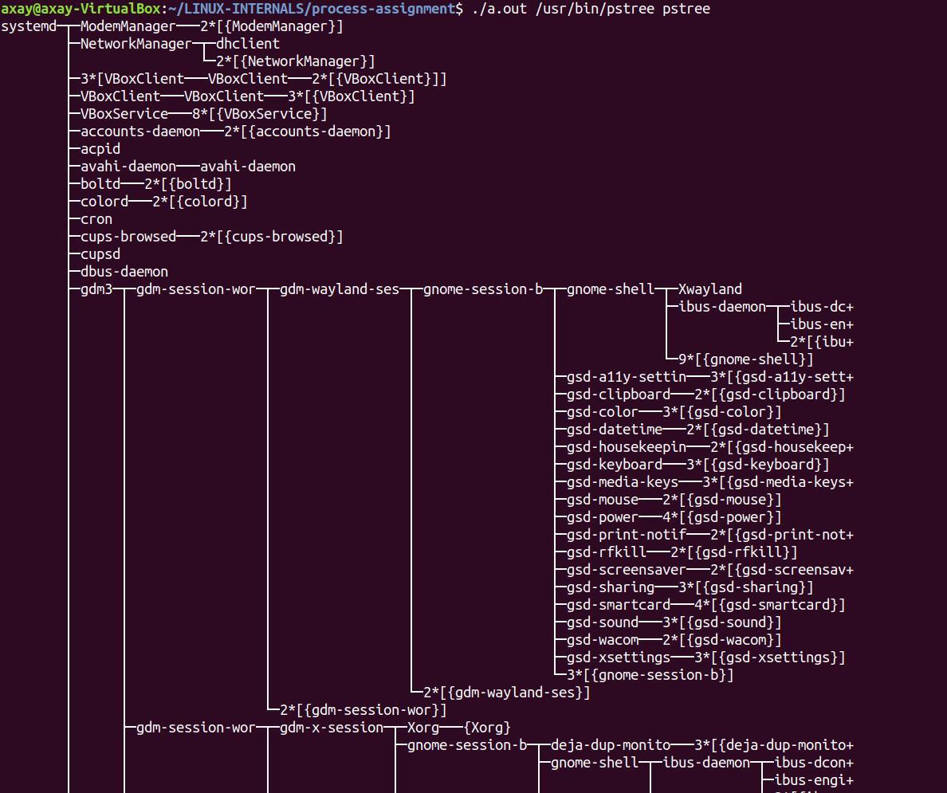

// 5(a).Write a program parent process wait untill ,while child process open a file and read file
// data into empty buffer.

#include <sys/types.h>
#include <sys/stat.h>
#include <fcntl.h>
#include <unistd.h>
#include <stdlib.h>
#include <stdio.h>

int main(){

int pid, fd;

pid = fork();
if(pid==0){
// run this as s child process
fd = open("linux400.txt", O_CREAT | O_RDWR, 777);
char to_write[] = "this lines will be added to file. this one is also be added";
int leng = strlen(to_write);
char to_read[leng];
int i;
if (fd>0){
if((i = write(fd, to_write, leng)) < 0){
perror("error occured while writing to a file");
}
}
read(fd, to_read, leng);
} else{
// run this as a parent process
wait(0);
printf("parent process\n");
}
return 0;
}
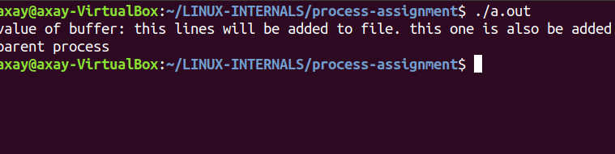

// 5(b).Write a program, where functions of the program are called in the reverse order of
// their function calls from main().

#include<stdio.h>
#include<stdlib.h>

void callBack1(){
printf("callback 1\n");
}
void callBack2(){
printf("callback 2\n");
}
void callBack3(){
printf("callback 3\n");
}

int main(){
printf("registering callback1\n");
atexit(callBack1);
printf("registering callback2\n");
atexit(callBack2);
printf("registering callback3\n");
atexit(callBack3);
printf("exit() main exiting now...\n");
exit(0); //_exit() is not calling the functions which are previously registered using atexit function
}

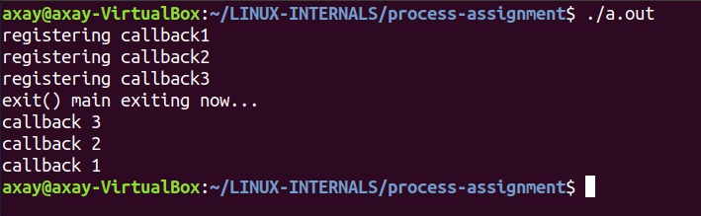

// 6. Write a program child executes(exec()) a new program , while parent waits for
// child task to get complete.

#include <sys/types.h>
#include <sys/stat.h>
#include <fcntl.h>
#include <unistd.h>
#include <stdlib.h>
#include <stdio.h>

int main(){

int pid;

pid = fork();
if(pid==0){
// run this as s child process
printf("this is a child process\n");
printf("new child Process pid = %d\n", getpid());
printf("new child Parent Process pid = %d\n", getppid());
int ret = execl("/usr/bin/vim", "vim","info1.txt", 0);
// int ret = execl("/bin/ls", "ls", 0);
} else{
// run this as a parent process
wait(0);
printf("this is a parent process\n");
printf("parent Process pid = %d\n", getpid());
printf("child Parent's parent Process pid = %d\n", getppid());
}
while(1);
return 0;
}

