SQL Solved Assignments

4.Aggregation using functions

**Q 43**. Generate report showing total number of employees.

**Query**:

use employees;

select count(emp_no) from employees;

**Result:**



**Q 44**. Generate report showing total number of transactions at store 2.

**Query**:

use retail;

select * from tran_hdr where store_id='2';

**Result:**

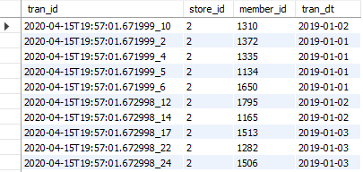

**Q 45**. Generate report showing average price for baked goods category.

**Query**:

use retail;

select AVG(price) from product where category='Baked goods';

**Result:**



**Q 46**. -- Generate report showing number of employees born in year 1960.

**Query**:

use employees;

select count(*) as total from employees where year(birth_date)='1960'

**Result:**



**Q 47**. Generate report showing min price for beverages category.

**Query**:

use retail;

select min(price) from product where category='Beverages' group by price;

**Result:**

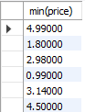

**Q 48**. -- Generate report showing max price for frozen category.

**Query**:

use retail;

select max(price) from product where category='frozen' group by price;

**Result:**

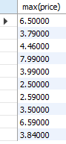

**Q 49**. Generate report showing total amount of sales for transaction date '2019-01-03'.

**Query**:

select tran_id,tran_dt,sum(amt)

as total from tran_dtl

where tran_dt='2019-01-03'

group by tran_id;

**Result:**

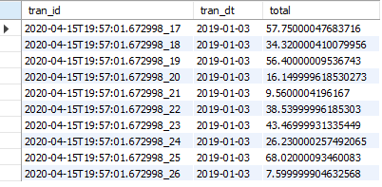

**Q 50**. Generate report showing average price of all products.

**Query**:

use retail;

select product_id,avg(price) from product group by product_id;.

**Result:**

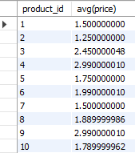

**Q 51**. Generate report showing number of members.

**Query**:

select count(member_id) from member;

**Result:**



**Q 52**. Generate report showing total number of employees.

**Query**:

use employees;

select count(emp_no) from employees;

**Result:**



**Q 53**. -- Generate report showing total salary withdrawn by all employees.

**Query**:

use employees;

select emp_no,AVG(salary) as total_salaries from salaries group by emp_no;

**Result:**

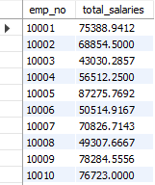

**Q 54**. Generate report showing average salary of employee.

**Query**:

use employees;

select avg(salary) as average_salary from salaries;

**Result:**



**Q 55**. -- Generate report showing maximum salary withdrawn.

**Query**:

select max(salary) as maximum_salary from salaries;

**Result:**



**Q 55**. Generate report showing minimum salary withdrawn.

**Query**:

select min(salary) as minimum_salary from salaries;

**Result:**

