SQL Solved Assignments

3.Report generation

**Q 28**. Display emp_id, first name for employees on the report

**Query**:

use employees;

select emp_no,first_name from employees;

**Result:**

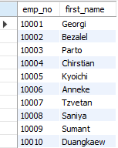

**Q 29**. Generate a report that shows all products all columns

**Query**:

use retail;

select * from product;

**Result:**

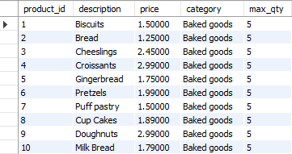

**Q 30**. Generate a report that shows product_id, description, category for all products belonging to any two categories

**Query**:

use retail;

SELECT product_id,description,category FROM product

WHERE category IN ("Baked Goods", "Dairy");

**Result:**

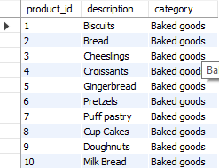

**Q 31**. Insert 3 products to product table with description field as empty

**Query**:

use retail;

insert into product values

('101','',5,'indian','4'),

('102','',4,'indian','5'),

('103','',2,'indian','3');

**Result:**

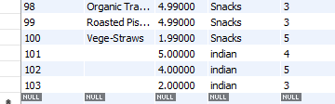

**Q 32**. -Generate a report that shows product_id, description for all products.

**Query**:

use retail;

SELECT product_id,description,category FROM product;

**Result:**

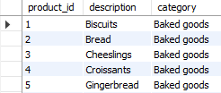

**Q 33**. Generate report showing all details of employees table.

**Query**:

use employees;

select * from employees;

**Result:**

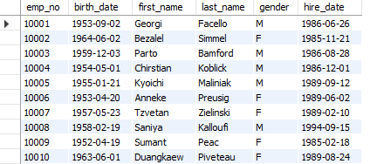

**Q 34**. Generate report showing all details of salaries table.

**Query**:

use employees;

select * from salaries;.

**Result:**

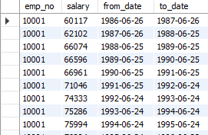

**Q 35**. Generate report showing all details of departments table.

**Query**:

use employees;

select * from departments;

**Result:**

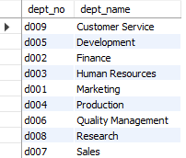

**Q 36**. Generate report showing all details of dept_emp table

**Query**:

select * from dept_emp;

**Result:**

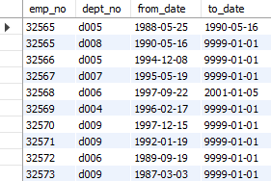

**Q 37**. Generate report showing all details of titles table.

**Query**:

select * from titles;

**Result:**

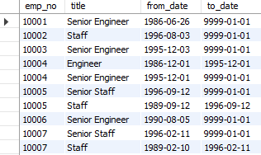

**Q 38**. Generate report showing member_id,first_name and last_name from member table.

**Query**:

use retail;

select member_id,first_name,last_name from member;

**Result:**

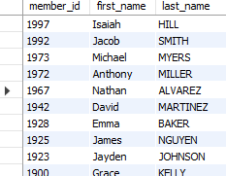

**Q 39**. -- Generate report showing member_id , reg_date and reg_store from member table.

**Query**:

use retail;

select member_id,reg_date,store_id from member;.

**Result:**

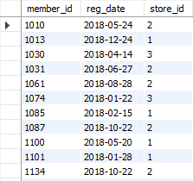

**Q 40**. Generate report showing product_id , description,price from product table.

**Query**:

use retail;

select product_id,description,price from product;

**Result:**

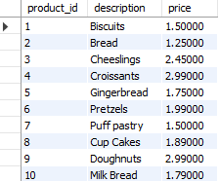

**Q 41**. Generate report showing tran_id , qty and amt from tran _dtl table.

**Query**:

use retail;

select tran_id,qty,amt from tran_dtl;

**Result:**

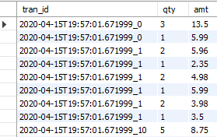

**Q 42**. -- Generate report showing tran_id, member_id, store_id and tran_dt from tran_hdr table.

**Query**:

use retail;

select tran_id, member_id, store_id, tran_dt from tran_hdr;

**Result:**

