 | DEPARTMENT OF COMPUTER ENGINEERING
PBLE Report
Semester | S.E. Semester III – Computer Engineering
Subject | Analysis of Algorithm
Subject Professor In-charge | Dr. Swapnil S. Sonawane

Roll Number: | Name of Students :
26102B2008 | Om Kailash Gavali

Name of the Project:
Campus Shortest Route Finder - Dijkstra’s Algorithm (PBLE 2)
Project Description:

The Campus Shortest Route Finder is a menu-driven C program that models a college campus as a weighted graph. Locations such as the Main Gate, Library, Computer Department, Laboratory and Auditorium are the vertices, and the roads between them are the edges, with the road length as the weight. The graph is stored as an adjacency matrix (0 on the diagonal and INF = 9999 where there is no direct road). The user selects a source location, and the program uses Dijkstra’s Greedy Algorithm to find the shortest distance from that source to every other location. A parent (predecessor) array is maintained so that the actual shortest path to each destination can be reconstructed and displayed. The program also shows the intermediate steps of the algorithm, validates menu choices and rejects negative distances.
Algorithm (Greedy Method):
1. Set dist[source] = 0 and dist[v] = INF for all other vertices; mark all vertices as unvisited and set parent[v] = -1.
2. Pick the unvisited vertex u with the smallest dist[u] and mark it visited (its shortest distance is now final).
3. For every unvisited neighbour v of u, if dist[u] + graph[u][v] < dist[v], update dist[v] and set parent[v] = u (relaxation).
4. Repeat steps 2 and 3 until all reachable vertices are visited.
5. Reconstruct each path by following the parent[] array from the destination back to the source.
Time Complexity: O(V²), where V is the number of locations. The outer loop runs V times, and in each iteration finding the minimum-distance unvisited vertex takes O(V) and relaxing the neighbours using the adjacency matrix takes another O(V), giving V × O(V) = O(V²). Space complexity is O(V²) for the adjacency matrix.
Test Case (sample campus, source = Main Gate):
Roads (km): Main Gate–Library 4, Main Gate–Computer Dept 8, Main Gate–Laboratory 10, Library–Computer Dept 3, Library–Laboratory 7, Computer Dept–Laboratory 2, Computer Dept–Auditorium 6, Laboratory–Auditorium 3.
Output: Library = 4 (Main Gate → Library); Computer Department = 7 (Main Gate → Library → Computer Department); Laboratory = 9 (Main Gate → Library → Computer Department → Laboratory); Auditorium = 12 (Main Gate → Library → Computer Department → Laboratory → Auditorium).
Project Code:
/*
* PBLE 2: Campus Shortest Route Finder - Dijkstra's Algorithm
* Subject : Analysis of Algorithms (AOA)
*
* A menu-driven C program that stores a campus road network as an
* adjacency matrix and finds the shortest distance (and path) from a
* selected source location to every other location using Dijkstra's
* Greedy Algorithm.
*
* Time Complexity : O(V^2) (adjacency matrix + linear search for min)
* Space Complexity: O(V^2) (adjacency matrix)
*/

#include <stdio.h>
#include <stdlib.h>

#define MAX 10 /* maximum number of locations */
#define INF 9999 /* value used when there is no direct road */
#define NAME_LEN 30 /* maximum length of a location name */

/* ---------- Global data ---------- */
char names[MAX][NAME_LEN]; /* location names */
int graph[MAX][MAX]; /* adjacency matrix of road distances */
int dist[MAX]; /* dist[i] = shortest distance found */
int parent[MAX]; /* parent[i] = previous vertex on path */
int visited[MAX]; /* 1 if shortest distance is final */
int n = 0; /* number of locations */
int source = -1; /* selected source location (0-based) */

int graphEntered = 0; /* flag: graph has been entered */
int sourceSelected = 0; /* flag: source has been selected */
int distComputed = 0; /* flag: Dijkstra has been executed */

/* ---------- Safe integer input (handles non-numeric input) ---------- */
int readInt(const char *prompt)
{
int x, c;
printf("%s", prompt);
while (scanf("%d", &x) != 1)
{
while ((c = getchar()) != '\n' && c != EOF);
if (c == EOF)
exit(0);
printf("Invalid input! Please enter a number: ");
}
return x;
}

/* ---------- Load the sample campus from the problem statement ---------- */
void loadSampleGraph()
{
int i, j;
n = 5;

sprintf(names[0], "Main Gate");
sprintf(names[1], "Library");
sprintf(names[2], "Computer Department");
sprintf(names[3], "Laboratory");
sprintf(names[4], "Auditorium");

for (i = 0; i < n; i++)
for (j = 0; j < n; j++)
graph[i][j] = (i == j) ? 0 : INF;

/* roads are two-way, so the matrix is symmetric */
graph[0][1] = graph[1][0] = 4; /* Main Gate - Library */
graph[0][2] = graph[2][0] = 8; /* Main Gate - Computer Department */
graph[0][3] = graph[3][0] = 10; /* Main Gate - Laboratory */
graph[1][2] = graph[2][1] = 3; /* Library - Computer Department */
graph[1][3] = graph[3][1] = 7; /* Library - Laboratory */
graph[2][3] = graph[3][2] = 2; /* Comp. Dept - Laboratory */
graph[2][4] = graph[4][2] = 6; /* Comp. Dept - Auditorium */
graph[3][4] = graph[4][3] = 3; /* Laboratory - Auditorium */
}

/* ---------- Menu 1: Enter campus graph ---------- */
void enterGraph()
{
int i, j, d, choice;

choice = readInt("\nLoad sample campus data? (1 = Yes, 0 = Enter manually): ");

if (choice == 1)
{
loadSampleGraph();
}
else
{
n = readInt("Enter number of locations (2 to 10): ");
while (n < 2 || n > MAX)
n = readInt("Invalid! Enter number of locations (2 to 10): ");

for (i = 0; i < n; i++)
{
printf("Enter name of location %d: ", i + 1);
scanf(" %29[^\n]", names[i]);
}

/* diagonal = 0, everything else = INF until a road is entered */
for (i = 0; i < n; i++)
for (j = 0; j < n; j++)
graph[i][j] = (i == j) ? 0 : INF;

printf("\nEnter road distances (enter -1 if there is no direct road)\n");
for (i = 0; i < n; i++)
{
for (j = i + 1; j < n; j++)
{
printf("Distance between %s and %s: ", names[i], names[j]);
d = readInt("");
while (d < -1)
{
printf("Negative distances are not allowed!\n");
d = readInt("Re-enter distance (-1 for no road): ");
}
if (d >= 0)
graph[i][j] = graph[j][i] = d;
}
}
}

graphEntered = 1;
sourceSelected = 0;
distComputed = 0;
source = -1;
printf("\nCampus graph stored successfully (%d locations).\n", n);
}

/* ---------- Print the list of locations ---------- */
void displayLocations()
{
int i;
printf("\nNo. Location\n");
printf("---------------------------\n");
for (i = 0; i < n; i++)
printf("%-4d %s\n", i + 1, names[i]);
}

/* ---------- Menu 2: Display adjacency matrix ---------- */
void displayMatrix()
{
int i, j;

displayLocations();

printf("\nAdjacency Matrix (INF = %d means no direct road)\n\n", INF);
printf(" ");
for (j = 0; j < n; j++)
printf("%6d", j + 1);
printf("\n ");
for (j = 0; j < n; j++)
printf("------");
printf("\n");

for (i = 0; i < n; i++)
{
printf("%4d |", i + 1);
for (j = 0; j < n; j++)
{
if (graph[i][j] == INF)
printf("%6s", "INF");
else
printf("%6d", graph[i][j]);
}
printf("\n");
}
}

/* ---------- Menu 3: Select source location ---------- */
void selectSource()
{
int choice;

displayLocations();
choice = readInt("\nEnter source location number: ");
while (choice < 1 || choice > n)
choice = readInt("Invalid location! Enter a valid location number: ");

source = choice - 1;
sourceSelected = 1;
distComputed = 0;
printf("\nSelected source location: %s\n", names[source]);
}

/* ---------- Print current distance array (intermediate result) ---------- */
void printDistances()
{
int i;
printf(" Current distances: ");
for (i = 0; i < n; i++)
{
if (dist[i] == INF)
printf("[%d]=INF ", i + 1);
else
printf("[%d]=%d ", i + 1, dist[i]);
}
printf("\n");
}

/* ---------- Menu 4: Dijkstra's algorithm ---------- */
void dijkstra()
{
int i, count, u, v, min;

/* Step 1: initialisation */
for (i = 0; i < n; i++)
{
dist[i] = INF;
parent[i] = -1;
visited[i] = 0;
}
dist[source] = 0;

printf("\n--- Dijkstra's Algorithm (Source: %s) ---\n", names[source]);
printf("Initial distances set: source = 0, all others = INF\n\n");

/* Step 2: repeat n times - pick the nearest unvisited vertex */
for (count = 0; count < n; count++)
{
u = -1;
min = INF;

for (v = 0; v < n; v++)
{
if (!visited[v] && dist[v] < min)
{
min = dist[v];
u = v;
}
}

if (u == -1) /* remaining vertices are unreachable */
break;

visited[u] = 1;
printf("Step %d: Pick '%s' (shortest distance = %d)\n",
count + 1, names[u], dist[u]);

/* Step 3: relax all edges going out of u */
for (v = 0; v < n; v++)
{
if (!visited[v] && graph[u][v] != INF &&
dist[u] + graph[u][v] < dist[v])
{
dist[v] = dist[u] + graph[u][v];
parent[v] = u;
printf(" Update '%s': distance = %d (via '%s')\n",
names[v], dist[v], names[u]);
}
}
printDistances();
printf("\n");
}

distComputed = 1;
printf("Shortest distances calculated successfully.\n");
printf("Time Complexity: O(V^2), V = %d\n", n);
}

/* ---------- Recursively print path using parent[] ---------- */
void printPath(int v)
{
if (parent[v] == -1)
{
printf("%s", names[v]);
return;
}
printPath(parent[v]);
printf(" -> %s", names[v]);
}

/* ---------- Menu 5: Display shortest paths ---------- */
void displayPaths()
{
int i;

printf("\nSource: %s\n\n", names[source]);
printf("%-22s %-10s %s\n", "Destination", "Distance", "Shortest Path");
printf("-------------------------------------------------------------------\n");

for (i = 0; i < n; i++)
{
if (i == source)
continue;

printf("%-22s ", names[i]);
if (dist[i] == INF)
{
printf("%-10s %s\n", "INF", "No path available");
}
else
{
printf("%-10d ", dist[i]);
printPath(i);
printf("\n");
}
}
}

/* ---------- Menu 6: Distance from source to all locations ---------- */
void displayDistances()
{
int i;

printf("\nShortest distance from %s to all locations:\n\n", names[source]);
printf("%-22s %s\n", "Location", "Distance");
printf("-------------------------------\n");

for (i = 0; i < n; i++)
{
printf("%-22s ", names[i]);
if (dist[i] == INF)
printf("INF (unreachable)\n");
else
printf("%d\n", dist[i]);
}
}

/* ---------- Main: menu-driven driver ---------- */
int main()
{
int choice;

printf("=============================================\n");
printf(" CAMPUS SHORTEST ROUTE FINDER (DIJKSTRA)\n");
printf("=============================================\n");

do
{
printf("\n============== MENU ==============\n");
printf("1. Enter Campus Graph\n");
printf("2. Display Adjacency Matrix\n");
printf("3. Select Source Location\n");
printf("4. Find Shortest Distance\n");
printf("5. Display Shortest Paths\n");
printf("6. Display Distance from Source to All Locations\n");
printf("7. Exit\n");
printf("==================================\n");
choice = readInt("Enter your choice: ");

switch (choice)
{
case 1:
enterGraph();
break;

case 2:
if (!graphEntered)
printf("\nPlease enter the campus graph first (option 1).\n");
else
displayMatrix();
break;

case 3:
if (!graphEntered)
printf("\nPlease enter the campus graph first (option 1).\n");
else
selectSource();
break;

case 4:
if (!graphEntered)
printf("\nPlease enter the campus graph first (option 1).\n");
else if (!sourceSelected)
printf("\nPlease select a source location first (option 3).\n");
else
dijkstra();
break;

case 5:
if (!distComputed)
printf("\nPlease find the shortest distances first (option 4).\n");
else
displayPaths();
break;

case 6:
if (!distComputed)
printf("\nPlease find the shortest distances first (option 4).\n");
else
displayDistances();
break;

case 7:
printf("\nExiting program. Thank you!\n");
break;

default:
printf("\nInvalid choice! Please enter a number between 1 and 7.\n");
}
} while (choice != 7);

return 0;
}

Output Screenshots:
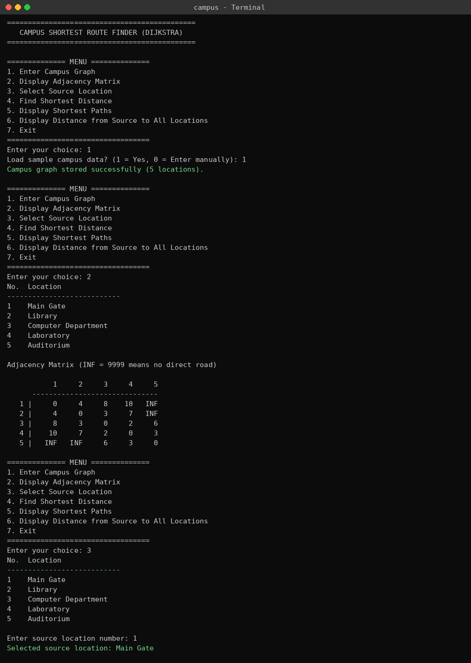
Screenshot 1: Loading the sample campus graph and displaying the adjacency matrix; selecting the source (Main Gate).
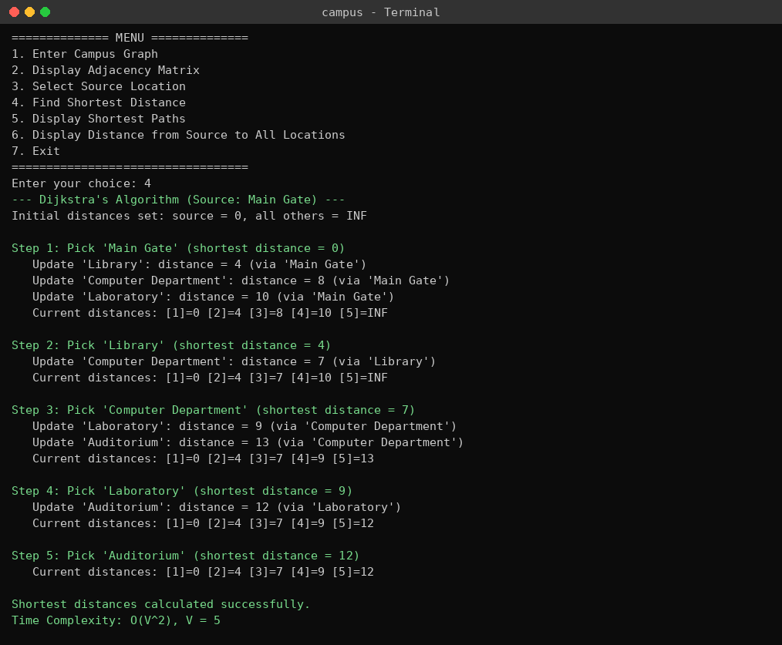
Screenshot 2: Dijkstra’s algorithm step-by-step (Source: Main Gate) with intermediate distance updates.
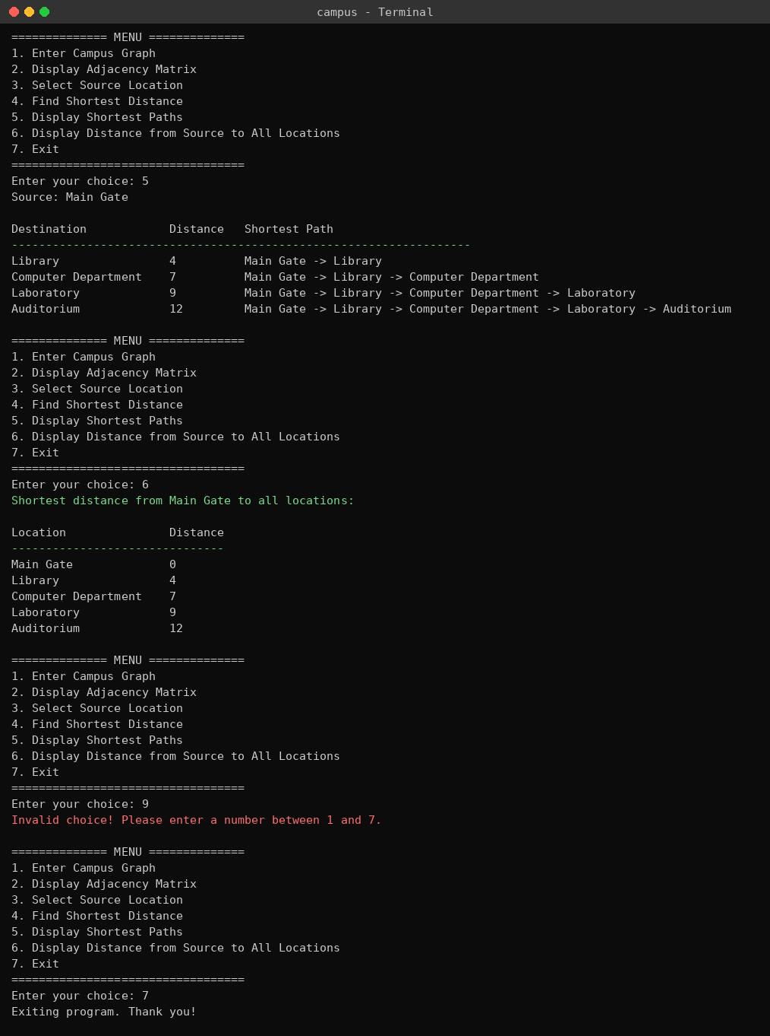
Screenshot 3: Shortest paths, distance to all locations, invalid-choice handling and Exit.

GitHub Repository Link of Project:

