LDR

Aim : To control the LED brightness using an LDR by detecting changes in light intensity.

Circuit :
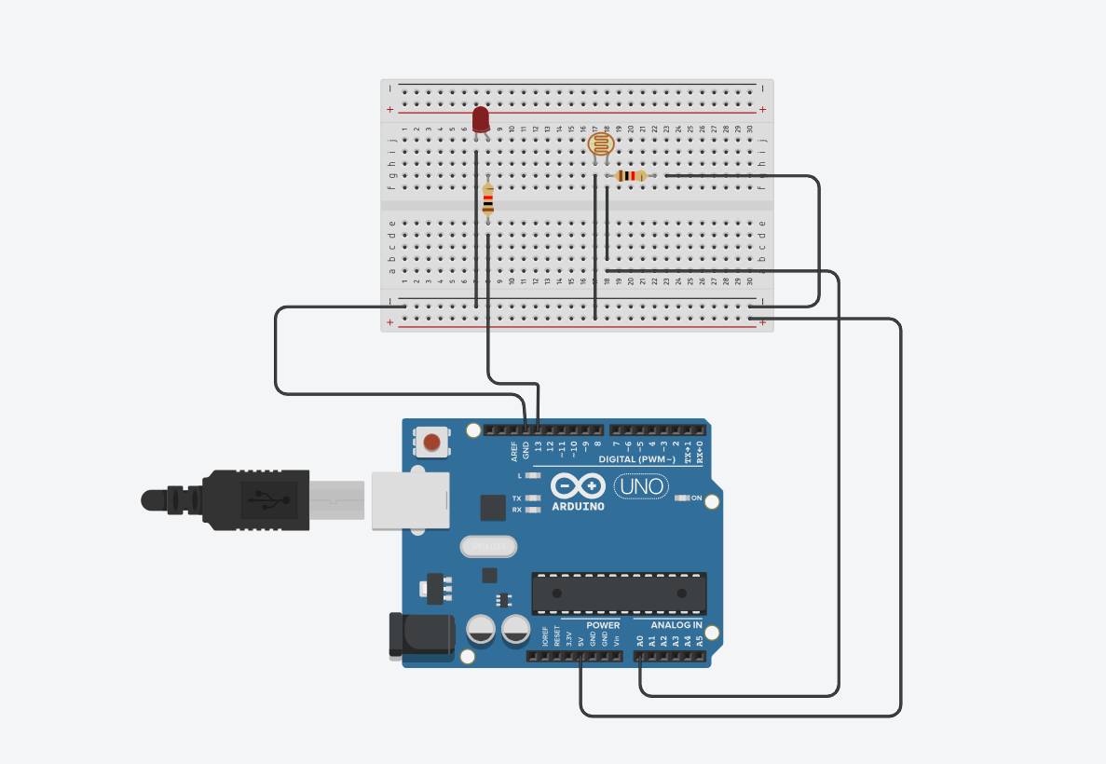

Code :
int ldrPin = A0;
int ledPin = 9;
int ldrValue = 0;
int ledValue = 0;

void setup() {
Serial.begin(9600);
pinMode(ledPin, OUTPUT);
}

void loop() {
ldrValue = analogRead(ldrPin);

ledValue = map(ldrValue, 0, 1023, 255, 0);
// More light → lower brightness
// Less light → higher brightness

analogWrite(ledPin, ledValue);

Serial.print("LDR Value: ");
Serial.println(ldrValue);

delay(10);
}
Observation :
As the light on the LDR changes, the LED brightness increases or decreases accordingly.

