Potentiometer
Aim : To study the working of a potentiometer and control LED brightness using Arduino.
Circuit :
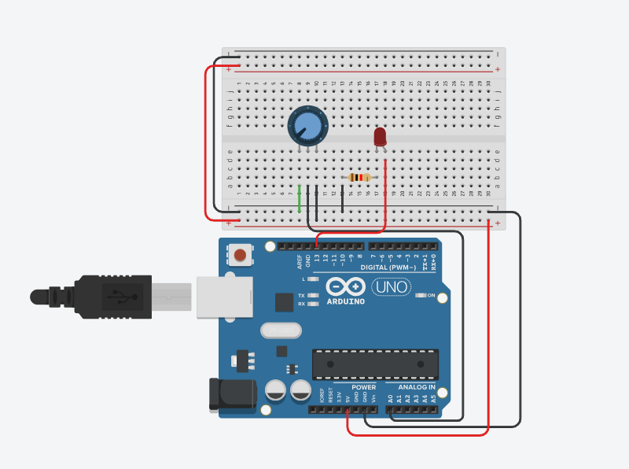

Code :
int potPin = A0;
int ledPin = 13;
int potValue = 0;
int ledValue = 0;

void setup() {
pinMode(ledPin, OUTPUT);
Serial.begin(9600);
}

void loop() {
potValue = analogRead(potPin);
ledValue = map(potValue, 0, 1023, 0, 255);
analogWrite(ledPin, ledValue);

Serial.print("Potentiometer Value: ");
Serial.println(potValue);s

delay(10);
}

Observation :
As the potentiometer is rotated, the LED brightness increases or decreases smoothly according to the change in resistance.

