SINGLE LED

Aim : To blow led on Arduino using breadboard
Circuit :
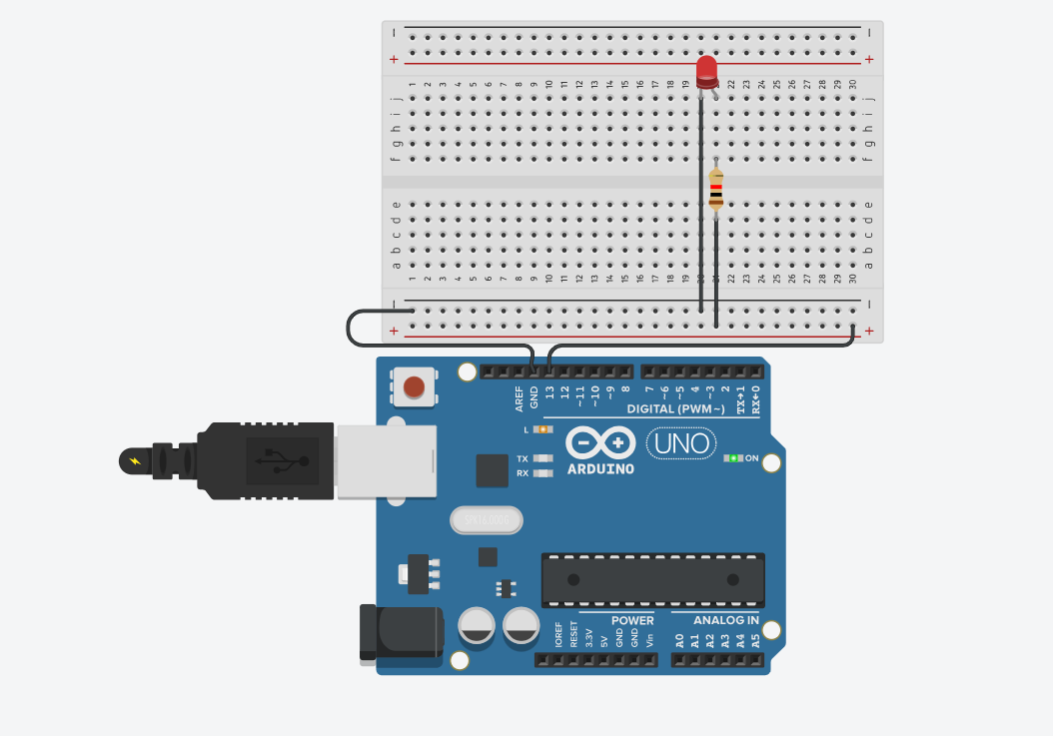
Code :
// C++ code
void setup()
{
pinMode(LED_BUILTIN, OUTPUT);
}

void loop()
{
digitalWrite(LED_BUILTIN, HIGH);
delay(1000); // Wait for 1000 millisecond(s)
digitalWrite(LED_BUILTIN, LOW);
delay(1000); // Wait for 1000 millisecond(s)
}
Observation :
The LED blinks repeatedly, staying ON for 1 second and OFF for the next 1 second.

