Traffic Light

Aim : To connect three LEDs to an Arduino using a breadboard.

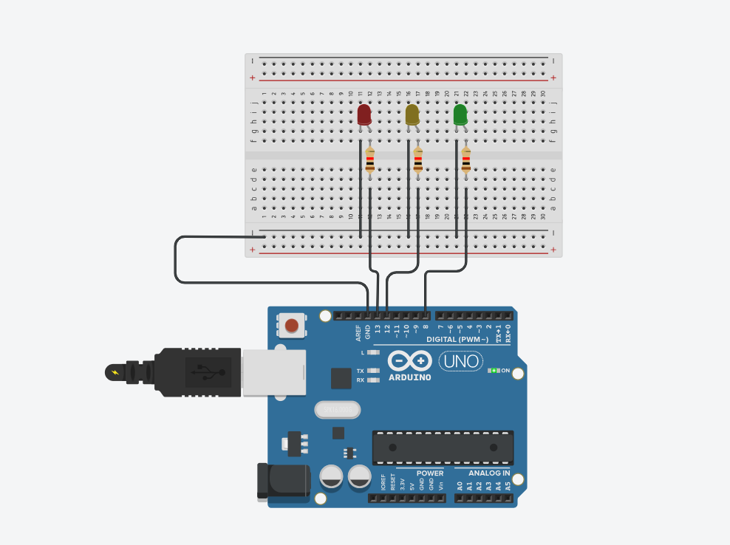

Code :
//C++ oode
int led1=8;
int led2=12;
int led3=13;
void setup()
{
pinMode(led1, OUTPUT);
pinMode(led2, OUTPUT);
pinMode(led3, OUTPUT);

}

void loop()
{
digitalWrite(led1, HIGH);
delay(1000);
digitalWrite(led1, LOW);
delay(1000);

digitalWrite(led2, HIGH);
delay(1000);
digitalWrite(led2, LOW);
delay(1000);

digitalWrite(led3, HIGH);
delay(1000);
digitalWrite(led3, LOW);
delay(1000);
}

Observation : All three LEDs light up and turn off one after another, mimicking a traffic signal sequence: RED → YELLOW → GREEN.

