Push Button
Aim : To use push button to glow LED on Arduino.

Circuit :
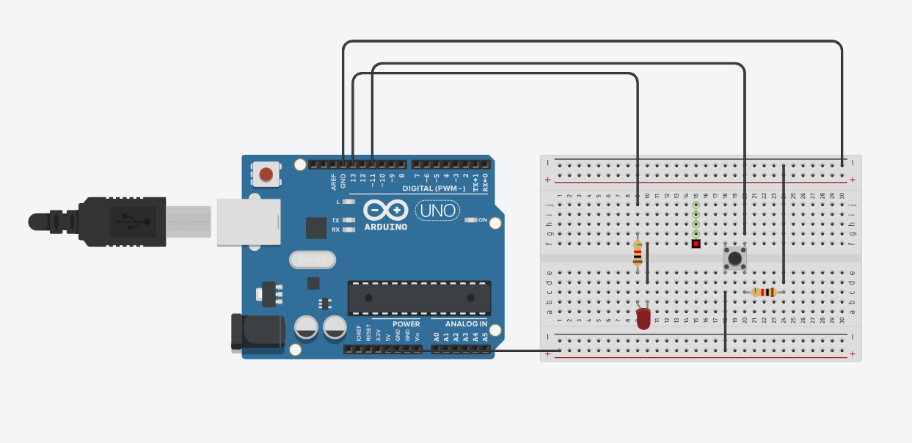

Code :
int led = 13;
int pushButton = 11;

// the setup routine runs once when you press reset:
void setup()
{
Serial.begin(9600);
pinMode(pushButton, INPUT);
pinMode(led, OUTPUT);
}

//the loop routine runs over and over again forever:
void loop()
{
int buttonState = digitalRead(pushButton);
Serial.println(buttonState);
if (buttonState == 1) {
digitalWrite(led, HIGH);
} else
{
digitalWrite(led, LOW);
}
delay(1);
}

Observation:
The LED responds immediately to the button press because the loop continuously checks the button state.

