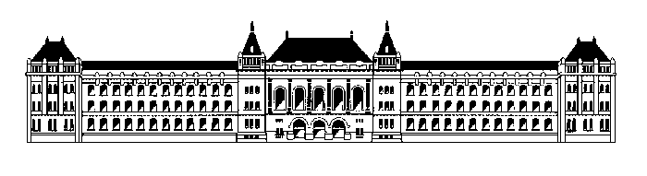
TECHNICAL UNIVERSITY OF BUDAPEST
Faculty of Electrical Engineering and Informatics
Department of Telecommunications

OMNeT++
Discrete Event Simulation System

Examples manual
THIS DOCUMENT IS BADLY OUT OF DATE!!!

by:
Gábor Lencse, András Varga

Last updated: March 12, 1997

Contents
1. Contents
2. Introduction
3. The NIM example (by VA)
3.1 Introduction
3.2 Topology
3.3 Simple modules
3.4 Running NIM
4. The Token Ring example (by LG)
4.1 What is modelled in this example
4.2 The network structure
4.3 The NED description
4.4 The definitions of the simple modules
4.5 Running Token Ring
4.6 Some output from the Token Ring
4.7 References
5. The FDDI example (by LG)
5.1 Introduction
5.2 A brief introduction to FDDI
5.3 The FDDI-MAC model
5.3.1 What is modelled and what is not modelled
5.4 Implementation of the structure (the NED files)
5.5 Implementation of the simple modules
5.6 References
6. The DYNA example (by VA)
6.1 Introduction
6.2 The NED files
6.3 The simple modules
6.4 Running Dyna

Introduction
This manual documents the example programs supplied with OMNeT++.
The authors of the example programs and their documentation is shown in the chapter titles. The initials mean:
VA András Varga
LG Gábor Lencse
I hope that the example programs will help you understand the OMNeT++ system and you can make more use of it.

András Varga

The NIM example (by VA)

Introduction
This simulation program demonstrates how object-oriented concepts can be applied in OMNeT++. The example shows how one can use inheritance, virtual functions and the NED language's like phrase to create and use a family of simple modules that behave in a similar (but not identical) way.
The topic of the model, Nim is an ancient game with two players and a bunch of sticks. The rules say that the players take turns, removing 1, 2, 3 or 4 sticks from the heap of sticks at each turn. The one who takes the last stick is the loser.

Topology
The game can be modelled in OMNeT++ as a network with three modules: the 'game' (a manager module) and two players.
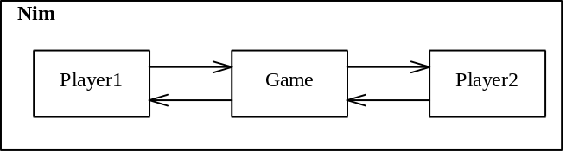
Module structure for the Nim game
Player1, Player2 and Game are simple modules. The Game module will start and manage the game, announce the winner and so on. We will implement the Game module with a simple module type that will also be called Game.
As for Player1 and Player2, we can implement three kinds of player types:
- SimplePlayer simply takes a random number of sticks;
- SmartPlayer knows the winning algorithm;
- InteractivePlayer asks the user for each move.
For example, Player1 can be SmartPlayer, Player2 can be SimplePlayer; we will be able to select it in the configuration file.
The enclosing module, Nim is a compound module of which the system module is created.
In the NED description of the Nim game, note that the actual types of the two players are left as parameters (player1_type and player2_type), using the like phrase of the NED language; each player can be any of the player types mentioned above. Since they are also defined to be input parameters in the network definition, their value can be specified in the ini file or will be asked run-time.

//-------------------------------------------------------------
// file: nim.ned
// (part of NIM - an OMNeT++ demo simulation)
//
// NIM is an ancient game with two players and a bunch of sticks.
//
// The players take turns, removing 1..4 sticks from the heap
// at each turn.
//
// The player who must take the *last* stick is the loser.
//
//-------------------------------------------------------------

// Declaration of simple module type Game
simple Game
parameters:
num_sticks, // starting number of sticks
first_move; // 1=Player1, 2=Player2
gates:
in: from_player1, // input and output gates
from_player2; // for connecting to Player1/Player2
out: to_player1,
to_player2;
endsimple

// Player is a common interface to which all player modules (SimplePlayer,
// SmartPlayer, InteractivePlayer) will conform
simple Player
gates:
in: in; // gates for connecting to Game
out: out;
endsimple

// The NIM game's network: Game and two players interconnected
module Nim
parameters:
player1_type : string,
player2_type : string;
submodules:
// create the Game module, with the initial number of
// sticks and the starting player as random parameters
game: Game
parameters:
num_sticks = intuniform (21, 31),
first_move = intuniform (1, 2);
// for players, define their module types as parameters to
// the parent module
player1: player1_type like Player;
player2: player2_type like Player;
connections:
player1.out --> game.from_player1,
player1.in <-- game.to_player1,

player2.out --> game.from_player2,
player2.in <-- game.to_player2;
endmodule

// Create an instance of the Nim module
network nim: Nim
parameters:
player1_type = input("InteractivePlayer"),
player2_type = input("SmartPlayer");
endnetwork

Simple modules
The module types SmartPlayer, SimplePlayer, InteractivePlayer and Game are implemented in C++, using the OMNeT++ library classes and functions.
Each module type is represented by a C++ class, derived from cSimpleModule. Let us see the implementation of Game first:
//-------------------------------------------------------------
// file: game.cc
// (part of NIM - an OMNeT++ demo simulation)
//-------------------------------------------------------------

#include <stdio.h>
#include <string.h>

#include "omnetpp.h"

// derive Game from cSimpleModule
class Game : public cSimpleModule
{
Module_Class_Members(Game,cSimpleModule,8192)
// this is a macro; it expands to constructor definition etc.
// 8192 is the size for the coroutine stack (in bytes)

virtual void activity();
// this redefined virtual function holds the algorithm
};

// register the simple module class to OMNeT++
Define_Module( Game )

// Operation of Game:
// The Game module first waits for a message from both players and extracts
// the message names that are also the players' names. Then it enters a loop,
// with the player_to_move variable alternating between 1 and 2. With each
// iteration, it sends out a message with the current number of sticks to
// the corresponding player and gets back the number of sticks taken by that
// player. When the sticks are out, the module announces the winner and ends
// the simulation.

void Game::activity()
{
// strings to store player names; [0] is unused
char player[3][32];

// read parameter values
int num_sticks = par("num_sticks");
int player_to_move = par("first_move");

// waiting for players to tell their names
for (int i=0; i<2; i++)
{
cMessage *msg = receive();
if (msg->arrivedOn("from_player1"))
strcpy( player[1], msg->name());
else
strcpy( player[2], msg->name());
delete msg;
}

// ev represents the user interface of the simulator
ev << "Let the game begin!\n";
ev << "Player 1: " << player[1] << " Player 2: " << player[2]
<< "\n\n";

do
{
ev << "Sticks left: " << num_sticks << "\n";
ev << "Player " << player_to_move << " ("
<< player[player_to_move] << ") to move.\n";

cMessage *msg = new cMessage("", num_sticks);
// num_sticks will be the msg kind
if (player_to_move == 1)
send(msg, "to_player1");
else
send(msg, "to_player2");

msg = receive();
int sticks_taken = msg->kind();
delete msg;

num_sticks -= sticks_taken;

ev << "Player " << player_to_move << " ("
<< player[player_to_move] << ") took "
<< sticks_taken << " stick(s).\n";

player_to_move = 3 - player_to_move;
}
while (num_sticks>0);

ev << "\nPlayer " << player_to_move << " ("
<< player[player_to_move] << ") won!\n";

endSimulation();
}

Now the sources for the three player module classes. We create a common Player class and derive the specific player types from that:

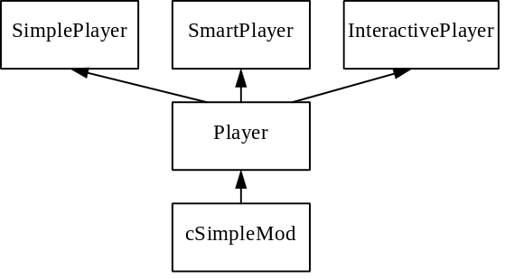
C++ classes in NIM
Player implements the general behaviour of a player, but two details are implemented in the specific player classes, with virtual functions:
- the calculation of the number of stick to be taken: calculateMove(), and
- the name of the player: playerName().
The source file is broken down to a header and a code part:
//-------------------------------------------------------------
// file: players.h
// (part of NIM - an OMNeT++ demo simulation)
//-------------------------------------------------------------

#include "omnetpp.h"

// The three player types (SimplePlayer,SmartPlayer,InteractivePlayer)
// will be derived from a commom Player base class.

// derive abstract class Player from cSimpleModule
class Player : public cSimpleModule
{
Module_Class_Members( Player, cSimpleModule, 8192)
// this is a macro; it expands to constructor definition etc.
// 8192 is the size for the coroutine stack (in bytes)

virtual void activity();
// this redefined virtual function holds the algorithm

virtual char *playerName() = 0;
virtual int calculateMove( int num_sticks ) = 0;
};

class SimplePlayer : public Player
{
Module_Class_Members( SimplePlayer, Player, 8192)
virtual char *playerName();
virtual int calculateMove( int num_sticks );
};

class SmartPlayer : public Player
{
Module_Class_Members( SmartPlayer, Player, 8192)
virtual char *playerName();
virtual int calculateMove( int num_sticks );
};

class InteractivePlayer : public Player
{
Module_Class_Members( InteractivePlayer, Player, 8192)
virtual char *playerName();
virtual int calculateMove( int num_sticks );
};

Now the corresponding .cc file. It is well commented so there's no need to say more here.
//-------------------------------------------------------------
// file: players.cc
// (part of NIM - an OMNeT++ demo simulation)
//-------------------------------------------------------------

#include <stdio.h>
#include <string.h>

#include "omnetpp.h"
#include "players.h"

// register player module types with the Player interface
Define_Module_Like( SmartPlayer, Player )
Define_Module_Like( SimplePlayer, Player )
Define_Module_Like( InteractivePlayer, Player )

// Operation of Player:
// A Player first introduces himself by sendings its name to the Game
// module. Then it enters an infinite loop; with each iteration, it receives
// a message from Game with the number of sticks left, calculates its move
// and sends back a message containing the move.

void Player::activity ()
{
// initialisation setPhase: send module type to Game module
cMessage *msg = new cMessage( playerName() ); // create a message
send (msg, "out"); // send it to Game

// infinite loop to process moves; simulation will be terminated by Game
for (;;)
{
// messages have several fields; here, we'll use the message kind
// member to store the number of sticks
cMessage *msgin = receive(); // receive message from Game
int num_sticks = msgin->kind(); // extract message kind (an int)
// this hold the number of sticks
// still on the stack
delete msgin; // dispose of the message

// call virtual function (implemented in cSmartPlayer etc.)
// to calculate the number of sticks to take.
int move = calculateMove( num_sticks );

ev << playerName() << " is taking " << move <<
" out of " << num_sticks << " sticks.\n";

cMessage *msgout = new cMessage; // create empty message
msgout->setKind( move ); // use message kind as storage
// for move
send( msgout, "out"); // send the message to Game
}
}

char *SimplePlayer::playerName()
{
return "SimplePlayer";
}

int SimplePlayer::calculateMove( int num_sticks )
{
// random choice, at least 1, at most 4
return 1 + intrand( num_sticks<4 ? num_sticks : 4 );
}

char *SmartPlayer::playerName()
{
return "SmartPlayer";
}

int SmartPlayer::calculateMove( int num_sticks )
{
// calculate move
int move = (num_sticks + 4) % 5;

// if it comes out to be zero, it needs to be adjusted to one;
// this means that the other player is in the winning position
if (move == 0) move = 1;
return move;
}

char *InteractivePlayer::playerName()
{
return "InteractivePlayer";
}

int InteractivePlayer::calculateMove( int num_sticks )
{
// ask the user interactively
int move;
int max = num_sticks<4 ? num_sticks : 4;

ev.prompt("Take how many sticks? ");
ev >> move;
while (move<1 || move>max)
{
ev.printfmsg("Please enter a number in range 1..%d", max);
ev >> move;
}
return move;
}

Running NIM
The ini file for the NIM program:
#---------------------------------------------------------------------------
# omnetpp.ini
# This file is read by every OMNeT++ executable. It contains general
# configuration and values for the model parameters given as `input'
# in the NED files. You can define several `simulation runs' in the
# ini file which can be run independently.
# # and ; denote comments.
# Alternative file name (instead of `omnetpp.ini'): -f command line flag
#---------------------------------------------------------------------------

# The [General] section contains settings for all simulation runs.
# Almost all settings in [General] can also be placed in the [Run 1],
# [Run 2] etc. sections of this file so you can set different values
# for each run.
[General]

# network: name of the model to be simulated. Networks are defined
# in NED files. You can specify a different network for each
# simulation run
network = nim

# ini-warnings: affects processing of this file. If set to `yes',
# OMNeT++ prints out which settings were looked for in the
# ini file and what default values were used if they
# were not found
ini-warnings = yes

# Many more options can be set in the [General] section; see the User Manual
# for the most important ones, the Reference Manual for a complete list, or
# the sources: grep for readOptions() in the envir directory.
# (duration of the simulation, file names, random number seeds etc.)

# The [Cmdenv] section contains settings used by the Command Line user
# interface. See the manual for a complete list or grep for readOptions()
# in the envir/cmdenv directory.
[Cmdenv]

# runs-to-execute: Cmdenv can execute several simulation runs one after
# another. The list can be given here like: 1,3-6,10
# If no value is given, Cmdenv executes all runs
# described in this file ([Run 1], [Run 2] etc.), or if
# no runs are defined, it does one run.
# Command-line equivalent: -r.
runs-to-execute = 1

# The following settings control how much gets printed during simulation.
module-messages = yes
verbose-simulation = no
#display-update = 10

# [Tkenv] section: settings for the Tcl/Tk user interface. See the manual or
# grep for readOptions() in the envir/tkenv directory.
[Tkenv]

# The [All runs] section contains model parameter values common to all runs.
# Be careful NOT to place [General] settings here; they will not be used!
[Parameters]
nim.player1_type = "InteractivePlayer"

# [Run 1] section: model parameter values for the first run. You can also
# use most of the [General], [Cmdenv], [Tkenv] etc. settings here to override
# the globally set value.
[Run 1]
nim.player2_type = "SmartPlayer"

[Run 2]
nim.player2_type = "SimplePlayer"

The screen output of a sample run (provided that NIM was linked with Cmdenv):
OMNeT++ Discrete Simulation, TUB Dept. of Telecommunications, 1990-97

Preparing for Run #1...
Setting up network `nim'...
Enter parameter `nim.player2_type':(default: "SmartPlayer") "InteractivePlayer"
Running simulation...
Let the game begin!
Player 1: SmartPlayer Player 2: InteractivePlayer

Sticks left: 29
Player 2 (InteractivePlayer) to move.
Take how many sticks? 3
InteractivePlayer is taking 3 out of 29 sticks.
Player 2 (InteractivePlayer) took 3 stick(s).
Sticks left: 26
Player 1 (SmartPlayer) to move.
SmartPlayer is taking 1 out of 26 sticks.
Player 1 (SmartPlayer) took 1 stick(s).
Sticks left: 25
Player 2 (InteractivePlayer) to move.
Take how many sticks? 4
[....]
Take how many sticks? 4
InteractivePlayer is taking 4 out of 5 sticks.
Player 2 (InteractivePlayer) took 4 stick(s).
Sticks left: 1
Player 1 (SmartPlayer) to move.
SmartPlayer is taking 1 out of 1 sticks.
Player 1 (SmartPlayer) took 1 stick(s).

Player 2 (InteractivePlayer) won!
<!> Module nim.game: Simulation stopped with endSimulation().

End run of OMNeT++

The Token Ring example (by LG)
This example contains a model of an IEEE 802.5 (Token Ring) LAN. For size limitations, we do not go into explaining the Token Ring protocol in detail here; instead, you can read about it in any computer networks textbook, for example Tanenbaum [1], or find descriptions on the Net, like [2].

What is modelled in this example
The essential features of the IEEE 802.5 MAC are modelled correctly:
- Ring topology
- Token access protocol
- 4 or 16 Mbit/s data rate
- 3 byte token length
- min 21, max 5000 byte packet length
- the destination station also repeats the frame; the source deletes it when it arrives back.
The model contains the normal operation of MAC layer, so the following features are not modelled:
- The frame status bits (address recognized, frame copied etc) are not modelled
- No transmission errors: all frames are assumed to arrive correctly
- No ring fault detection or ring recovery is modelled; neither is the initial ring attachment process
Modelling all the above features would not only make the simulation model a lot more complex, it was also considered unnecessary for normal, performance-estimation simulations.

The network structure
The network consists of stations connected in the form of a ring. The number of stations is a parameter of the model. A station is assumed to be a computer that may send packets to any other station and may receive packets from them. The structure of the network is the following:
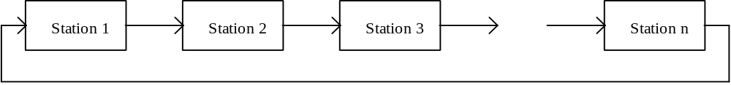
A station is built from 3 modules:
- a traffic generator that generates packets with random length addressed to randomly chosen other stations
- a traffic sink where all the packets destined to this station finish their life cycle
- a media access control (MAC) module that buffers the packets it receives from the generator, and sends them to the destination station working according to the rules of the Token Ring protocol. It repeats all the data packets not addressed to/from this station. It captures the token if it has packet(s) to send, then transmits one data packet and retransmits the token to the ring immediately after the completition of transmitting the packet. If there is nothing to send, then it just repeats the token. It repeats even the packets destined to this station, and at the end of the modelled transmission delay it also forwards them to the sink module that models the higher layers. A packet is stripped out from the ring by its source station when the packet arrives back to it.
The internal structure of a station looks like this:
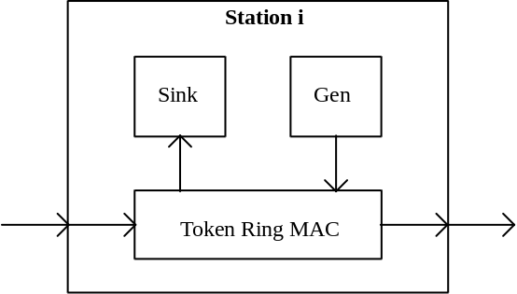
The structure is described in the NED language and can be found in the next subsection.

The NED description
There are two ned files: tknmods.ned contains the simple modules and tknring.ned contains the description of the network.
//-------------------------------------------------------------
// File: tknmods.ned
//
// Declaration of simple module types
//
// Authors: Gabor Lencse, Andras Varga (TU Budapest)
// Based on the code by:
// Maurits André, George van Montfort,
// Gerard van de Weerd (TU Delft)
//-------------------------------------------------------------

// TokenRingMAC: implements the Token Ring protocol
simple TokenRingMAC
parameters:
data_rate, THT;
gates:
in: phy_in, from_gen;
out: phy_out, to_sink;
endsimple

// Generator: generates data packets for MAC
simple Generator
parameters:
num_messages, const num_stations, ia_time;
gates:
out: out;
endsimple

// Sink: destroys the packets and creates statistics
simple Sink
gates:
in: in;
endsimple

//--------------------------------------------------
// File: tknring.ned
//
// Network description of a Token Ring network
//
// Authors: Gabor Lencse, Andras Varga (TU Budapest)
// Based on the code by:
// Maurits Andr‚, George van Montfort,
// Gerard van de Weerd (TU Delft)
//
//--------------------------------------------------

include
"tknmods";

// Computer: node in the network; it will be connected to its right neighbour
module Computer
gates:
in: in;
out: out;
submodules:
mac: TokenRingMAC
parameters:
data_rate = ancestor data_rate,
THT = ancestor THT;
gen: Generator
parameters:
num_messages = ancestor num_messages,
num_stations = ancestor num_stations,
ia_time = ancestor ref ia_time;
sink: Sink;
connections:
in --> mac.phy_in,
mac.phy_out --> out,
mac.to_sink --> sink.in,
gen.out --> mac.from_gen;
endmodule

// TokenRing: ring with a configurable number of Computers
module TokenRing
parameters:
const num_stations, num_messages, ia_time,
THT, data_rate, cable_delay;

submodules:
comp: Computer [num_stations];

connections:
comp[num_stations - 1].out --> delay cable_delay --> comp[0].in,

for i = 0 .. num_stations - 2 do
comp [i].out --> delay cable_delay --> comp [i + 1].in;
endfor;
endmodule

network token: TokenRing
parameters:
num_stations = input( 3 ),
num_messages = input( 2000 ),
ia_time = input( 1ms ),
THT = 10ms,
data_rate = 4000000, // 4 Mbit/s
cable_delay = 1 us;
endnetwork

The definitions of the simple modules
The definitions of the simple modules can be found in the token.cc file, which includes the token.h file.
//-----------------------------------
// file: token.h
//-----------------------------------

class TokenRingMAC : public cSimpleModule
{
Module_Class_Members(TokenRingMAC,cSimpleModule,8192)
virtual void activity();
};

class Generator : public cSimpleModule
{
Module_Class_Members(Generator,cSimpleModule,8192)
virtual void activity();
};

class Sink : public cSimpleModule
{
Module_Class_Members(Sink,cSimpleModule,8192)
virtual void activity();
};

//-------------------------------------------------------------
// File: token.cc
//
// Implementation of simple module types
//
// Authors: Gabor Lencse, Andras Varga (TU Budapest)
// Based on the code by:
// Maurits André, George van Montfort,
// Gerard van de Weerd (TU Delft)
//-------------------------------------------------------------

#include <stdio.h>
#include "omnetpp.h"
#include "token.h"

// Turn on code that prints debug messages
#define TRACE_MSG

// Message kind values
#define DATA_FRAME 0
#define TOKEN 1

Define_Module( Sink )
Define_Module( Generator )
Define_Module( TokenRingMAC )

// Utility function that prints out info about a message
void printMsg(cMessage &msg)
{
ev.printf( "\"%s\"\n", msg.name() );
}

//
// Activities of the simple modules
//
void Generator::activity ()
{
char msgname[30];

int num_messages = par("num_messages");
int num_stations = par("num_stations");
cPar& ia_time = par("ia_time"); // take by ref since it can be random

int my_address = parentModule()->index();

for (int i = 0; i < num_messages; i++)
{
// select destination randomly (but not the local station)
int dest = intrand(num_stations-1);
if (dest>=my_address) dest++;

// select packet length
//
// Fields of a Token Ring data frame are (field lengths given in octets):
// SD(1), AC(1), FC(1), DEST(6), SOURCE(6), DATA(n), CS(4), ED(1), FS(1)
// Length of DATA field (n) is bounded only by the Token Holding Time.
// Typical THT value is 10ms, thus
// length [bits] <= THT*DATARATE = 10ms*4Mbit/s = 5000 bytes
long length = (long) intuniform(21, 5000);

// create message
sprintf(msgname, "%d-->%d", my_address,dest);
cMessage *msg = new cMessage(msgname, DATA_FRAME);
msg->addPar( *new cPar("dest", 'L', dest) );
msg->addPar( *new cPar("source", 'L', my_address) );
msg->addPar( *new cPar("gentime", 'D', simTime()) );
msg->setLength(8*length); // the length is measured in bits

// pass down the message for Token Ring MAC
#ifdef TRACE_MSG
ev.printf("gen[%d]: Generated new msg: ",my_address);
printMsg(*msg);
#endif
send(msg, "out");

// wait between messages
//
// Note that ia_time is a reference to the module parameter "ia_time"
// that will be evaluated here. The module parameter can also be a random
// value (for example: truncnormal(0.5,0.1) ).
wait( ia_time );
}
}

void TokenRingMAC::activity()
{
cQueue send_queue("send-queue");
int my_address = parentModule()->index();
cOutVector sendqueue_len("sendqueue-length",1);

long datarate = par("data_rate"); // 4 or 16 Mbit/s
double THT = par("THT"); // Token Holding Time: typically 10ms

// station 0 issues the token
if (my_address == 0)
{
cMessage *token = new cMessage("token", TOKEN);
token->setLength(8*3); //IEEE 802.5: token length is 3 bytes
send( token, "phy_out");
}

// enter token ring protocol
for(;;)
{
cMessage *msg = receive();

// new message from the generator
if ( msg->arrivedOn("from_gen") ) // DATA_FRAME
{
#ifdef TRACE_MSG
ev.printf("MAC[%d]: New msg from higher layer: ",my_address);
printMsg(*msg);
ev.printf("MAC[%d]: - adding to send-queue\n",my_address);
#endif

// insert message into send buffer
send_queue.insertHead( msg );
sendqueue_len.record( send_queue.length() );
}

// token arrived from network
else if ( msg->arrivedOn("phy_in") && msg->kind()==TOKEN )
{
#ifdef TRACE_MSG
ev.printf("MAC[%d]: Token arrived: ",my_address);
printMsg(*msg);
#endif

// if we have messages to send, send them now, within the THT
//
// We'll use wait() for modelling the transmission time. This means
// that we do not process messages that arrive in the meanwhile;
// they accumulate in the putaside-queue and will be retrieved
// by subsequent receive() calls.
// These messages can be of two kind:
// 1. new messages from the generator. They will be sent with the
// next token.
// 2. our frames that travelled around the ring and arrived back to us.
// We'll have to strip them out from the ring anyway so they
// can wait a little.
simtime_t tht_expires = simTime()+THT;
while (!send_queue.empty())
{
// peek at next message and see if it is within the THT
cMessage *m = (cMessage *) send_queue.peekTail();
simtime_t transmission_time = m->length()/(double)datarate;
if (simTime()+transmission_time > tht_expires)
break; // no time left for this packet

// remove message from the send buffer
send_queue.getTail();
sendqueue_len.record( send_queue.length() );

// add delivery time and send it
m->addPar( *new cPar("sendtime", 'D', simTime()) );
#ifdef TRACE_MSG
ev.printf("MAC[%d]: Sending frame from send-queue: ",my_address);
printMsg(*m);
ev.printf("MAC[%d]: - transmission time: %s. (During transm, messages\n",
my_address, simtimeToStr(transmission_time));
ev.printf("MAC[%d]: from higher layer are temporarily stored in the putaside-queue)\n",
my_address);
#endif
send( m, "phy_out");
wait( transmission_time );
}

// release token
#ifdef TRACE_MSG
ev.printf("MAC[%d]: Releasing token.\n",my_address);
#endif
send( msg, "phy_out");
}

// frame arrived from network
else if ( msg->arrivedOn("phy_in") && msg->kind() == DATA_FRAME )
{
#ifdef TRACE_MSG
ev.printf("MAC[%d]: Frame from network: ",my_address);
printMsg(*msg);
#endif

// extract source and destination
int dest = (long) msg->par ("dest");
int source = (long) msg->par ("source");

// is this station the addressee?
if (dest == my_address)
{
// The arrival of a message in the model represents the arrival
// of the first bit of the packet. It has to be completely received
// before we can pass it up to the higher layer. This delay is
// implemented here with a delayed send.
//
// create a copy and send it up
cMessage *m = (cMessage *) msg->dup();
#ifdef TRACE_MSG
ev.printf("MAC[%d]: - we are the destination, pass up a copy to higher layer.\n",my_address);
#endif
sendDelayed( m,m->length()/(double)datarate,"to_sink");
}

// In the Token Ring protocol, a frame is stripped out from the ring
// by the source of the frame when the frame arrives back to its
// originating station. The addresse just repeats the frame, like
// any other station in the ring.
if (source == my_address)
{
#ifdef TRACE_MSG
ev.printf("MAC[%d]: - arrived back to sender, strip it out of the ring.\n",my_address);
#endif
delete msg;
}
else
{
#ifdef TRACE_MSG
ev.printf("MAC[%d]: - forward it to next station.\n",my_address);
#endif
send( msg, "phy_out");
}
}
}
}

void Sink::activity()
{
int my_address = parentModule()->index();

cOutVector queuing_time("queuing-time",1);
cOutVector transm_time("transmission-time",1);

for(;;)
{
// receive a message
cMessage *msg = receive();

// extract statistics and write out to vector file
simtime_t generated = msg->par("gentime"),
sent = msg->par("sendtime"),
arrived = msg->arrivalTime();
queuing_time.record( sent - generated );
transm_time.record( arrived - sent );

#ifdef TRACE_MSG
ev.printf("sink[%d]: Message received: ",my_address);
printMsg(*msg);
ev.printf("sink[%d]: - time between creation and arrival: %lf\n",
my_address, arrived-generated);
#endif

// message no longer needed
delete msg;
}
}

Running Token Ring
After you have built a simulation executable, you use the omnetpp.ini file to specify parameter values for the simulation. This file can contain information like the following:
[General]
network = token
ini-warnings = yes
warnings = yes
snapshot-file = token.sna
log-parchanges = no
random-seed = 1
sim-time-limit = 10s
;cpu-time-limit= 180s

[Cmdenv]
runs-to-execute = 1,2,3
module-messages = no
verbose-simulation = no
display-update = 100ms

[Tkenv]
use-mainwindow = yes
print-banners = yes
animation-delay = 300ms
update-freq-fast = 10
update-freq-express = 1000
breakpoints-enabled = yes

[Parameters]
token.num_stations = 3
token.num_messages = 10000

[Run 1]
token.ia_time = truncnormal(0.005, 0.003)
output-vector-file = token1.vec

[Run 2]
token.ia_time = truncnormal(0.010, 0.006)
output-vector-file = token2.vec

[Run 3]
token.ia_time = truncnormal(0.018, 0.010)
output-vector-file = token3.vec

With these setting the simulation will run until 1000ms (in simulation time) and the network will be quite overloaded. Try to increase wait_time to reduce the traffic. By changing the number of computers the offered load will also change.
A screen snapshot from running the simulation with Tvenv:
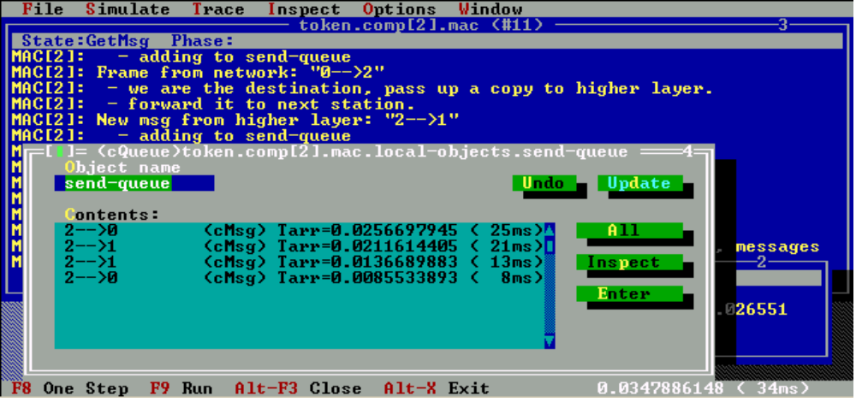

Some output from the Token Ring
The simulation writes data into an output vector files, one for each run. The initial part of one output vector file:
vector 0 "token.comp[0].mac" "sendqueue-length" 1
0 0 1
vector 3 "token.comp[1].mac" "sendqueue-length" 1
3 0 1
vector 6 "token.comp[2].mac" "sendqueue-length" 1
6 0 1
3 1e-06 0
vector 7 "token.comp[2].sink" "queuing-time" 1
7 0.00461 1e-06
vector 8 "token.comp[2].sink" "transmission-time" 1
8 0.00461 0.004609
6 0.00461 0
vector 1 "token.comp[0].sink" "queuing-time" 1
1 0.006833 0.00461
vector 2 "token.comp[0].sink" "transmission-time" 1
2 0.006833 0.002223
0 0.006833 0
7 0.008185 0.006833
8 0.008185 0.001352
0 0.016 1
[...]

The splitvec program of OMNeT++ or grep can be used to pick out one vector from the file (for example, vector 1 is the queuing times in computer 1; these are the lines that begin with 1). The results could easily be plotted with Gnuplot, or imported into spreadsheet programs.
The following chart was made with MS-Excel.
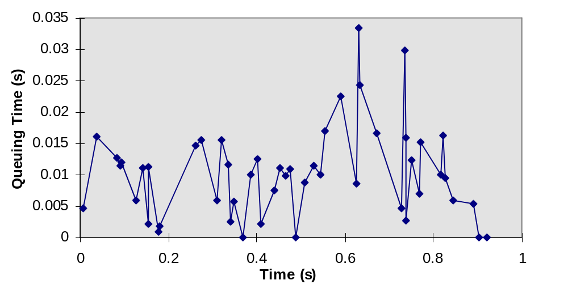
Queueing time in computer 1.

References
[1] A. S. Tanenbaum, Computer Networks. Prentice-Hall, 1989, pp. 153-162.
[2] http://www.nodec.com/tech/token.htm

The FDDI example (by LG)

Introduction
Fiber Distributed Data Interface (FDDI) is a 100-Mbps fiber optic network standard. It has a dual ring topology that can be extended by wiring concentrators. The so-called Timed-Token access protocol is applied for media access control purposes. In this example, you can find the detailed simulation of the Media Access Control (MAC) sublayer.
The example contains two different network models built upon the FDDI MAC model. One is a simulation of an FDDI ring in general; the other is a simulation of an existing FDDI network, the Northern FDDI Ring of the Technical University of Budapest, with the load taken from real measurements.
For more information about FDDI-MAC, see the standard. [1] Now I will give a brief introduction to FDDI in the next subsection.

A brief introduction to FDDI
FDDI (Fiber Distributed Data Interface) has found its niche as a reliable, high-speed backbone for mission critical and high traffic networks. It can transport data at a rate of 100 megabits per second, and can support up to 500 stations on a single network. FDDI was designed to run through fiber cables, transmitting light pulses to convey information back and forth between stations, but it can also run on copper using electrical signals.
FDDI maintains a high reliability because FDDI networks consist of two cell-rotating rings. These rings work to back each other up, so should something go wrong on the network, an alternate way to get the data can be found. FDDI is also considered reliable because it has mechanisms to fix its own problems.
FDDI uses a dual ring topology, which is to say that it is comprised of two cell-rotating rings. A dual-attached rooted station on the network is attached to both of these rings.
A dual-attached station on the ring has at least two ports - an A port, where the primary ring comes in and the secondary ring goes out, and a B port where the secondary ring comes in, and the primary goes out. A station may also have a number of M ports, which are attachments for single-attached stations. Stations with at least one M port are called concentrators.
The sequence in which stations gain access to the medium is predetermined. A station generates a special signaling sequence called a Token that controls the right to transmit. This Token is continually passed around the network from one node to the next. When a station has something to send, it captures the Token, sends the information in well formatted FDDI frames, then releases the token. The header of these frames includes the address of the station(s) that will copy the frame. All nodes read the frame as it is passed around the ring to determine if they are the recipient of the frame. If they are, they extract the data, retransmitting the frame to the next station on the ring. When the frame returns to the originating station, the originating station strips the frame. The token-access control scheme thus allows all stations to share the network bandwidth in an orderly and efficient manner.
This text was taken from: [2]. If you want to know more about FDDI, you may find an FDDI tutorial over there. Raj Jain has wrote a good book about FDDI. [3]

The FDDI-MAC model
I describe the operation of the FDDI-MAC with a tool I call Extended State Transition Diagram (E-STD). The code of the FDDI MAC simple module is directly based on the E-STD description.
The most important deviation of E-STD from a normal STD is the following. In the case of an ordinary STD the system is exactly in one state, and events may cause state changes. In our case, the system can be in a certain number of states simultaneously, and the events together with some "conditions" may make the system to leave some states and/or enter some of them. At the time an event occurs, the system has to be in a given state (Required State) and may be in some other states (Allowed States) but it is not allowed to be in any other states. An event may cause state changes and some actions to be performed.
The model has two operation modes; a flag named accelerated is used to select one of them. In the first mode (with the accelerated flag clear), the destination station of a packet will repeat the packet and the source station deletes it when the packet arrives back. This behaviour complies with the standard. In the second mode (when the accelerated flag is set) the destination station of a packet will strip the packet from the ring, which allows faster simulation compared to the first one.
The table below should be self explanatory, so not a detailed interpretation, just some comments are given here.
- The actions given in the "Activity" column are written in pseudo code, the OMNeT++ functions are slightly different from those that are used here. The style of the code is a mix of Pascal and C, this notation was chosen to avoid ambiguity about the meaning of "=". (It is always clear what ":=" or "==" means, but "=" might have caused misunderstandings.)
- The explanation of the conditions is the following:
  - token_usable: the same as in standard;
  - may send: can be gained as the conjunction of some conditions, see the C++ code;
  - accelerated: represents the accelerated flag (described above)
- !(R) means that MAC will not remain in the required state.
- FR2ME is an abbreviation of FRAME_TO_ME.
- In many cases *_END events are just scheduled to delete a state given state of the MAC at the appropriate time. Of course, this unnecessarily slows down the simulation a bit and could have been avoided by omitting the states but they were found to be useful in detecting implementation errors.
- The letters E and I in the Src (source of the event) colum mean External and Internal, respectively.
Extended State Transiton Diagram of the FDDI MAC for simulation with OMNeT++

Event | Src | Required State | Allowed State(s) | Condition | New State(s) | Activity
TOKEN_ARRIVED | E | - | REPEAT | !token_usable | BEFORE_TOKEN_REPEAT, | Schedule(t+station_latency,TOKEN_REPEAT_BEGIN)
 |  |  |  |  | TOKEN_RECEIVE | Schedule(t+token_time,TOKEN_RECEIVE_END)
 |  |  |  | token_usable | TOKEN_CAPTURE | Schedule(t+token_time,TOKEN_CAPTURE_END)
TOKEN_REPEAT_BEGIN | I | BEFORE_TOKEN_REPEAT | TOKEN_RECEIVE |  | TOKEN_REPEAT, !(R) | SendOut(token)
 |  |  |  |  |  | Schedule(t+token_time, TOKEN_REPEAT_END)
TOKEN_REPEAT_END | I | TOKEN_REPEAT |  |  | !(R) | -
TOKEN_RECEIVE_END | I | TOKEN_RECEIVE | TOKEN_REPEAT |  | !(R) | EarlyToken := !LateCounter
 |  |  |  |  |  | if ( EarlyToken ) TRT := T_Opr; else LateCounter := 0
TOKEN_CAPTURE_END | I | TOKEN_CAPTURE |  |  | BEFORE_TRANSMIT, !(R) | EarlyToken := !LateCounter
 |  |  |  |  |  | if ( EarlyToken ) { THT := TRT; TRT := T_Opr; }
 |  |  |  |  |  | else LateCounter := 0;
 |  |  |  |  |  | Schedule(t+station_latency, TRANSMIT_OWN_BEGIN)
TRANSMIT_OWN_BEGIN | I | BEFORE_TRANSMIT |  |  | TRANSMIT_OWN !(R) | SendOut(packet)
 |  |  |  |  |  | Schedule(t+tr. time, TRANSMISSION_END)
TRANSMISSION_END | I | TRANSMIT_OWN | FRAME_STRIP | may send | TRANSMIT_OWN | SendOut(packet)
 |  |  |  |  |  | Schedule(t+tr. time, TRANSMISSION_END)
 |  |  |  | may not send | TOKEN_SEND, !(R) | SendOut(token)
 |  |  |  |  |  | Schedule(t+token_time, TOKEN_SEND_END)
TOKEN_SEND_END | I | TOKEN_SEND | FRAME_STRIP |  | !(R) | -
OWN_FRAME_ARRIVED | E | - | TRANSMIT_OWN, |  | FRAME_STRIP | Schedule(t+rec. time, FRAME_STRIP_END)
 |  |  | TOKEN_SEND
FRAME_STRIP_END | I | FRAME_STRIP | TRANSMIT_OWN, |  | !(R) | -
 |  |  | TOKEN_SEND
FR2ME_ARRIVED | E | - | REPEAT | accelerated | FR2ME_RECEIVE | Schedule(t+rec. time, FR2ME_RECEIVE_END)
 |  |  |  |  |  | packet_to_me := current_packet
 |  |  |  | !accelerated | FR2ME_RECEIVE, | Schedule(t+rec. time, FR2ME_RECEIVE_END)
 |  |  |  |  | BEFORE_REPEAT | packet_to_me := current_packet
 |  |  |  |  |  | Schedule(t+station_latency, REPEAT_BEGIN)
 |  |  |  |  |  | packet_to_be_repeated := current_packet
FR2ME_RECEIVE_END | I | FR2ME_RECEIVE | REPEAT |  | !(R) | SendUp(packet_to_me)
FR2REP_ARRIVED | E | - | REPEAT |  | BEFORE_REPEAT | Schedule(t+station_latency, REPEAT_BEGIN)
 |  |  |  |  |  | packet_to_be_repeated := current_packet
REPEAT_BEGIN | I | BEFORE_REPEAT | FR2ME_RECEIVE |  | REPEAT | SendOut(packet_to_be_repeated)
 |  |  |  |  |  | Schedule(t+tr. time, REPEAT_END)
REPEAT_END | I | REPEAT | BEFORE_REPEAT, FR2ME_RECEIVE, |  | !(R) | -
 |  |  | TOKEN_RECEIVE, TOKEN_CAPTURE,
 |  |  | BEFORE_TOKEN_REPEAT
TRT_EXPIRED | I | - | * | LateCounter==0 | * | LateCounter:=1; TRT:=T_Opr;
 |  |  |  |  |  | Schedule(t+TTRT, TRT_EXPIRED)
 |  |  |  | LateCounter==1 | TOKEN_LOST | Give an error message, ...

What is modelled and what is not modelled
Of course, just the parts of the FDDI were found to be relevant are modelled. This is a single ring built out of Single Attachment Stations (SAS) and Single Attachment Concentrators (SAC). The dual ring topology is not modelled, because the second ring is used just for backup purposes and is useful e.g. in case of cable break, but our aim was to simulate the normal operation of the ring. All the SAS-s contain a MAC entity operating according to the E-STD described above. This is a quite precise simulation of the normal operation of the MAC, but all the ring initialization and ring recovery mechanisms were omitted. In the beginning of the simulation, the value of T_Opr is set in all the stations and a token is inserted into the ring by a chosen station. During the operation no errors may occur. The exact fiber lengths between stations were taken from the measurement logbooks. The value of station_latency was taken from [4]. The effect of the wiring concentrators is modelled by a constant delay.

Implementation of the structure (the NED files)
Two FDDI network simulation models were built. The simplest one consists of identical stations called "Computers". They contain a traffic generator, that generates packets to randomly chosen other stations. All the stations are connected to the next station in the ring plus to a statistic collecting module called "Stat". The other simulated FDDI Ring is built up from SASs and SACs. They are connected to each in the way as in the Northern FDDI Ring of the Technical University of Budapest.
Now we present the NED files that describe the structure of the building blocks and also the topology of the simulated networks.
<FDDI_mod.NeD, FDDI.NeD>

Implementation of the simple modules
The activities of the simple modules are implemented in C++. As the file is too long to be include in this document, the reader is encouraged to download it from the same place where this document was found or to write an e-mail to the author of this chapter (Gabor.Lencse@hit.bme.hu).
Now some comments about running the FDDI examples: If you run it for the first time, it is recommended to choose the simple FDDI1 network. Should you be interested in the network called NRing (the precise simulation of an existing FDDI network) you can get the measurement data from the author.

References
[1] Fiber Distributed Data Interface (FDDI) Token Ring Media Access Control (MAC)
ANSI X3.139-1987
[2] http://www.iol.unh.edu/training/fddi/htmls/index.html
[3] Raj Jain: FDDI Handbook: high-speed networking using fiber and other media
Addison-Wesley, 1994
[4] OPNET Example Models Manual, Release 2.4 (Chapter FDDI)
MIL 3, Inc.

The DYNA example (by VA)

Introduction
The DYNA simulation is an example that shows dynamic module creation.
Dyna is an abstract model of a client-server network. There is one server and several client computers. The network between server and clients is modelled as a single module ("switch") to which all nodes connect with duplex point-to-point links. Thus, the topology looks like this:

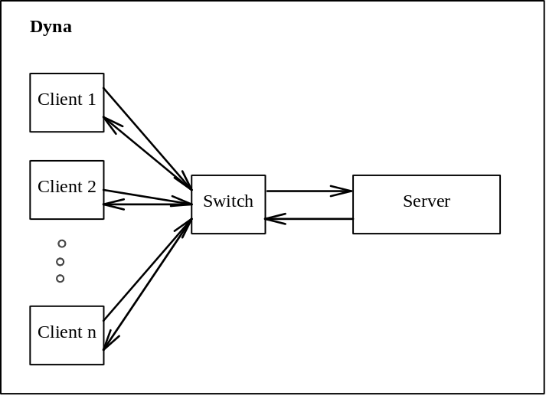

The clients communicate with the server in sessions, initiated at random intervals. One session looks like this:
- connection establishment. The client sends a connection request (CONN_REQ packet) and expects an acknowledgement from the server that the connection was accepted (CONN_ACK).
- message exchange. This setPhase is a sequence of request-answer pairs (REQUEST and ANSWER packets), repeated a random number of times.
- connection teardown. The client sends a disconnect request (DISC_REQ) and expects an acknowledgement (DISC_ACK).
The client does not wait forever for the sender to reply, it uses a certain timeout in all three phases. If the timeout expires, the client assumes that the connection is broken and aborts the session.
The switch module simply routes the packets from the clients towards the server and vica versa. In the model, each packet contains a field with the destination so that the switch can route them properly. The switch can only process one packet at a time and has a single queue (M/M/1). It is assumed to have a certain processing power that is expressed as the number of packets it can route per second.
The server module assigns a separate process for each session. This is implemented in the model with dynamically created modules; each module handles one session and then terminates.

The NED files
The topology of the network is described as below. The number of clients is supplied as the num_clients parameter to the network.
--------------------------------------------------------------
-- fileName: dyna.ned
-- Example simulation with dynamically created modules
--
-- Basic module structure:
-- several Clients <===> Switch <---> Server
--
-- Server launches ServerProcess processes to do actual job
--
-- A.Varga, Dec 14 1996
--------------------------------------------------------------

simple Client
parameters: timeout, conn_interarrival, num_requests;
gates: out: out; in: in;
endsimple

simple Switch
parameters: pk_rate;
gates: out: out[]; in: in[];
endsimple

simple Server
gates: out: out; in: in;
endsimple

simple ServerProcess
gates: out: out; in: in;
endsimple

module ClientServer
parameters: num_clients;
submodules:
client: Client[num_clients]
parameters: timeout = 5.0,
conn_interarrival = exponential( 5.0 ),
num_requests = truncnormal( 10.0, 5.0 );
server: Server;
switch: Switch
parameters: pk_rate = 80;
gatesizes: in[num_clients+1], out[num_clients+1];
connections:
for i = 0 .. num_clients-1 do
client[i].out --> delay 0.01 --> switch.in[i];
client[i].in <-- delay 0.01 <-- switch.out[i];
endfor
server.out --> delay 0.01 --> switch.in[num_clients];
server.in <-- delay 0.01 <-- switch.out[num_clients];
endmodule

network dyna: ClientServer
parameters: num_clients = input;
endnetwork

The simple modules
The simulation uses constants to identify message types (CONN_REQ etc.). These are listed in the following common header file:
//-------------------------------------------
// file: dyna.h
//-------------------------------------------
#include "omnetpp.h"

/* message kind values */
enum { CONN_REQ,
CONN_ACK,
REQUEST,
ANSWER,
DISC_REQ,
DISC_ACK,
PROCESS_FINISHED
};

(The PROCESS_FINISHED type is used internally by the server.)
First, let us see the simple module type implementing the client. Its operation should be straightforward.
//-------------------------------------------
// file: client.cc
//-------------------------------------------
#include "dyna.h"

class Client : public cSimpleModule
{
Module_Class_Members(Client,cSimpleModule,16384)
virtual void activity();
};

Define_Module( Client )

void Client::activity()
{
int own_addr = gate( "out" ).toGate()->index();
int server_addr = gate( "out" ).toGate()->size()-1;
double timeout = par( "timeout" );
cPar& conn_interarrival = par( "conn_interarrival" );
cPar& num_requests = par( "num_requests" );

cMessage *conn_req, *conn_ack, *request, *answer, *disc_req, *disc_ack;
int act_num_req, i;

for(;;)
{
wait( conn_interarrival );

/* connection setup */
ev << "sending CONN_REQ\n";
conn_req = new cMessage( "CONN_REQ", CONN_REQ );
conn_req->addPar( *new cPar("src") = own_addr );
conn_req->addPar( *new cPar("dest") = server_addr );
send( conn_req, "out" );

ev << "waiting for CONN_ACK\n";
conn_ack = receive( timeout );
if (conn_ack==NULL)
goto broken;
delete conn_ack;

/* communication */
act_num_req = (long)num_requests;
for (i=0; i<act_num_req; i++)
{
ev << "sending REQUEST\n";
request = new cMessage( "REQUEST", REQUEST );
request->addPar( *new cPar("src") = own_addr );
request->addPar( *new cPar("dest") = server_addr );
send( request, "out" );

ev << "waiting for ANSWER\n";
answer = receive( timeout );
if (answer==NULL)
goto broken;
delete answer;
}

/* connection teardown */
ev << "sending DISC_REQ\n";
disc_req = new cMessage( "DISC_REQ", DISC_REQ );
disc_req->addPar( *new cPar("src") = own_addr );
disc_req->addPar( *new cPar("dest") = server_addr );
send( disc_req, "out" );

ev << "waiting for DISC_ACK\n";
disc_ack = receive( timeout );
if (disc_ack==NULL)
goto broken;
delete disc_ack;

continue;

broken: ev << "Timeout, connection broken!\n";
}
}

The source for the module type implementing the server follows. It creates a separate ServerProc simple module for handling each session; the pointers to those modules are kept in the process_tab[] array that is indexed with the address of the client. (This can be done because a client only participates in one session at a time.)
A new session process (that is, ServerProc module) is created when a connection request is received from a client; the appropriate process_tab[] entry is filled. Subsequent packets from the client (requests and disconnect request) are relayed to that process; this is done via direct message sending. When the session terminates, its process sends a PROCESS_FINISHED message to the server module so that it can delete the session process module and clear the process_tab[] entry.
//-------------------------------------------
// file: server.cc
//-------------------------------------------
#include "dyna.h"

class Server : public cSimpleModule
{
Module_Class_Members(Server,cSimpleModule,16384)
virtual void activity();
};

Define_Module( Server )

void Server::activity()
{
const int num_proc = 50;
cModule *process_tab[num_proc];
for( int i=0; i<num_proc; i++) process_tab[i]=NULL;

cModuleType *srvproc_type = findModuleType( "ServerProcess" );

for(;;)
{
cMessage *msg = receive();
int type = msg->kind();
char *procname;
int src, id;

switch( type )
{
case CONN_REQ:
src = msg->par("src");
ev << "CONN_REQ: Creating process " << src << '\n';
procname = indexedname(NULL,"process",src);
//ptr to static buffer
process_tab[src] = srvproc_type->create( procname, this );
srvproc_type->buildInside( process_tab[src] );
process_tab[src]->scheduleStart( simTime() );

process_tab[src]->gate("out").setTo( &gate("out") );

sendDirect( msg, 0.0, process_tab[src], "in" );
break;

case REQUEST:
case DISC_REQ:
src = msg->par("src");
ev << "REQUEST/DISC_REQ: Redirecting msg to process "
<< src << '\n';
if (process_tab[src]==NULL)
simulation.error("Process not registered");
sendDirect( msg, 0.0, process_tab[src], "in" );
break;

case PROCESS_FINISHED:
id = msg->par("id");
ev << "process " << id << " finished, deleting\n";
process_tab[ id ]->deleteModule();
process_tab[ id ]=NULL;
break;
}
}
}

The following listing contains the dynamically created ServerProcess module. It is the logical counterpart of the client module so their codes look somewhat similar.
//-------------------------------------------
// file: servproc.cc
//-------------------------------------------
#include "dyna.h"

class ServerProcess : public cSimpleModule
{
Module_Class_Members(ServerProcess,cSimpleModule,16384)
virtual void activity();
};

Define_Module( ServerProcess )

void ServerProcess::activity()
{
cMessage *msg;
int client_addr, own_addr, type;

ev << "Started, waiting for CONN_REQ\n";
msg = receive();
client_addr = msg->par("src");
own_addr = msg->par("dest");

ev << "remote is " << client_addr << ", sending, CONN_ACK\n";
msg->setName( "CONN_ACK" );
msg->setKind( CONN_ACK );
msg->par("src") = own_addr;
msg->par("dest") = client_addr;
send( msg, "out" );

for(;;)
{
ev << "waiting for REQUEST or DISC_REQ\n";
msg = receive();
int type = msg->kind();

if (type==DISC_REQ)
break;

if (type!=REQUEST)
simulation.error( "protocol error!" );

ev << "got REQUEST, sending ANSWER\n";
msg->setName( "ANSWER" );
msg->setKind( ANSWER );
msg->par("src") = own_addr;
msg->par("dest") = client_addr;
send( msg, "out" );
}

ev << "got DISC_REQ, sending DISC_ACK\n";
msg->setName( "DISC_ACK" );
msg->setKind( DISC_ACK );
msg->par("src") = own_addr;
msg->par("dest") = client_addr;
send( msg, "out" );

msg = new cMessage("PROCESS_FINISHED", PROCESS_FINISHED);
msg->addPar( *new cPar("id") = client_addr );
sendDirect( msg, 0.0, parentModule(), "in" );
}

Finally, here's the implementation of the switch module. It is not particularly complicated. The only thing worth noting is that as the side effect of wait(), it uses the put-aside queue for actual queueing of the packets to be routed.
//-------------------------------------------
// file: switch.cc
//-------------------------------------------
#include "dyna.h"

class Switch : public cSimpleModule
{
Module_Class_Members(Switch,cSimpleModule,16384)
virtual void activity();
};

Define_Module( Switch )

void Switch::activity()
{
double pk_delay = 1.0 / par( "pk_rate" );
for(;;)
{
/* receive msg (implicit queueing!) */
cMessage *msg = receive();

/* processing delay */
wait( pk_delay );

/* send msg to destination */
int dest = msg->par("dest");
ev << "Relaying msg to " << dest << '\n';
send( msg, "out", dest);
}
}

Running Dyna
The ini file:
[General]
network = dyna

ini-warnings = yes
random-seed = 1
warnings = yes
snapshot-file = dyna.sna
output-vector-file = dyna.vec
sim-time-limit = 500
cpu-time-limit= 20

[Cmdenv]
module-messages = yes
verbose-simulation = yes
display-update = 0.5s

[Tkenv]
use-mainwindow = yes
print-banners = yes
animation-delay = 300ms
update-freq-fast = 10
update-freq-express = 100
breakpoints-enabled = yes

[Run 1]
dyna.num_clients = 6

