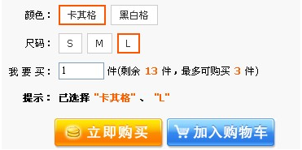

代码如下:

（jQuery版）

[xhtml] view plaincopy
- <html>
- <style>
- .unchecked{
- border: 1px solid gray;
- padding: 6px 6px 6px 6px;
- }
- .checked{
- border: 2px solid #c00;
- padding: 6px 6px 6px 6px;
- }
- </style>
- <script src="http://code.jquery.com/jquery-1.4.2.min.js" ></script>
- <script type="text/javascript">
- var obj={
- colorSpan:"",
- sizeSpan:""
- };
- function change(span)
- {
- $('span[name="'+$(span).attr('name')+'"]').each(function(){
- if(this.checked&&this!=span)
- {
- this.className="unchecked";
- this.checked=false;
- }
- });
- obj[$(span).attr('name')]=span.innerHTML;
- span.className="checked";
- span.checked=true;
- select();
- }
- function select()
- {
- var html='';
- for(var i in obj)
- {
- if(obj[i]!='')
- {
- html+='<font color=orange>"'+ obj[i]+'"</font> 、';
- }
- }
- html='<b>已选择:</b> '+html.slice(0,html.length-1);
- $('#resultSpan').html(html);

- }
- </script>
- <body>
- <br />
- <div>
- 颜色: <span class='unchecked' name='colorSpan' checked='false' onclick='change(this);' >卡其格</span> <span class='unchecked' name='colorSpan' checked='false' onclick='change(this);' >黑白格</span>
- </div>
- <br />
- <br />
- <div>
- 尺码: <span class='unchecked' name='sizeSpan' checked='false' onclick='change(this);' >S</span> <span class='unchecked' name='sizeSpan' checked='false' onclick='change(this);' >M</span> <span class='unchecked' name='sizeSpan' checked='false' onclick='change(this);' >L</span>
- </div>
- <br />
- <br />
- <div>
- <b>提示:</b> <span id='resultSpan'></span>
- </div>
- </body>
- </html>

(纯JS版)

[xhtml] view plaincopy
- <html>
- <style>
- .unchecked
- {
- border: 1px solid gray;
- padding: 6px 6px 6px 6px;
- }
- .checked
- {
- border: 2px solid #c00;
- padding: 6px 6px 6px 6px;
- }
- </style>
- <body>
- <br />
- <div>
- 颜色: <span class='unchecked' name='colorSpan'>卡其格</span> <span class='unchecked' name='colorSpan'>
- 黑白格</span>
- </div>
- <br />
- <br />
- <div>
- 尺码: <span class='unchecked' name='sizeSpan'>S</span> <span class='unchecked' name='sizeSpan'>
- M</span> <span class='unchecked' name='sizeSpan'>L</span>
- </div>
- <br />
- <br />
- <div>
- <b>提示:</b> <span id='resultSpan'></span>
- </div>
- </body>
- </html>

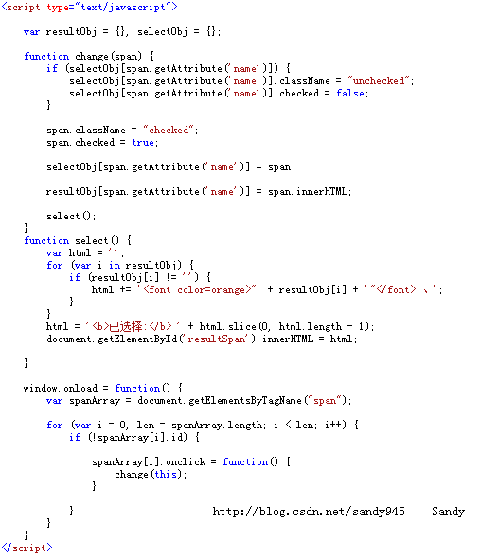

原帖地址:

