Analyzing the MGE Database Linkage
on Microstation Graphic Elements

On occasion you may be unable to use Feature/Attribute Manager within MGMAP to determine the feature and attribute tables for graphic elements. When this occurs, key in anal or select Element > Information and then select the graphic element. Scroll the vertical bar until you see the database linkages in the dialog box.

The linkages can be represented in a 4 word format (DMRS) or 8 word format (RIS, Informix, Oracle, ...). The 4 word format contains the entity number in the 2nd word and the mslink in the 3rd word and high order byte of the 4th word. See Figure 1. The 8 word format contains the entity number in the 4th word and the mslink in the 5th and 6th words. See Figures 2 and 3.

The database linkages are represented as hexadecimal numbers and must be converted to decimal prior to using the numbers to perform RIS sql queries on the database. This can be accomplished using a scientific calculator. See Figure 4.

4 Word Format for Database Linkage

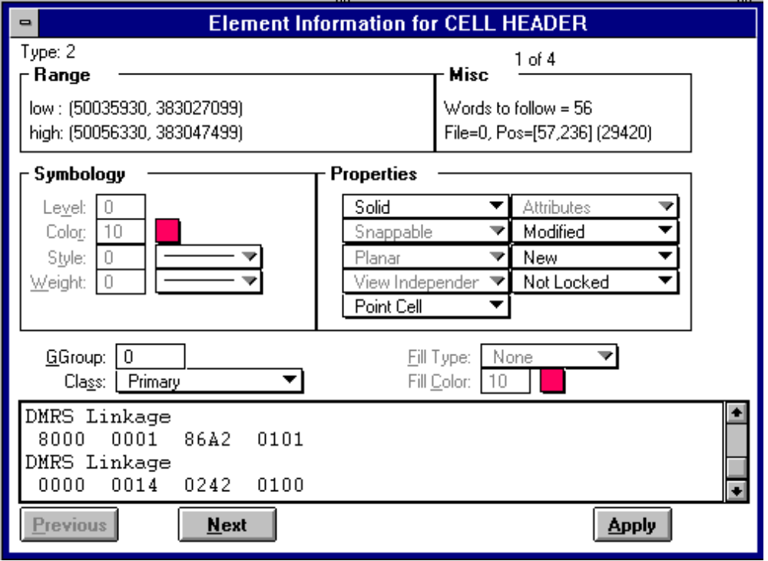

Figure 1
DMRS Linkage Example

The first word indicates whether the linkage is read/write or read only.

8000 (32768 decimal)- Indicates that the linkage is read-only. Feature linkages are read-only.

0000 (0 decimal) - Indicates that the linkage is read/write. Attribute linkages are read/write.

The second word represents the entitynum value in the mscatalog table.

0001 (1 decimal) - For the example given in Figure 1, the entitynum column has a value of 1 in the mscatalog table with the tablename column of the record containing the name of the feature table. The default table name is “feature”.

select * from mscatalog where entitynum = 1

0014 (20 decimal) - For the example given, the entitynum column has a value of 20 in the mscatalog table with the tablename column containing the name of the feature’s attribute
table. For example the table name could be “building”.

select * from mscatalog where entitynum = 20

The third word and high order byte of the fourth word are used for mslink values in the table specified in the second word, either the feature table or the feature “attribute” table.

high order byte of the fourth word

86A2 0101 - In this example, precede 86A2 with a 01 to form the hexadecimal number 186A2 which converts to a decimal number of 100002, the mslink value for the associated record in the feature table. The low order byte is not used by MGE.

select * from feature where mslink = 100002

0242 0100 - In this example, the high order byte is 00. Simply convert the hexadecimal number in the third word to decimal. The hexadecimal 242 converts to a decimal number of 578, which is the mslink value for the associated record in the attribute table.

select * from <attribute table> where mslink = 578

Note that the attribute table name is determined from the tablename column in mscatalog for the record with an entitynum of 20.

After converting hexadecimal numbers to decimal using a scientific calculator and combining the third word and high order byte of the fourth word, the following summarizes the information available to perform sql queries on the database

DMRS Linkage mslink value in the feature table select * from feature where mslink = 100002

32768 1 100002 feature information

DMRS Linkage

0 20 578 attribute table information

mslink value in the feature’s “attribute” table
select * from <attribute table> where mslink = 578
e.g. select * from building where mslink = 578

entitynum in the mscatalog table
select * from mscatalog where entitynum = 1
select * from mscatalog where entitynum = 20

8 Word Format for Database Linkage

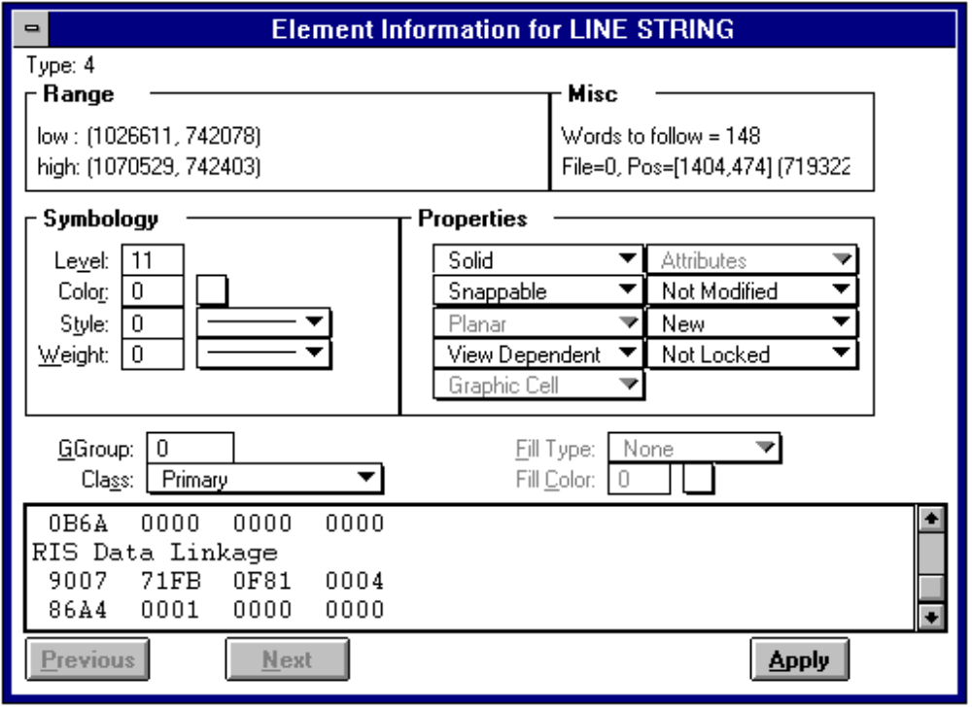
Figure 2
RIS Data Linkage Example for a Feature Table

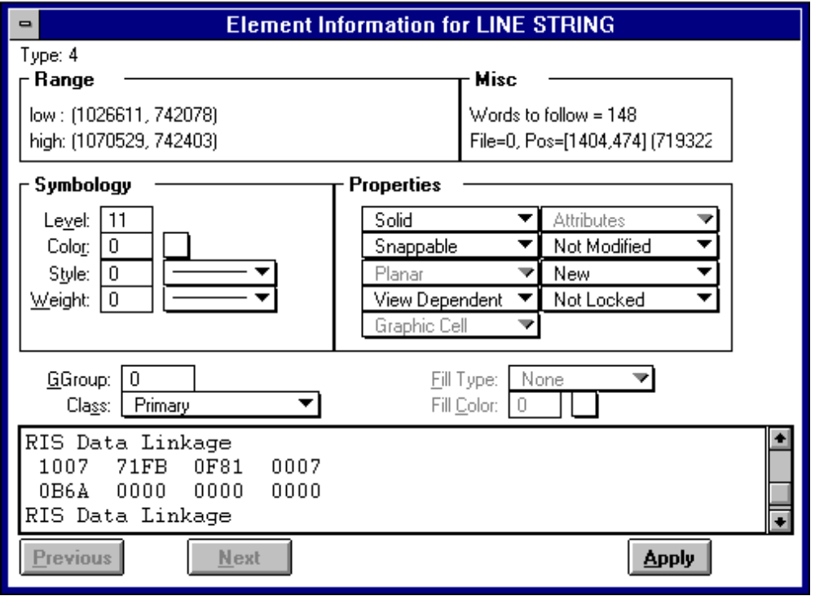

Figure 3
RIS Data Linkage Example for an Attribute Table

As with the 4 word format, the first word of the 8 word data linkage is used to determine whether the linkage is read/write or read only.

9007 - Indicates that the linkage is read-only. Feature linkages are read-only. See Figure 2.

1007 - Indicates that the linkage is read/write. Attribute linkages are read/write. See Figure 3.

The second word indicates the type of database linkage (RIS, Oracle, Informix, Ingres, dBASE, ...). Some examples are:

6091 - Oracle
1971 - dBASE
3948 - Informix
71FB - RIS (Used in the example shown in Figures 2 and 3.)

The third word is not used by MGE and will always be 0F81.

The fourth word is the entitynum value in the mscatalog table.

0004 (decimal 4) - The value of the entitynum column in the mscatalog table for the feature table. See Figure 2.

select * from mscatalog where entitynum = 4

0007 (decimal 7) - The value of the entitynum column in the mscatalog table for the feature code attribute table. See Figure 3.

select * from mscatalog where entitynum = 7

The fifth and sixth words are used for the mslink value of either the feature table or the feature’s attribute table.

86A4 0001 - Swap the order of the fifth and sixth columns to get the hexadecimal number 186A4 which converts to a decimal number of 100004. See Figure 2.

select * from feature where mslink = 100004

0B6A 0000 - Swap the order of the fifth and sixth columns to get the hexadecimal number B6A which converts to a decimal number of 2922. See Figure 3.

select * from <attribute table> where mslink = 2922

The seventh and eighth words are not used by MGE.

Range of valid mslink values

4 word format - 2²⁴ = 0 - 16,777,215
8 word format - 2³² = 0 - 4,294,967,295

Controlling the Database Linkage Type

The type of database linkages processed by MGE are controlled by the MS_LINKTYPE variable in the interact.cfg and the batch.cfg files for NT systems. The files are located in the mgnuc/cfg directory or in the cfg directory for the project. On CLIX systems the variable is set in the alpha.env, command.env, and graphics.env files in mgnuc/bin or in the project cfg directory. An example of a variable setting is:

MS_LINKTYPE=DMRS:RIS

The above variable setting will cause DMRS linkages (4 word format) to be generated when placing linkages through an MGE process (like feature maker, digitizing, point placer,...), but will also cause the MGE system to recognize DMRS and RIS linkages (8 word format) when reading attribute data.

The linkage detacher functionality in MGMAP will allow you to reformat the type of database linkage of existing graphic elements. By using the “reformat option”, all existing linkages will be converted to the linkage format listed first in the MS_LINKTYPE variable. This process will also re-order the linkages so that the feature linkage always precedes its associated attribute linkage.

Converting hexidecimal numbers to decimal

You can use one of the electronic calculators in scientific mode to convert hexadecimal to decimal. Select Hex and key in the hexadecimal number. Then select Dec to convert the hexadecimal number to decimal.

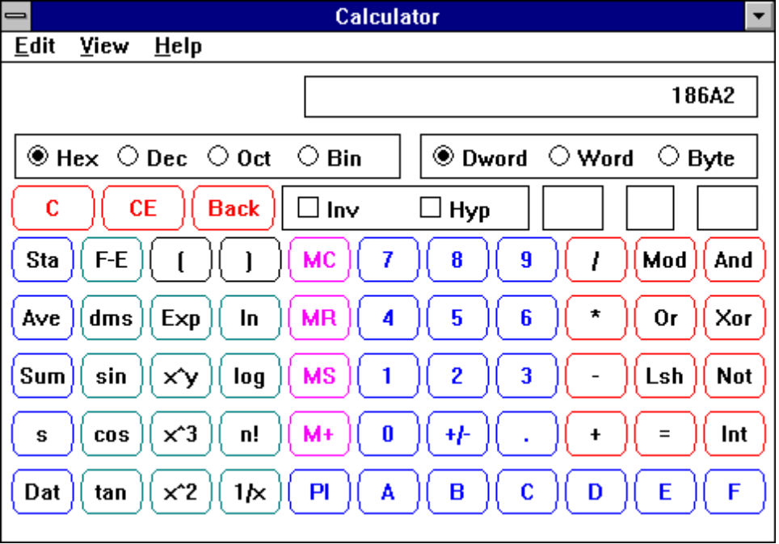

Figure 4
Scientific Calculator

