omniSpectrum appendix(Database Description 28.2.2014)

# Database Diagram

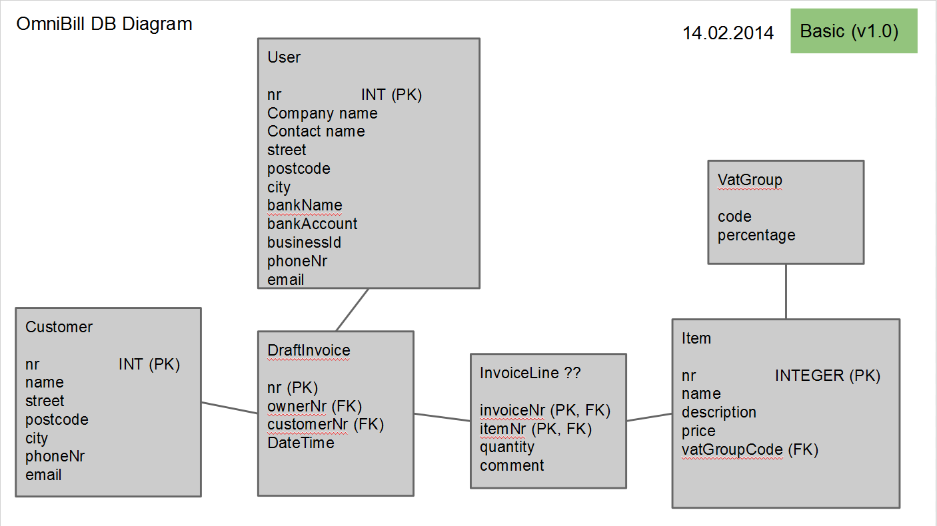

# Database Description

### Customer data

The omniBill application will be created for small/middle size companies and individuals, thus the amount of customers will vary from 1 up to 50. More than that it is expected that most of the business relationship will last for no longer than half of the year, but it will be up to the user for how long to store information about a customer.

|  |  |  |
| --- | --- | --- |
| **Stored data** | **Description** | **Mandatory** |
| Customer number | Unique integer identifier | M |
| Company name | Alphabetic character value | M |
| Contact name | A person, representative of customer company |  |
| Street address | physical address |  |
| Postcode | five digits |  |
| City | Name of the city where customer is located |  |
| phone | digits and special characters like +() |  |
| email | any valid character, unique | M |

### User own data

In the basic version of application only one user will be able to use the omniBill application, and with high probability that data will be stored in stings XML file rather than database. At any point of time user will be able to edit or delete own data.

|  |  |  |
| --- | --- | --- |
| **Stored data** | **Description** | **Mandatory** |
| User number | Unique integer identifier | M |
| Company name | Alphabetic character value | M |
| Contact name | A person, representative of user company |  |
| Street address | physical address |  |
| Postcode | five digits |  |
| City | Name of the city where user is located |  |
| phone | digits and special characters like +() |  |
| email | any valid character, unique | M |
| bankName | Alphbetical character | M |
| bankAccount | digits and country code | M |
| businessId | Unique company code |  |

### VAT group data

Assistance parameter table which will be used to define a value added tax for an item or service. It is expected that it will be rarely changed and changes will happen only if Finnish government will change the percentage of those group.

|  |  |  |
| --- | --- | --- |
| **Stored data** | **Description** | **Mandatory** |
| Group Code | Unique group identifier | M |
| Percentage | Numeric value (0 - 100) | M |

### Item or service data

Information about items will vary from business niche and size, it is expected that data will be changed about once a year. That data will act as master data so in that sense will not be frequently changed as well as amount will be pretty much the same over time.

|  |  |  |
| --- | --- | --- |
| **Stored data** | **Description** | **Mandatory** |
| Item number | Unique item identifier | M |
| item name | Alphabetical character | M |
| description | plain text |  |
| price | float number |  |
| vatGroupCode | foreign key to vat group |  |

### Draft Invoice data

Invoices will be created on a daily basis, however amount of drafts will be no more than 100 and will mostly consist of foreign keys. Once Invoice will be issued – all related data will be exported and stored for ledger keeping only.

|  |  |  |
| --- | --- | --- |
| **Stored data** | **Description** | **Mandatory** |
| Invoice number | Unique invoice identifier | M |
| user number | Unique user identifier | M |
| customer number | Unique customer identifier | M |
| Date and time | Automatic time stamp | M |