

SOFTWARE REQUIREMENTS DOCUMENTATION
of Invoicing System omniBill

omniSpectrum

Version 1.2
Created by Karppinen Niko, Freitas Daniel, Shkunov Alexander 14.05.2014
Reviewed by P.Kamaja
Approved by
Table of contents
1 Introduction 1
2 Overview of invoicing system 1
2.1 Overall Description 1
2.2 Use Case Diagram 2
2.3 Services 2
2.4 Actors 3
3 Use Cases 3
3.1 Use case dependency diagram 3
3.2 Use Case Description 4
3.2.1 Master data management 4
3.2.2 Operational data management 6
3.2.3 Output management 7
3.3 Data Requirements of Displays and Reports 8
4 Class Model 10
4.1 Class Diagram 10
4.2 Class Descriptions 10
4.2.1 User 10
4.2.2 Customer 11
4.2.3 Vat Group 12
4.2.4 Service Item 12
4.2.5 Invoice 13
4.2.6 Invoice Line 14
4.3 Objects’ Life Cycles 14
4.3.1 User 14
4.3.2 Customer 14
4.3.3 Vat Group 14
4.3.4 Service Item 15
4.3.5 Invoice 15
4.3.6 Invoice Line 15
4.4 Data Dictionary 15
5 Summary of Data Use 18
6 Business Rules 18
7 Interfaces to other Systems 18
8 System Design 19
9 Non-functional requirements 20
9.1 Security 20
10 Test Cases 20
10.1 Master Data Management 20
10.1.1 Scenario 20
10.2 Operational Data management 21
10.2.1 Scenario 21
10.3 Output management 21
10.3.1 Scenario 21
11 Preliminary Implementation Plan 22
11.1 1st Iteration (Preparation): 22
11.2 2nd Iteration (Analysis and Design): 22
11.3 3rd Iteration (Prototyping and unit testing) 23
11.4 4th Iteration (Implementation and Quality Assurance) 23

Introduction
The following document has as its purpose to define omniBill’s software requirements. The intended audience of this document are the teachers and the students responsible for the aforementioned project. This document is based on the system requirements, user stories, mockups and initial business case description. For this document the Haaga-Helia report guideline have been followed as well as the documentation made available by the professors on the course’s page. The version you see here is already in its final version, but it might be updated in the future.

Overview of invoicing system

Overall Description
Project omniBill was an initiative originally conceived by Niko Karppinen who, after intensive research, decided to come up with a simple solution to invoicing systems. Consequently, this lead to the creation of omniSpectrum, an organization team headed by Alexander Shkunov, Daniel Freitas and Niko Karppinen.

Project omniBill is a simple stand-alone, lightweight and modular invoicing desktop software. Primarily, it will be created for small and micro businesses as well as for individual users. Many small firms still use excel spreadsheets for those purposes, and even though spreadsheets are a universal tool, they were not developed with that purpose in mind, for this reason creating and editing invoices becomes a manual, time consuming and ineffective daily routine. Although it is possible to find some web applications for those purposes, there is a catch - web apps always require hosting which always requires money, so sooner or later the user will need to pay for the service. However, omniBill will be shipped for free. Furthermore, with web apps one needs a persistent Internet connection, with modern technologies that is, unfortunately, not always the case. Additionally, security and privacy of your data in a web application are always a concern.

Use Case Diagram
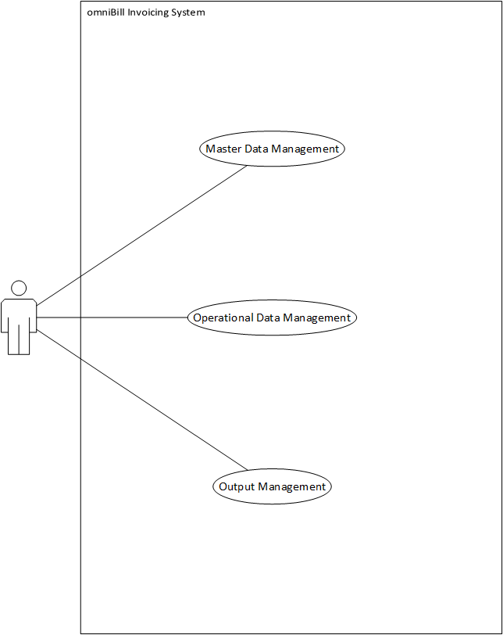

Services
Master data management
This use case serves for retrieving and saving such data as Customer data, Items data, User own company data.

Operational data management
This use case serves for creating invoices and checking history of invoices.

Output management
This use case serves for printing or exporting invoices into PDF format

Actors
Main user
User is a person who responsible for receiving a customer’s request for service by phone or e-mail, create an invoice and send it back to customer.

Use Cases

Use case dependency diagram
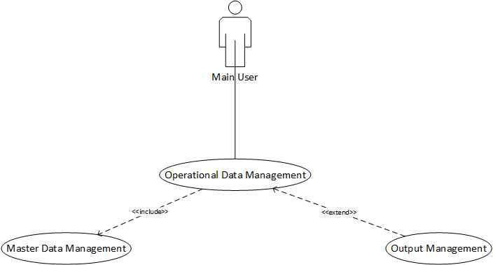

Use Case Description

Master data management
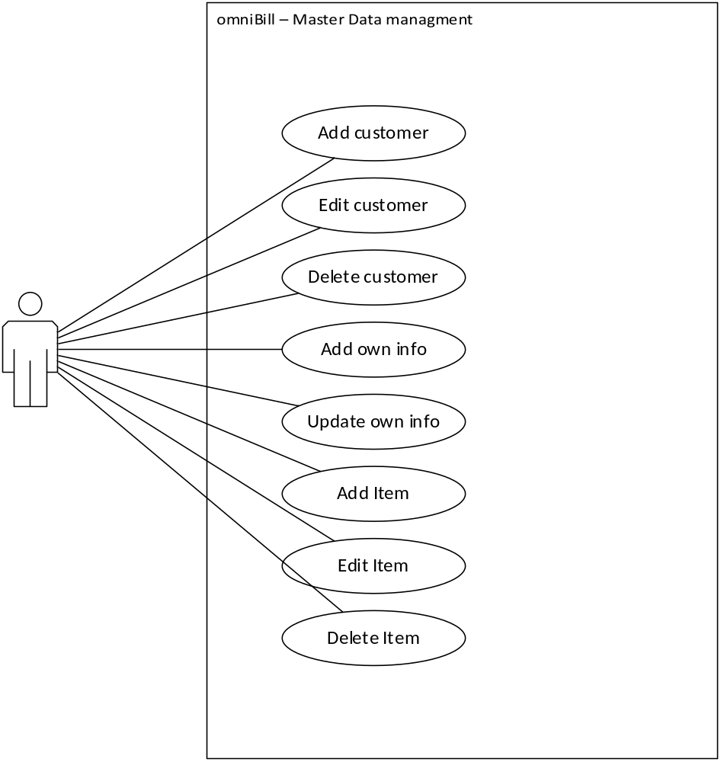

Use Case |  | Master data management
Actor |  | Main user
Pre-condition |  | The system has been installed. The user start to use system.
Goal |  | The User, Customer and Service items have been stored in the system with unique identifiers.
1 | User clicking application exe file and on the start if this is the first use – the system will ask user to fill his own information. Otherwise later the application will just start normally displaying main window.
2 | User Clicks Customer button and the list of customers is shown
3 | User selects desired customer and press edit or delete upper menu button based on action he want to proceed, otherwise user can create new customer.
4 | User Clicks Items button and the list of service items is shown.
5 | User selects desired service items and press edit or delete upper menu button based on action he want to proceed, otherwise user can create new service items.
6 | If user wants to update his own information he/she presses settings button and choosing option edit own information either deletes it or updates.

Operational data management
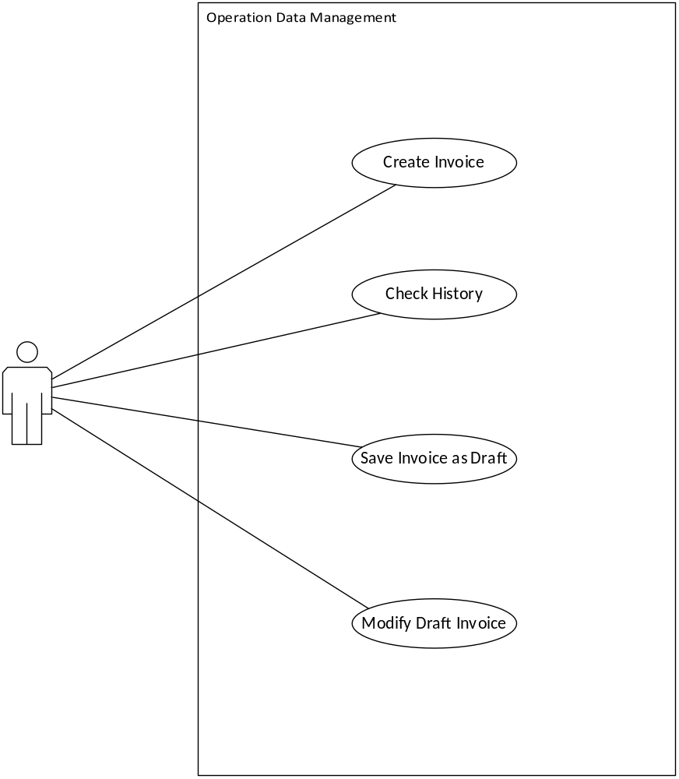

Use Case |  | Operational data management
Actor |  | Main user
Pre-condition |  | Master data has been added.
Goal |  | The invoice or invoice draft is created.
1 | User press Invoice button and the system displays the form to create a new invoice.
2 | User Fills all the needed information.
3 | The Invoice will be saved as draft automatically
4 | Later user can check the history of previously issued invoices or list of drafts by pressing appropriate upper menu button.

Output management
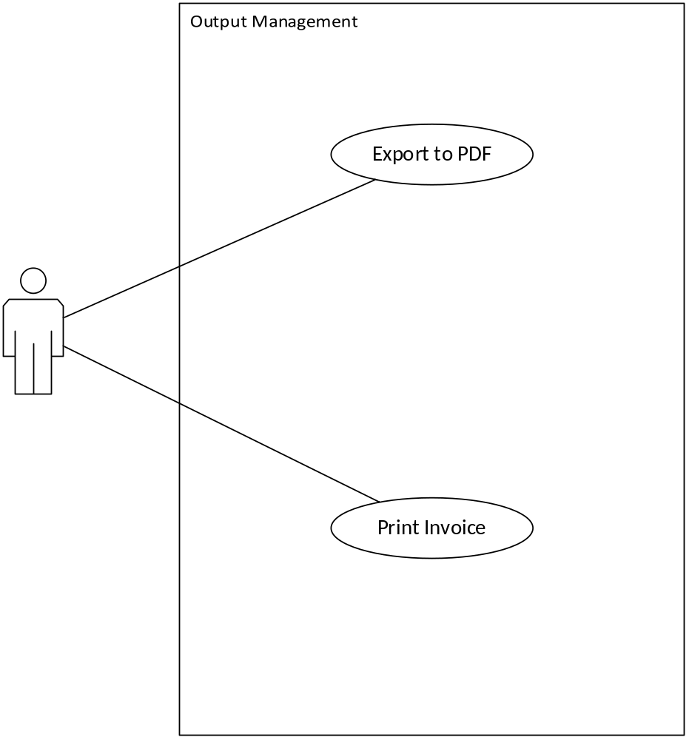

Use Case |  | Output management
Actor |  | Main user
Pre-condition |  | The user has at list one invoice ready
Goal |  | The invoice is printed on paper or saved as PDF doc.
1 | Right after filling appropriate information the user can press Issue button in upper menu.
2 | The dialog box appear where user is given a choice whether user wants to print or export invoice.
3 | User selects and system automatically finalize the output operation.
4 | Later user can select old invoice from history and print it or export it again.

Data Requirements of Displays and Reports
User registry
Company name
Contact name
street
postcode
city
bank name
bank account
business id
phone number
email

Customer entry
name
street
postcode
city
phone number
email

Service Item entry
name
description
price
vat tax

Invoice entry
invoice number
User registry Info
Company name
Contact name
street
postcode
city
bank name
bank account
business id
phone number
email
Customer registry Info
name
street
postcode
city
phone number
email
Item name
item price
item tax
item quantity
item comment

Class Model

Class Diagram
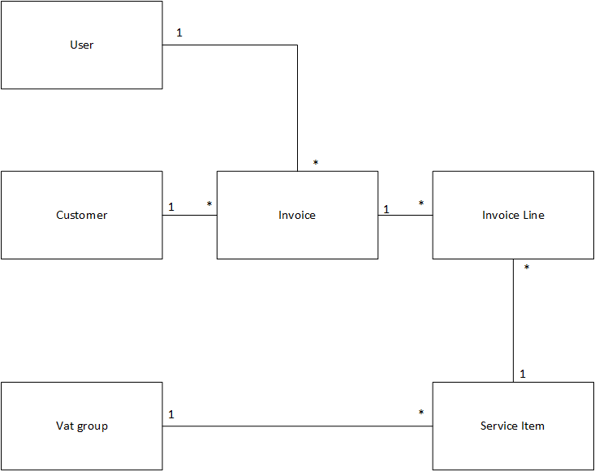

Class Descriptions

User
Class name | User
Definition | User is the person responsible for executing operations in the system.
Super class | -
Attributes | user id | integer | Unique Identifier for user; Automatically Assigned
Attributes | Company name | String
Attributes | Contact name | String
Attributes | street | String
Attributes | postcode | String
Attributes | city | String
Attributes | bank name | String
Attributes | bank account | String
Attributes | business id | String
Attributes | phone number | String
Attributes | email | String
Operations | Create, Read, Update, Delete
Associations | -
Responsibilities | Provide basic information about user
Volume | At the moment the system will only have one user

Customer
Class name | Customer
Definition | Customer is a company who is willing to engage into a long term commercial relation with the user.
Super class | -
Attributes | Customer Id | integer | Unique Identifier for customer; Automatically Assigned
Attributes | Customer name | String
Attributes | street | String
Attributes | postcode | String
Attributes | city | String
Attributes | phone number | String
Attributes | email | String
Operations | Create, Read, Update, Delete
Associations | -
Responsibilities | Provide basic info about customer
Volume | Depending on the business it can range from 1 to 1000 customers, with volatility from 10 to 1000 customer per year.

Vat Group
Class name | Vat Group
Definition | Vat Group indicates the groups of value added tax which is determined by the local government
Super class | -
Attributes | code | integer | Unique Identifier for vat group; Automatically Assigned
Attributes | value | Double
Operations | Create, Update, Delete
Associations | -
Responsibilities | Provide basic information about vat group
Volume | The volume may directly depends on the government and the current laws. In Finland, for example, the government acknowledges 3 groups.

Service Item
Class name | Service Item
Definition | Service Item indicates the services offered by the user to its customers.
Super class | -
Attributes | Service Id | integer | Unique Identifier for service; Automatically Assigned
Attributes | name | String
Attributes | description | String
Attributes | price | Decimal
Attributes | vat group | Integer
Operations | Create, Read, Update, Delete
Associations | VAT group
Responsibilities | Provide basic info about service items.
Volume | Depending on the business it can range from 1 to 1000 service items, with volatility from 10 to 10000 service items per year.

Invoice
Class name | Invoice
Definition | Invoice is an agreement between the customer and user about goods or services the user shall deliver to the customer thereafter the customer will pay for it.
Super class | -
Attributes | Invoice Id | integer | Unique Identifier for customer; Automatically Assigned
Attributes | Owner Id | integer
Attributes | Customer Number | integer
Attributes | Date and time | Date
Operations | Create, Read, Export, Print
Associations | user, customer
Responsibilities | Provide basic info about invoice
Volume | Depending on the business it can range from 0 to large amount of invoices, with volatility from 0 to 10000000 invoices per year.

Invoice Line
Class name | Invoice Line
Definition | Invoice line is a part of invoice which represent the line of the invoice which includes item name and quantity.
Super class | -
Attributes | Invoice Id | integer | PK
Attributes | Item Id | integer | PK
Attributes | quantity | integer
Attributes | comment | String
Operations | Carried out by the system
Associations | invoice, service item
Responsibilities | Provide basic info about invoice line
Volume | Depending on the business it can range from 0 to large amount of invoice lines, with volatility from 0 to 100000000 invoice lines per year.

Objects’ Life Cycles

User
User is registered in the system, user info is used to create invoices.

Customer
Customer is created in the system, customer info is used to create invoices.

Vat Group
Vat group is defined by developers, vat group info is used to create invoices and vat group can be changed by the user.

Service Item
Service item is created in the system, service item info is used to create invoice lines which will be included into invoice.

Invoice
Invoice is created in the system, invoice is printed or exported and old invoice info is can be used to create new invoices.

Invoice Line
Invoice line is created in the system, invoice line is included and undividable part of the invoice.

Data Dictionary
Table name | Description | Medium / max amount
User | User is the person responsible for executing operations in the system. | 1 / 1
Customer | Customer is a company who is willing to engage into a long term commercial relation with the user. | 10 / 1000
Vat group | Vat Group indicates the groups of value added tax which is determined by the local government | 3 / 10
Service Item | Service Item indicates the services offered by the user to its customers. | 20 / 1000
Invoice | Invoice is an agreement between the customer and user about goods or services the user shall deliver to the customer thereafter the customer will pay for it. | 100 / ∞
Invoice line | Invoice line is a part of invoice which represent the line of the invoice which includes item name and quantity. | 300 / ∞

Table | Column | Description | Data type | NULL / unique | PK
Customer | Customer number | Surrogate key | Integer | Not Null | PK
 | Company name |  | NVARCHAR(100) | Not null
 | Contact name |  | NVARCHAR(50)
 | Street address |  | NVARCHAR(100)
 | Postcode |  | NVARCHAR(10)
 | City |  | NVARCHAR(50)
 | phone |  | NVARCHAR(50)
 | email |  | NVARCHAR(50)
User | User number | Surrogate key | Integer | Not Null | PK
 | Company name |  | NVARCHAR(100)
 | Contact name |  | NVARCHAR(100) | Not Null
 | Street address |  | NVARCHAR(100)
 | Postcode |  | NVARCHAR(10)
 | City |  | NVARCHAR(100)
 | phone |  | NVARCHAR(100)
 | email |  | NVARCHAR(100) | Not null
 | bankName |  | NVARCHAR(100)
 | bankAccount |  | NVARCHAR(100)
 | businessId |  | NVARCHAR(100)
Vat group | Group Code | Surrogate key | Integer | Not Null | PK
 | Percentage |  | Decimal | Not Null
Service item | Item number | Surrogate key | Integer | Not Null | PK
 | item name |  | NVARCHAR(100) | Not Null
 | description |  | NVARCHAR(1000)
 | price |  | Decimal
 | vat Group Code | foreign key | integer
Invoice | Invoice number |  | Integer | Not null | PK
 | user number | foreign key | Integer | not null
 | customer number | foreign key | Integer | Not null
 | Date and time |  | DATETIME | Not null
Invoice line | invoice number | foreign key | Integer | Not Null | PK
 | service item id | foreign key | Integer | Not null | PK
 | quantity |  | Integer | Not null
 | comment |  | NVARCHAR(500)

Summary of Data Use
The following table summarises and gives top level understanding of the use of the stored information by different use cases.

Class  Use case | User | Customer | Vat group | Service item | Invoice | Invoice line
Master Data Management | C, U, D | C, U, D |  | C, U, D
Operational Data Management | R | R | R | R | C, U | C, U, D
Output management | R | R | R | R | R | R

Business Rules
- Only reliable employee or Sales representative should be main user
- Only one user should exists per department
- After creating each 10 new customers user have to manually check if some customer doesn't want to continue business relations anymore
- After creating each 20 new service items user have to manually check if some service items are not offered by the user company anymore
- If the customer doesn't comply to invoice agreement regarding the expiration date, then the user sends a reminder to customer and postpone automatically due date only once for five days

Interfaces to other Systems
The basic version 1.0 of the omniBill Invoicing System should not support any other systems thus will not provide any external interface.

System Design
The tools that will be used for the first prototype are Visual Studio IDE, Windows Presentation Foundation and the MS SQL Compact Edition database. For the second prototype will be used Qt Creator (Cross-platform C++ development environment) and SqLite database. The company responsible person either sales assistant or office chief will use the desktop application that runs on his computer natively.

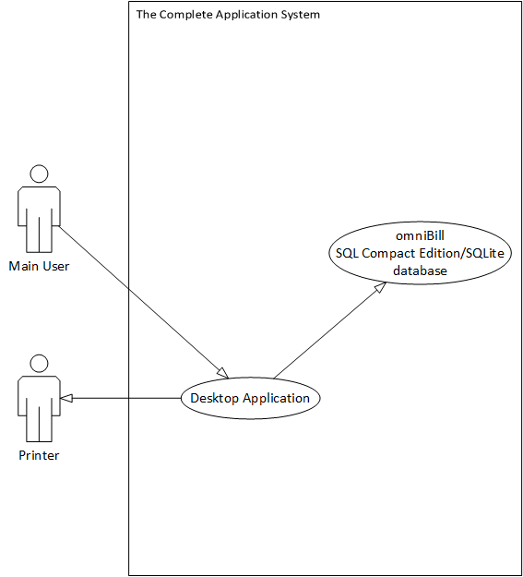

Non-functional requirements

Security
Only authorised user who get permission from chief is allowed to use the services provided by the use cases. The following table summarises the user rights.’
Use Case  Actor | Master data  management | Operational data management | Output  management
Main user | X | X | X

Test Cases

Master Data Management
When entering the appropriate field, unique identifiers are assigned to them, following the instructions provided in the application.

Scenario
Use Case | Master data managment
Actor: | Main Actor
Pre Condition: | The user has successfully set up omniBill for the first time
Goal: | The main actor is able to successfully store the desired information into the database
1 | The actor selects the desired tab.
2 | The actor fills in the fields with the appropriate information.
3 | The actor selects the appropriate action.
4 | The system performs the desired operation.
5 | The systems display a message indicating the failure or success of the previously performed operation.

Operational Data management
When entering the appropriate field, unique identifiers are assigned to them, following the instructions provided in the application.

Scenario
Use Case | Operational data management
Actor: | Main Actor
Pre Condition: | The user has successfully inputted all the needed master data
Goal: | The main actor is able to successfully create invoice and check history of invoices
1 | The actor selects the desired tab.
2 | The actor fills in the fields with the appropriate information.
3 | The actor selects the appropriate action.
4 | The system performs the desired operation.
5 | The systems display a message indicating the failure or success of the previously performed operation.

Output management
When entering the appropriate field, unique identifiers are assigned to them, following the instructions provided in the application.

Scenario
Use Case | Output management
Actor: | Main Actor
Pre Condition: | The user has successfully created at least one invoice
Goal: | The main actor is able to successfully print invoice or export it
1 | The actor selects the desired tab.
2 | The actor fills in the fields with the appropriate information.
3 | The actor selects the appropriate action.
4 | The system performs the desired operation.
5 | The systems display a message indicating the failure or success of the previously performed operation.

Preliminary Implementation Plan

1st Iteration (Preparation):
Project management:
- Software proposal
- Ideas brainstorming
- Market research
- Defining the project scope and Development strategy

Requirements Analysis:
- Sketching conceptual Use cases.
- Sketching conceptual ER diagram

Software Design
- Finding appropriate technology
- Defining Solution Design
- Mock ups of User Interface

2nd Iteration (Analysis and Design):
Project management:
- Defining Phases and stages of development
- Creating set of tasks

Requirements Analysis:
- Complete ER diagram
- Complete Use Cases
- Defining components
- System design
- Requirements documentation

Software design:
- Database diagram
- Complete UI mock ups
- Components Architecture
- Class diagram
- Test plan

3rd Iteration (Prototyping and unit testing)
Software design:
- Individual components complete design
- Assurance of solution integrity

Implementation:
- Physical database implementation
- Basic UI implementation
- Generating Models and implementing data access layer
- Logical layer component implementation
- Integration and testing
- Adding specific printing and converting functionalities to components
- Integration and testing

4th Iteration (Implementation and Quality Assurance)
Implementation:
- Porting to Qt

Project planning:
- Creating reports

Analysis and design:
- Updating documentation

Quality Assurance:
- Integration and testing
- Creating test reports

