

SOFTWARE DESIGN DOCUMENTATION
of Invoicing System omniBill

omniSpectrum

Version1.0
Created by Karppinen Niko, Freitas Daniel, Shkunov Alexander 30.03.2014
Reviewed by Juha Pispa
Approved by

Table of contents
1 Database Design 1
1.1 Logical Design 1
1.2 Physical Design 1
1.3 Database Implementation 4
2 Architectural design 4
2.1 System Structure 4
2.2 Database component 5
2.3 Data Access Layer 5
2.4 Logic layer 6
2.5 Output Component 6
2.6 Presentation layer 6
3 User Interface design 7
3.1 User Interface screens 7
3.1.1 Master Application layout 7
3.1.2 About view 7
3.1.3 List view 8
3.1.4 Quick details view 9
3.1.5 Single view 9
3.2 Information content of tabs 10
3.3 Navigational model 11
4 Component design 12
4.1 Components class diagrams 12
4.1.1 Data Access Layer 12
4.1.2 Core logic component 12
4.1.3 Output component 13
4.1.4 Presentation layer 13
4.2 Components interaction 14
5 Testing plan 14
5.1 Component and System testing 14
5.2 Usability testing 14

Database Design
Database design derives from analysis documentation. Entity relation diagram described in previous documents will be used as basis for logical and sequentially for physical scheme of the database.

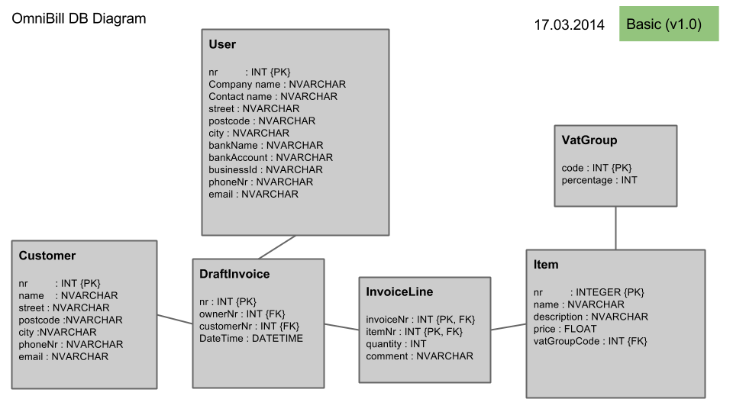
Logical Design

Physical Design
Physical Schema
All the primary key represented by integer data type and should use auto increment. Column descriptions with data types correspond to technical storage (Relational database, SQL CE local database / SQLite local database.

Data Dictionary
Table name | Description | Medium / max amount
User | User is the person responsible for executing operations in the system. | 1 / 1
Customer | Customer is a company who is willing to engage into a long term commercial relation with the user. | 10 / 1000
Vat group | Vat Group indicates the groups of value added tax which is determined by the local government | 3 / 10
Service Item | Service Item indicates the services offered by the user to its customers. | 20 / 1000
Invoice | Invoice is an agreement between the customer and user about goods or services the user shall deliver to the customer thereafter the customer will pay for it. | 100 / ∞
Invoice line | Invoice line is a part of invoice which represent the line of the invoice which includes item name and quantity. | 300 / ∞

Table | Column | Description | Data type | NULL / unique | PK
Customer | Customer number | Surrogate key | Integer | Not Null | PK
 | Company name |  | NVARCHAR(100) | Not null
 | Contact name |  | NVARCHAR(50)
 | Street address |  | NVARCHAR(100)
 | Postcode |  | NVARCHAR(10)
 | City |  | NVARCHAR(50)
 | phone |  | NVARCHAR(50)
 | email |  | NVARCHAR(50)
User | User number | Surrogate key | Integer | Not Null | PK
 | Company name |  | NVARCHAR(100)
 | Contact name |  | NVARCHAR(100) | Not Null
 | Street address |  | NVARCHAR(100)
 | Postcode |  | NVARCHAR(10)
 | City |  | NVARCHAR(100)
 | phone |  | NVARCHAR(100)
 | email |  | NVARCHAR(100) | Not null
 | bankName |  | NVARCHAR(100)
 | bankAccount |  | NVARCHAR(100)
 | businessId |  | NVARCHAR(100)
Vat group | Group Code | Surrogate key | Integer | Not Null | PK
 | Percentage |  | Decimal | Not Null
Service item | Item number | Surrogate key | Integer | Not Null | PK
 | item name |  | NVARCHAR(100) | Not Null
 | description |  | NVARCHAR(1000)
 | price |  | Decimal
 | vat Group Code | foreign key | integer
Invoice | Invoice number |  | Integer | Not null | PK
 | user number | foreign key | Integer | not null
 | customer number | foreign key | Integer | Not null
 | Date and time |  | DATETIME | Not null
Invoice line | invoice number | foreign key | Integer | Not Null | PK
 | service item id | foreign key | Integer | Not null | PK
 | quantity |  | Integer | Not null
 | comment |  | NVARCHAR(500)

Database Implementation
For windows version Microsoft libraries for data access will be used. The implementation of Qt version will rely on Qt drivers. No object relation mappings will be used, all the interactions will happen through standard sql queries.

Architectural design

System Structure
The omniBill system is a standalone desktop application, thus it represents monolith single-tier architecture. The only interaction with external resources is printing, but for obvious reasons, that kind of interaction in conjunction with network structure is up to the user and operation system in use.

The application consist of five components:
- Data storage (Sql compact edition / SQLite & XML)
- Data Access Layer (C# / C++)
- Logic Layer (C# / C++)
- Output Component (C# / C++)
- Presentation Layer (XAML / QML)
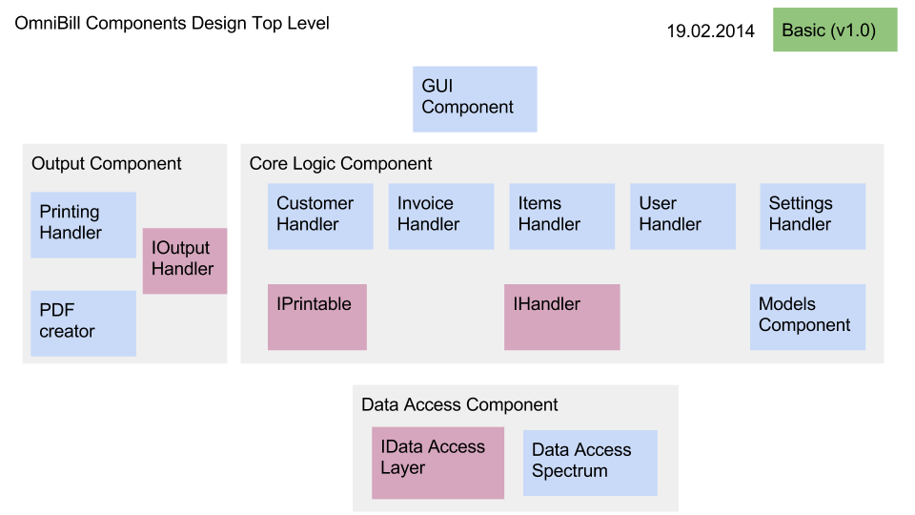

Database component
The main reason for choosing Sql compact edition and SQLite relational database management systems is quite simple: they are quite light, so not much computational resources needed to run the engine on a laptop. Plus to that the needed libraries for running the database can be easily shipped to user, which ease the life for a user because he does not need to worry about purchasing additional software. For specific settings data XML files will be used.

Data Access Layer
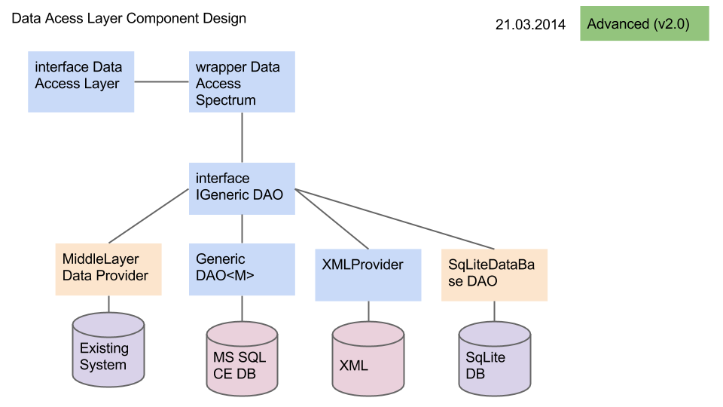

The data access layer consists of three functional classes, one public interface and one internally used generic interface. Interface “Data access Layer” is the public interface which declare services the whole component provides to other components. Wrapper “Data Access Spectrum” serves as a context class which manages all other classes inside the component. Wrapper was created according to Composition design pattern and with purpose to illuminate even more the data access layer from the rest of the application, so that any changes what happens inside data access layer does not influence any other component, thus modularity, flexibility and easy class/data storage in use replacement is guaranteed.

Logic layer
Logic layer consists of model defined handlers such as customer handler, invoice handler and etc. Mainly it has three purposes: adaptor between data access and user interface, adaptor between output management and user interface, financial calculations. All the handlers interacts with data access layer only through single Wrapper, thus “black box” concept and modularity is kept. All the handlers implement IHandler interface in order to provide common declaration of service provision and possibility for polymorphism usage later.

Output Component
Output component consist of two functional classes, where both implements the same public interface “output handler”. Printer handler stands for calling platform services for printing a document, whereas pdf creator stands for creating pdf files.

Presentation layer
Presentation Layer consist of user interface mark-up file “main window” and code-behind file which stands for handling events, such as button clicks and calls appropriate logic handler.

User Interface design

User Interface screens

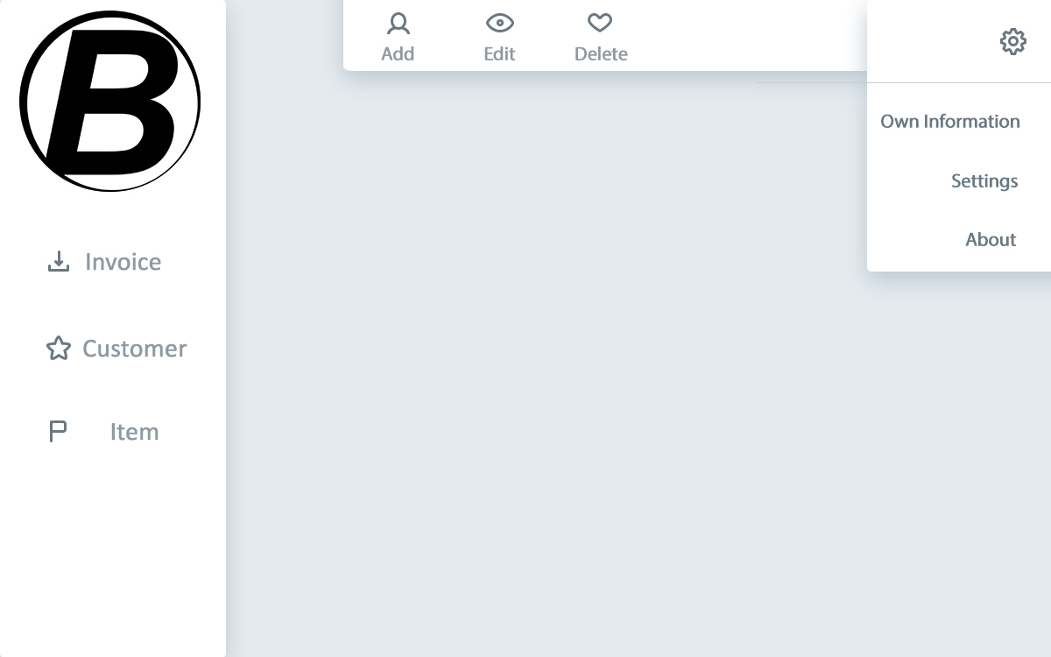
Master Application layout
Content Wrapper

All the content pages/views will be dynamically rendered in the section named in the picture above “Content Wrapper”.

About view
About view will also serve as a starting screen, displayed on every application start
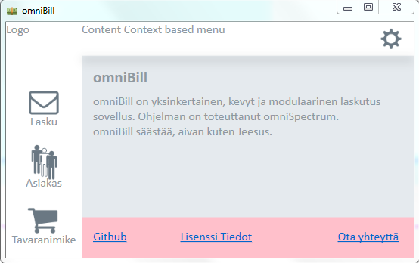

List view
For main application entities, which are “Customer, Invoice, Item” The list view will be almost identical with few minor differences. List view will be represented by table with rows division, but without columns division.
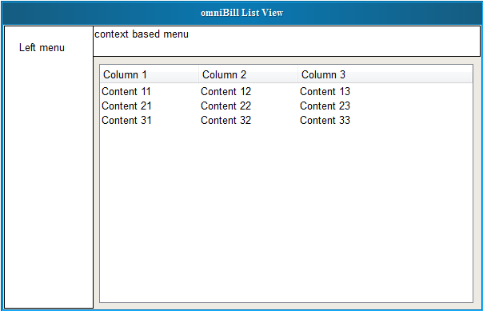

Quick details view
For main application entities, which are “Customer, Invoice, Item” The quick details view will be almost identical with few minor differences.
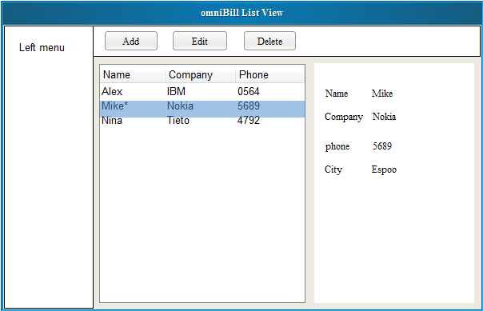

Single view
For main application entities, which are “Customer, Invoice, Item, User” The single view will be almost identical with few minor differences.
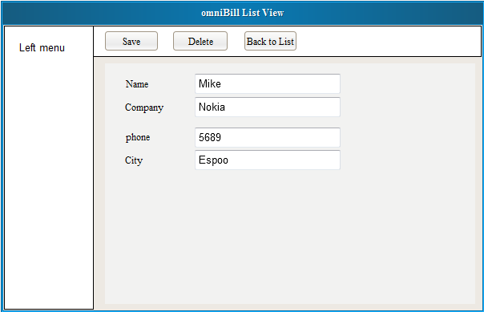

Information content of tabs
Tab | Content | Possible actions
About tab | omniBill application description, message to end user, current version of application, links to omniSpectrum github web page, link to license, link to omniSpectrum email. | Open in default browser omniSpectrum github page, Send email using default email app.
User tab | User company name, user full name, street, post code, city, bank name, business id, phone number, emal | Update user information, Clear user information
Settings | Current language in use, current version | Check for updates, change language
Customer list tab | Company name, contact name, city | Add new customer, Select customer for quick view
Customer quick view side tab | Company name, contact name, street, postcode, city, phone number, email | Update selected customer info, delete selected customer, Create invoice for the selected customer
Customer single view tab | Company name, contact name, street, postcode, city, phone number, email | Save changes, cancel changes, delete customer
Service item list tab | Item name, item price | Add new service item, select service item for quick view
Service item quick view tab | Item name, item description, item price, item added value tax | Update selected service item info, delete selected service item, create invoice with selected service item
Service item single view | Item name, item description, item price, item added value tax | Save changes, cancel changes, delete service item
New Invoice tab | Customer info, user info, invoice lines, terms of invoice (period to pay) | Selected customer, select service items, define terms of the invoice, issue invoice, check ledger of invoices, cancel invoice creation
New invoice tab issue invoice popup | None | Print, export to PDF, cancel
Invoice ledger tab | Invoice number, customer company, date | Select for quick view
Invoice ledger quick view tab | Invoice number, full customer info, full user info, full info about invoice lines with service items | Repeat invoice

Navigational model
Application starts on “About tab”.
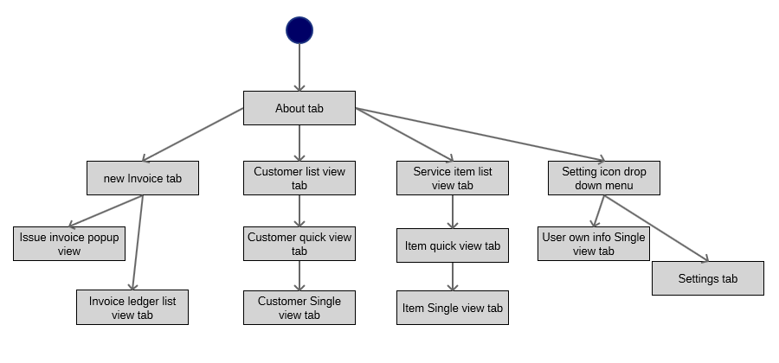

Component design

Components class diagrams

Data Access Layer
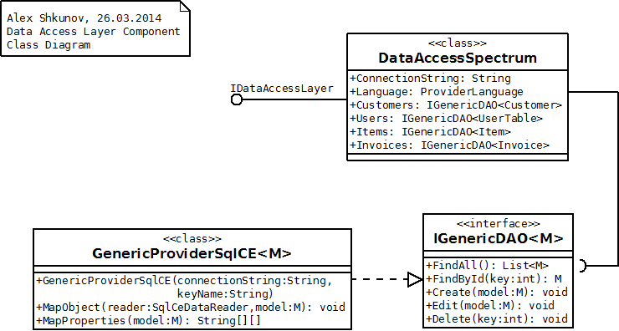

Core logic component
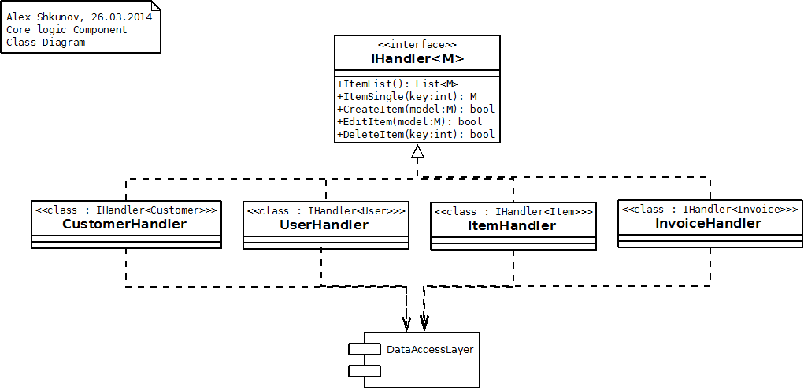

Output component
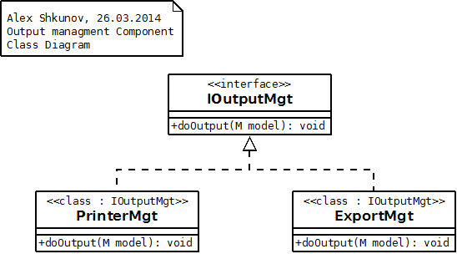

Presentation layer
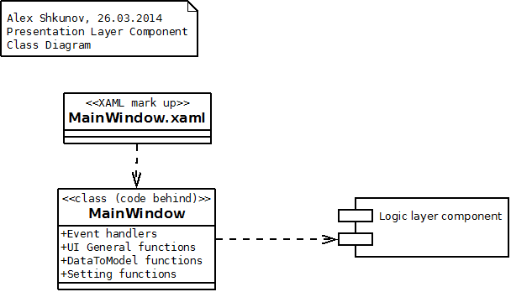

Components interaction
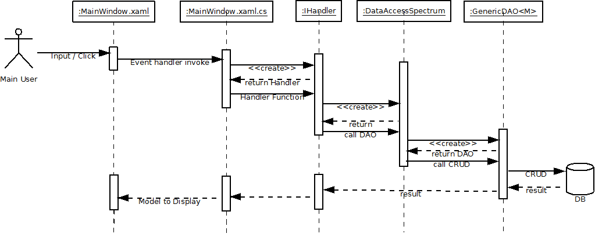

Testing plan
Several methods will be used in testing. All the results will be recorded and delivered as testing report.

Component and System testing
For each and every component unit testing will be done. Most important functions should be tested for logical errors presence and correct program flow. After component integration, system testing should be conducted based on software requirements use cases. Test report should include criticality of each found errors. Conducted tested should be prioritized. Scenarios for test cases already defined in omniBill Software requirements documentation.

Usability testing
For testing usability volunteers will be asked for help. They will be asked opinions about: background colour, font family and size, size of navigational icons. After that they will be asked to conduct simple actions with the software, and time of completion will be recorded. In the end volunteers will be asked for free feedback about omniBill usability. All test results will be recorded and delivered within testing report.

