

SYSTEM REQUIREMENTS DOCUMENTATION
of Invoicing System omniBill

omniSpectrum

Version 1.1
Created by Karppinen Niko, Freitas Daniel, Shkunov Alexander 13.05.2014
Reviewed by P.Kamaja
Approved by

Table of contents
1 Background 1
1.1 omniBill’s functions 1
1.2 Focus of the analysed system area 2
2 Overall description of Invoicing System 2
2.1 Customer information management 2
2.2 Own information management 2
2.3 Managing items / services information 2
2.4 Managing invoices 3
2.5 Checking the invoicing history 3
2.6 Exporting and printing documents 3
2.7 System environment of marketing and sales 3
2.7.1 Interest group descriptions 3
2.8 Concepts 4
2.8.1 Conceptual structure 4
2.8.2 Description of concepts 4
3 Functional Description 5
3.1 Managing Own Information 5
3.1.1 Adding own information into the registry 5
3.1.2 Updating own information in the registry 5
3.2 Managing Customer Information 6
3.3 Managing Item and Service information 6
3.4 Managing Invoice 6
3.5 Managing output 6
4 Information processing tasks 6
4.1 Customer Information management – process 6
4.1.1 Adding Customer 6
4.1.2 Updating Customer Information 7
4.1.3 Deleting Customer 7
4.2 Own Information management – process 7
4.2.1 Registering a new user 7
4.2.2 Updating User info 7
4.2.3 Deleting User info 8
4.3 Items / service information management – process 8
4.3.1 Adding new item 8
4.3.2 Updating item 8
4.3.3 Deleting item 8
4.4 Invoice information management – process 8
4.4.1 Create invoice 8
4.4.2 Save invoice 8
4.4.3 Print invoice 9
4.4.4 Check history 9
5 Automation 9
5.1 Automated data processing tasks 9
5.1.1 Master data management 10
5.1.2 Operation data management 13
5.1.3 Output management 15
5.2 Database 16
5.2.1 Customer data 16
5.2.2 User own data 16
5.2.3 VAT group data 17
5.2.4 Item or service data 17
5.2.5 Draft Invoice data 18
5.3 Links to other information processing systems 18
5.4 Non-functional Requirements for Invoicing System 18
5.4.1 Security 18
5.4.2 Usability 18
5.4.3 Interface requirements 19

Background
Project OmniBill was an initiative originally conceived by Niko Karppinen who, after intensive research, decided to come up with a simple solution to invoicing systems. Consequently, this lead to the creation of OmniSpectrum, an organization team headed by Alexander Shkunov, Daniel Freitas and Niko Karppinen.

Projet omniBill is a simple stand-alone, lightweight and modular invoicing desktop software. Primarily, it will be created for small and micro businesses as well as for individual users. Many small firms still use excel spreadsheets for those purposes, and even though spreadsheets are an universal tool, they were not developed with that purpose in mind, for this reason creating and editing invoices becomes a manual, time consuming and ineffective daily routine. Although it is possible to find some web applications for those purposes, there is a catch - web apps always require hosting which always requires money, so sooner or later the user will need to pay for the service. However, omniBill will be shipped for free. Furthermore, with web apps one needs a persistent Internet connection, with modern technologies that is, unfortunately, not always the case. Additionally, security and privacy of your data in a web application are always a concern.

omniBill’s functions
The omniBill offers an easy and fast way to create, edit and print invoices in conjunction with the possibility to store basic information about customers. Elementary procedures with just a couple of clicks will give the user the needed outcome. At any point in time, it will be possible to check an invoice journal to see the history of previous actions and, for example, print or convert an old invoice into a PDF file.

The goal of the omniBill program is to improve the quality of small business companies and individuals and thus essentially increase efficiency and productivity in their work by making their invoicing process easier.

Focus of the analysed system area
Focus of this analysis is on omniBill Invoicing System and it’s data processing. Analysis will be basis for the description written in project plan.
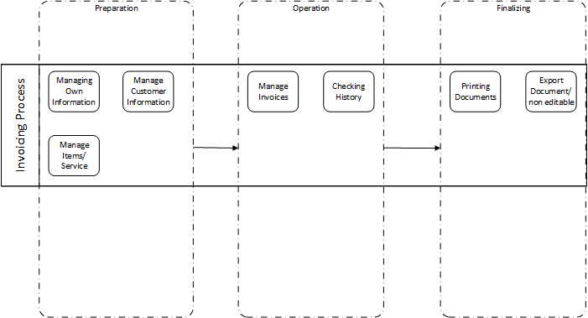

Overall description of Invoicing System

Customer information management
Customers that user wants to be stored will be saved for posterior use. The user has the option to either save a customer for later use or discard it after concluding the desired operation.

Own information management
The user has the possibility to update his/her own information such as the company’s unique identifier, physical address, telephone number, which will all be included in the invoice.

Managing items / services information
The user has possibility to store in database information about the items/services he/she provides in order to facilitate the invoicing process.

Managing invoices
At the heart of the omniBill invoicing system lies the ability of managing one’s invoice.

Checking the invoicing history
The user has the possibility to check the history of all the invoices ever issued.

Exporting and printing documents
The user is able to print documents without the need for a third party application.

System environment of marketing and sales

Interest group descriptions
Business Customer
The target user base of omniBill are small/medium businesses and individuals that are looking for an easy, simple and minimalistic way of issuing invoices without the need to pay for a premium product or spend days at an end trying to figure out overly complex applications.

Customer categories are:
- Small/Medium companies
- Individuals/Freelancers
- omniSpectrum

New invoice customer candidate contacts and:
gives → customer information (name- and contact information)
gets ← a unique customer number as accepted to invoice custome

When customer information has changed customer:
gives → update information

When new invoice is created:
gives → New invoice

Concepts

Conceptual structure
Customer
Invoice
Item /
Service
User
1..1
0..*
0..*
1..*
0..*
1..1

Description of concepts
Customer
The customer is a medium/small company or individual to whom the invoice is issued. Customer information includes, but is not limited to, IBAN, bank requisites, customer contact information, contact person.
User
User is the person responsible for interacting with the software described in this document. Each user will have his/her own account and the software will be responsible for automatically handling each user’s data. Every user will have his/her own unique login and password which will be used to login to the system.
Item or Service
Items in this context refers to the services offered by the user to the customer. Each item will have its own unique identifier, name, description and a price. Taxes applied shall all be calculated automatically.

Invoice
Invoice is the final output of the omniBill application. It basically consists of an aggregation of the components described in the preceding paragraphs.

Functional Description
Function has been described as process diagrams by software components. Only relevant information flows – from Invoicing System point of view – have been described.
Finalized Invoice
Customer
User
omniBill

User Handler
Invoice Handler
Output Handler

Customer Handler

Service Handler

Managing Own Information
Mainly managing own information contains of:
- adding own information into the registry
- updating own information in the registry

Adding own information into the registry
When user first time starts to use the application he/she will need to input own contact and business requisites which all will be used in invoice creation later.

Updating own information in the registry
At any time using the application user have a possibility to change his business or contact requisites to keep up to date.

Managing Customer Information
Mainly managing customer information contains of:
- adding customer information into the database
- updating customer information in the database
- deleting customer information from the database

Managing Item and Service information
Mainly managing Item and Service information contains of:
- adding Item and Service information into the database
- updating Item and Service information in the database
- deleting Item and Service information from the database

Managing Invoice
Mainly managing Invoice information contains of:
- creating an Invoice information
- checking the history of previously issued invoices

Managing output
Output management is about either printing or exporting a document into pdf.

Information processing tasks

Customer Information management – process

Adding Customer
In order for the customer to be added to the software’s database, he/she must contact the user responsible for handling omniBill’s operations. Afterwards, the customer will give all the necessary information required by the company so that the company or individual can be successfully added to the database. Finally, after executing the preceding steps the customer may be added by the user to the software’s database.

Updating Customer Information
If the customer wishes to modify the data previously stored in the database then he/she must contact the company and notify them about the changes they wish to make regarding their data. The information is then passed to the user responsible for handling omniBill’s operations who will subsequently update the information as requested.

Deleting Customer
If the customer no longer intends to have a business relationship with the user and wishes to remove itself from the database, then it is necessary to contact the company to give a formal notification of his/her intentions. After that the data may be deleted by the user. Once the data is deleted omniBill offers no way of recovering it later on.

Own Information management – process

Registering a new user
When a user launches the application for the first time, omniBill should automatically detect whether there is already a user in the xml files. In case no users are found omniBill will them prompt the user to create a new account. The user the should fill in the require info at his/her own discretion and finish the operation so that the application can be fully functional.

Updating User info
If the user wishes to update his/her info then he/she should be capable of doing so by going to the settings menu.

Deleting User info
If a company wishes to remove a user from the softwares database, omniBill allows him/her to do so by simply going to the settings.

Items / service information management – process

Adding new item
The user should be able to add a new item/service by clicking on the corresponding tab which should open the context menu wherein the “add new item” icon is contained.

Updating item
The user is able to update any item or service info by going to the corresponding tab and clicking on the update item info button.

Deleting item
The user should be able to delete an item by going to the corresponding tab and clicking the delete button.

Invoice information management – process

Create invoice
Once customer contact the user and ask for some service - the user should be able to create a new invoice for subsequent handling by clicking on the corresponding icon which should open the context menu wherein the “create invoice” icon is located.

Save invoice
If customer wants to have an invoice in a digital form the user can export it as a PDF format.

Print invoice
If a customer wants to have an invoice in a paper form the user can print an invoice and the n deliver it later to the customer.

Check history
While financial accounting process the user might want to check the history of the previously issued invoices.

Automation

Automated data processing tasks
The service functions of the omniBill Invoicing System are described as sub-systems and use cases.

Master data management
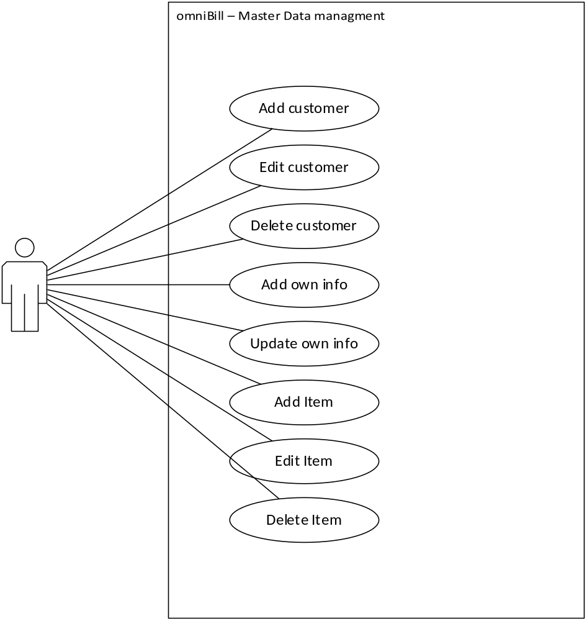

Adding customer
Using this application function, new customers can be added to the system. When adding a new customer, a unique customer ID will be given to each customer from a counter. There has to be a way to make sure the customer to be created doesn't already exist in the system. The retrieval of stored customer information must be easy and fluent. The search criteria may be:
- customer name or any part of the beginning of name
- City
- Company name

When taking the new system into use, there has to be a means to define the start number for the counter giving the unique numbers for the new customers.

Editing customer
Using this application function, the existing customer information can be changed in the system. Search criteria are the same as adding customer.

Deleting customer
Using this application function, the existing customer information can be deleted from the system. System should take care of related child tables in the database.

Adding own information
Using this application function, the user information can be added into the system. Later it should be available in settings.

Updating own information
Using this application function, the existing user information can be changed in the system’s settings.

Adding item
Using this application function, new item or service can be added to the system. When adding a new item or service, a unique item ID will be given to each item from a counter. There has to be a way to make sure the item to be created doesn't already exist in the system. The retrieval of stored item information must be easy and fluent. The search criteria may be:
- item name or any part of the beginning of description
- Manufacturer
- category

When taking the new system into use, there has to be a means to define the start number for the counter giving the unique numbers for the new items.

Editing item
Using this application function, the existing item or service information can be changed in the system. Search criteria are the same as adding customer.

Deleting item
Using this application function, the existing item or service information can be deleted from the system. System should take care of related child tables in the database.

Operation data management
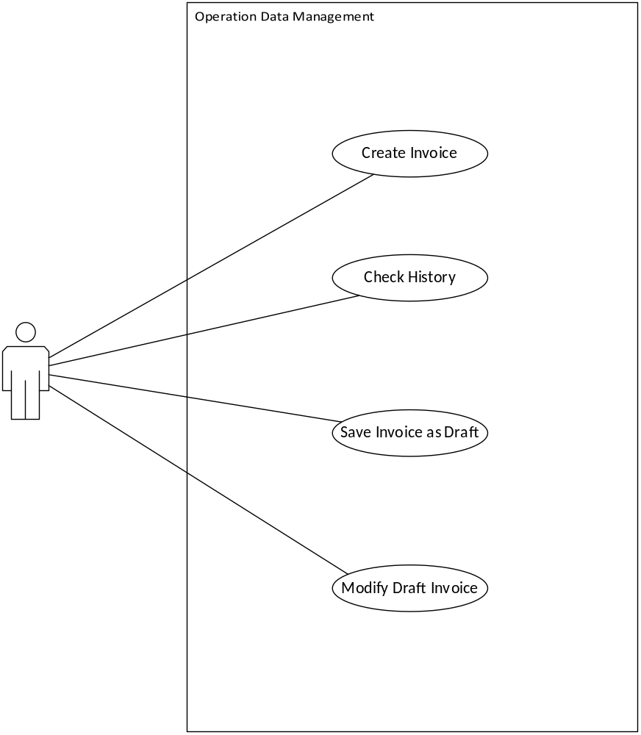
Create invoice
Using this application function, new invoice can be created in the system. When creating new invoice, a unique invoice number will be given to each invoice from a counter. There has to be a way to make sure the invoice to be created doesn't already exist in the system. The retrieval of stored invoice information must be easy and fluent. The search criteria may be:
- invoice number
- Date
- Company name
- Customer name
- Items

When taking the new system into use, there has to be a means to define the start number for the counter giving the unique numbers for the new invoices.

Check history
Using this application function, the list of previously issued invoices information can be retrieved from the system. Search criteria are the same as creating invoice.

Save invoice as draft
Using this application function, the unfinished invoice information can be stored in the system for later.

Modify draft invoice
Using this application function, the existing draft invoice information can be retrieved from the system. Search criteria are the same as creating invoices.

Output management
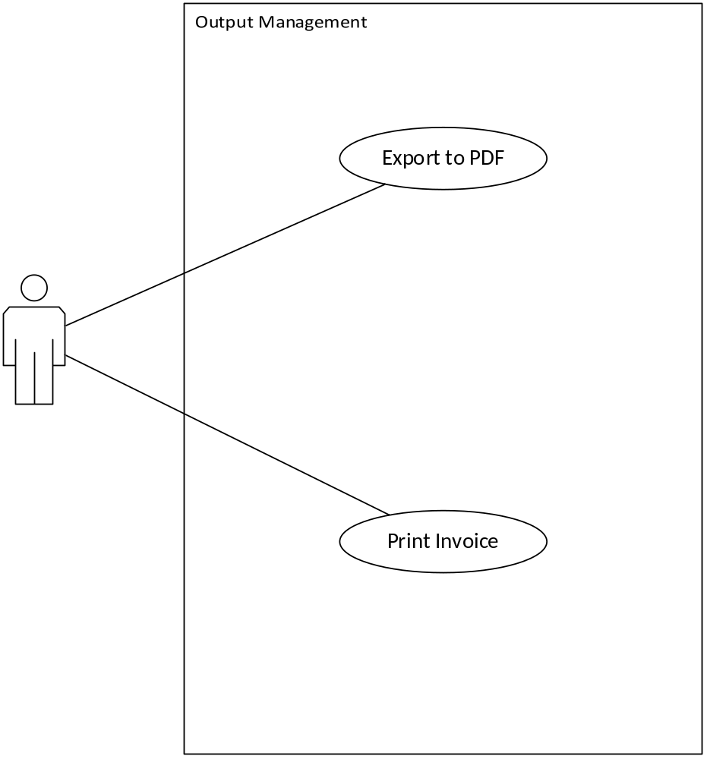
Export to PDF
Using this application function, the created invoice information can be exported from the system to Portable Document Format.

Print invoice
Using this application function, the created invoice information can be printed from the system so that it could be possible to deliver it by post.

Database

Customer data
The omniBill application will be created for small/middle size companies and individuals, thus the amount of customers will vary from 1 up to 50. More than that it is expected that most of the business relationship will last for no longer than half of the year, but it will be up to the user for how long to store information about a customer.

Stored data | Description | Mandatory
Customer number | Unique integer identifier | M
Company name | Alphabetic character value | M
Contact name | A person, representative of customer company
Street address | physical address
Postcode | five digits
City | Name of the city where customer is located
phone | digits and special characters like +()
email | any valid character, unique | M

User own data
In the basic version of application only one user will be able to use the omniBill application, and with high probability that data will be stored in stings XML file rather than database. At any point of time user will be able to edit or delete own data.

Stored data | Description | Mandatory
User number | Unique integer identifier | M
Company name | Alphabetic character value | M
Contact name | A person, representative of user company
Street address | physical address
Postcode | five digits
City | Name of the city where user is located
phone | digits and special characters like +()
email | any valid character, unique | M
bankName | Alphbetical character | M
bankAccount | digits and country code | M
businessId | Unique company code

VAT group data
Assistance parameter table which will be used to define a value added tax for an item or service. It is expected that it will be rarely changed and changes will happen only if Finnish government will change the percentage of those group.
Stored data | Description | Mandatory
Group Code | Unique group identifier | M
Percentage | Numeric value (0 - 100) | M

Item or service data
Information about items will vary from business niche and size, it is expected that data will be changed about once a year. That data will act as master data so in that sense will not be frequently changed as well as amount will be pretty much the same over time.
Stored data | Description | Mandatory
Item number | Unique item identifier | M
item name | Alphabetical character | M
description | plain text
price | float number
vatGroupCode | foreign key to vat group

Draft Invoice data
Invoices will be created on a daily basis, however amount of drafts will be no more than 100 and will mostly consist of foreign keys. Once Invoice will be issued – all related data will be exported and stored for ledger keeping only.
Stored data | Description | Mandatory
Invoice number | Unique invoice identifier | M
user number | Unique user identifier | M
customer number | Unique customer identifier | M
Date and time | Automatic time stamp | M

Links to other information processing systems
In the basic version of the omniBill the architecture does not support any connections to other information systems, however in later versions some kind of middle data access layer will be developed in order to provide user company possibility to share data storage between omniBill and previous information system in order to ensure data integrity and illuminate data repetition.

Non-functional Requirements for Invoicing System

Security
Rights of Access:
All users should authenticate themselves with username and password before being able to access all the functionality of omniBill. Implementing a user hierarchy is not in the scope of this project.

Usability
The user interface should be minimalistic, simple and self-explanatory at all times. The layout, buttons, tab tiling should always keep consistent.

Minimizing User Input
The user interface should minimize the amounts of clicks needed between the initial screen and the desired task. On top of that, the user input should be handled whenever possible by omniBill.

Error handling and error messages:
System should include efficient error preventing procedures and error messaging should be clear and informative.

Automation
Most of the computations and calculations will be done automatically in order to assit the use to accomplish the desired task.

Interface requirements
The application omniBill is stand-alone, cross platform, native desktop, thus it should be rendered nicely on all kind of netbooks with 11 inches screens up to big 24 inch screens providing the responsiveness.

