Owen Lindsey

CST-239

Professor Couch

Milestone 6

10/29/2023

**Part 1.)** UML class diagrams and explanations AND Loom video:

https://www.loom.com/share/c8922890de8a4d73b6160973c924b2ed?sid=755b72ef-b49c-4277-9b36-32d945383d61

Summary of UML diagrams:

The UML diagram for the Milestone Project depicts the structure and relationships between key classes and components in the store management system. At the center of the diagram is the SalableProduct class, representing generic products that can be sold in the store. Three specialized classes, Weapon, Armor, and Health, inherit from SalableProduct, showcasing an inheritance relationship. These subclasses inherit attributes and behaviors from the superclass while adding their own unique characteristics specific to their product type.

The InventoryManager class manages the store's inventory, containing methods to add, retrieve, and return products. It collaborates with the SalableProduct class for product management.

The ShoppingCart class represents a user's shopping cart, capable of storing products and displaying their contents. It maintains a list of SalableProduct items and provides methods for adding, removing, and displaying products.

The StoreFront class acts as the main interface, interacting with users through a console-based menu. It initializes the store's inventory, enables users to view products, make purchases, cancel purchases, view the shopping cart, and exit the program. The class also handles the generation of a receipt file upon program exit.

UML DIAGRAM ON PAGE BELOW:

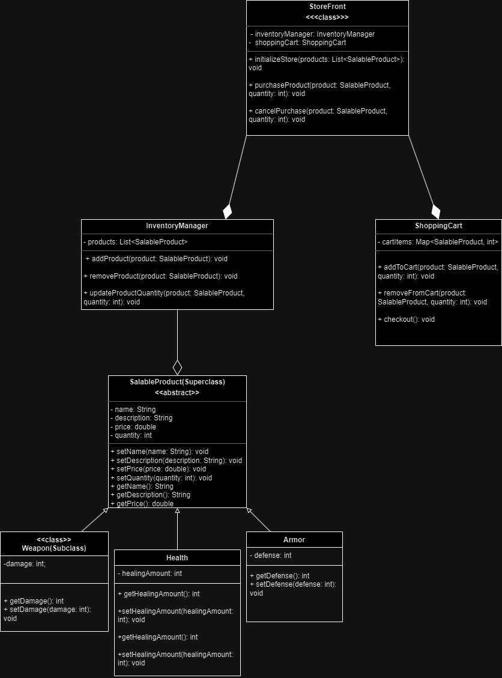

**Part 2.)** Flowchart design and logic

Summary of flowchart / software logic / user logic:

The user will be greeted by a menu with 5 options on start. These options are **purchasing products**, **viewing products**, **canceling purchases**, **viewing carts**, and **exiting**. If the user desires to view products a list of x number of items in the stores inventory will populate in the console. From the list the user will be able to select the item they wish to purchase. If they wish to track their spending, they may view their cart to see the products they have chosen to purchase in the future. Once the user decides to purchase the product(s) they will then be shown a receipt of the items and then the program will update the inventory and exit.

**FLOWCHART ON PAGE BELOW:**

**Part 2.)** Flowchart design and logic

Summary of flowchart / software logic / business logic:

The presented flowchart illustrates a comprehensive process for managing a store's inventory system. It begins with the initialization of an AdministrationService, leading to the loading of the initial inventory from a JSON file. This file is read and parsed to create SalableProduct objects, which are then added to the store's inventory. Subsequently, a console interface is started to handle user commands. Users can update the inventory, return inventory data in JSON format, increment product quantities, or choose to quit. The flowchart provides a systematic and intuitive representation of the store's inventory management workflow.

**FLOWCHART ON PAGE BELOW:**

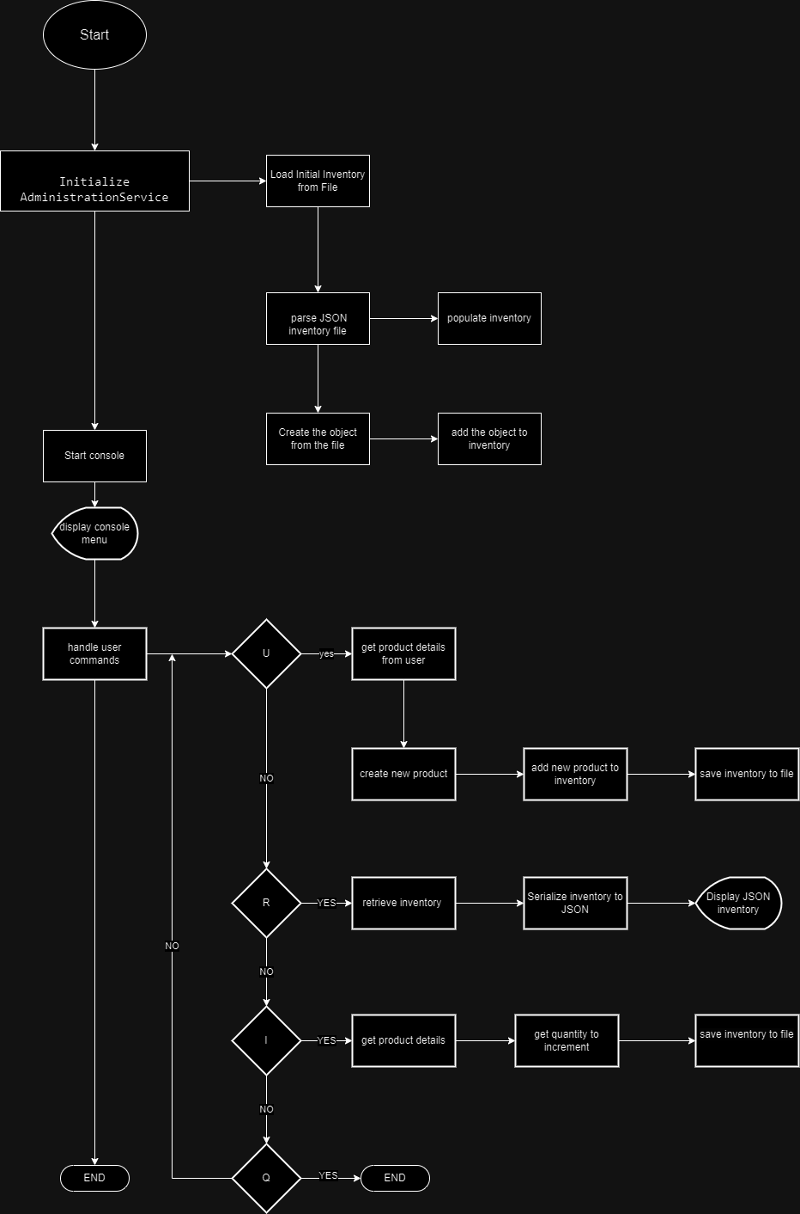

References:

NA