Owen Lindsey

CST-250

Activity 2

2/4/2024

Chess Board console app running. The challenges were met by asking the user what piece they wish to move and then asking for placement on the board. I also decorated the board, so it is easier to read for the user.

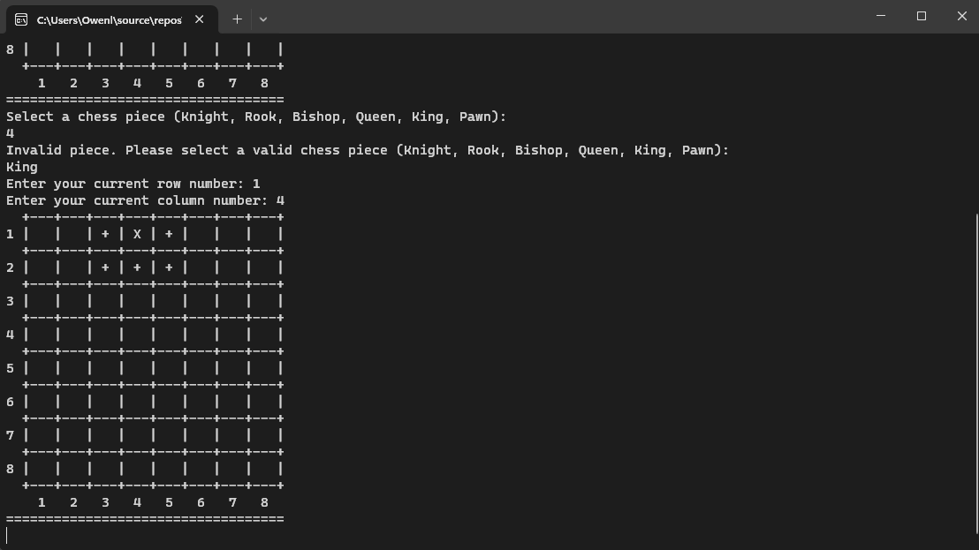

This screenshot is of chess board Gui app running. This satisfies the challenges by updating each button with the word legal and the piece’s name. Rest assured all pieces work here is the Rook and the Bishop being placed on the board.

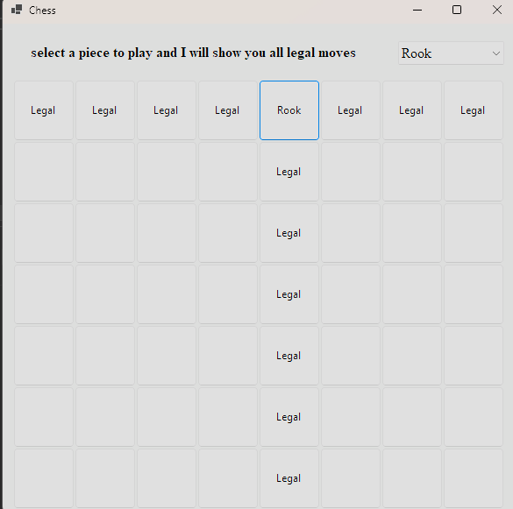

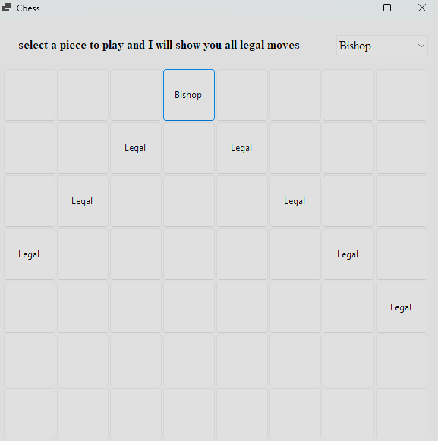

Animal classes Loom video : [Animal Class Project (loom.com)](https://www.loom.com/share/d7cd1f0de2054d54838223949e9160a4)