Owen Lindsey

Professor Sluiter

CST-345

CLC – Activity 8

Option 1: Serving Others

Service to others, a cornerstone of Christian values, gains unprecedented efficiency and reach in today's world through the strategic application of database technology, enhancing the capacity of faith-based organizations to fulfill their missions. Emphasizing the biblical command to love one's neighbor, Christian organizations, as highlighted by Grand Canyon University's "Statement on the Integration of Faith and Work," are called to integrate faith into all aspects of life, including professional and community endeavors.

Database technology emerges as a pivotal tool in this context, offering unparalleled capabilities in managing and analyzing data related to charitable activities. This technology can efficiently track donations and resources, manage volunteer efforts, assess community needs, and facilitate communication and outreach. It thus enables organizations to direct their efforts where most needed, enhancing the overall impact of their service.

In Arizona, the Governor's Office of Youth, Faith and Family (GOYFF) is a noteworthy example of a faith-based organization effectively utilizing database technology. GOYFF coordinates the “beconnected” initiative, partnering with faith communities to support service members, veterans, and their families. They use data-driven approaches to enhance their outreach and service programs. Through these initiatives, they demonstrate how database technology can be strategically applied to improve the efficiency and impact of faith-based missions. This model aligns with the ethos of service in Christianity, emphasizing the role of faith-based communities in societal support and well-being.

SQL databases in support of Christian missions:

SQL databases are indispensable tools that empower organizations globally to manage and analyze large datasets effectively. For Christian organizations, the strategic use of SQL databases can significantly enhance the mission by providing insights through reporting and analytics, particularly during key seasonal events.

By utilizing SQL databases, Christian organizations can meticulously track the outcomes of various charitable initiatives—be it toy collections during Christmas, food donations at Thanksgiving, or special programs during Easter. This data-driven approach allows for a comparative analysis of each event's success, enabling the organization to allocate resources and efforts where they are most impactful. With SQL databases, the organization can quickly query event-specific data, measure effectiveness, and adjust strategies to maximize outreach and support.

Moreover, the relationships with partners, which are crucial for the mission's success, can be efficiently managed within an SQL database. Documenting the start and end dates of partnership agreements, detailing the nature of collaborations, and recording transactional interactions are all facilitated by SQL databases. These records are not only essential for maintaining professionalism and accountability but also serve as a historical repository that informs future partnership strategies.

SQL databases also offer versatility in managing softer aspects of organizational life. For instance, incentives for partners, such as hosting community lunches or recognition events, can be tracked. This adds a personal touch to the professional relationship, fostering a community spirit that is often at the heart of Christian missions.

ER:

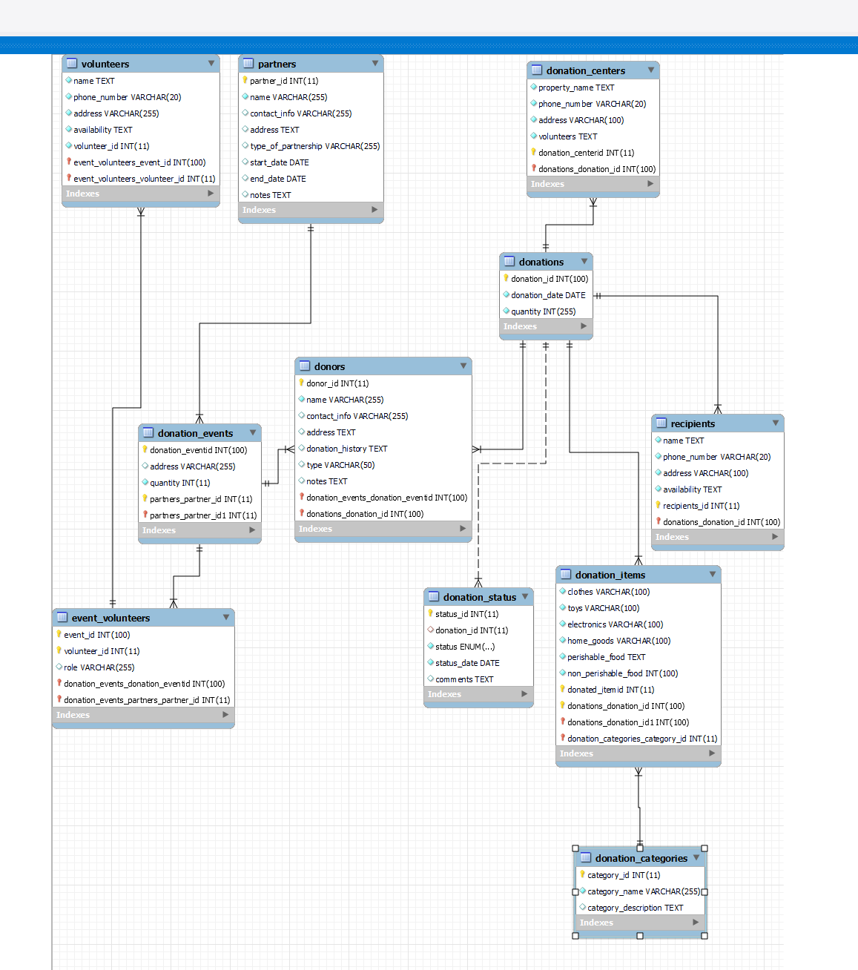

Summary of features:

The ER diagram for this Christian organization's database emphasizes the efficient tracking of donations and the engagement of its community. The schema highlights three pivotal features:

The donation_events table is a cornerstone of the database, enabling the organization to meticulously record and manage details about each donation-related event. This functionality is crucial for evaluating the success of various events, such as holiday-themed drives or community outreach initiatives, and for strategic planning of future activities.

Central to the organization's operations is the event_volunteers table, which captures the participation of volunteers at different events. By tracking volunteer involvement, the organization can not only recognize and provide incentives for their contributions but also analyze volunteer trends to ensure adequate staffing for future events.

The partners table serves as a testament to the organization's collaboration with local entities. It allows the organization to keep a record of all partners who support its mission, whether through sponsorship, donations, or services. This table helps identify and strengthen relationships with consistent supporters and is instrumental in fostering a network of regular and committed partners.

References:

Governor's Office of Youth, Faith and Family. (n.d.). Faith-Based Community Engagement. Retrieved from <https://goyff.az.gov/FaithBasedCommunityEngagement>