Owen Lindsey

CST-345

Professor Sluiter

Milestone 4

11/12/2023

Part 1: Querying Categories

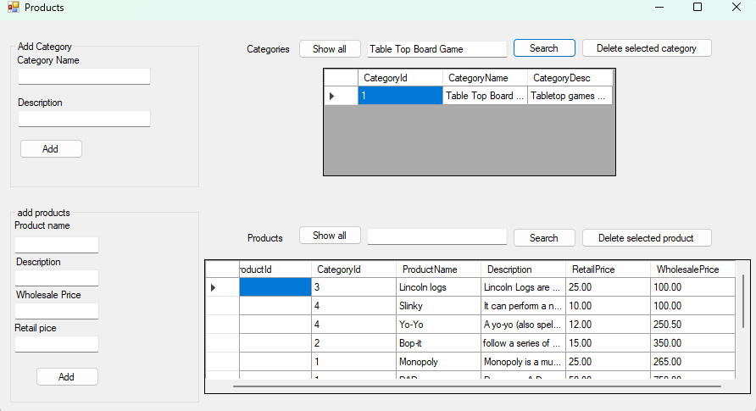

This screen shot displays my application querying for a specific category in our milestone schema. This application can use the ID number, the category name, or the category description to find the desired category.

Part 2: Add a new Category

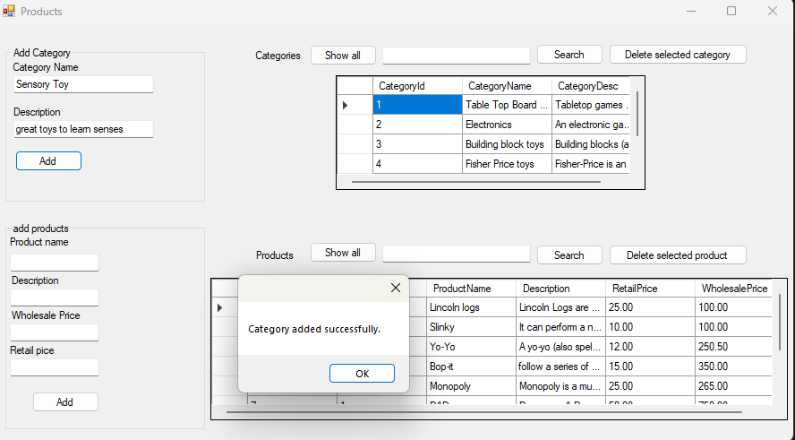

This screen shot shows that a category can be created directly from our application. The BtnAddCategory_ClickEvent handles the user of our GUI applying changes to our backend scheme through our front end.

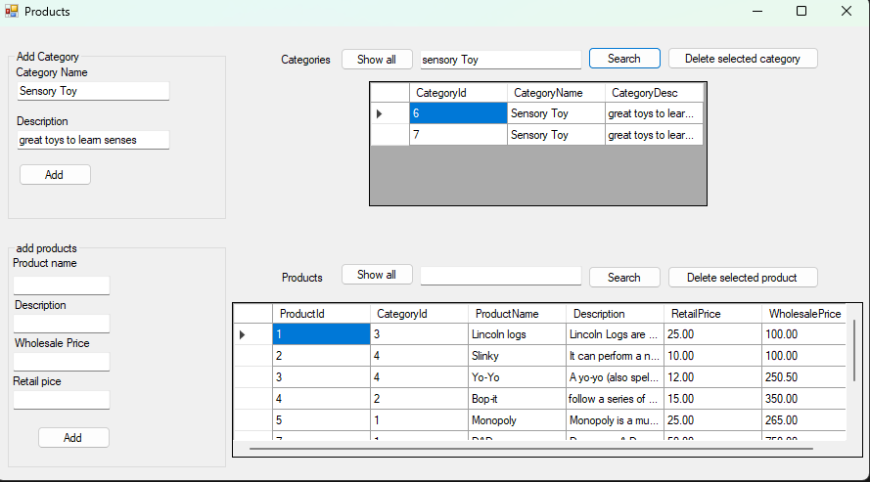

This screenshot shows that the user accidentally created two of the same categories. Their job now hangs in the balance of fixing this mistake. Thankfully this application sports the ability to delete categories in the BtnDeleteSelectedCategory_ClickEvent handler.

Part 3: Delete a category

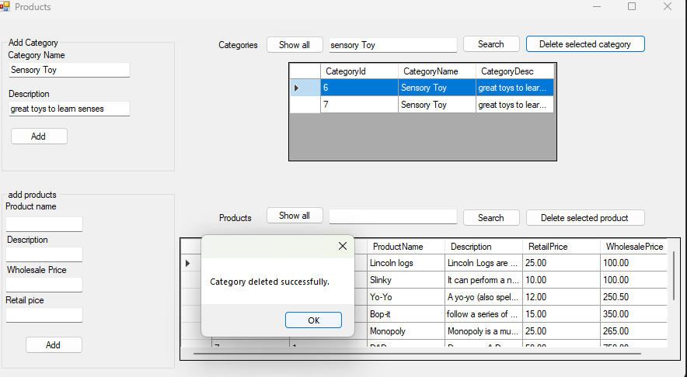

The user must select the cell that contains the table data they wish to delete from the schema. Thankfully due to the search function we can identify the duplicate and easily select the data that we no longer need and then use the delete function to remove that data.

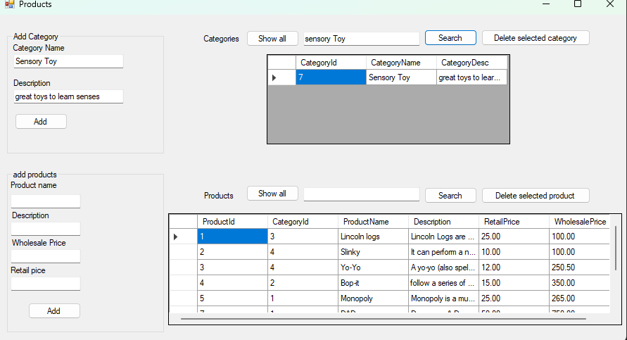

This screenshot shows that the user that accidentally added two of the same table has now successfully deleted that category from our table. The user can now rest easy, and their job is no longer in jeopardy.

Part 4: Add a new product

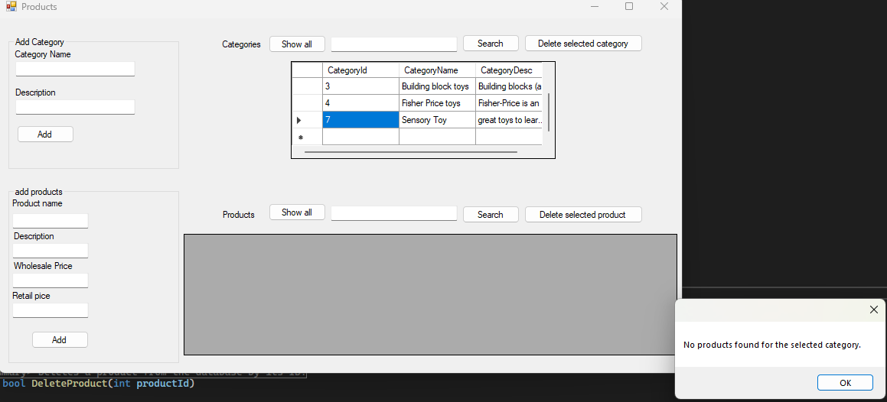

Now the user would like to see if he deleted the correct table and discovers that he deleted the incorrect table. He was able to figure this out due to the applications GvCategories_CellClick event handler. This allows him to click the categoryID cell to see which products are associated with that business. He now knows that the table is empty, and it needs to be populated with the correct data quickly!

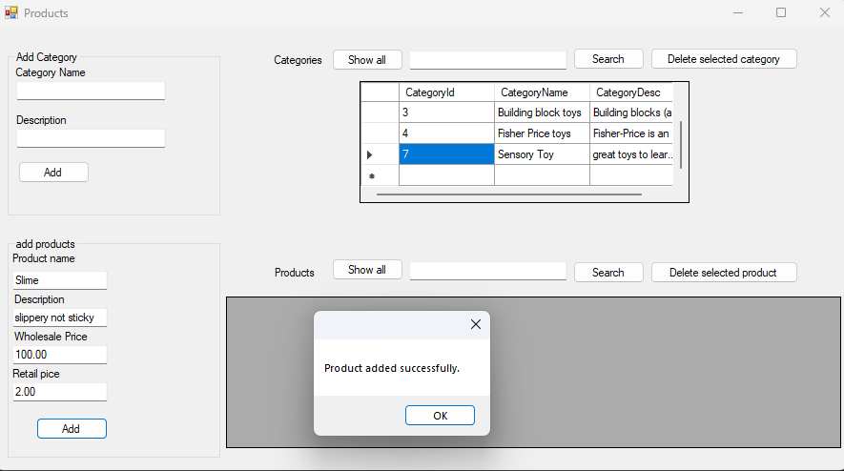

Thankfully, the user has the old table data printed out and can add the product exactly how it was without any issue. The success message on screen shows that the user inputs the data correctly and the selected cell shows that data is going to be related to the sensory toy. This is due to the BtnAddProduct_ClickEvent that allows the user to submit this schema change to our backend.

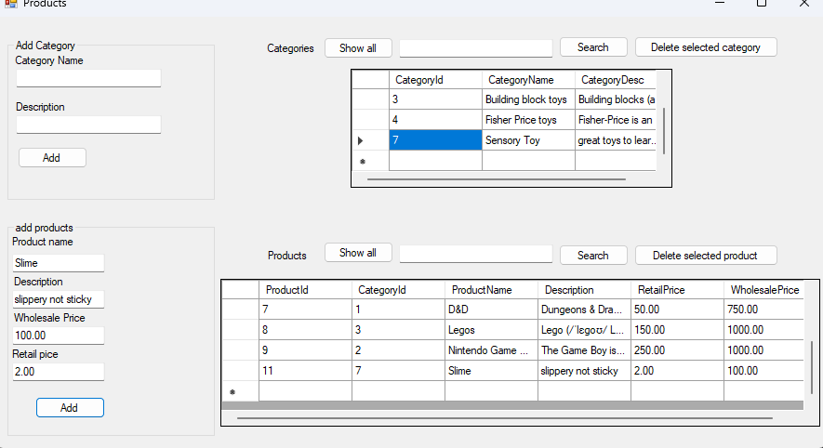

This shows the users desired category ID number is related to the recent data he had just input. This shows the user is now completely in the clear and can continue to do their job!

Part 5: Query Products

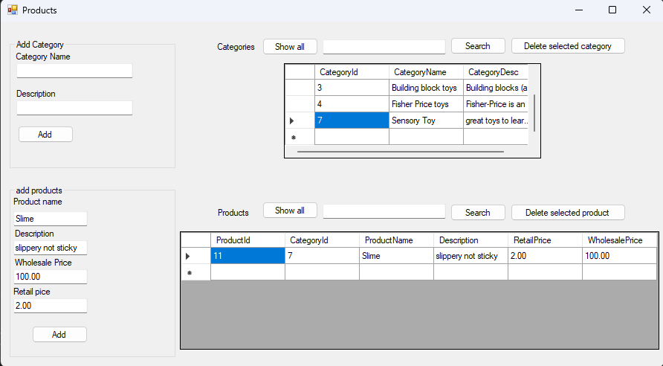

This shows the user can also just click the cell of the category ID. This will populate the product data grid view with the data related to that category. In this example our user double checked their input data ensuring that the schema change was successful.