Owen Lindsey

Professor Sluiter

CST- 345

10/15/2023

Milestone 2

Part 1: SQL Workbench diagrams

* The “**customers”** table contains customer-related details, with each customer having potential links to “**payments”** via the “**CustomerID”**.
* The **payments** table logs payment amounts and dates and is linked to the respective customer who made the payment.
* Products in the “**products”** table are categorized using the “**product_categories”** table. Each product entry has a foreign key, “**categoryID”**, tying it to a particular category.
* Every store in the “**stores”** table has associated employees, represented by the foreign key, “**EmployeeID”**, linking back to the “**employees”** table.
* The “**orderitem”** table captures information about individual orders, linking to customer details, product information, store data, and employee data.
* Further granularity of order data is available in “**orderdetails”**, storing specifics such as quantity and price per product.
* Products are also associated with “**vendors”** through the “**VendorID”** foreign key in the “**products”** table.
* A screenshot of a computer

  Description automatically generatedThe “**employees”** table documents employee details, with each employee linked to a particular store.

Part 2: SQL statements

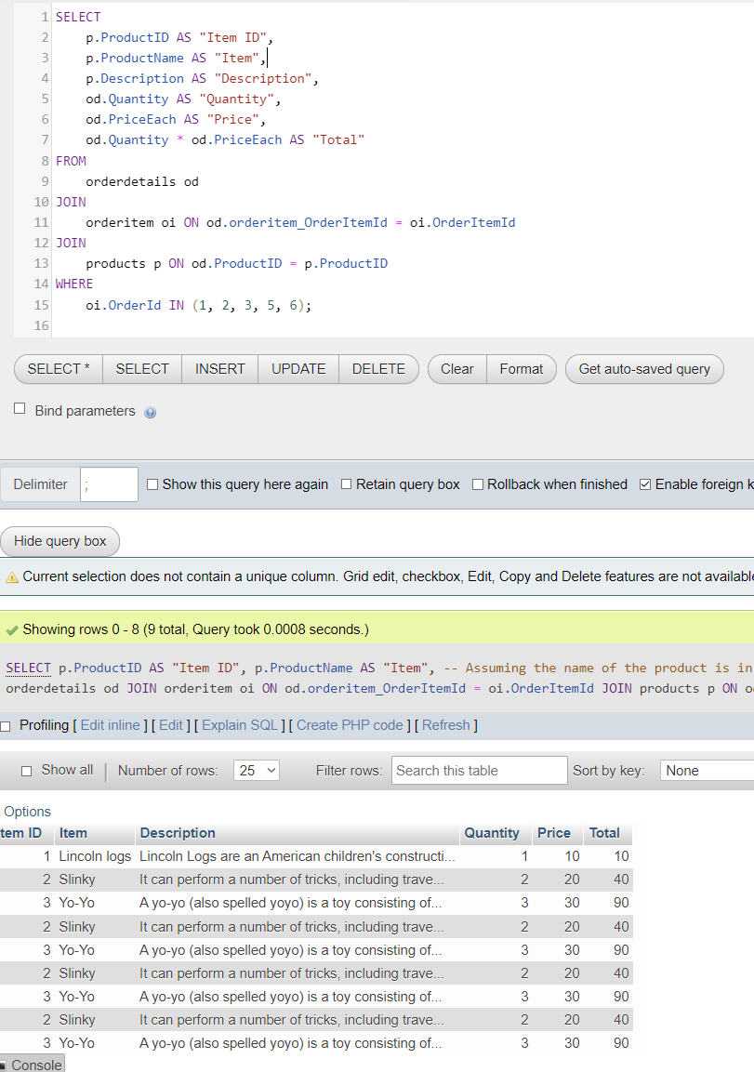This screenshot demonstrates the execution of an SQL query that retrieves detailed information about specific orders. The columns displayed include the product ID, product name (Item), a description of the product, the quantity ordered, the price per item, and the total price for that quantity. The result set shows various items like 'Lincoln logs', 'Slinky', and 'Yo-Yo' with their corresponding quantities, prices, and totals.

The SQL query retrieves details about a specific order by joining several tables: orderitem, products, orderdetails, employees, stores, and payments. It displays the order ID, employee name, store name, product name, quantity of the product, total price for that product, payment amount, and the date of payment. The relationships between these tables are established using JOIN clauses on matching columns, ensuring the accurate gathering of interconnected data. By specifying WHERE oi.OrderID = 1 / 2 / 3, the query filters the results to show details only for order with ID 1.

