# CST-350 Activity 8 Bible Verse Searcher

## Introduction

This assignment is designed to simulate a real-world business environment, where students will use enterprise-programming tools to develop a complex Bible Verse application, thereby honing their skills in solving business problems through coding.

It is similar to a Milestone in that you will follow design requirements rather than tutorial instructions to accomplish your goal. This application will draw on experience from all of the activities and milestones from this semester.

## Application Description

Create a Bible Verse application that allows the user to

1. Find Bible verses by
   1. Providing a direct reference to a Book, chapter, and verse.
   2. Providing a search term and viewing a list of references that contain the term.
2. Add comments to a verse, saving them for later viewing verses.

Figure 1 A mobile Bible app that allows users to add comments while reading a verse.

Application Features

1. Data Source

Import an existing data source into a SQL server. Use "scrollmapper/bible_databases," located in your topic Resources, to download a MS SQL version of the import file.

1. **Search page** with a search form that contains the following form elements:
   * Check box to search Old Testament, New Testament, or both.
   * Input for search term.
   * Search Button (that will search in the database table for the Bible verse).
2. Search Results

When performing a search, display a list of all of the verses that contain the key word or phrase entered by the user. 

Figure 2 Search results for "Kingdom of Heaven"

1. Reference page with drop-down menus displaying:
   1. all the books of the Bible
   2. chapter numbers

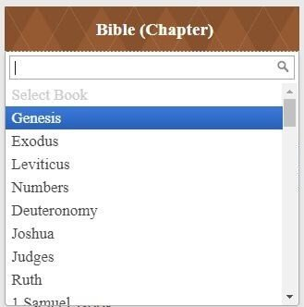

Figure 3 User is selecting a Book from the Bible from a drop-down menu.

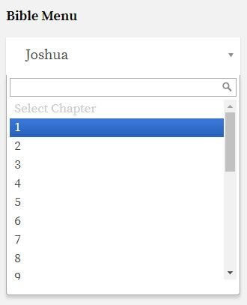

Figure 4 User is selecting a chapter number from the Book of Joshua.

1. Reference results

When performing a reference search, the user will see a list of all verses from the selected chapter. The verses should be displayed in a standard list template. Each verse in the list will have a “details” button that leads to a single verse page.

Figure 5 The verses from John 3 are listed in a table view.

1. Single verse page

This view displays a single Bible verse and any associated notes that have been entered.

A text entry field allowing the user to add more notes.

Technical Requirements:

* + Must be designed using N-Layer web architecture.
  + Must be designed using a data access object (DAO) design pattern.
  + Must be designed using object-oriented programming (OOP) principles.
  + All classes must be fully documented, including a source file header and header for each class.
  + All class methods must be fully documented, including a class header that includes a description of the method, all methods, all return values, and any exceptions thrown.
  + All class method implementation must be fully documented with single inline comments.

## A screenshot of a computer Description automatically generatedDeliverables:

1. Design documents in Word:
   1. UML diagram showing classes, properties and methods used in the app.
   2. Wireframes showing the user interface plan.
   3. ER diagram showing the tables and their relationships.
2. Convert the Microsoft Word document with screenshots of the application being run to a PDF file. Show each screen of the output and put a caption under each picture explaining what is being demonstrated.
3. In the same document, in one paragraph, write a summary of the key concepts that were demonstrated in this lesson. Be sure to explain how this application would be used to impact a Christian community, how would it serve the customer, and what problems it solves.
4. Submit a ZIP file of the project file. In order to save space, you can delete the bin and the obj folders of the project. These folders contain the compiled version of the application and are automatically regenerated each time the build or run commands are executed.
5. Attach the PDF document separately from the zip file. Multiple files can be uploaded with an assignment.