*Owen Lindsey*

*Professor Hughes, Bill*

*CST-350 Activity 3*

*10/20/2024*

**Part 1 Setting up a User Database**  
*Page 22 SELECT * FROM dbo.UserAccount*   
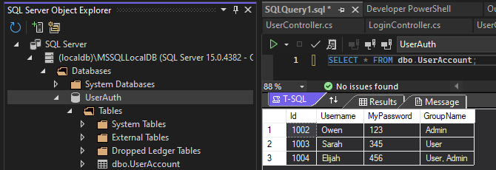

**Part 1 Setting up a User Database**  
*Page 23 adding to data from UserAccount table INSERT INTO*

Table response:

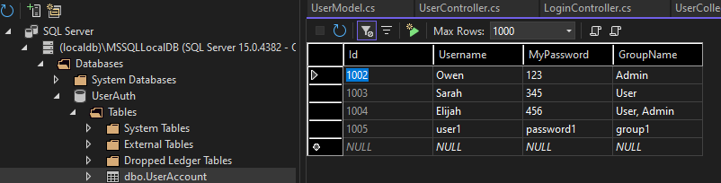

**Part 2 Application features**

*Before delete user*  
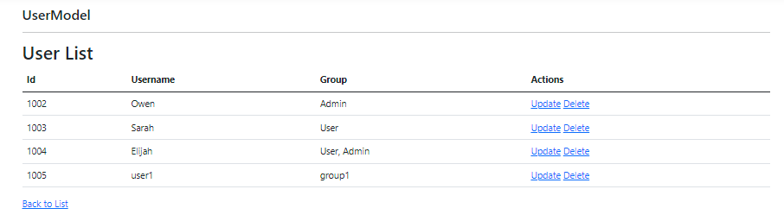  
*After delete user operation*  
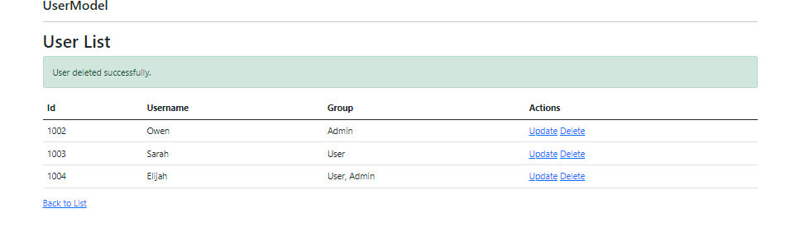

**Part 2 Delete methods**

*Delete method in Data Access Layer*  
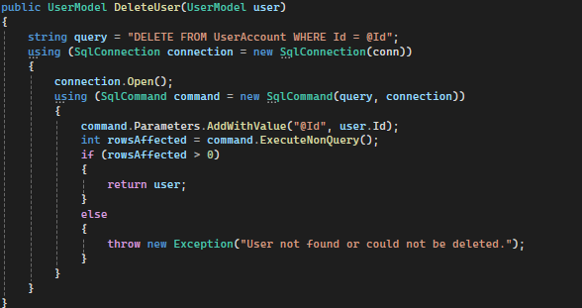  
*Delete method in Business Layer*



**Part 3 screenshot with program running**

*Get all users populating*



**Part 3 get all users methods**

*GetAllUsers method in Data Access Layer*

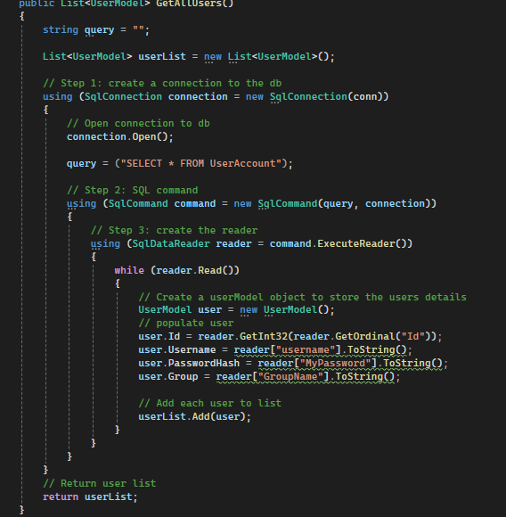

**Part 3 get all users methods**

*GetAllUsers method in Buisness Layer*

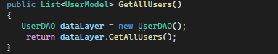

**Part 4 Summary of key concepts**

This lesson demonstrated key concepts in setting up a user database for full-stack applications. We covered SQL Server configuration, implementing CRUD operations, and connecting C# to databases using ADO.NET. Important terms introduced include T-SQL, Separation of Concerns (SoC), Docker for macOS users, and ADO.NET methods like ExecuteScalar and ExecuteNonQuery.