Owen Lindsey

Professor Sparks, James

09/05/2024

CST-391

Milestone 1

Description of application:  
  
  
This application will allow an aircraft maintenance organization manager their fleet. The organization will be able to;

1. See a list of aircraft they are responsible for, its most recent maintenance, and the most recent maintenance details.
2. Open maintenance history on each aircraft to see all the maintenance completed over its lifetime. This form will display the maintenance date, the details, and the technician responsible for the maintenance completed. The user can edit each of these entries or contribute new maintenance data.
3. View the performance metrics of each aircraft. These metrics will be displayed with different graph types to have visual feedback. From this form, the user can add performance metrics, receive total flight times, average oil consumption data, etc.

Functionality Requirements:

* As a user I want to be able to add aircraft performance metrics.
* As a user I want to be able to select an aircraft to update it with maintenance information.
* As a user I want to be able to add aircraft to our hangar spaces whenever a new aircraft comes in for acceptance.
* As a user I want to be able to view and update graphs that give a visual display of maintenance and performance metrics such as maintenance down time; flight hours; engine hours, etc.

Initial database design:   
  
ER diagram -

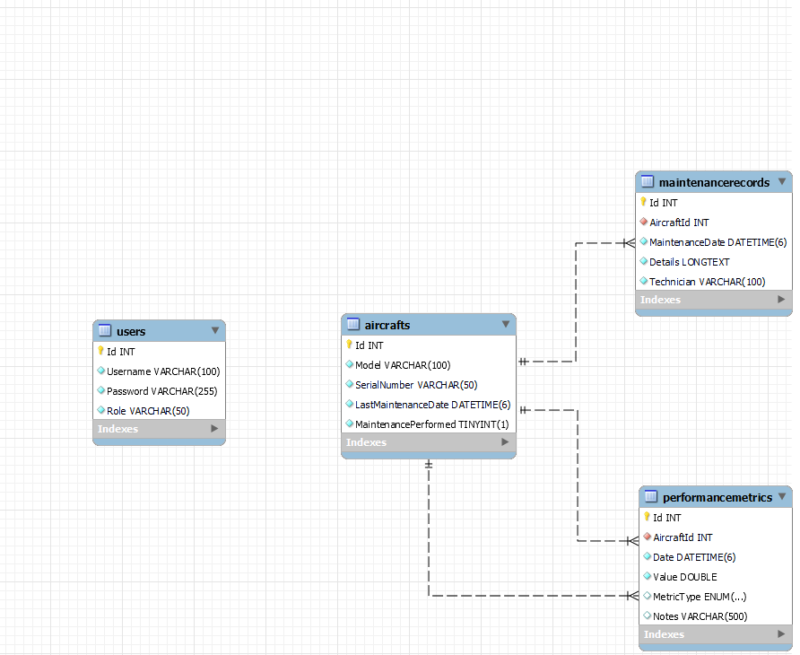

Initial UI sitemap:

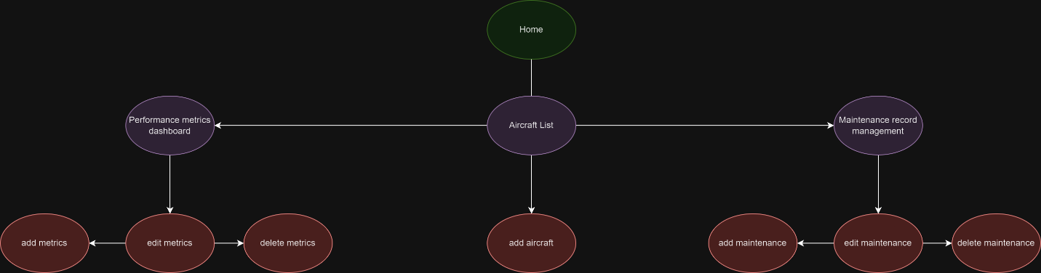

Initial UI wireframes:   
page 1 -

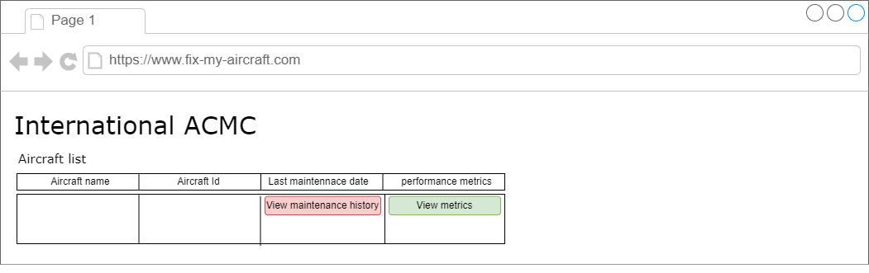Page 2 -  
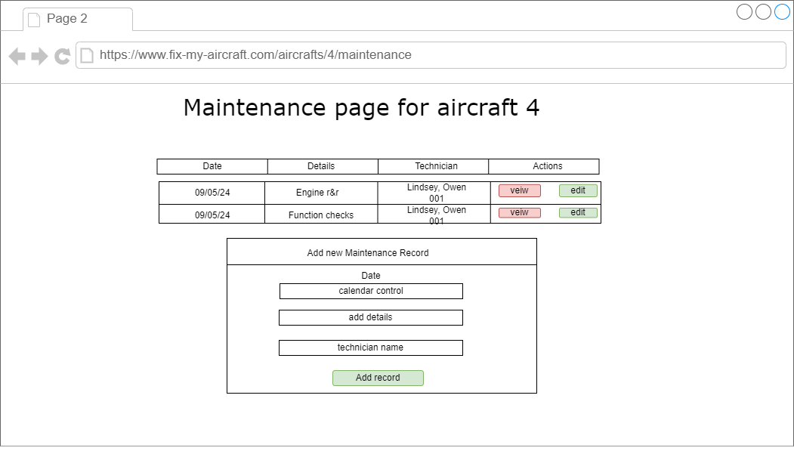

Page 3 - 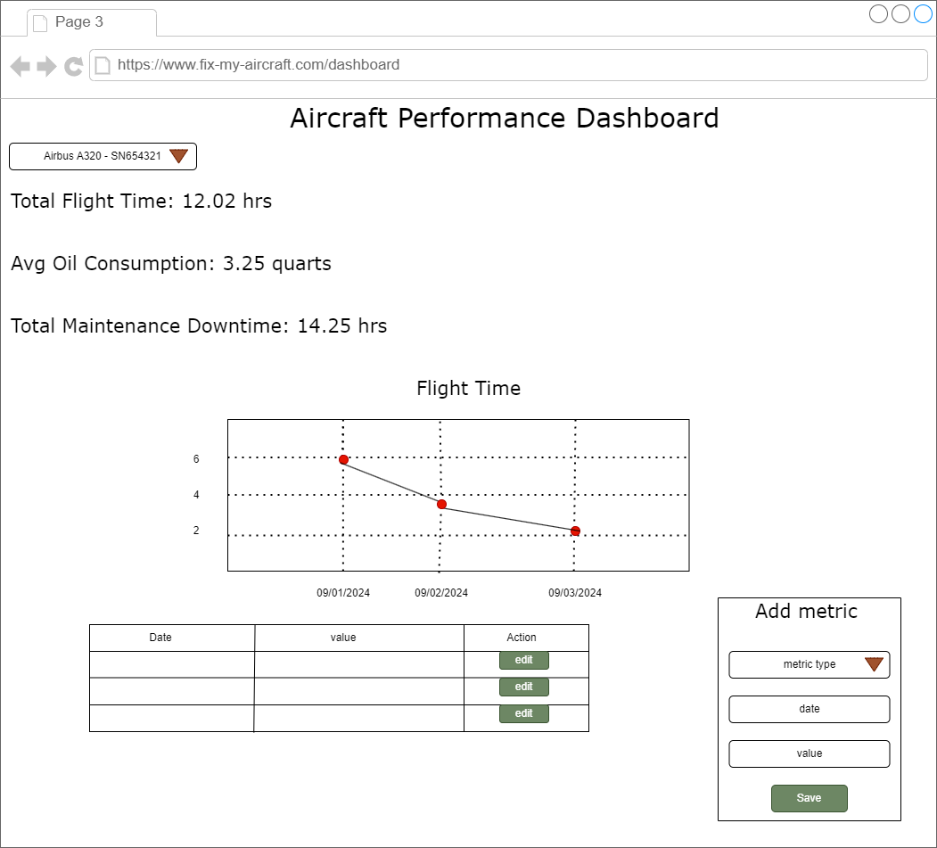

Initial UML classes:   
aircraft class -

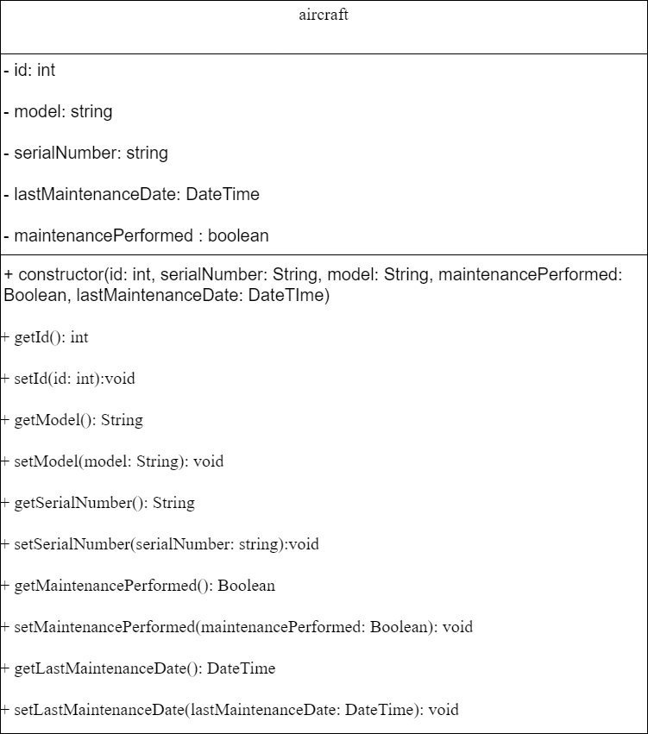

MaintenanceRecord -

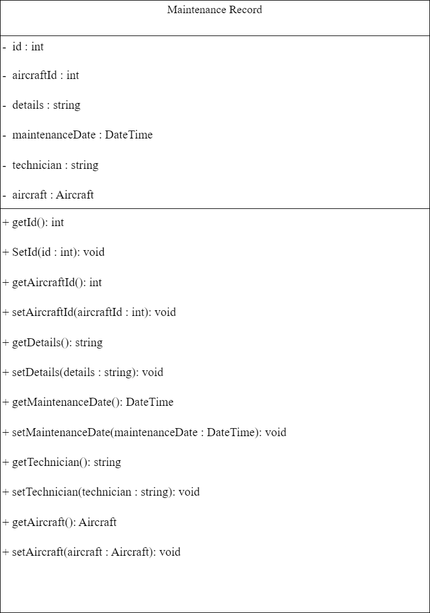

User -

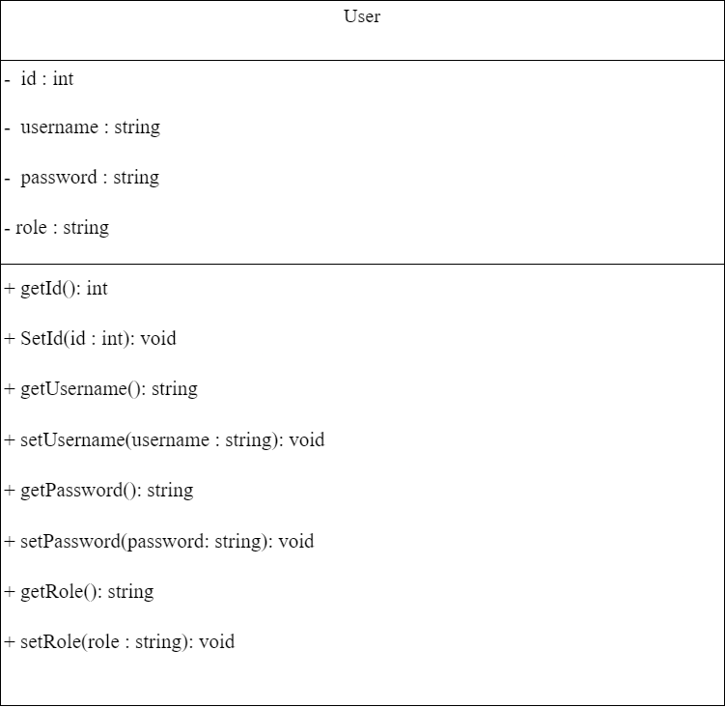

PerformanceMetric -

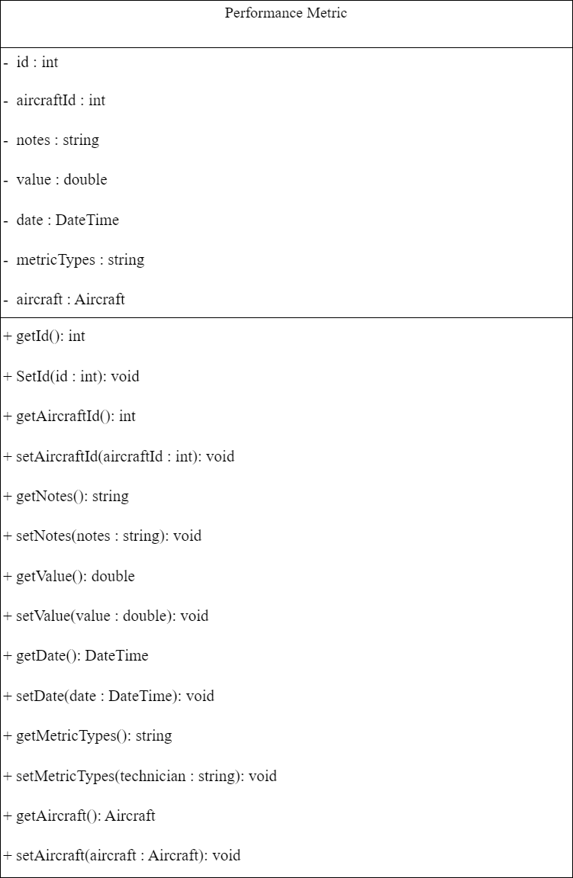

Risks:

1. User validation and oversites in User permissions being handled and defended properly.

2. Injection attacks, there are a lot of fields that will require form validation. Ensuring malicious actors cannot inject script into the form's entry will be important.

3. Falling behind. I will need to be realistic about the boundaries of this assignment. The data and algorithms needed in the performance metric portion of the site will be intensive at some points. I need to remember to get the website and its components WORKING before attempting to optimize.