Owen Lindsey

Professor Sparks, James

09/28/2024

CST-391

Milestone 2

**Aircraft Maintenance Management Application Instructor Feedback:**

**Milestone 1 feedback:**

**1)** You do not document how users are created, managed and their role in the application (login?). The category Users only appears in the database

**2)** On the dashboard you show 'Flight Time' but it is not in the database or in the UI.

**3)** Watch out for misspellings and typos. In Actions, you have 'veiw' buttons.

**4)** Inconsistent capitalization: You have a 'Maintenance page for aircraft 4'

Overall, good work and an interesting project idea.

*Fix the issues mentioned in the 'refined submission'. Points taken will increase on the refined proposal on matters discussed here that you did not fix.*

**Aircraft Maintenance Management Application:**  
**Application description:**   
  
*This application will allow an aircraft maintenance organization manager their fleet. The system provides the following key features;*

1. **Fleet Overview:**   
    *- Display a comprehensive list of all aircraft under the organization's responsibility.*

* *Show each aircraft the most recent maintenance and important details.*

1. **Detailed Maintenance History:**

* *Access a complete maintenance history for each aircraft*
* *View all maintenance records, including date, details, and responsible technician.*
* *Edit existing maintenance entries or add new ones as needed.*

1. **Performance Metrics Dashboard:**

* *Visualize key performance indicators using various graph types.*
* *Monitor and analyze metrics such as flight hours, fuel efficiency, and maintenance frequency.*
* *Input new performance data and generate reports on total flight times, average oil consumption, and other relevant statistics.*

1. **Role-Based Access Control:**

* *Implement different access levels for Admin and User roles to ensure data security and appropriate feature access.*

1. **User Roles and Privileges:**

* *The application implements a role-based access control system with two primary key roles: Admin and User.*

6.  **Admin Privileges:**

* *Full access to all features of the aircraft maintenance system.*
* *Ability to add, modify, or delete user accounts.*
* *Permission to make critical changes to aircraft data or maintenance records.*
* *Access to system-wide analytics and reports.*
* *Capability to manage and assign roles to other users.*

7. **User Privileges:**

* *View aircraft maintenance records and performance metrics.*
* *Update non-critical information.*
* *Access basic analytics and reports.*
* *Perform routine data entry and updates within their assigned scope.*

**Aircraft Maintenance Management Application:**

**Functionality Requirements (User Story description):**

1. **Aircraft Performance Tracking**

* *As a User, I want to add and update aircraft performance metrics so I can keep track of each aircraft’s operational efficiency.*
* As an Admin, I want to manage all performance tracking data across the fleet.

2. **Maintenance Record Management:**

* *As a User, I want to select an aircraft and update its maintenance information so that I can keep maintenance records current and accurate.*
* *As an Admin, I want to review, approve, and make critical changes to records when necessary.*

3. **Fleet Expansion:**

* *As an Admin, I want to add new aircraft to our hangar spaces whenever a new aircraft is acquired or arrives for maintenance, so that our fleet inventory stays up to date.*

4. **Visual Analytics:**

* *As a User, I want to view and interact with graphs that visually display maintenance performance metrics (such as maintenance downtime, flight hours, and engine hours) so that I can quickly assess the status and trends of the fleet.*
* *As an Admin, I want access to more detailed and system-wide analytics for fleet management.*

**Aircraft Maintenance Management Application:**

**Functionality Requirements (User Story description):**

5. **Data Entry and Editing:**

* *As a User, I want to input new data and edit existing information maintenance records and performance metrics to ensure our database remains accurate and current.*
* *As an Admin, I want to have override capabilities for all data entries and the ability to manage data input and permissions.*

6. **Reporting**

* *As a User, I want to generate basic reports on aircraft performance and maintenance history to support regular operations.*
* *As an Admin, I want to create and access reports across the entire fleet.*

7. **User Management:**

* *As an Admin, I want to create, modify, and delete user accounts, and assign appropriate roles to ensure proper access control within the system.*

8. **Authentication and Authorization:**

* *As a User or Admin, I want to log in securely to access my role specific features and ensure the safety of sensitive aircraft maintenance data.*

**Database Design for Aircraft Maintenance Management Application:**

*ER diagram -*

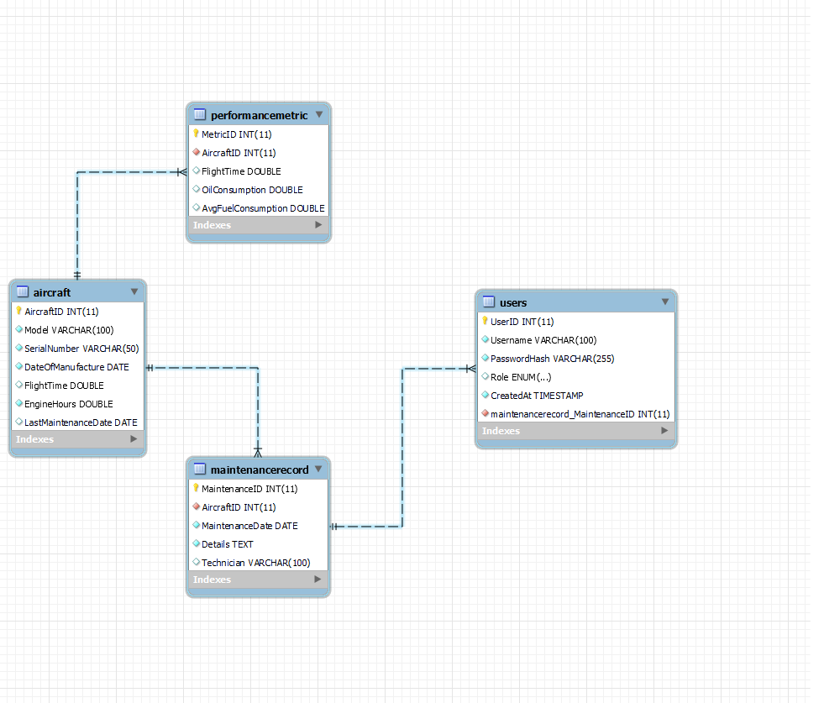

**Sitemap for Aircraft Maintenance Management Application:**

*Sitemap:*

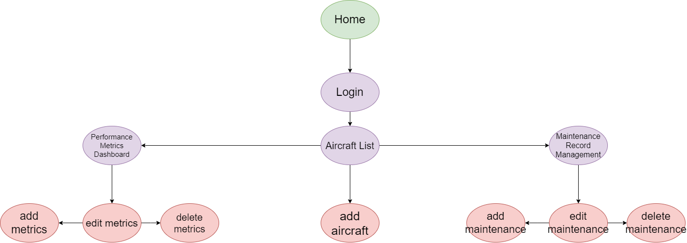

**Wireframes for Aircraft Maintenance Management Application:**

*Page 1) Login Wireframe:*

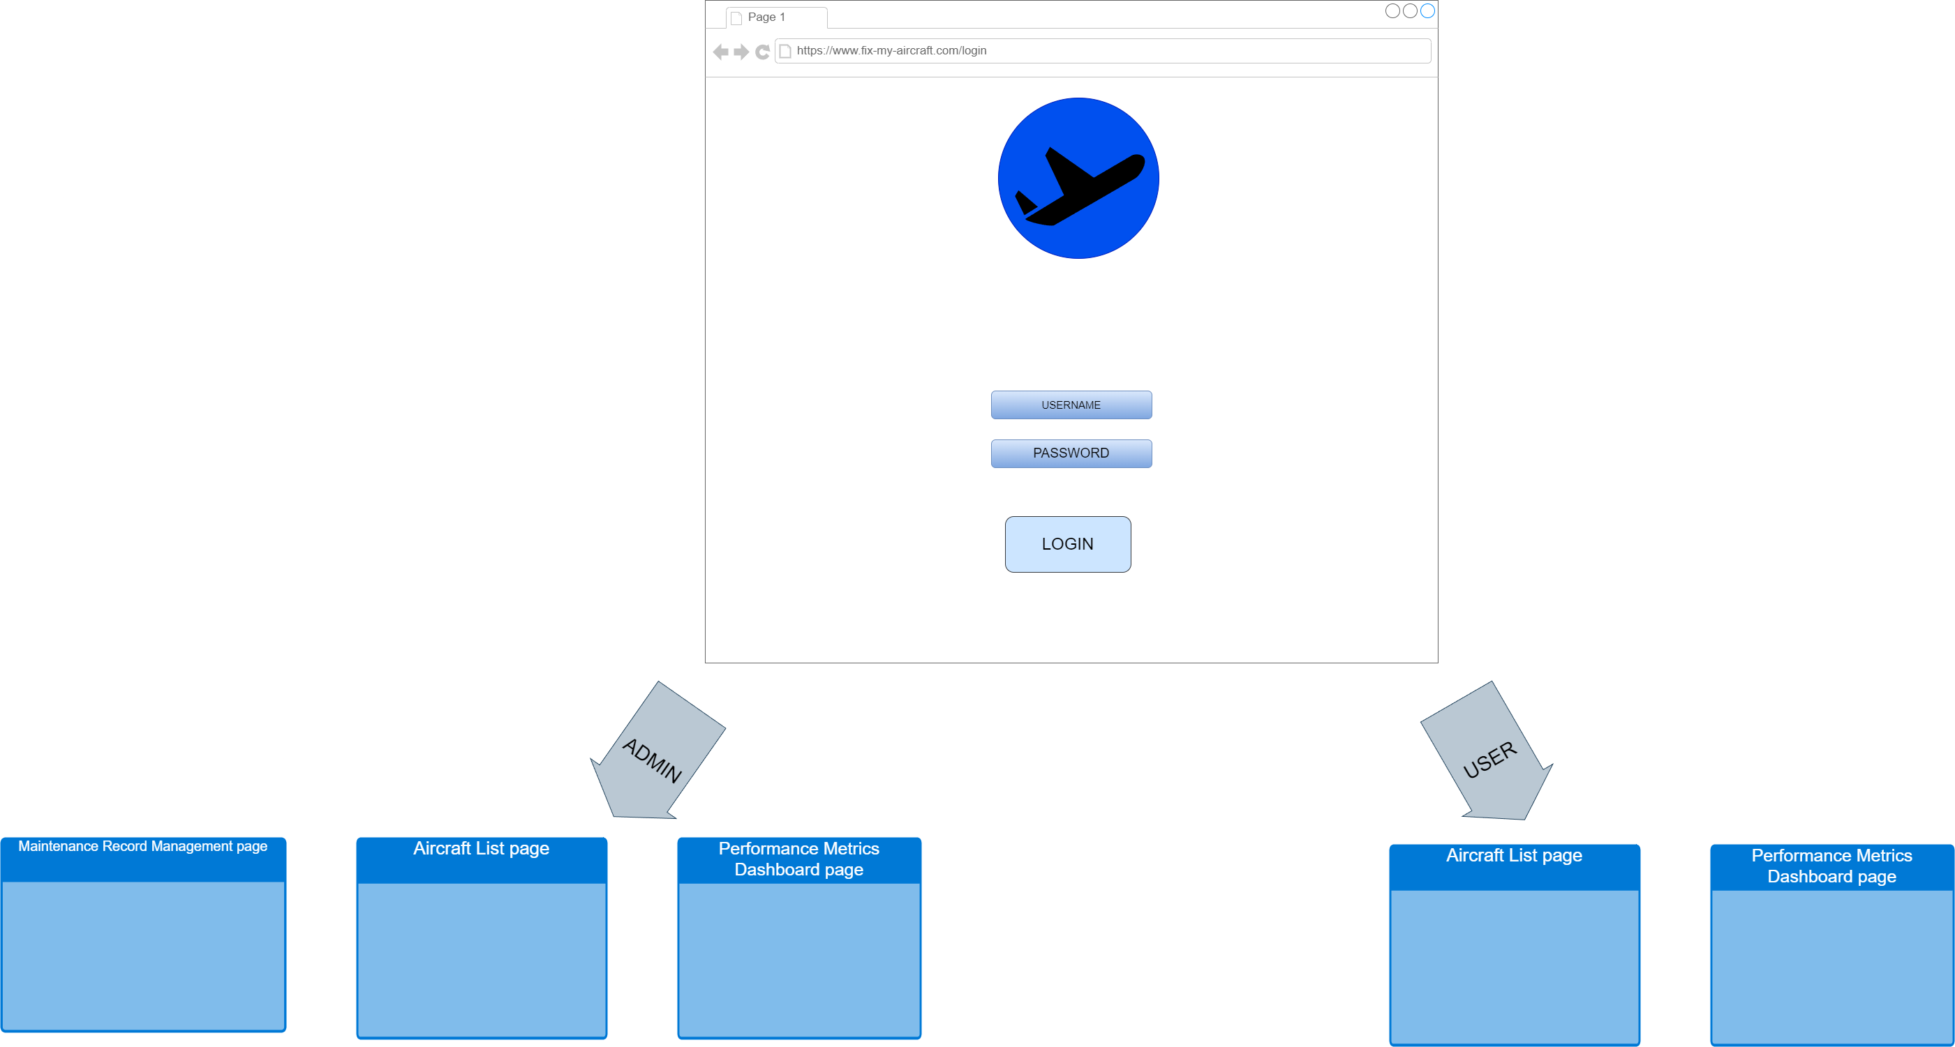

**Wireframes for Aircraft Maintenance Management Application:**

*Page 2) Aircraft List Wireframe:*

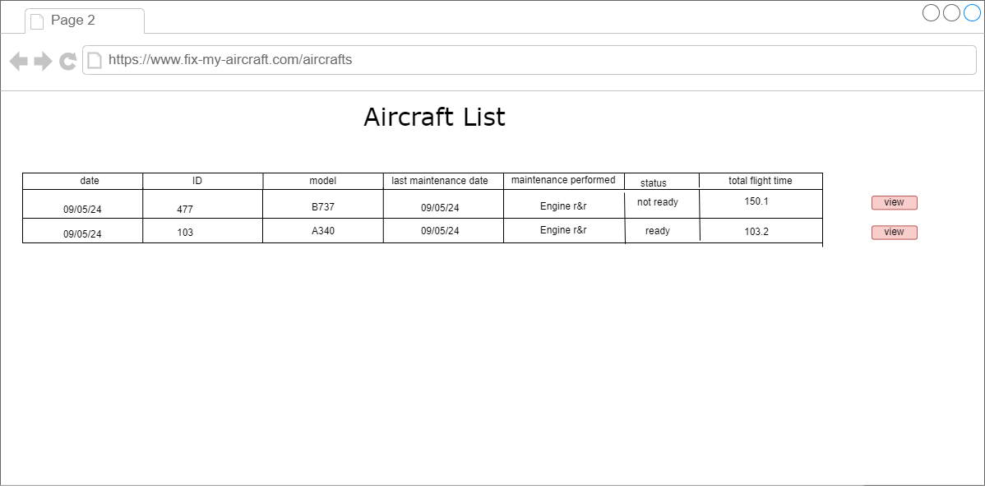

**Wireframes for Aircraft Maintenance Management Application:**

*Page 3) Aircraft Metrics Performance Dashboard Wireframe:*

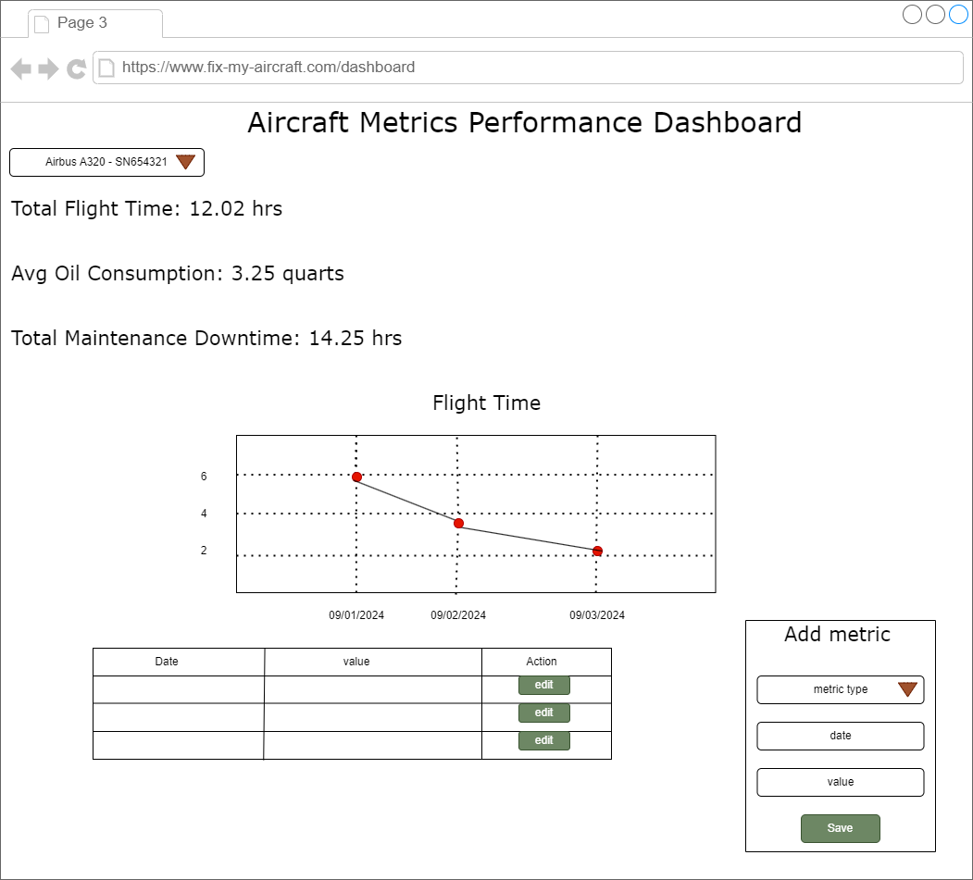

**Wireframes for Aircraft Maintenance Management Application:**

*Page 4) Maintenance Record Management Wireframe:*   
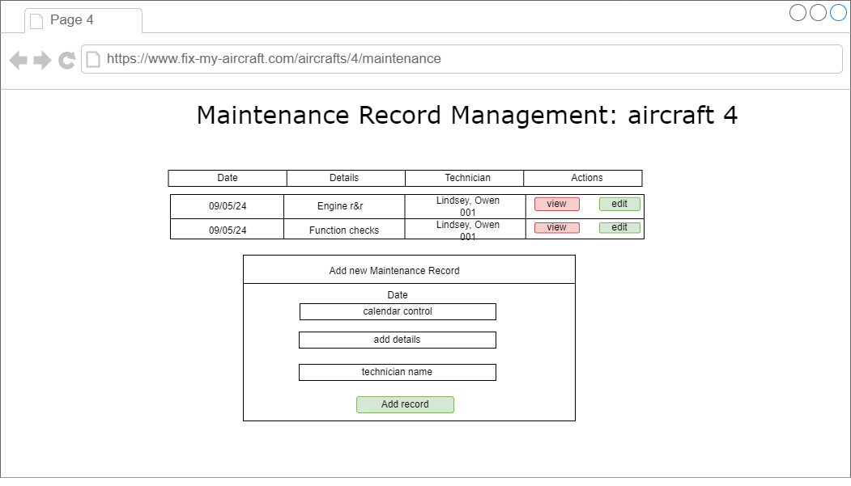

**UML classes for Aircraft Maintenance Management Application:**

aircraft class:

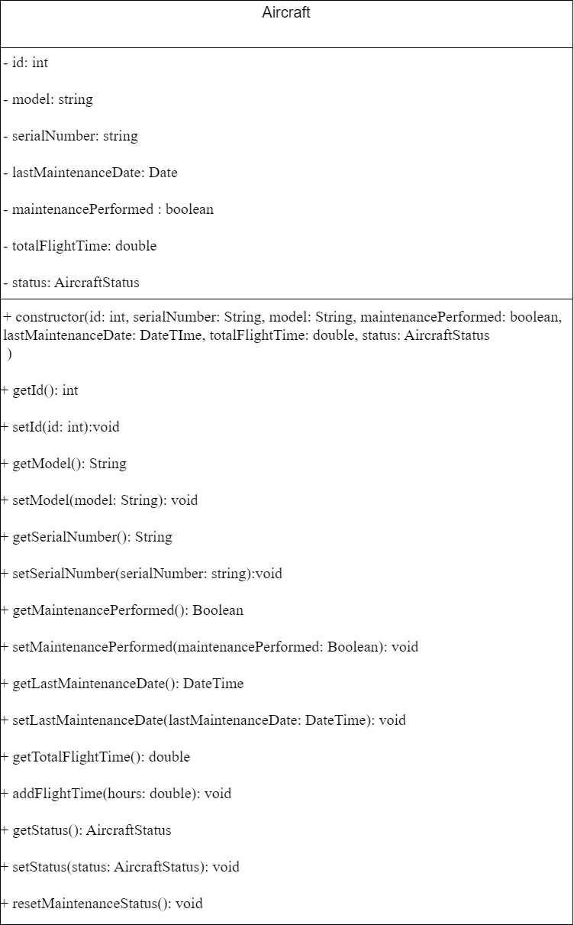

**UML classes for Aircraft Maintenance Management Application:**

*MaintenanceRecord:*

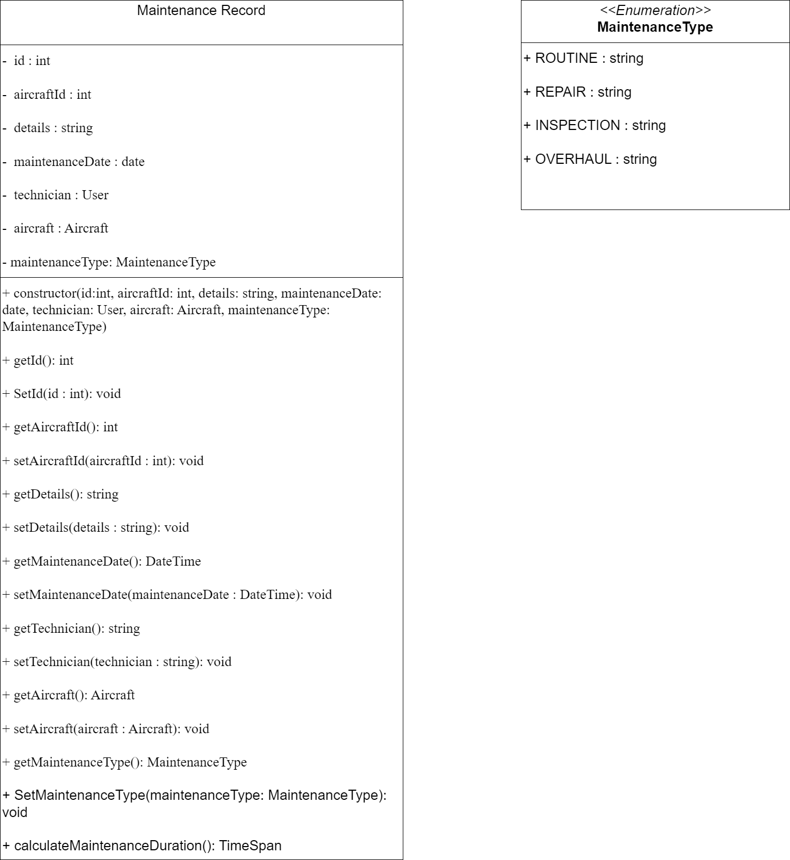

**UML classes for Aircraft Maintenance Management Application:**

*User:*

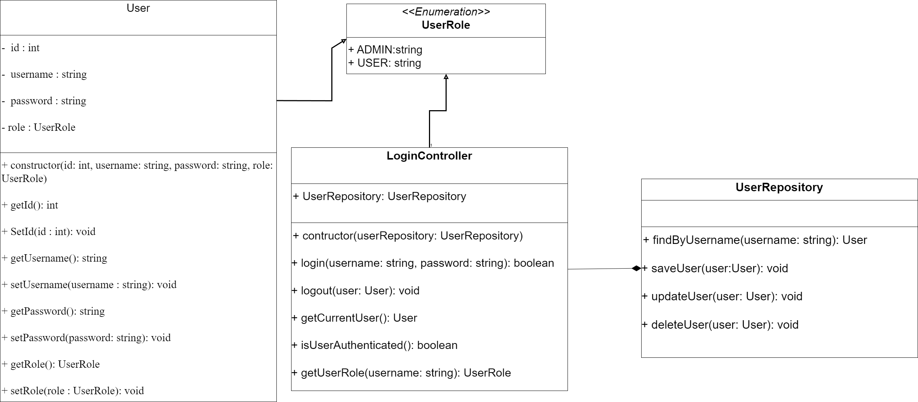

**UML classes for Aircraft Maintenance Management Application:**

*PerformanceMetric:*

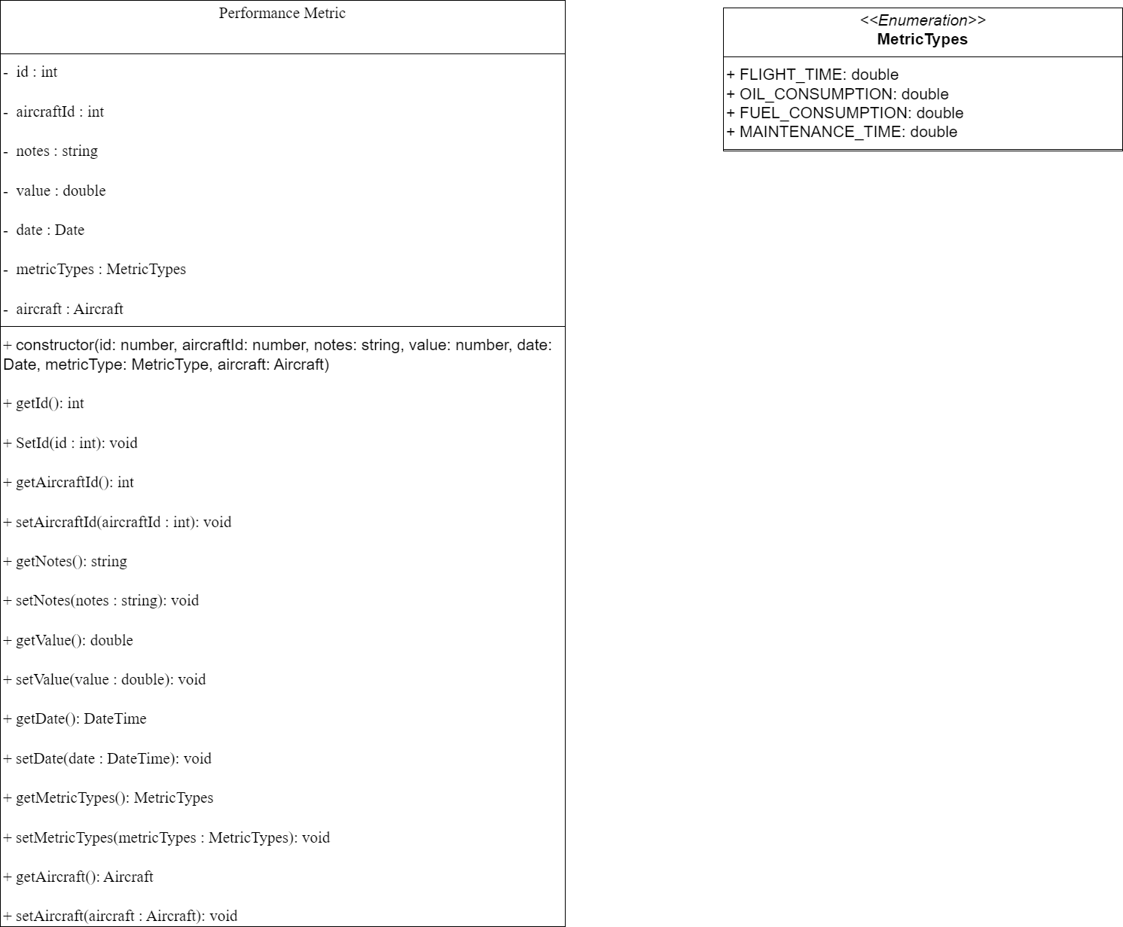

**Risks of Aircraft Maintenance Management Application:**

*1. Security Risks:*

***1.1 User Authentication and Authorization:***

**Risk:**

* *Inadequate user validation and oversight in permission*   *management.*

**Impact:**

* *Unauthorized access to sensitive aircraft data within the application.*

**Mitigation:**

* *Implement a simple but effective role-based access control system.*
* Thoroughly test user permissions for both admin and regular user roles.

**Risks of Aircraft Maintenance Management Application:**

*1. Security Risks:*

***1.2 Input Validation:***

**Risk:**

* *Vulnerability to basic injection attacks due to improper input handling.*

**Impact:**

* Potential for data corruption or unauthorized access.

**Mitigation:**

* *Implement basic input validation and sanitization for all form fields.*
* Use prepared statements for database queries to prevent SQL injection attacks.

**Risks of Aircraft Maintenance Management Application:**

*2. Data Management:*

***2.1 Data Integrity:***

**Risk:**

* *Incorrect data entry or manipulation in maintenance records.*

**Impact:**

* Inaccurate reporting and potential logical errors in the application.

**Mitigation:**

* *Add basic data validation rules to the user interface.*
* *Implement simple error checking for critical fields (date formats, numeric ranges).*

**Risks of Aircraft Maintenance Management Application:**

*3. Project Management:*

***3.1 Scope and Time Managment:***

**Risk:**

* *Project scope could become too ambitious for the class time frame.*

**Impact:**

* Incomplete features or rushed implementations.

**Mitigation:**

* *Clearly define core features required for the assignment.*
* *Prioritize functionality over optimization initially.*
* *Keep up with an organized timeline.*

**Risks of Aircraft Maintenance Management Application:**

*4. Performance Considerations:*

***4.1 Basic Application Performance:***

**Risk:**

* *Inefficient code* *leading to slow performance, especially for data intensive operations.*

**Impact:**

* Poor user experience and potential issues during project demonstrations.

**Mitigation:**

* *Focus on writing clean, efficient code for core functionalities.*
* *If time allows, implement basic optimization for data retrieval and display.*

**Aircraft Maintenance Management Application API:**

***1. Aircraft endpoints:***

* ***GET:*** */aircrafts*
* ***GET:*** */aircraft/{id}*
* ***POST:*** */aircrafts*
* ***PUT:*** */aircrafts/{id}*
* ***PUT: /****aircrafts/{id}*
* ***DELETE:*** */aircrafts/{id}*

***2. Maintenance endpoints:***

* ***GET:*** */aircrafts/{id}/maintenances*
* ***GET:*** */aircrafts/{id}/maintenances/{maintenanceId}*
* ***POST:*** */maintenance*
* ***PUT:*** */aircrafts/{id}/maintenances/{maintenanceId}*
* ***DELETE :*** */aircrafts/{id}/maintenances/{maintenanceId}*

**Aircraft Maintenance Management Application API:**

***3. Metrics endpoints:***

* ***GET:*** */aircrafts/{id}/metrics*
* ***GET:*** */aircrafts/{id}/metrics/{metricId}*
* ***POST:*** */aircrafts/{id}/metrics*
* ***PUT:*** */aircrafts/{id}/metrics{metricId}*
* ***DELETE:*** */aircrafts/{id}/metrics/{metricId}*

***4. User endpoints:***

* ***GET:*** */users/*
* ***GET:*** */users/{id}*
* ***POST:*** */users*
* ***PUT:*** */users/{id}*
* ***DELETE:*** */users/{id}*

***5. Authentication endpoints:***

* ***POST:*** */auth/login*
* ***POST:*** */auth/logout*