Owen Lindsey

Professor Sparks, James

10/20/2024

CST-391

Milestone 3

**Aircraft Maintenance Management Application Instructor Feedback:** **Milestone 2 feedback:**

1. Metric type: What is the purpose? The metric seems to be about 3 metrics. I do not see a metric type recorded in the database.
2. The sitemap does not distinguish between users and admins, but the wire frames do.
3. Overall looks interesting. I'm concerned about its complexity. Do you have time to create the API and two user interfaces?

**Revisions of milestone 2 to milestone 3**

|  |  |
| --- | --- |
| Project Update | Description |
| Login Requirement | Removed due to time constraints |
| User Interfaces | Decision to not create two separate user interfaces due to timeframe limitations. |
| Design Document | Authentication and login requirements removed from the design document |

**Aircraft Maintenance Management Application:**  
**Application description:**   
  
*This application will allow an aircraft maintenance organization manager their fleet. The system provides the following key features.*

1. **Fleet Overview:**   
    *- Display a comprehensive list of all aircraft under the organization's responsibility.*

* *Show each aircraft the most recent maintenance and important details.*

1. **Detailed Maintenance History:**

* *Access a complete maintenance history for each aircraft*
* *View all maintenance records, including date, details, and responsible technician.*
* *Edit existing maintenance entries or add new ones as needed.*

1. **Performance Metrics Dashboard:**

* *Visualize key performance indicators using various graph types.*
* *Monitor and analyze metrics such as flight hours, fuel efficiency, and maintenance frequency.*
* *Input new performance data and generate reports on total flight times, average oil consumption, and other relevant statistics.*

**Aircraft Maintenance Management Application:**

**Functionality Requirements (User Story description):**

1. **Aircraft Performance Tracking**

* *As a User, I want to add and update aircraft performance metrics so I can keep track of each aircraft’s operational efficiency.*

2. **Maintenance Record Management:**

* *As a User, I want to select an aircraft and update its maintenance information so that I can keep maintenance records current and accurate.*

3. **Fleet Expansion:**

* *As a User, I want to add new aircraft to our hangar spaces whenever a new aircraft is acquired or arrives for maintenance, so that our fleet inventory stays up to date.*

4. Visual **Analytics:**

* *As a User, I want to view and interact with graphs that visually display maintenance performance metrics (such as maintenance downtime, flight hours, and engine hours) so that I can quickly assess the status and trends of the fleet.*

5. **Data Entry and Editing:**

* *As a User, I want to input new data and edit existing information maintenance records and performance metrics to ensure our database remains accurate and current.*

6. **Reporting**

* *As a User, I want to generate basic reports on aircraft performance and maintenance history to support regular operations.*

**Database Design for Aircraft Maintenance Management Application:**

*ER diagram -*

**Sitemap for Aircraft Maintenance Management Application:**

*Sitemap:*

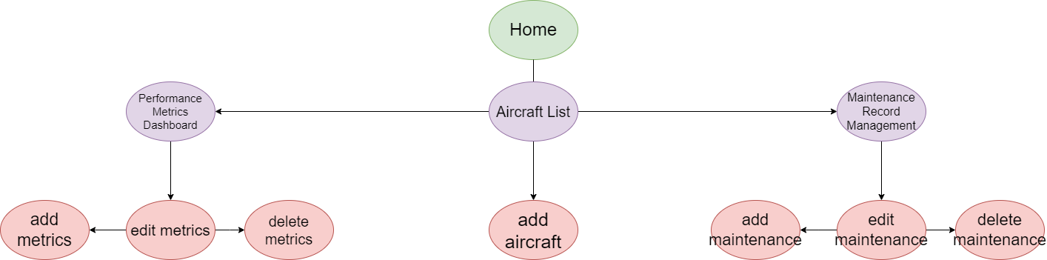

**Wireframes for Aircraft Maintenance Management Application:**

*Page 1: Aircraft List Wireframe:*

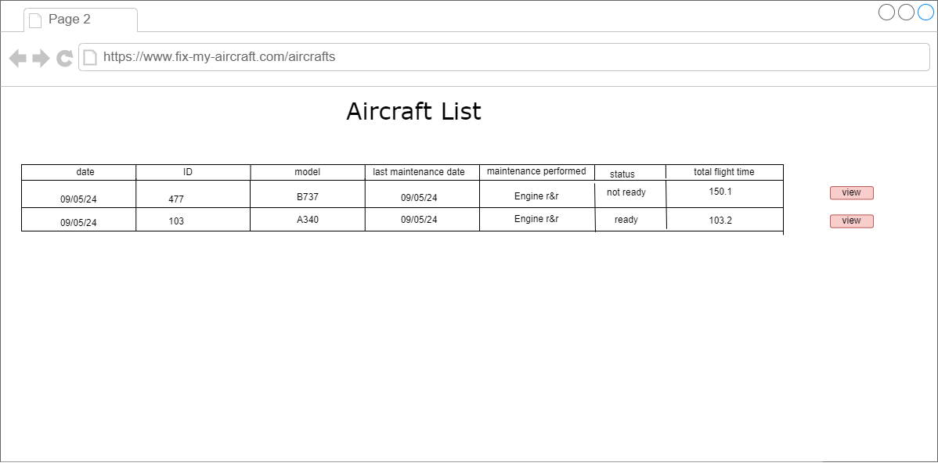

**Wireframes for Aircraft Maintenance Management Application:**

*Page 2: Aircraft Metrics Performance Dashboard Wireframe:*

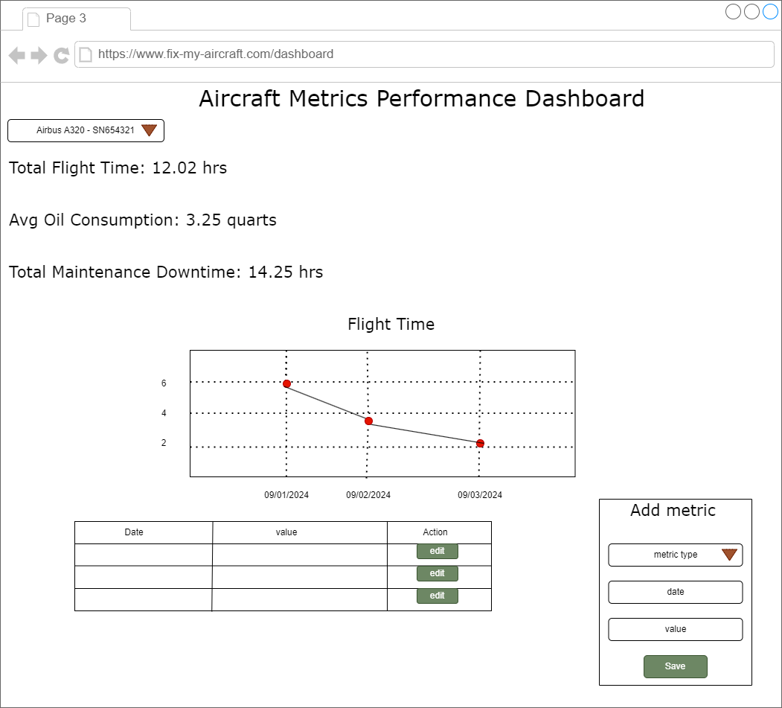

**Wireframes for Aircraft Maintenance Management Application:**

*Page 3: Maintenance Record Management Wireframe:*   
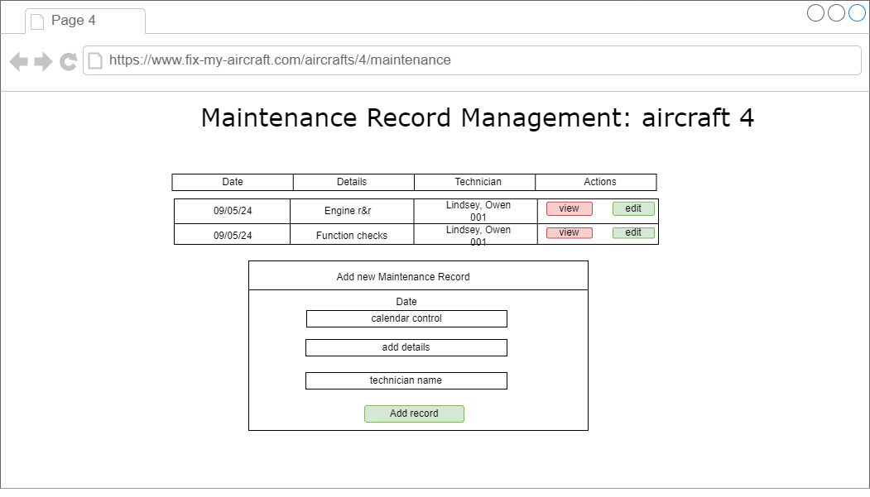

**UML classes for Aircraft Maintenance Management Application:**

aircraft class:

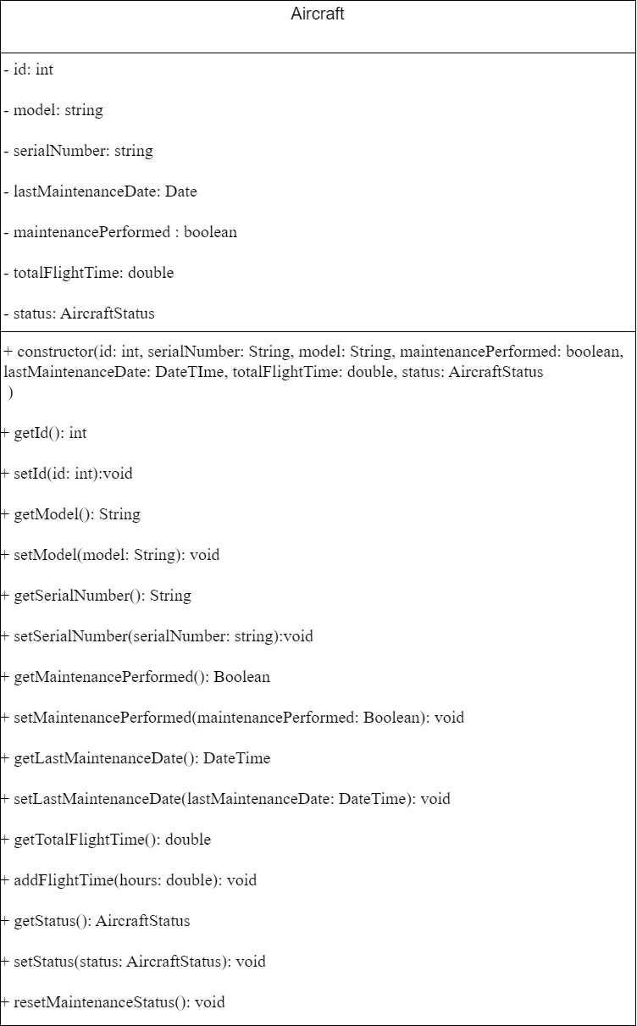

**UML classes for Aircraft Maintenance Management Application:**

*MaintenanceRecord:*

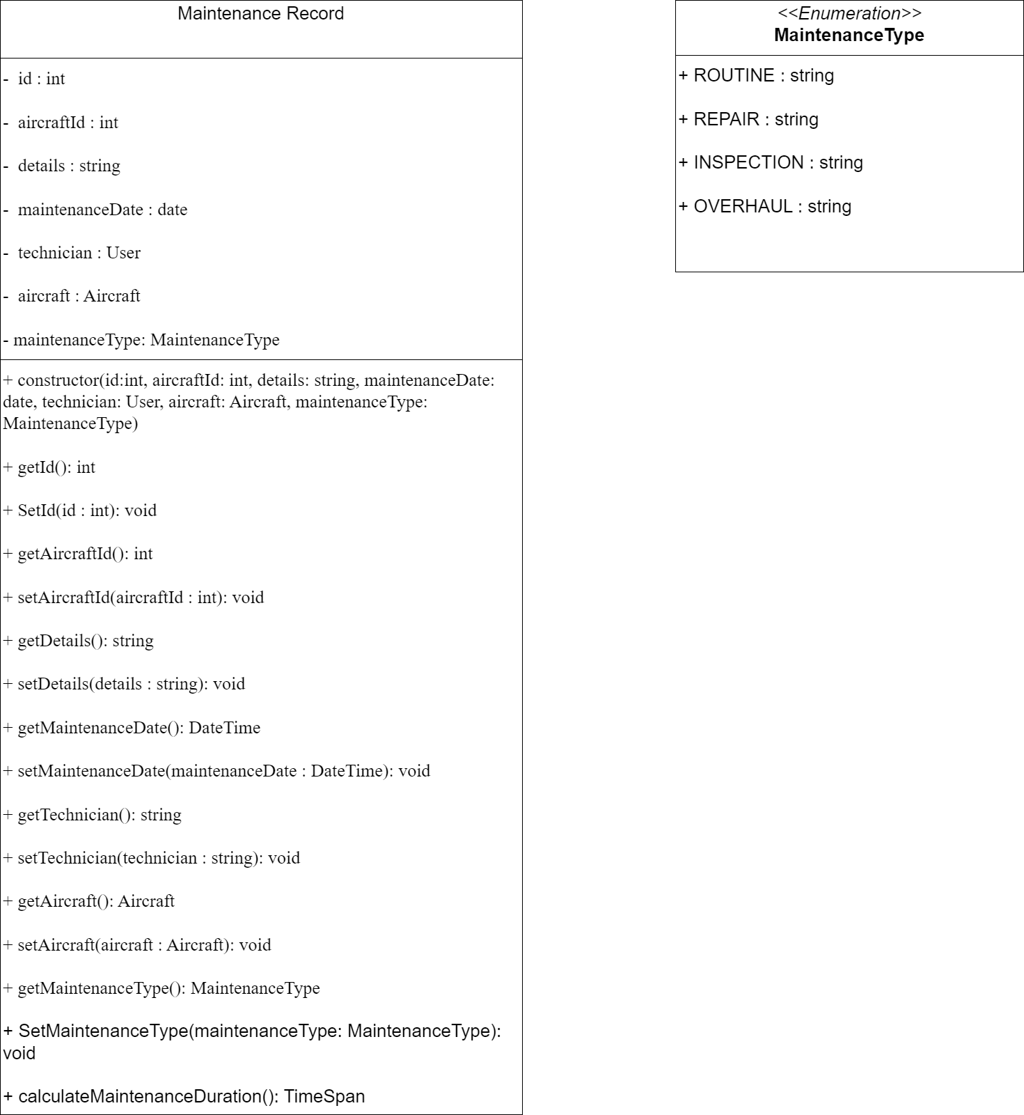

**UML classes for Aircraft Maintenance Management Application:**

*PerformanceMetric:*

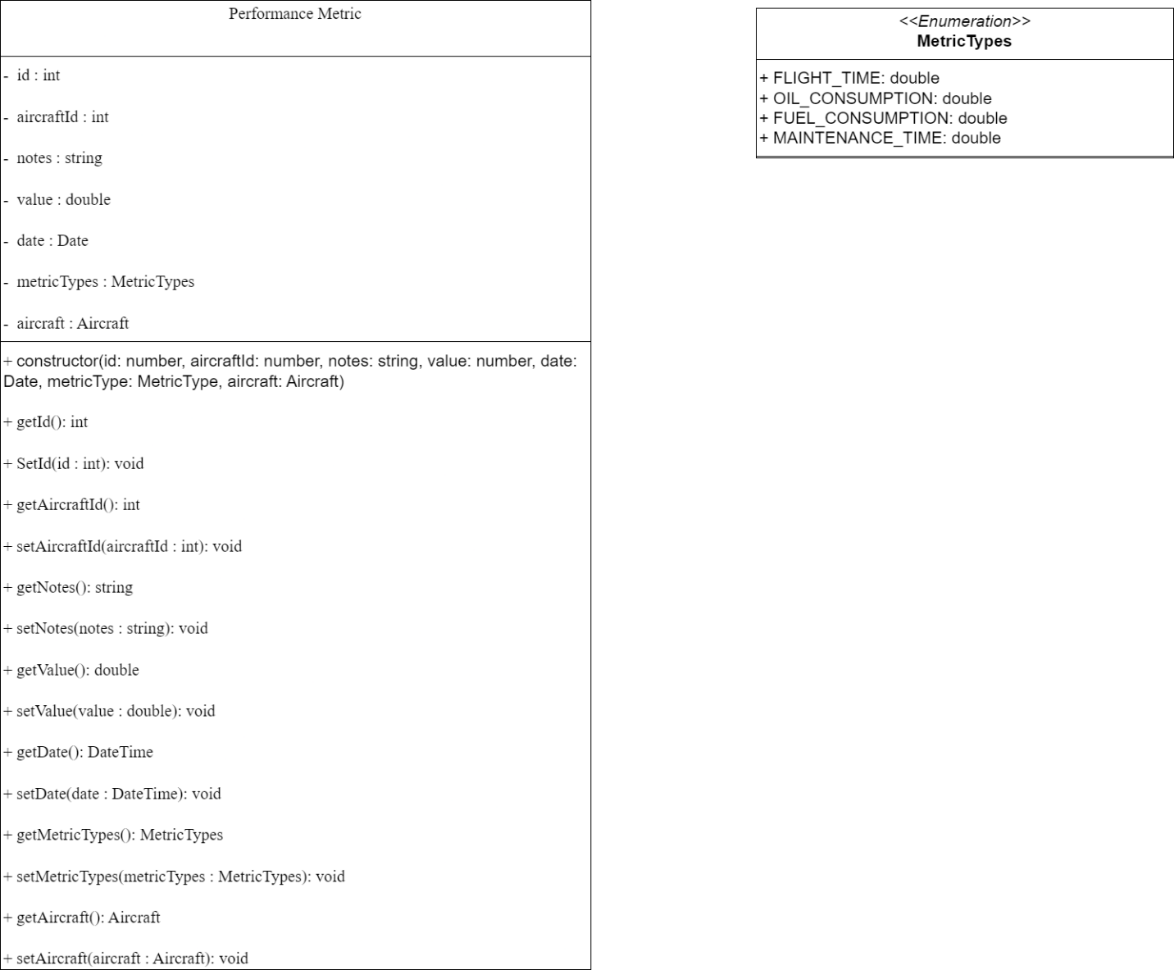

**Risks of Aircraft Maintenance Management Application:**

*1. Security Risks:*

***1.2 Input Validation:***

**Risk:**

* *Vulnerability to basic injection attacks due to improper input handling.*

**Impact:**

* Potential for data corruption or unauthorized access.

**Mitigation:**

* *Implement basic input validation and sanitization for all form fields.*
* Use prepared statements for database queries to prevent SQL injection attacks.

**Risks of Aircraft Maintenance Management Application:**

*1. Data Management:*

***1.1 Data Integrity:***

**Risk:**

* *Incorrect data entry or manipulation in maintenance records.*

**Impact:**

* Inaccurate reporting and potential logical errors in the application.

**Mitigation:**

* *Add basic data validation rules to the user interface.*
* *Implement simple error checking for critical fields (date formats, numeric ranges).*

**Risks of Aircraft Maintenance Management Application:**

*2. Project Management:*

***2.1 Scope and Time Management:***

**Risk:**

* *Project scope could become too ambitious for the class time frame.*

**Impact:**

* Incomplete features or rushed implementations.

**Mitigation:**

* *Clearly define core features required for the assignment.*
* *Prioritize functionality over optimization initially.*
* *Keep up with an organized timeline.*

**Risks of Aircraft Maintenance Management Application:**

*3. Performance Considerations:*

***3.1 Basic Application Performance:***

**Risk:**

* *Inefficient code leads to slow performance, especially for data intensive operations.*

**Impact:**

* Poor user experience and potential issues during project demonstrations.

**Mitigation:**

* *Focus on writing clean, efficient code for core functionalities.*
* *If time allows, implement basic optimization for data retrieval and display.*

**Aircraft Maintenance Management Application API:**

***1. Aircraft endpoints:***

* ***GET:*** */aircraft*
* ***GET:*** */aircraft/{id}*
* ***POST:*** */aircraft*
* ***PUT:*** */aircraft/{id}*
* ***PUT: /****aircraft/{id}*
* ***DELETE:*** */aircraft/{id}*

***2. Maintenance endpoints:***

* ***GET:*** */aircraft/{id}/maintenances*
* ***GET:*** */aircraft/{id}/maintenances/{maintenanceId}*
* ***POST:*** */maintenance*
* ***PUT:*** */aircraft/{id}/maintenances/{maintenanceId}*
* ***DELETE :*** */aircraft/{id}/maintenances/{maintenanceId}*

**Aircraft Maintenance Management Application API:**

***3. Metrics endpoints:***

* ***GET:*** */aircraft/{id}/metrics*
* ***GET:*** */aircraft/{id}/metrics/{metricId}*
* ***POST:*** */aircraft/{id}/metrics*
* ***PUT:*** */aircraft/{id}/metrics{metricId}*
* ***DELETE:*** */aircraft/{id}/metrics/{metricId}*

**Aircraft Maintenance Management Application API:**

[*Postman Documentation*](https://documenter.getpostman.com/view/32764813/2sA3e1Apqr#e15ec84a-827e-4caa-bc70-bbe074c50b33)