Owen Lindsey

Professor Sparks, James

CST-391 Milestone 5

12/09/2024

**Aircraft Maintenance Management Application Instructor Feedback:** **Milestone 4 feedback:**

***Update: Beautiful work  
  
Moving video to top of presentation:***[**LOOM**](https://www.loom.com/share/8d939537a10643a19b88d9c0ac69c1bc)

**Revisions remain the same:**

|  |  |
| --- | --- |
| Project Update | Description |
| Login Requirement | Out of scope for the current timeline. Will implement in the future. |
| User Interfaces | Out of scope for the current timeline. Will implement in the future. |
| Design | I added two new pages to the web app.   Performance analytics is a page that displays the ‘performance analytics data in Recharts.   Dashboard page allows the user to navigate to the three main pages.   Refer to the updated sitemap, wireframes, and UMLs for more information. |

**Aircraft Maintenance Management Application:**  
**Application description:**   
  
*This application will allow an aircraft maintenance organization manager their fleet. The system provides the following key features.*

1. **Fleet Overview:**   
    *- Display a comprehensive list of all aircraft under the organization's responsibility.*

* *Show each aircraft the most recent maintenance and important details.*
* Allows users to add an aircraft to their organization’s fleet.

1. **Detailed Maintenance History:**

* *Access a complete maintenance history for each aircraft*
* *View all maintenance records, including date, details, and responsible technician.*
* *Edit existing maintenance entries or add new ones as needed.*

1. **Performance Metrics:**

* *Categorizes typical instrument measurements like oil consumption, flight time, etc. These categories are displayed in table format.*
* *Takes the user to the performance analytics page where this data is compiled and visualized in various Recharts.*
* *This data is important because it lets maintainers compare current flight trends with maintenance that is being performed. Possibly even foreshadow maintenance events before they occur.   
    
  For example, if an aircraft engine is consuming oil at an abnormally high rate, there could be a failure in the oil system that must be fixed.*
* *Input new performance data and generate reports on total flight times, average oil consumption, and other relevant statistics.*

**Aircraft Maintenance Management Application:**  
**Application description:**   
  
 **4. Performance Analytics:**

* *Highlights performance indicators using various chart types. This will help visualize where outliers occur and possibly raise concerns if any metric enters an abnormal range.*
* *Monitor and analyze metrics such as flight hours, fuel efficiency, and maintenance frequency.*
* *Input new performance data and generate reports on total flight times, average oil consumption, and other relevant statistics.*

**5. Dashboard:**

* *Gives the user a brief introduction of the web apps purpose. This will break down total aircraft, the amount of necessary maintenance required on their fleet, and the total amount of flight hours between all aircraft.*
* *Below the summaries we have navigation links to our fleet, maintenance record, and performance metric pages.*

**Aircraft Maintenance Management Application:**

**Functionality Requirements (User Story description):**

1. **Aircraft Performance Tracking**

* *As a User, I want to add and update aircraft performance metrics so I can keep track of each aircraft’s operational efficiency.*
* *As a User, I want to be able to look at charts that allow me to visually track performance data trends.*

2. **Maintenance Record Management:**

* *As a User, I want to select an aircraft and update its maintenance information so that I can keep maintenance records current and accurate.*

3. **Fleet Expansion:**

* *As a User, I want to add new aircraft to our hangar spaces whenever a new aircraft is acquired or arrives for maintenance, so that our fleet inventory stays up to date.*

4. Visual **Analytics:**

* *As a User, I want to view and interact with graphs that visually display maintenance performance metrics (such as flight hours and oilConsumption, and fuel consumption) so that I can quickly assess the status and trends of the fleet.*

5. **Data Entry and Editing:**

* *As a User, I want to input new data and edit existing information maintenance records and performance metrics to ensure our database remains accurate and current.*

6. **Reporting**

* *As a User, I want to generate basic reports on aircraft performance and maintenance history to support regular operations.*

**Database Design for Aircraft Maintenance Management Application:**

*ER diagram -*

**Sitemap for Aircraft Maintenance Management Application:**

*Sitemap:*

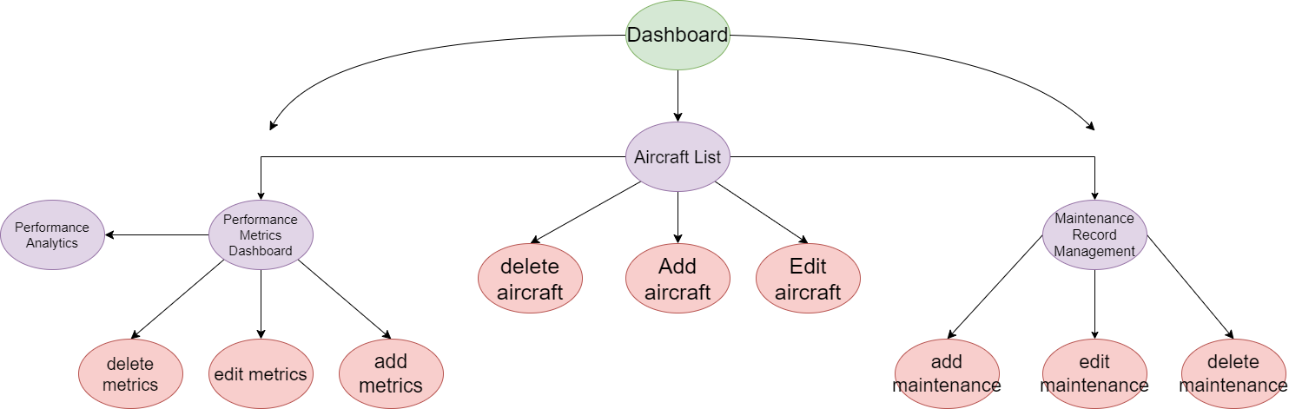

**Wireframes for Aircraft Maintenance Management Application:***Page 1: Dashboard:  
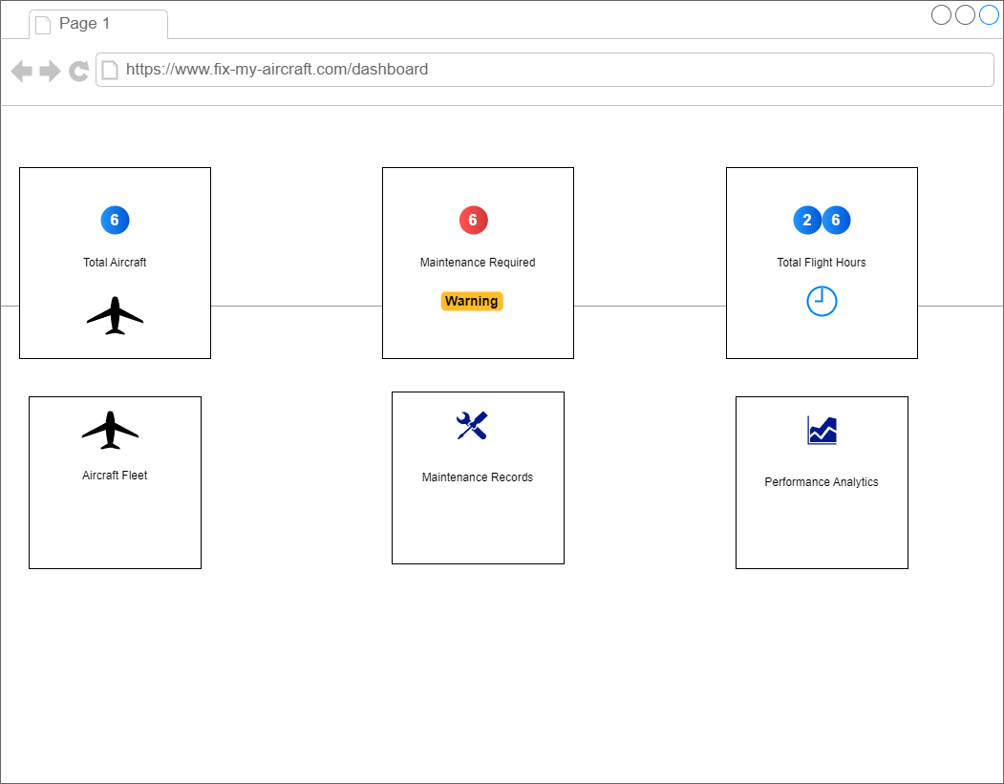*

**Wireframes for Aircraft Maintenance Management Application:**

*Page 2: Aircraft List Wireframe:*

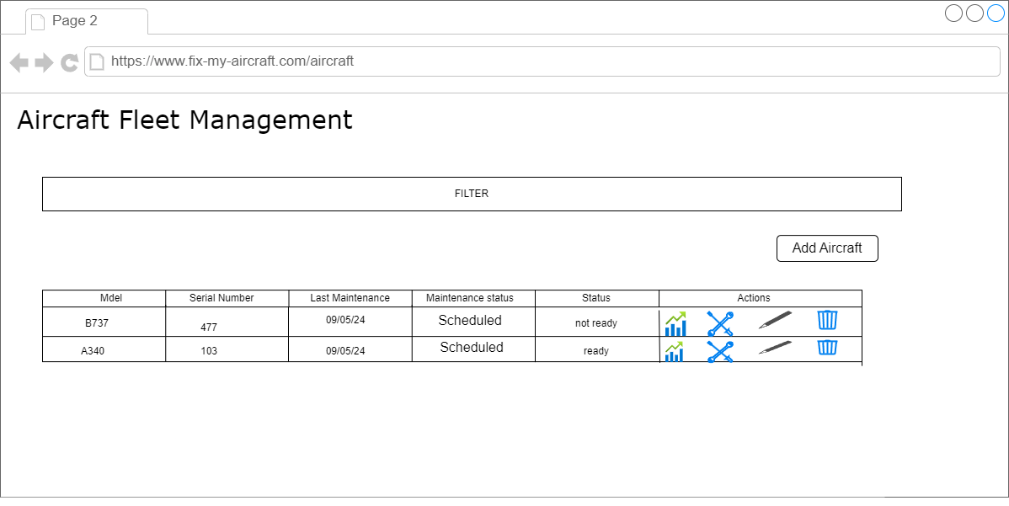

**Wireframes for Aircraft Maintenance Management Application:**

*Page 3: Aircraft Metrics Performance Wireframe:*

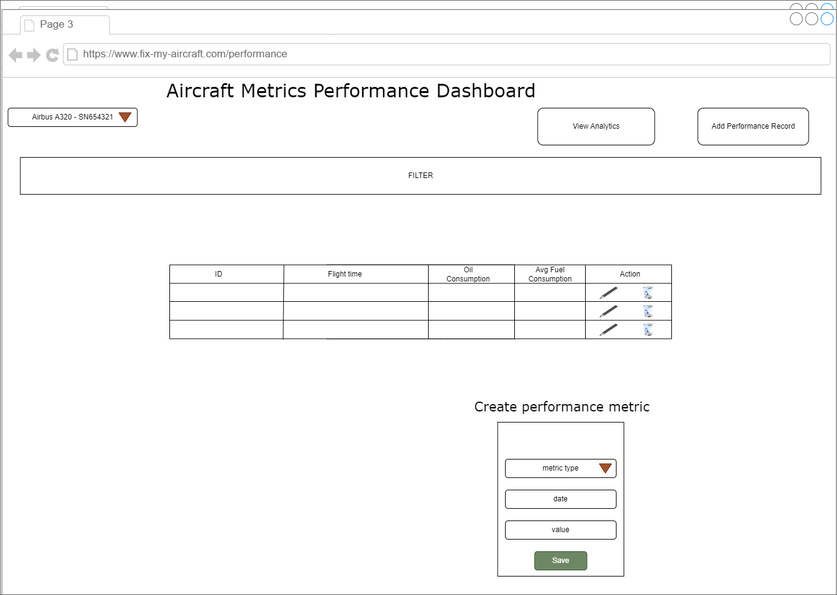

**Wireframes for Aircraft Maintenance Management Application:**

*Page 4: Maintenance Record Management Wireframe:*   
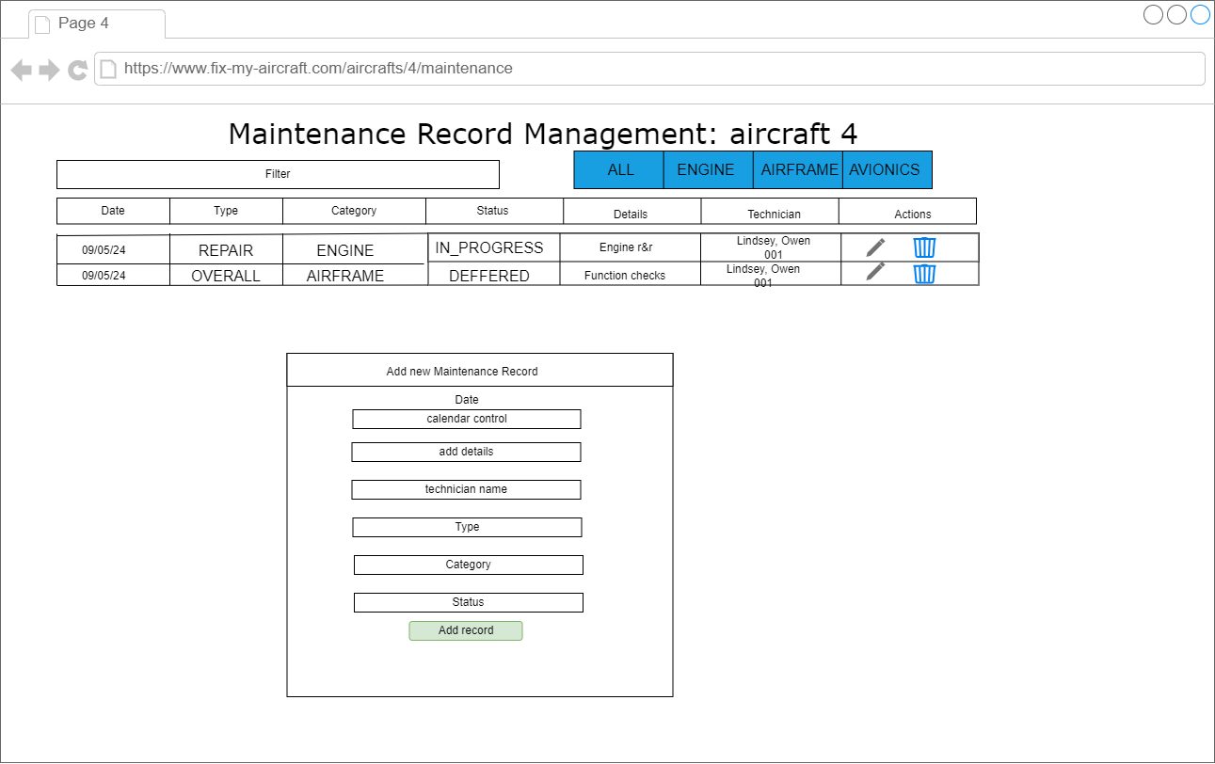

**Wireframes for Aircraft Maintenance Management Application:**

*Page 5: Aircraft Metrics Performance Wireframe:*

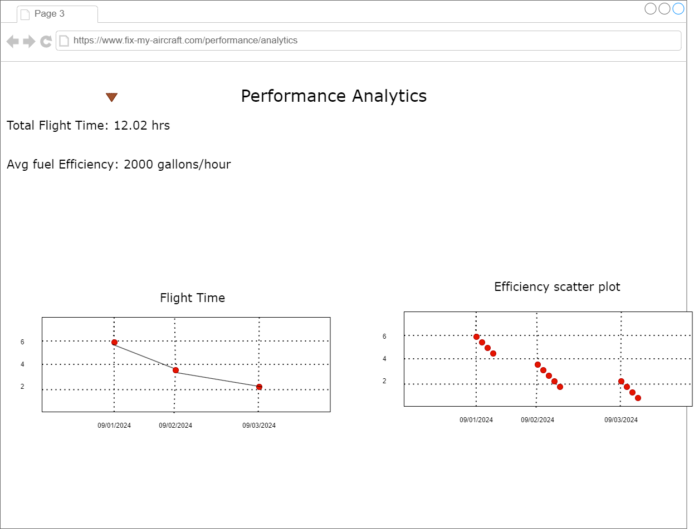

**UML classes for Aircraft Maintenance Management Application:**

aircraft class:

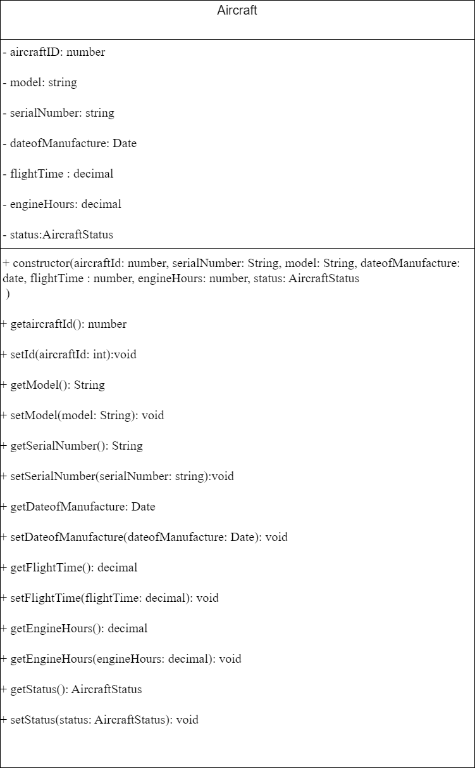

**UML classes for Aircraft Maintenance Management Application:**

*MaintenanceRecord:*

**UML classes for Aircraft Maintenance Management Application:**

*PerformanceMetric:*

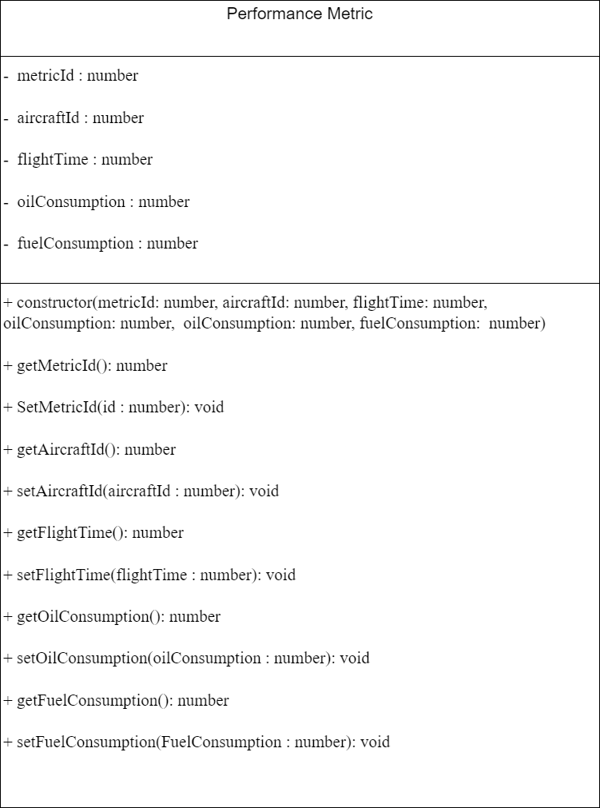

**Risks of Aircraft Maintenance Management Application:**

*1. Security Risks:*

***1.2 Input Validation:***

**Risk:**

* *Vulnerability to basic injection attacks due to improper input handling.*

**Impact:**

* Potential for data corruption or unauthorized access.

**Mitigation:**

* *Implement basic input validation and sanitization for all form fields.*
* Use prepared statements for database queries to prevent SQL injection attacks.

**Risks of Aircraft Maintenance Management Application:**

*1. Data Management:*

***1.1 Data Integrity:***

**Risk:**

* *Incorrect data entry or manipulation in maintenance records.*

**Impact:**

* Inaccurate reporting and potential logical errors in the application.

**Mitigation:**

* *Add basic data validation rules to the user interface.*
* *Implement simple error checking for critical fields (date formats, numeric ranges).*

**Risks of Aircraft Maintenance Management Application:**

*2. Project Management:*

***2.1 Scope and Time Management:***

**Risk:**

* *Project scope could become too ambitious for the class time frame.*

**Impact:**

* Incomplete features or rushed implementations.

**Mitigation:**

* *Clearly define core features required for the assignment.*
* *Prioritize functionality over optimization initially.*
* *Keep up with an organized timeline.*

**Risks of Aircraft Maintenance Management Application:**

*3. Performance Considerations:*

***3.1 Basic Application Performance:***

**Risk:**

* *Inefficient code leads to slow performance, especially for data intensive operations.*

**Impact:**

* Poor user experience and potential issues during project demonstrations.

**Mitigation:**

* *Focus on writing clean, efficient code for core functionalities.*
* *If time allows, implement basic optimization for data retrieval and display.*

**Aircraft Maintenance Management Application API:**

*[Postman Documentation](https://documenter.getpostman.com/view/32764813/2sA3e1Apqr)*

**Aircraft Maintenance Management Application Github:**

[*GitHub for backend src code*](https://github.com/omniV1/CST-391/tree/main/src/Milestone/aircraft-maintenance-api)[*Github for frontend src code*](https://github.com/omniV1/CST-391/tree/main/src/Milestone/aerospace-maintenance)

**Aircraft Maintenance Management Application Loom:**[*Loom*](https://www.loom.com/share/4803a73b147944b0aa5abe974a906ca6?sid=2fe64d2d-6662-41e0-9dbd-cae4753fcaf2)