Owen Lindsey

Professor Sparks, James

CST-391

09/05/2024

Activity 0

1. **NPM –v / Node –v showing the versions of each in my console.**

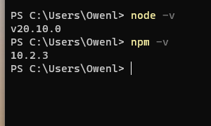

1. Hello world from app.js

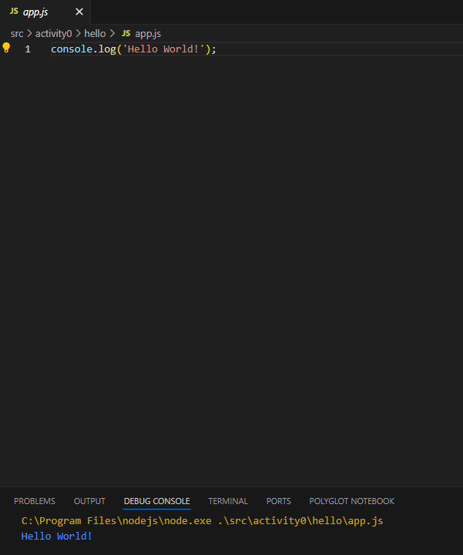

1. **NodeJS “Hello World” Application screen shot.** This screenshot shows the app.js running in the integrated terminal.

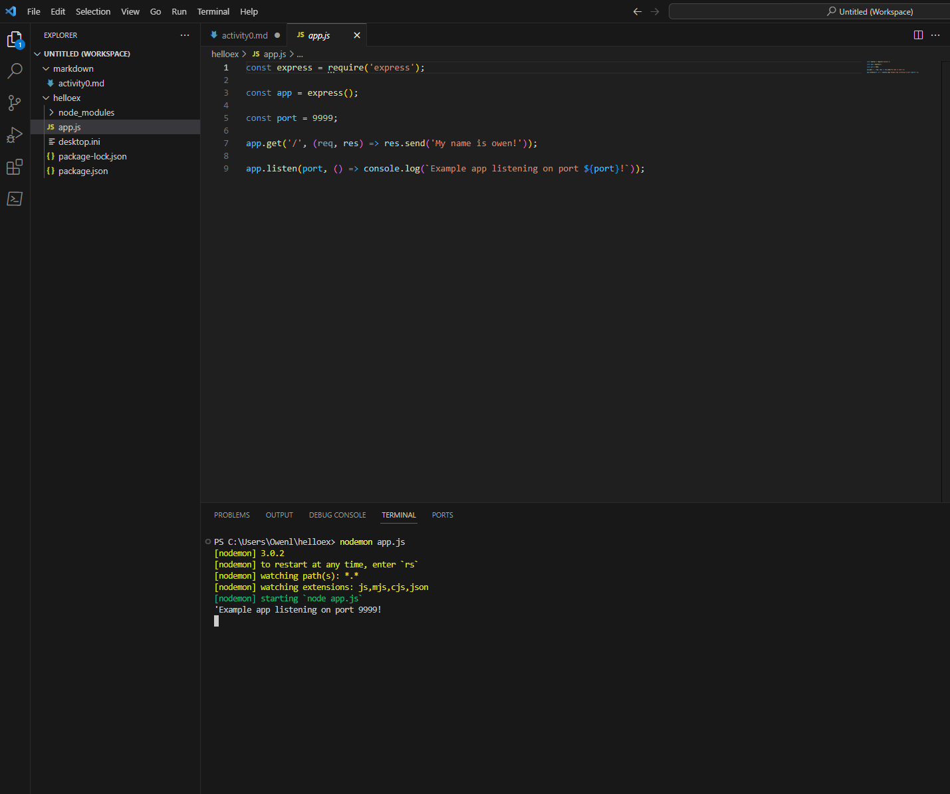

2.1 Web page of app.js.

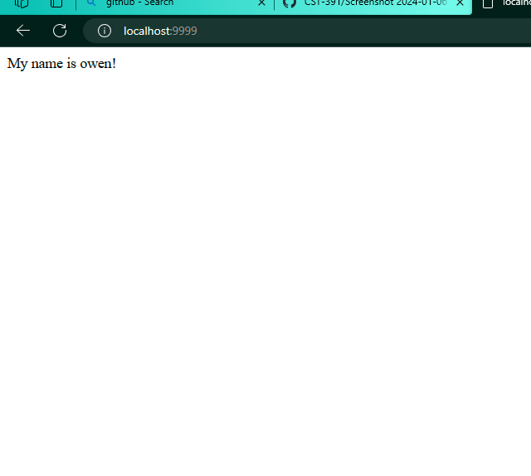

1. **NodeJS with TypeScript.** This screenshot will show our express server written in typescript with provided comments.

* TypeScript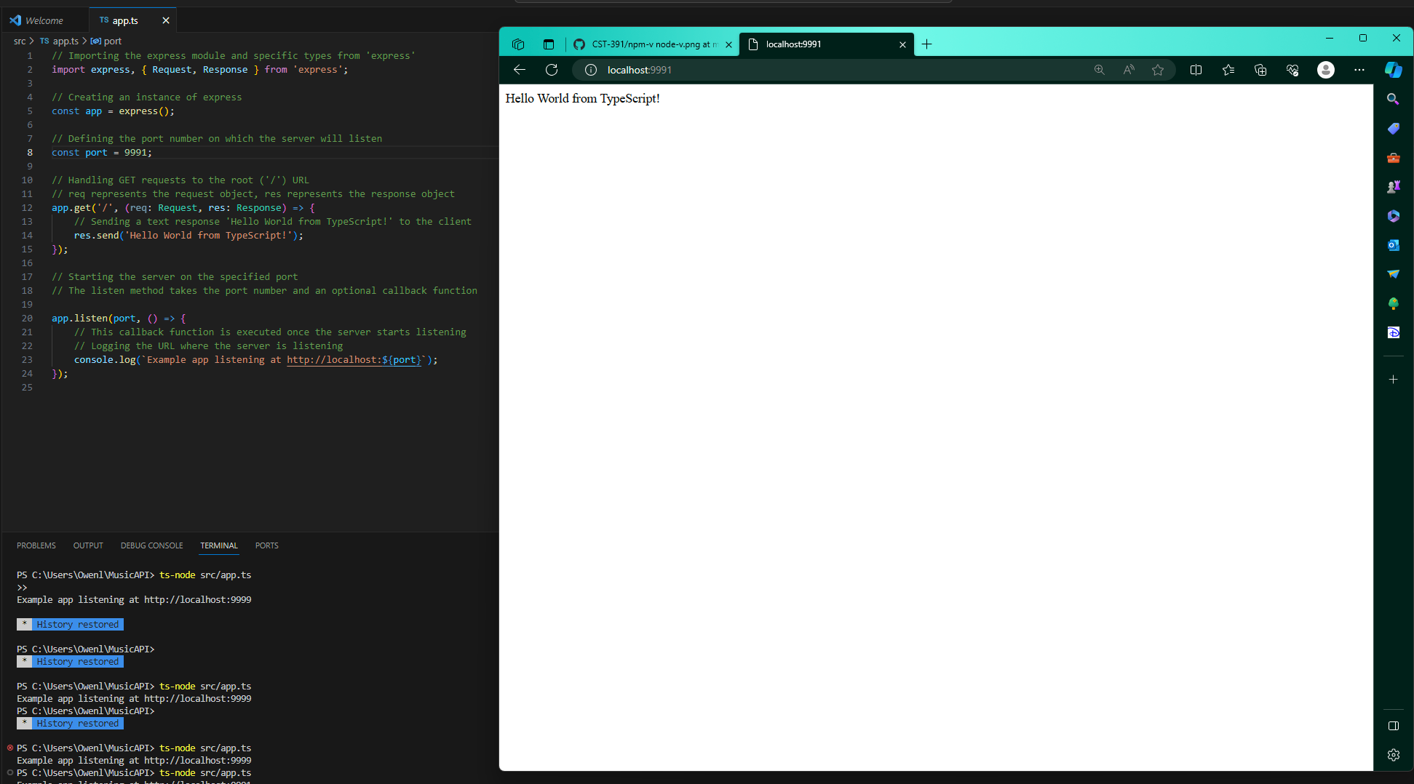

App.ts commented:

// Importing the express module and specific types from 'express'

import express, { Request, Response } from 'express';

// Creating an instance of express

const app = express();

// Defining the port number on which the server will listen

const port = 9991;

// Handling GET requests to the root ('/') URL

// req represents the request object, res represents the response object

app.get('/', (req: Request, res: Response) => {

// Sending a text response 'Hello World from TypeScript!' to the client

res.send('Hello World from TypeScript!');

});

// Starting the server on the specified port

// The listen method takes the port number and an optional callback function

app.listen(port, () => {

// This callback function is executed once the server starts listening

// Logging the URL where the server is listening

console.log(`Example app listening at http://localhost:${port}`);

});