*Owen Lindsey*

*Professor Sparks, James*

*CST-391 Activity 2*

*10/6/2024*

**Angular Directory Structure**

*Angular Default Folder Structure:*

|  |  |
| --- | --- |
| ***Folder*** | ***Purpose*** |
| *Node_modules/* | *Contains all the libraries and dependencies necessary for the project.* |
| *src/* | *The main folder where the source code of the app lives.* |
| *src/app* | *Stores static assets like images, fonts, and other files that can be used across the app.* |
| *src/enviornments* | *Houses configuration files for different environments, like production or development.* |

**Angular Directory Structure**

*Angular Default Folder Structure:*

|  |  |
| --- | --- |
| ***File*** | ***Purpose*** |
| *Angular.json* | *Configuration file for angular CLI that specifies how to build, serve, test, and lint the application.* |
| *Package.json* | *Lists the project dependencies and metadata, including scripts for common commands like build and start.* |
| *tsconfig.json* | *Provides the TypeScript compiler with instructions on how to compile TypeScript code into JavaScript.* |

**Angular Directory Structure**

*How Angular Generates the Default page:*

1. ***main.ts*** *- Initializes the platform that your application runs on, then it uses AppModule to bootsrap the application.*
2. ***app.component.\*****-*

* ***app.component.css:*** *Defines the styles for the root component.*
* ***app.component.html:*** *Contains the HTML template for the root component.*
* ***app.component.ts:*** *Contains the logic for the root component, such as data and behavior.*

1. ***app.module.ts:*** *The root module that tells Angular how to assemble the application. It identifies the app’s components, and services.*

**Angular Folder Content**

*Details Behind the Default folders:*

1. ***node_modules*** *– This directory is auto-generated when you install dependencies for the project using Node Package Manager. You will not need to manually alter the contents of this directory.*
2. ***src*** *– is the working directory where most of a developer's time is spent. It contains the logic, views, styles, images, along with whatever else you may need.*
3. ***src/app*** *- where the core of the angular application lives. It includes modules, components, services, etc.*
4. ***src/assets*** *- A place to store static asset files like images, json, icons, and more.*
5. ***src/enviornments*** *- Contains configuration settings for different stages of your application deployment, such as development, staging, and production.*
6. ***angular.json*** *- A blueprint for the Angular CLI. It defines various configurations for projects and specifies default settings for builders and schematics.*
7. ***package.json -*** *Acts like a manifest for the application. It defines the project dependencies and contains scripts to run tasks like starting the dev server, building the application, and running tests.*
8. ***tsconfig.ts*** *- Contains settings for the TypeScript compiler. TypeScript enhances JavaScript with types, and this file includes the rules on how TypeScript should be transpiled into JavaScript.*

**Angular File Content**

*Details Behind the Default files:*

1. ***main.ts****- file is the entry point for an Angular application. It's responsible for bootstrapping the root Angular module (AppModule) to run in the browser.*
2. ***app.component.\*****-*

* ***app.component.css:*** *Styles specific to the appComponent.*
* ***app.component.html:*** *The view template for the appComponent.*
* ***app.component.ts:*** *Contains the logic for the appComponent, including properties and methods.*

1. *App.module.ts -*

*The app.module.ts file serves as the application's central module. It declares to Angular which components and modules are essential for your app's functionality.*

**Screenshots**

*Terminal Showing Angular Version:*  
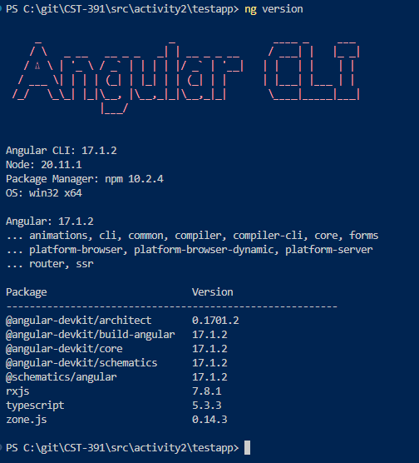

**Screenshots**

*App Initial Page Structure Before Editing:*  
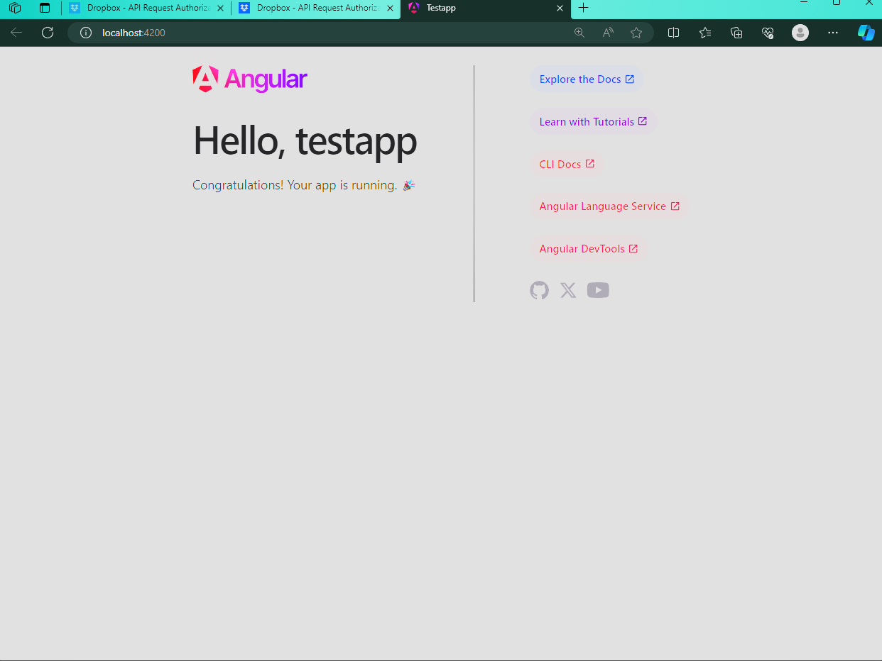

**Screenshots**

*AppComponent edited to show new app name and message below:*  
  
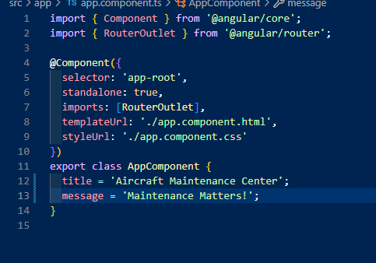  
  
  
**Screenshots**

*App.component.html edited to display the title and message from component.ts:*  
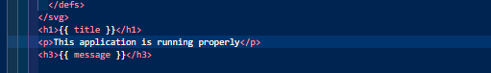

**Screenshots**

*TestApp displaying App Component variables:*  
