Activity 8 Guide: Injection and Prevention Java Spring Boot

Table of Contents
SQL Injection and Prevention 1
Introduction to SQL Injection and Prevention 1
Step by Step Instructions 3
Preview the SQL Injection Attack 7
About Union 10
SQL Injection from the hacker point of view 11
Perform Background research for the MySQL documentation 13
What is INFORMATION_SCHEMA? 13
Repeat the SQL queries as a hacker 16
Part 4: Fixing the Orders App 26
About Sanitize Input 31
2. Remove Potentially Dangerous Keywords 32
3. Allow Only Expected Input 32
4. Use a Whitelist Approach 32
5. Validate Input Length 33
Implement Sanitization 33
Key Takeaways 37
Check for Understanding 39
Deliverables: 41

SQL Injection and Prevention

Introduction to SQL Injection and Prevention
In this lesson, we will demonstrate SQL Injection and how to prevent it. SQL Injection is a common and serious security vulnerability that allows attackers to interfere with the queries that an application makes to its database. This can lead to unauthorized access to sensitive data, database manipulation, and other malicious activities.
The OWASP Top 10 (Open Source Foundation for Application Security) is an authoritative list of common and serious security problems. Injection, including “SQL injection”, is at position number 3.
Here is the list of the 10 most serious problems encountered with application security.

  - Broken Access Control
  - Cryptographic Failures
  - Injection
  - Insecure Design
  - Security Misconfiguration
  - Vulnerable and Outdated Components
  - Identification and Authentication Failures
  - Software and Data Integrity Failures
  - Security Logging and Monitoring Failures
  - Server-Side Request Forgery (SSRF)

Learning Objectives
By the end of this lesson, students will be able to:
- Understand the Basics of SQL Injection:
  - Identify what SQL Injection is and why it is a significant security threat.
  - Recognize how SQL Injection attacks are performed.
- Identify Vulnerable Code:
  - Identify parts of the code that are susceptible to SQL Injection.
  - Explain the role of DAOs (Data Access Objects), Services, and Controllers in managing data and where vulnerabilities might exist.
- Perform SQL Injection Attacks:
  - Conduct SQL Injection attacks in a controlled environment to understand the potential impact.
  - Use SQL statements and UNION operations to manipulate and access unauthorized data.
- Implement Prevention Techniques:
  - Apply parameterized queries and prepared statements to mitigate SQL Injection vulnerabilities.
  - Sanitize and validate user inputs to ensure they do not contain malicious content.
  - Identify how to use ORM tools like JPA, Spring Data JDBC, and JdbcTemplate correctly to avoid SQL Injection.
  - Minimize systems risks, threats, and vulnerabilities using best practices of secure programming.
- Practice with Security Tools:
  - Identify web application scanners used to identify SQL Injection vulnerabilities.
  - Explain how security testing tools can help in finding and fixing vulnerabilities.
- Handle Errors Securely:
  - Explain why custom error pages improve security by avoiding exposing sensitive information through error messages.
  - Implement proper error handling practices to enhance security.
- Follow Best Practices:
  - Apply the principle of least privilege to database user accounts.
  - Recognize and address other related vulnerabilities such as XSS, command injection, and path traversal.

Step by Step Instructions

- Download the starting application. The application is available at https://github.com/shadsluiter/ordersap-with-plain-sql
- Open the project with an IDE (VS Code pictures will be shown in this guide)
- Examine the structure of the application, seen in Figure 1 and Figure 2.

Orders DAO
Orders Controller
Users Controller
Orders Service
Users Service
Users DAO
orders-app
Figure 1 The Orders App uses a DAO, Service and Controller for managing data.

OrderEntity

Id: Long
date: DateTime
customerId: Long
notes: String
OrderModel

Id: String
date: DateTime
customerId: Long
notes: String
Figure 2 Two models used in the app. OrderEntity maps directly to the columns in the database. OrderModel is used in the controller and views.

- The database has two tables, users and orders, linked with a foreign key relationship, seen in Figure 3. Each user can have multiple orders.

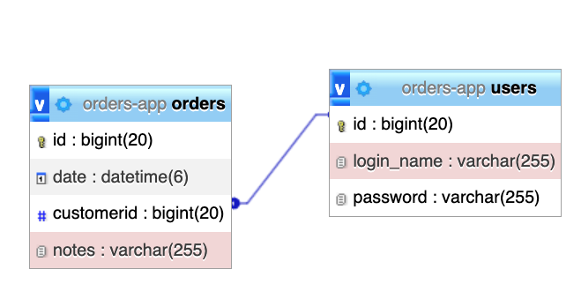
Figure 3 Two tables in the orders-app schema.
- Configure MariaDB with orders-app1.sql
Follow these steps to prepare MariaDB before running the injection exercises with the included orders-app1.sql script:
1. Start the MariaDB server locally and connect as root (or another admin user) through the mariadb client or your GUI of choice.
2. From the project root import the schema by running: mariadb -u root -p < orders-app1.sql. This creates the orders-app database, tables, and seed data.
3. Verify the import with commands such as SHOW DATABASES LIKE "orders-app";, USE orders-app;, and SELECT COUNT(*) FROM orders; to confirm the rows exist.
4. Update src/main/resources/application.properties so the datasource URL is jdbc:mariadb://localhost:3306/orders-app, the driver is org.mariadb.jdbc.Driver, and Hibernate uses the org.hibernate.dialect.MariaDBDialect dialect.
5. Restart the Spring Boot app so it connects to MariaDB before continuing with the SQL injection walk-through.

-- phpMyAdmin SQL Dump
-- version 5.2.0
-- https://www.phpmyadmin.net/
--
-- Host: localhost:8889
-- Generation Time: Jun 10, 2024 at 02:22 PM
-- Server version: 5.7.39
-- PHP Version: 8.1.13

SET SQL_MODE = "NO_AUTO_VALUE_ON_ZERO";
START TRANSACTION;
SET time_zone = "+00:00";

/*!40101 SET @OLD_CHARACTER_SET_CLIENT=@@CHARACTER_SET_CLIENT */;
/*!40101 SET @OLD_CHARACTER_SET_RESULTS=@@CHARACTER_SET_RESULTS */;
/*!40101 SET @OLD_COLLATION_CONNECTION=@@COLLATION_CONNECTION */;
/*!40101 SET NAMES utf8mb4 */;

--
-- Database: orders-app
--
CREATE DATABASE IF NOT EXISTS `orders-app` DEFAULT CHARACTER SET utf8 COLLATE utf8_general_ci;
USE `orders-app`;

-- --------------------------------------------------------

--
-- Table structure for table orders
--

DROP TABLE IF EXISTS orders;
CREATE TABLE orders (
id bigint(20) NOT NULL,
date datetime(6) NOT NULL,
customerid bigint(20) NOT NULL,
notes varchar(255) NOT NULL
) ENGINE=InnoDB DEFAULT CHARSET=utf8;

--
-- Dumping data for table orders
--

INSERT INTO orders (id, date, customerid, notes) VALUES
(1, '2024-01-01 00:00:00.000000', 1, 'Customer requested a fast delivery.'),
(3, '2024-01-03 00:00:00.000000', 3, 'This is for a birthday. \n Special message included.'),
(4, '2024-01-04 00:00:00.000000', 4, 'Specific delivery time for after 5 pm'),
(5, '2024-01-05 00:00:00.000000', 5, 'Please use eco-friendly packaging.'),
(7, '2024-01-07 00:00:00.000000', 2, 'Customer requested an expedited shipping.'),
(12, '2024-01-12 00:00:00.000000', 2, 'Customer requested a return label.'),
(15, '2024-01-15 00:00:00.000000', 5, 'Customer requested a price match.'),
(16, '2024-01-16 00:00:00.000000', 1, 'Customer wanted to track the shipment.'),
(18, '2024-01-18 00:00:00.000000', 3, 'Customer requested an extended warranty.');

-- --------------------------------------------------------

--
-- Table structure for table users
--

DROP TABLE IF EXISTS users;
CREATE TABLE users (
id bigint(20) NOT NULL,
login_name varchar(255) NOT NULL,
password varchar(255) NOT NULL
) ENGINE=InnoDB DEFAULT CHARSET=utf8;

--
-- Dumping data for table users
--

INSERT INTO users (id, login_name, password) VALUES
(1, 'alice', 'password123'),
(2, 'bob', 'Iwishtoberichandfamous!'),
(3, 'charlie', 'new_password'),
(4, 'david', '!%1abc'),
(5, 'eve', 'eveeveeveeve'),
(10, 'shad', '$2a$10$Bf88dy0PvXrVpH/sKy00vOcxq5XibCK3gAkATdc/ZnT7IsbvWtXtm');

--
-- Indexes for dumped tables
--

--
-- Indexes for table orders
--
ALTER TABLE orders
ADD PRIMARY KEY (id),
ADD KEY customerid (customerid);

--
-- Indexes for table users
--
ALTER TABLE users
ADD PRIMARY KEY (id);

--
-- AUTO_INCREMENT for dumped tables
--

--
-- AUTO_INCREMENT for table orders
--
ALTER TABLE orders
MODIFY id bigint(20) NOT NULL AUTO_INCREMENT, AUTO_INCREMENT=31;

--
-- AUTO_INCREMENT for table users
--
ALTER TABLE users
MODIFY id bigint(20) NOT NULL AUTO_INCREMENT, AUTO_INCREMENT=1002;

--
-- Constraints for dumped tables
--

--
-- Constraints for table orders
--
ALTER TABLE orders
ADD CONSTRAINT orders_ibfk_1 FOREIGN KEY (customerid) REFERENCES `users` (id);
COMMIT;

/*!40101 SET CHARACTER_SET_CLIENT=@OLD_CHARACTER_SET_CLIENT */;
/*!40101 SET CHARACTER_SET_RESULTS=@OLD_CHARACTER_SET_RESULTS */;
/*!40101 SET COLLATION_CONNECTION=@OLD_COLLATION_CONNECTION */;

- Examine the contents of each table.

- Notice that the orders table has a foreign key relationship. Each order.customerid number corresponds to a real user.id property, seen in Figure 4 and Figure 5.
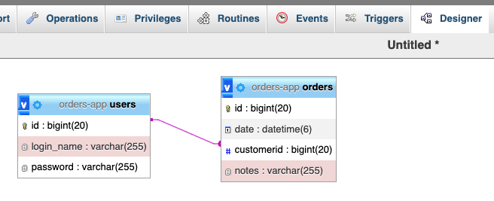
Figure 4 orders has a foreign key relation to the users table.

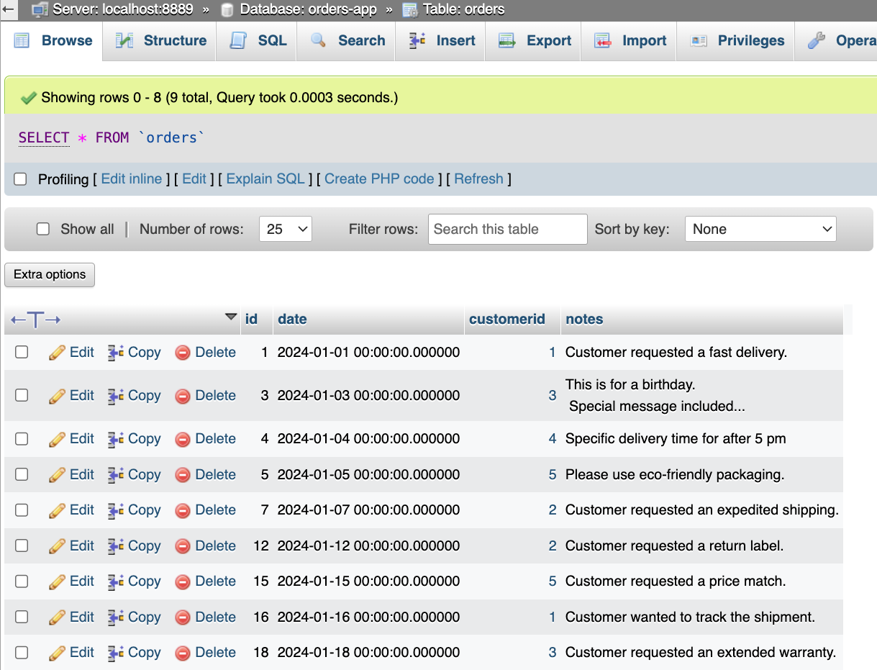
Figure 5 Contents of the orders table.

- Notice that each user has a password, seen in Figure 6. Some passwords are clear text. The last password was hashed for security.

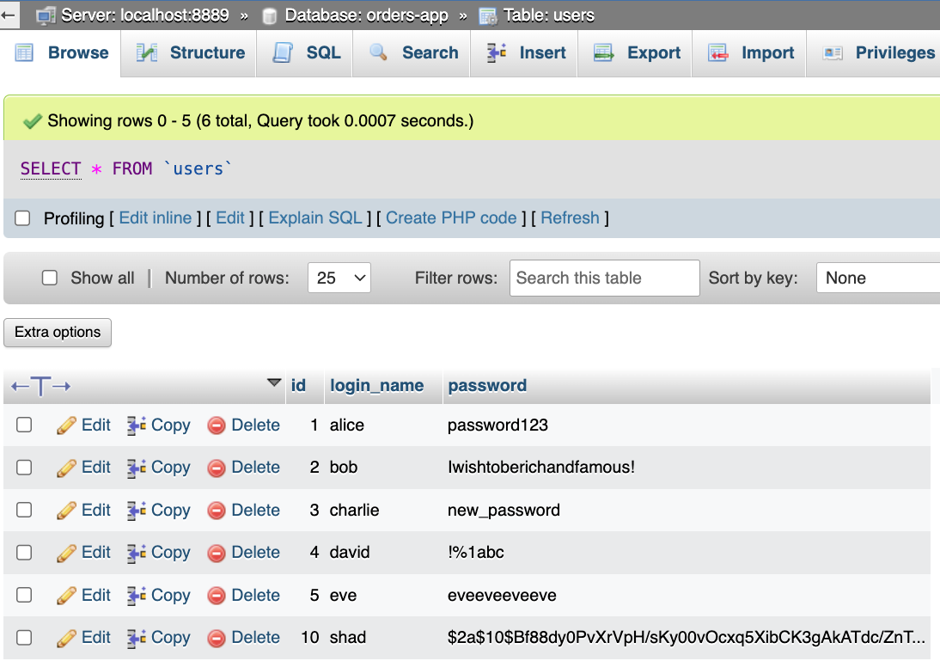
Figure 6 Contents of the users table.

Preview the SQL Injection Attack

During this tutorial we will perform a SQL injection attack against the application. The attacker will not have access to the mySQL admin tool, but only access to the user interface. However, it will be much easier for us to visualize the SQL statements in the tutorial if we first execute them in the admin tools.

- Perform a wildcard search on the orders table, seen in Figure 7.
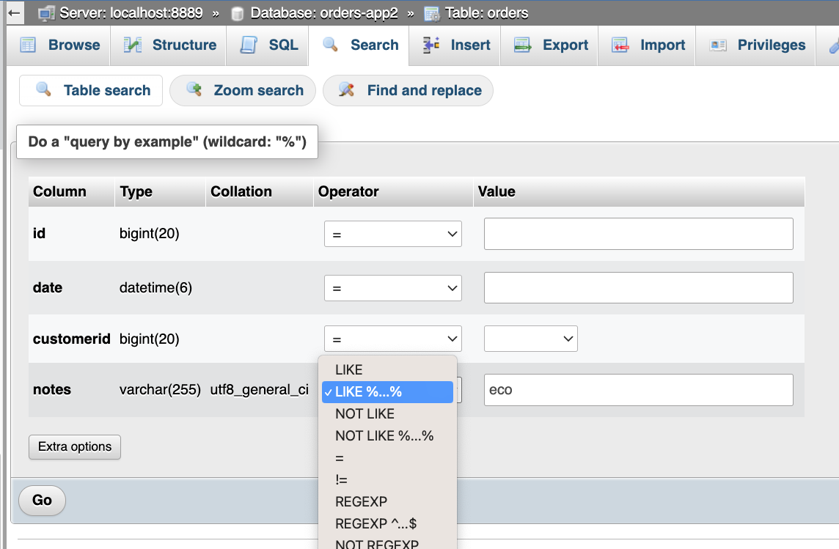
Figure 7 Searching for a wildcard search "%eco%" in the notes column.

- There should be some matching results if you provide a fragment of text that matches anything in the nodes column, shown in Figure 8.

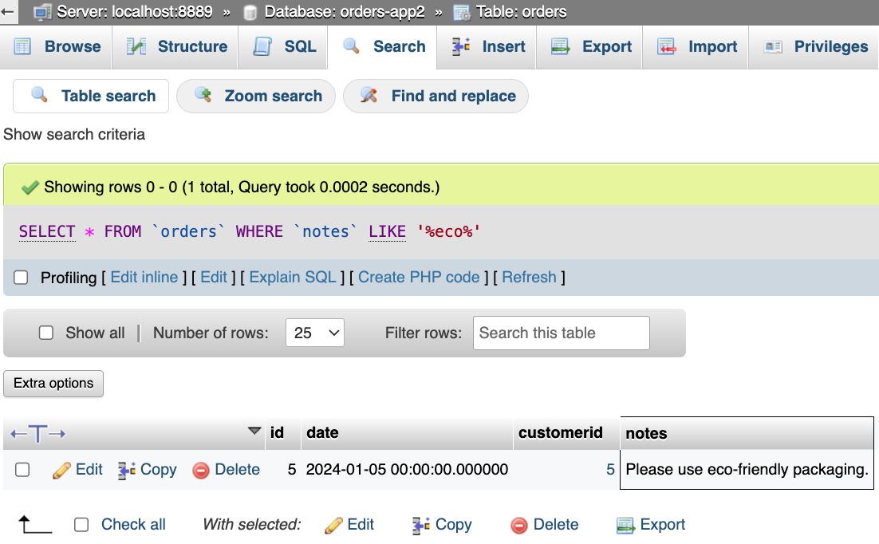
Figure 8 One result has the phrase "eco" in the notes.

- Choose “Edit Inline” to see the SQL statement used in the query, seen in Figure 9.

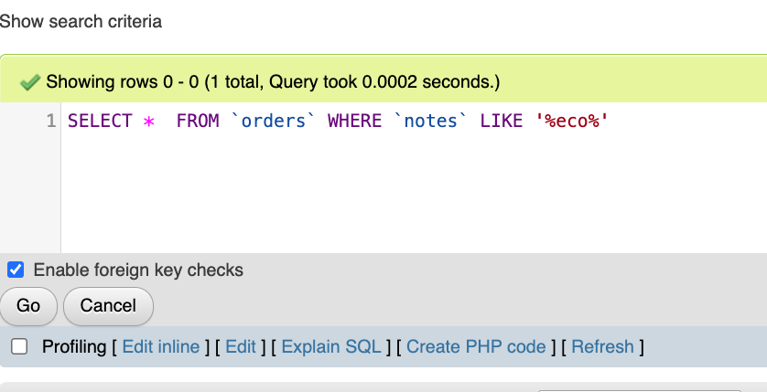
Figure 9 Editing the SQL search command.

- The following statement will be the key to the attack we will perform here as well as with the application user interface.

' UNION SELECT 999, '2024-01-01 00:00:00', 999, login_name FROM users WHERE 'a'LIKE'a

Let’s simulate the injection in the mySQL admin by copying the fragment and replacing the “eco” string, seen in Figure 10. The searchTerm is the only place where the hacker will have freedom to change the data.

Select eco in the SQL statement.
Figure 10 Selecting eco in the sql statement.
- Paste the “union” fragment over top of the eco string, seen in Figure 11. Notice that the carefully formatted SQL fragment matches perfectly with a legal SQL syntax. The two statements should return (1) all the orders since LIKE ‘%’ matches every row and (2) all login_names since ‘a’ LIKE ‘a%’ also matches every row.

Replaced eco
Figure 11 Fragment pasted over eco changes the sql statement to a union statement.
- Click Go to see the results, seen in Figure 12.

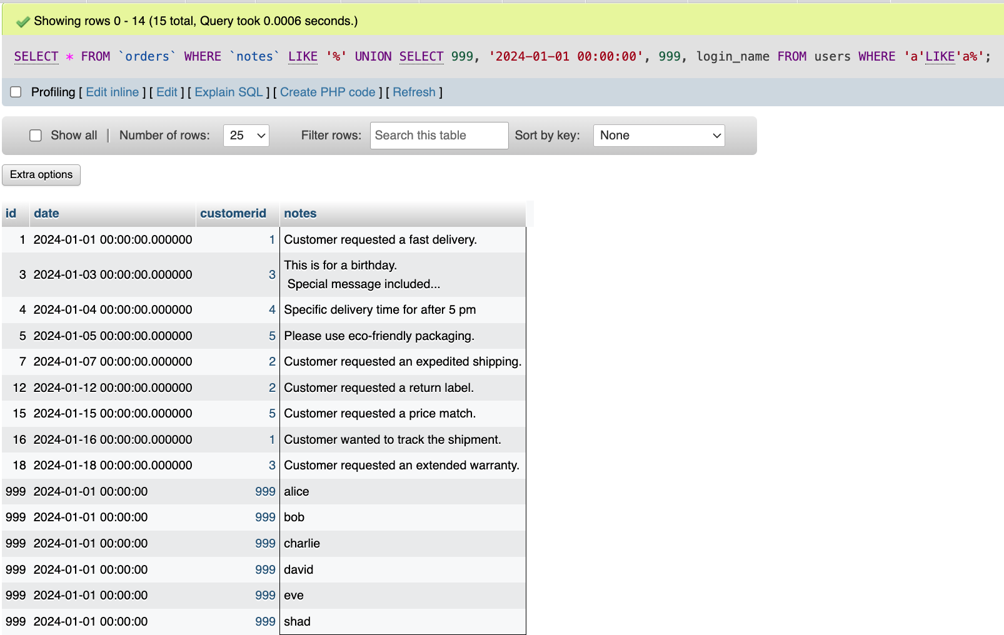
Results from the original SQL select.
Results from the UNION SQL select.
Figure 12 Two sets of results are UNION together.


- Take a screen shot of the application running at this point.
- Paste the image into a Word document.
- Put a caption below the image explaining what is being demonstrated.

About Union

Recall that a UNION statement returns two sets of rows. The key rule of a UNION statement is that the second SELECT statement must match the data type of each column. Since we already know the structure of the users table it is possible to use the placeholder values 999 and '2024-01-01 00:00:00' for three of the columns. The notes column is a string so we can match the login_name in column 4.

- Change the login_name column to password, seen in Figure 13.

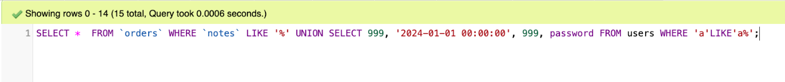
Figure 13 Searching for all passwords.
- The results seen in Figure 14 reveal the password in column 3.

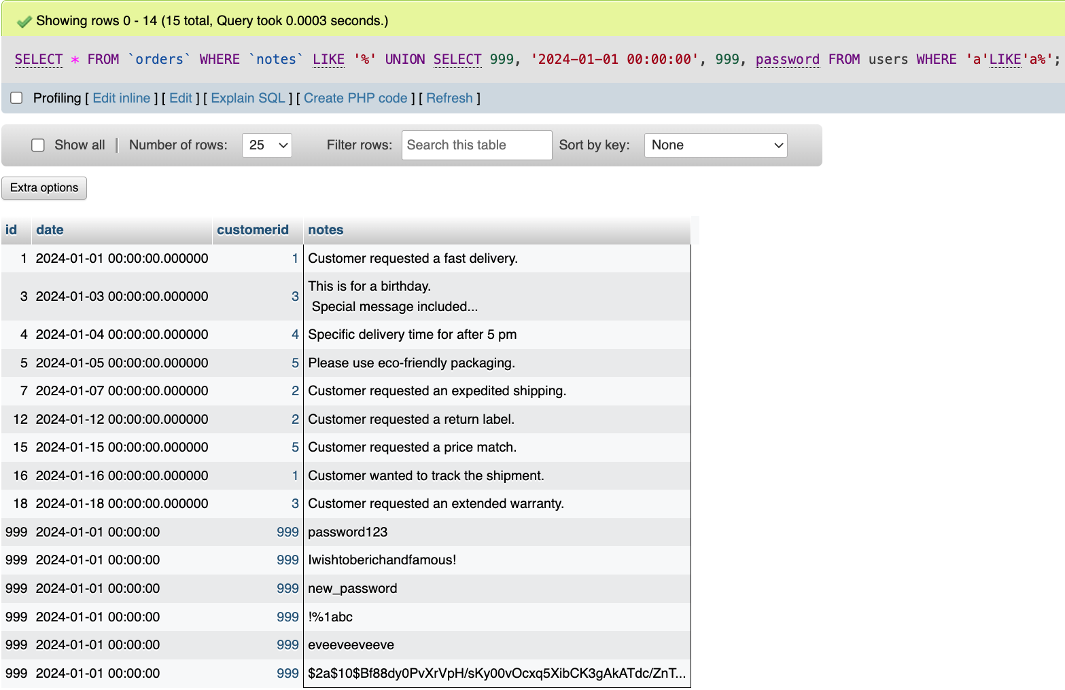
Results from the original SQL select.
Results from the UNION SQL select.
Figure 14 UNION statement now shows the password for each user.


- Take a screen shot of the application at this point.
- Paste the image into a Word document.
- Put a caption below the image explaining what is being demonstrated.

If you theoretically were a hacker trying to steal information from a SQL database, you would likely use an admin console to practice and refine the statements you plan to use on a real application.

SQL Injection from the hacker point of view

Now let’s attack the application as if we were a hacker. The hacker does not have the advantage of using mySQL admin or even knowing the name of the database, the table names nor the column names.

- Run the Orders App and perform a search for orders, shown in Figure 15.

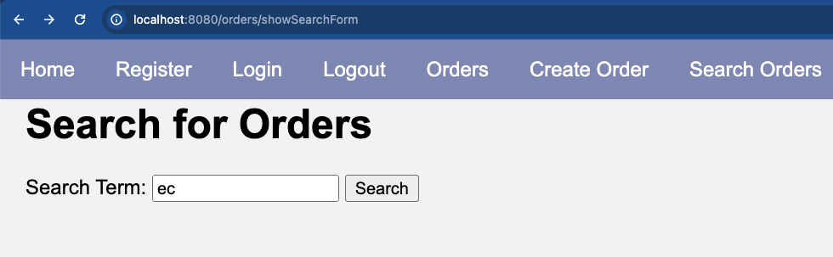
Figure 15 Performing a search query with the Orders App.

- The search results show as expected, seen in Figure 16.
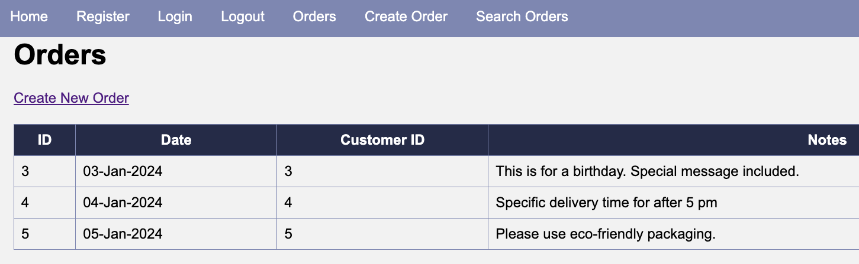
Figure 16 Three results match "ec".

- The key vulnerable point of the application is found in the Orders DAO, seen in Figure 17. The findBySearch method uses wildcard searches. The SQL string is concatenated with input directly from the user input box.
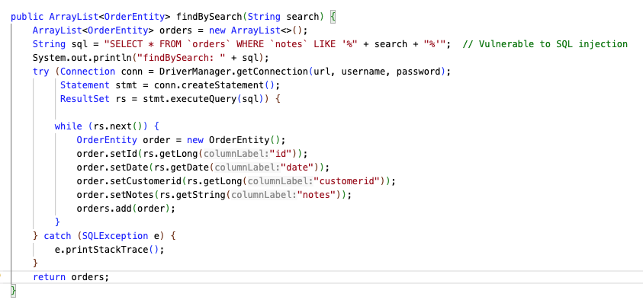

Figure 17 find by search method in OrdersDAO.

Perform Background research for the MySQL documentation

The key to performing any SQL injection attack is to gather sufficient relevant background information about the target. Let’s take the position of a hacker. Let’s also assume that we know the Orders application is running on MySQL. Other SQL variants will have slightly different details.

- Look up the MySQL documentation online. We discover that all MySQL servers contain an administrative database called INFORMATION_SCHEMA, seen in Figure 18.

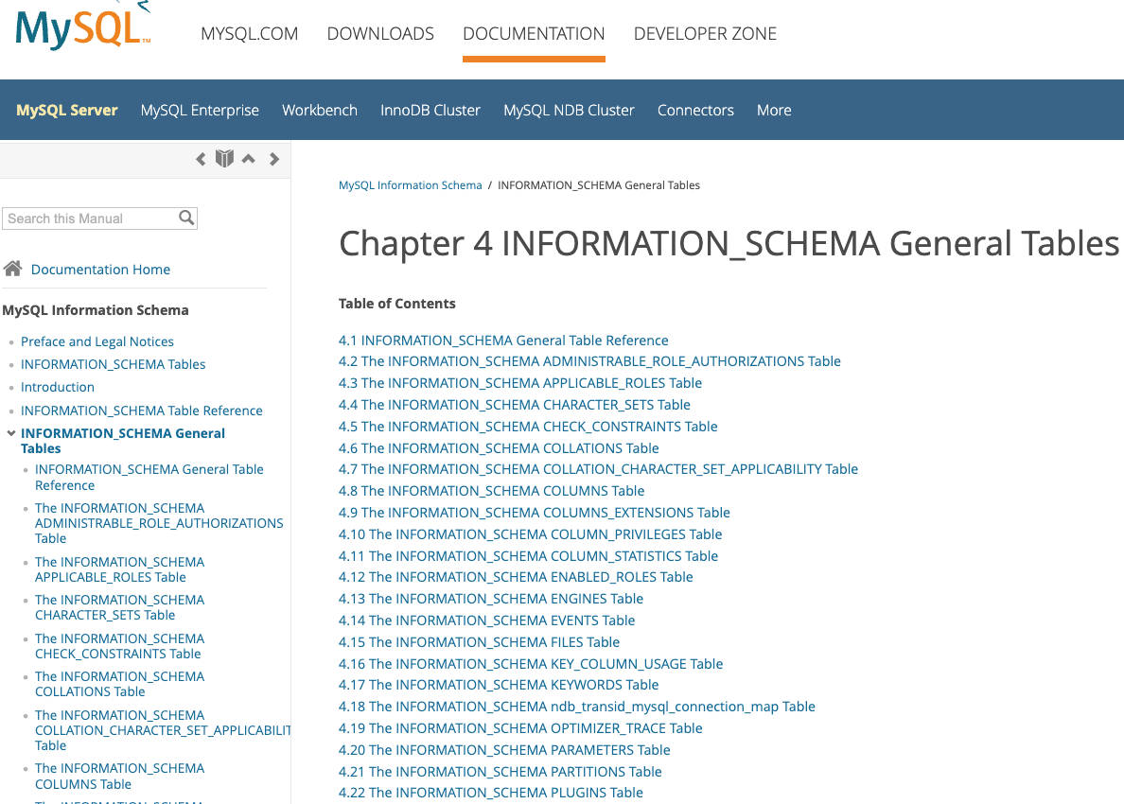
Figure 18 Documentation on MySQL website about INFORMATION_SCHEMA.

What is INFORMATION_SCHEMA?

Information schema is a database in MySQL that contains information about all other database instances on the server. The schema database contains names of tables, names of column and their data types. If your target is MS SQL, Oracle, Postgres or other database system, the details will be different.

- We will perform some practice searches on our own MySQL admin tool. This will give us a way to see the table structure and column names. Copy the following SQL query and insert it into the MySQL admin tool, seen in Figure 19 and Figure 20.

SELECT SCHEMA_NAME FROM INFORMATION_SCHEMA.SCHEMATA

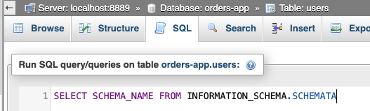
Figure 19 Select all the databases on this server.

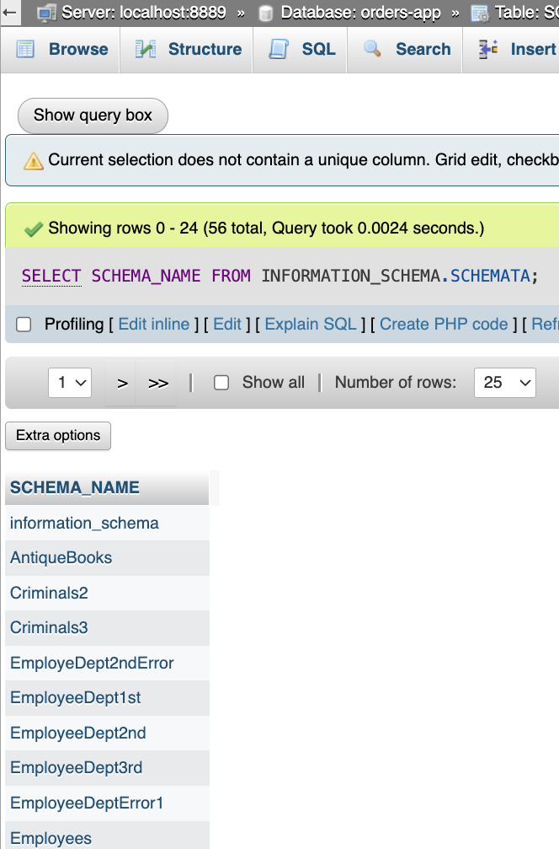
Figure 20 Selecting all the databases found on this server.

- There are many schemas (databases) on this server. Your instance of MAMP will likely have only a handful. Making an educated guess, we assume that orders-app is our target, shown in Figure 21.
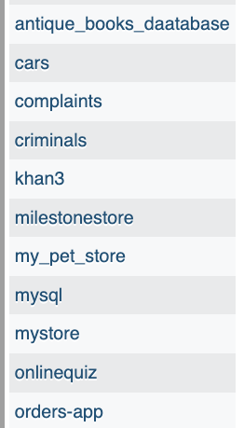
Figure 21 orders-app appears in the list of schemas on this server.

- Next, we select the table names from the orders-app schema, as soon in Figure 22.

SELECT TABLE_NAME FROM INFORMATION_SCHEMA.TABLES WHERE TABLE_SCHEMA LIKE 'orders-app';

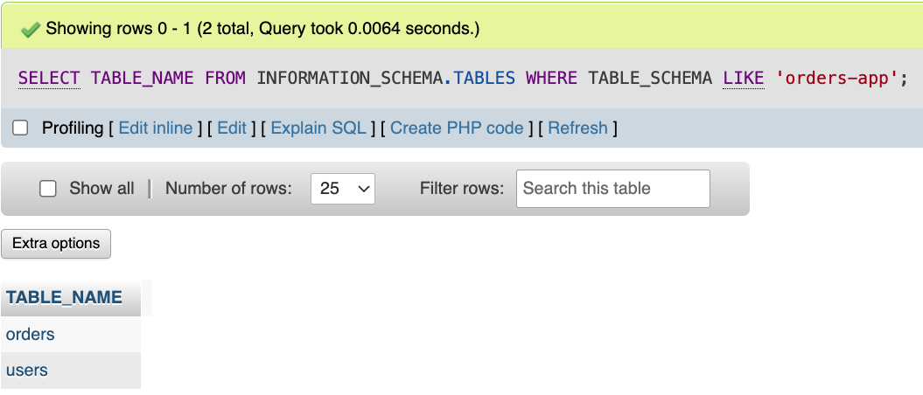
Figure 22 Selecting the table names from the orders-app schema.

- Next select the column names from the users table, seen in Figure 23.

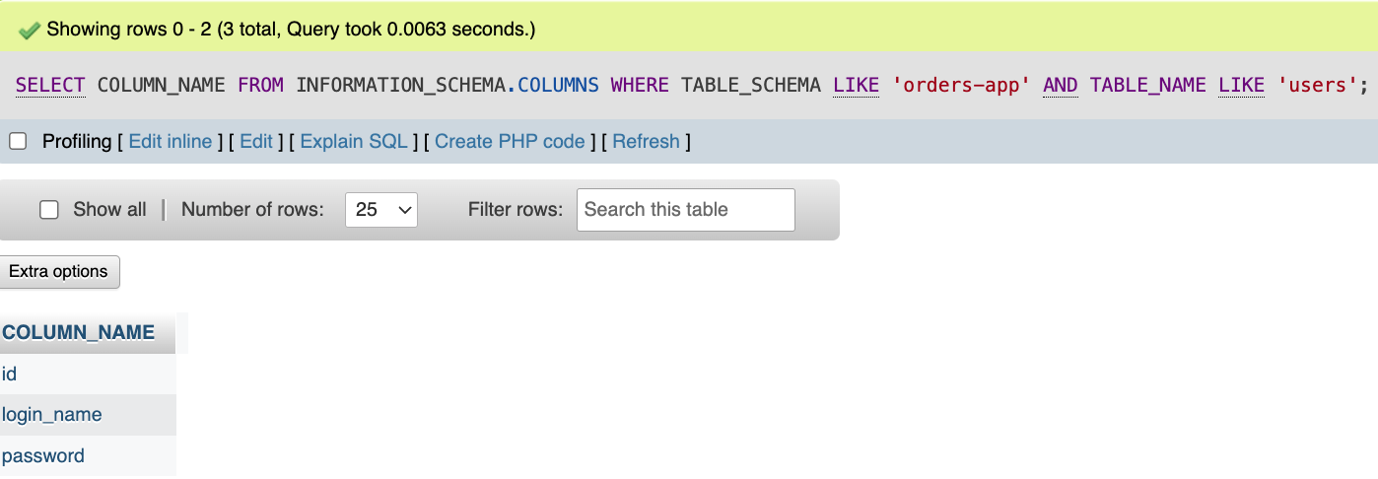
Figure 23 Selecting the column names from the users table.

Repeat the SQL queries as a hacker

Now that we have practiced SQL statements on INFORMATION_SCHEMA using the admin tools, let’s repeat the attack with similar statements using SQL injection using only the user interface of the Orders application.

- Go to the application interface and choose the “Search” option, shown in Figure 24.

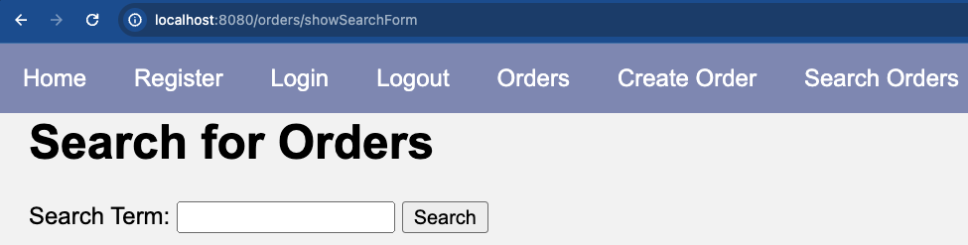
Figure 24 Search Orders screen on the application.

- Search for the schemas on this MySQL system, shown in Figure 25, with this injection.

' UNION SELECT 999, '2024-01-01 00:00:00', 999, SCHEMA_NAME FROM INFORMATION_SCHEMA.SCHEMATA WHERE 'a'LIKE'a

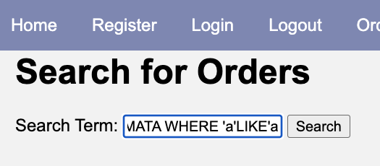
Figure 25 Pasting the SQL injection statement into the search box.

- The schema names should show after the orders search results, seen in Figure 26.

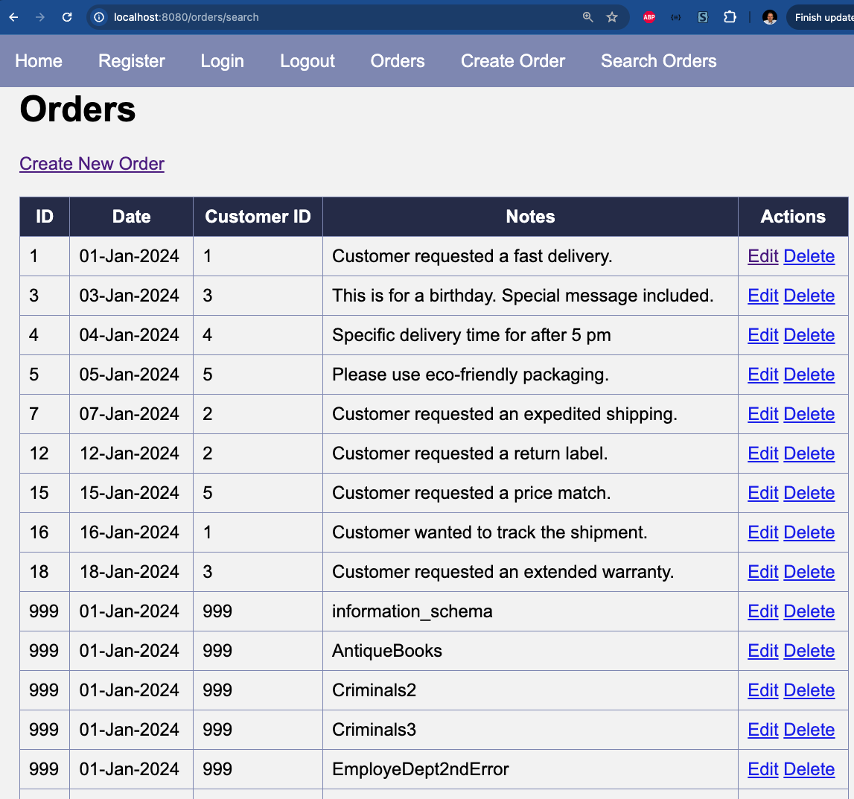
Figure 26 The UNION portion of the SQL query reveals the names of schemas found on this server.


- Take a screen shot of the application at this point.
- Paste the image into a Word document.
- Put a caption below the image explaining what is being demonstrated.

- Check the server console log. The program has been configured to show the effective SQL statement being run, as seen in Figure 27 and Figure 28.

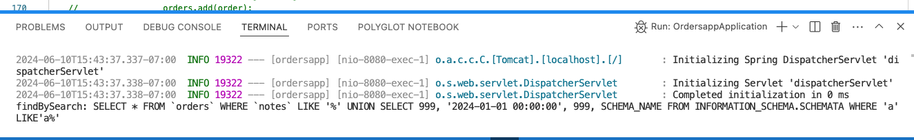
Figure 27 The OrdersDAO has a print statement which allows us to see the combined SQL and SQL injection statement.

Figure 28 println statement in the OrdersDAO allows us to see the SQL statement being used.

- Assuming that we can identify orders-app as the target, run a query to fetch all table names from orders-app, as shown in Figure 29 and Figure 30.

' UNION SELECT 999, '2024-01-01 00:00:00', 999, TABLE_NAME FROM INFORMATION_SCHEMA.TABLES WHERE TABLE_SCHEMA LIKE 'orders-app' AND 'a'LIKE'a

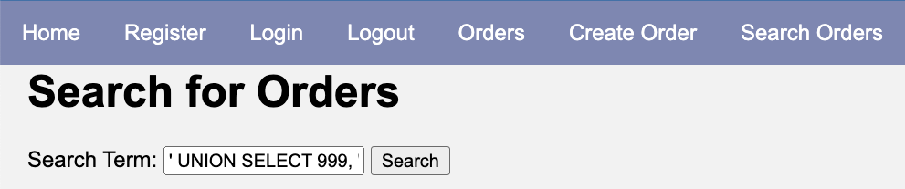
Figure 29 Pasting the SQL fragment into the search box.
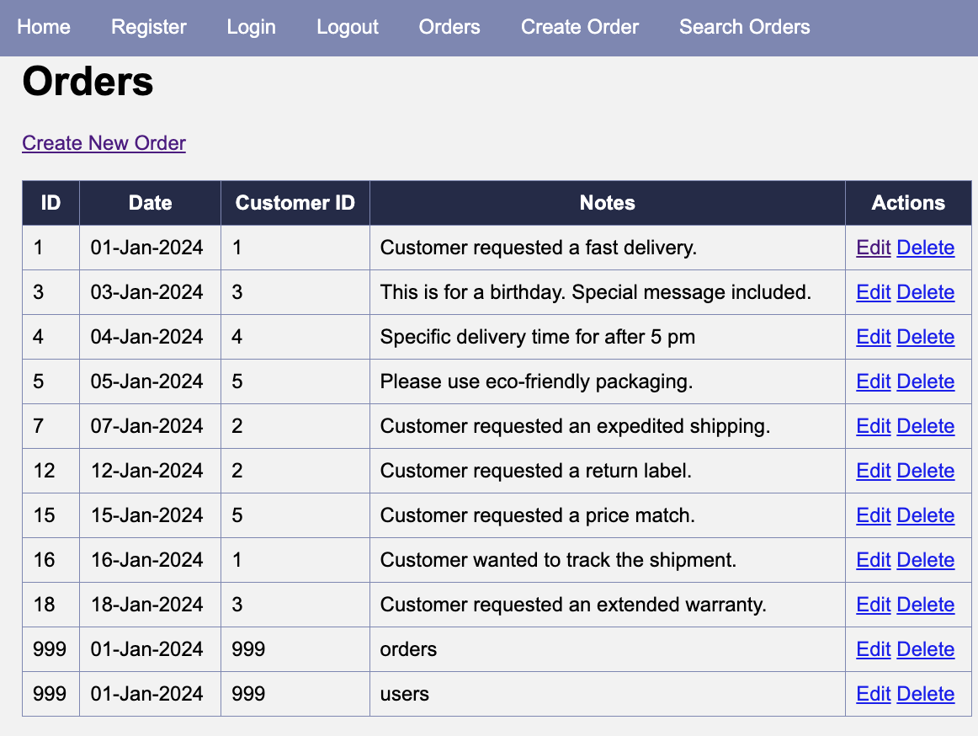
Figure 30 The UNION portion of the SQL SELECT reveals the names of the tables in the orders-app.

- Take a screen shot of the application at this point.
- Paste the image into a Word document.
- Put a caption below the image explaining what is being demonstrated.

- Look at the server console to see the SQL statement that was used, as seen in Figure 31.
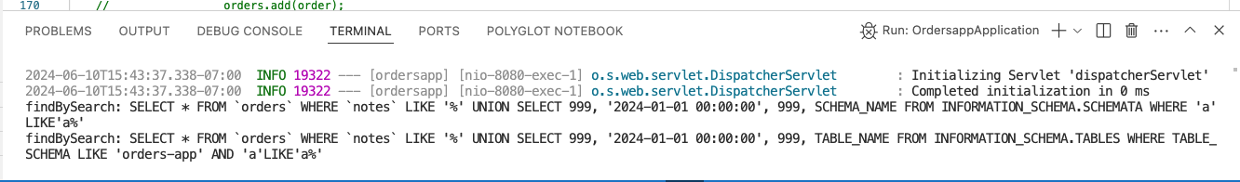
Figure 31 See the SQL statement that was used.

- Assuming we want to target the users table, let’s fetch all of the column names, shown in Figure 32 and Figure 33.

' UNION SELECT 999, '2024-01-01 00:00:00', 999, COLUMN_NAME FROM INFORMATION_SCHEMA.COLUMNS WHERE TABLE_SCHEMA LIKE 'orders-app' AND TABLE_NAME LIKE 'users' AND 'a'LIKE'a

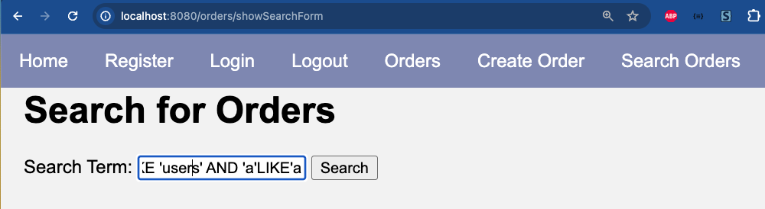
Figure 32 Pasting the SQL injection statement.

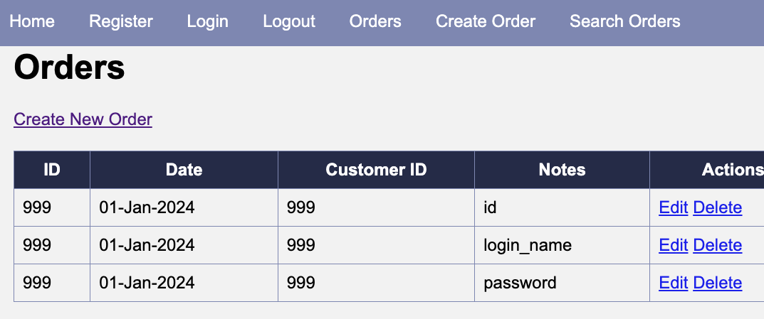
Figure 33 The results of the query show the column names in the users table.

- Take a screen shot of the application at this point.
- Paste the image into a Word document.
- Put a caption below the image explaining what is being demonstrated.

- Look in the server console to see the SQL statement that was used, as seen in Figure 34.
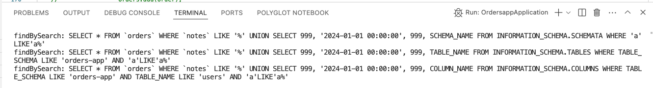
Figure 34 See the SQL statement that was used.

- Now we have the column names we can get both the login names and passwords of all users.

- First fetch the login_names, as seen in Figure 35 and Figure 36.

' UNION SELECT id, '2024-01-01 00:00:00', id, login_name FROM users WHERE 'a'LIKE'a

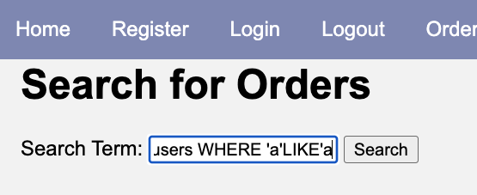
Figure 35 Pasting the SQL injection statement.
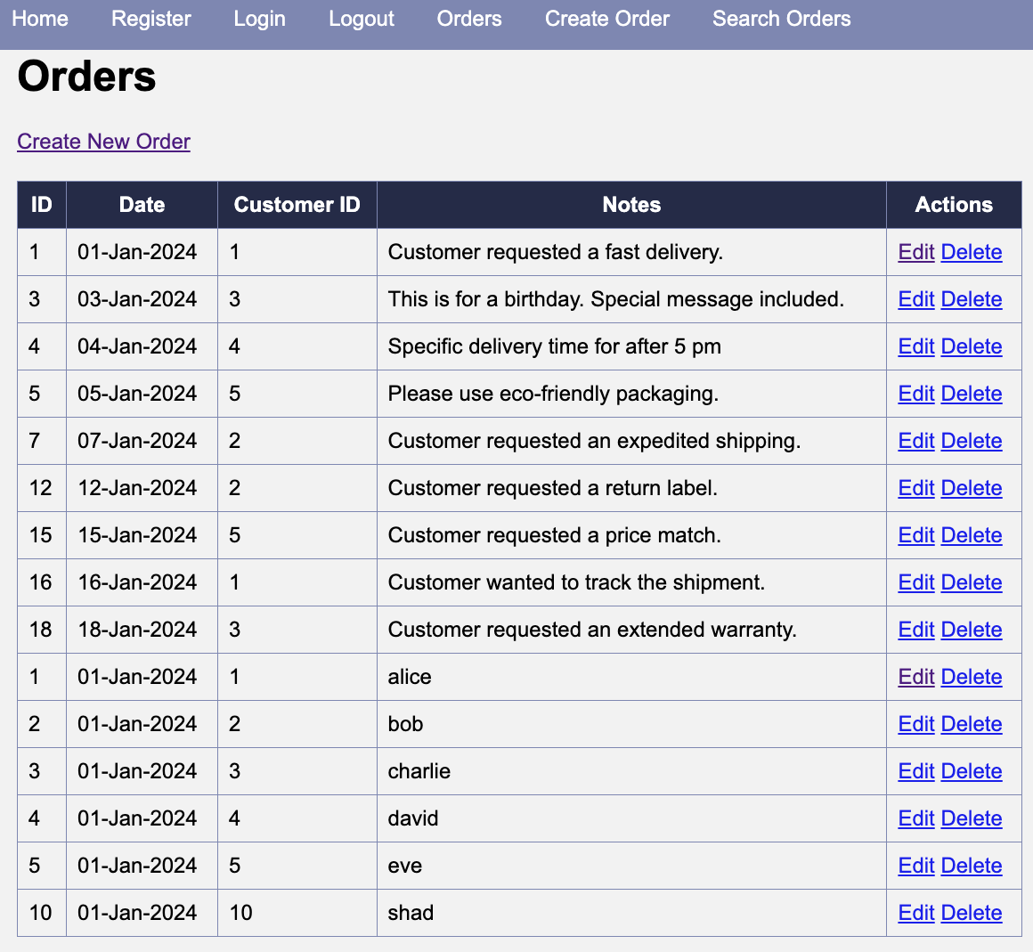

Figure 36 The UNION portion of the results shows the login_name contents.

- Take a screen shot of the application at this point.
- Paste the image into a Word document.
- Put a caption below the image explaining what is being demonstrated.

- Check the server console to see the SQL statement, shown in Figure 37.

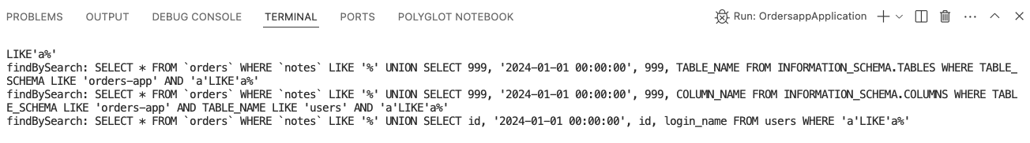
Figure 37 See the SQL statement.

- Fetch the passwords, seen in Figure 38 and Figure 39.

' UNION SELECT id, '2024-01-01 00:00:00', id, password FROM users WHERE 'a'LIKE'a

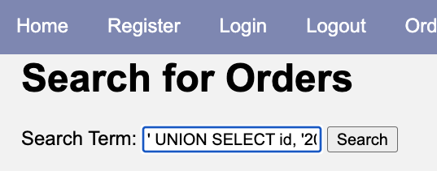
Figure 38 Pasting the SQL injection statement.

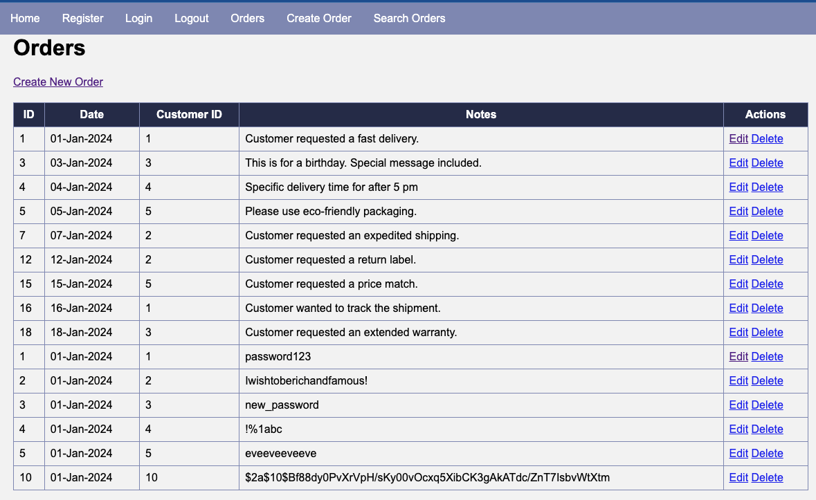

Figure 39 Passwords are revealed!

- Take a screen shot of the application at this point.
- Paste the image into a Word document.
- Put a caption below the image explaining what is being demonstrated.

- Look at the SQL statement in the server console, seen in Figure 40.
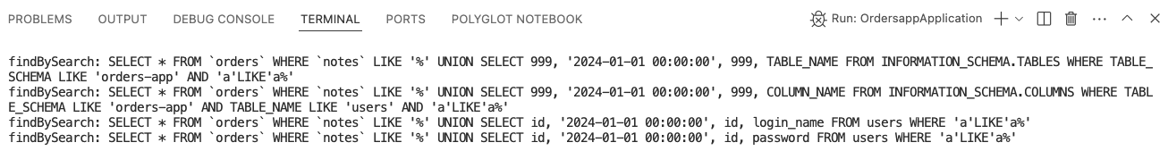
Figure 40 See the SQL statement.

- Now that we have the passwords, we can either login as the user if the password is clear text, or we can use the password hashes in a password cracking tool. If any of the passwords are weak, we should be able to login as the user in a short period of time.

Other SQL Injection attacks

In addition to fetching the username and password of every account, we can use SQL injection for other attacks. Review these statements. You do not need to execute them for this assignment’s deliverables. However, you should see their potential for harm.

Knowing the column names allows us to insert new data such as a new user account. Note: the query has a trailing space after the double hyphen.

'; INSERT INTO users (id, login_name, password) VALUES (null, 'new_admin', 'password'); --

We don’t necessarily have to crack a password if we can simply replace it. Note: the query has a trailing space after the double hyphen.

'; UPDATE users SET password = 'new_password' WHERE login_name = 'charlie'; --

We can perform some major damage to a system by dropping or renaming tables. Note: the query has a trailing space after the double hyphen.

'; DROP TABLE users; --

We can cover our tracks if we want to remove any accounts. Note: the query has a trailing space after the double hyphen.

// remove a user
'; DELETE FROM users WHERE login_name = 'user_to_delete'; --

We could modify or delete evidence of our activities by modifying logging data. This query assumes an application has access_logs table. Note: the query has a trailing space after the double hyphen.

'; INSERT INTO access_logs (user_id, timestamp) VALUES (1, NOW()); --

Identifying a SQL Vulnerability

Obviously, we don’t want this application to be used on a public website. Let’s examine the Java code to see where these vulnerabilities come from and how to fix them.

Four choices for Spring Boot Data Persistence

There are four degrees of database abstractions provided to Spring Boot applications for working with MySQL (or other databases). All these methodologies can be vulnerable to SQL injection attack if not coded properly.

JPA (Java Persistence API): This is the highest level of abstraction and allows developers to work with entities and repositories without writing SQL. Spring Data JPA is a common implementation.
Spring Data JDBC: This provides a simpler approach than JPA but still abstracts some boilerplate code. It allows the use of repositories with SQL queries.
JdbcTemplate: This is a lower level than Spring Data JDBC. It requires developers to write their SQL queries and map the results manually. It simplifies database interactions compared to using plain JDBC but still requires more manual work compared to JPA.
Plain JDBC: This is the lowest level. Developers need to open connections, write SQL queries, execute them, and handle the result sets manually. It offers the most control but also requires the most boilerplate code. We will discover that this is the type of database interaction that orders-app implements.

JPA
JPA itself is designed to mitigate SQL injection risks when used correctly. However, its vulnerability depends on how queries are constructed and executed.

Safe Usage: JPA encourages the use of JPQL (Java Persistence Query Language) and named parameters, which help in preventing SQL injection. For example:

@PersistenceContext
private EntityManager entityManager;

public List<User> findByUsername(String username) {
String jpql = "SELECT u FROM User u WHERE u.username = :username";
return entityManager.createQuery(jpql, User.class)
.setParameter("username", username)
.getResultList();
}
In this example, the :username parameter is safely handled by JPA, preventing SQL injection.

Unsafe Usage: If user input is directly concatenated into the JPQL or native SQL query strings, it can become vulnerable to SQL injection. Here is an example of unsafe usage:

public List<User> findByUsername(String username) {
String jpql = "SELECT u FROM User u WHERE u.username = '" + username + "'";
return entityManager.createQuery(jpql, User.class)
.getResultList();
}

In this example, the username variable is directly concatenated into the JPQL query string, which can allow an attacker to inject malicious SQL code.

Spring Data JDBC

Spring Data JDBC itself is not inherently vulnerable to SQL injection. The vulnerability depends on how the queries are constructed and used.

Safe Usage: Spring Data JDBC encourages the use of repositories and query methods that are safe from SQL injection when parameters are correctly passed and handled. For example, using query methods with named parameters:

public interface UserRepository extends CrudRepository<User, Long> {
@Query("SELECT * FROM users WHERE username = :username")
List<User> findByUsername(@Param("username") String username);
}

In this example, the :username parameter is safely handled by Spring Data JDBC, preventing SQL injection.

Unsafe Usage: If user input is directly concatenated into SQL queries, it can become vulnerable to SQL injection. Here is an example of unsafe usage:

public interface UserRepository extends CrudRepository<User, Long> {
@Query("SELECT * FROM users WHERE username = '" + username + "'")
List<User> findByUsername(String username);
}

In this example, the username variable is directly concatenated into the SQL query string, which can allow an attacker to inject malicious SQL code.

JdbcTemplate

JdbcTemplate itself is not inherently vulnerable to SQL injection. However, its safety depends on how it is used.

Safe Usage: When using JdbcTemplate, if you use placeholders for parameters and pass the parameters separately (as method arguments), it is safe and not vulnerable to SQL injection. Here's an example of safe usage:

String sql = "SELECT * FROM users WHERE username = ?";
List<User> users = jdbcTemplate.query(sql, new Object[] { username }, new UserRowMapper());

In this example, the ? is a placeholder for the username parameter, and JdbcTemplate correctly escapes and binds the parameter value, preventing SQL injection.

Unsafe Usage: If you concatenate user input directly into the SQL string, it becomes vulnerable to SQL injection. Here's an example of unsafe usage:

String sql = "SELECT * FROM users WHERE username = '" + username + "'";
List<User> users = jdbcTemplate.query(sql, new UserRowMapper());

Part 4: Fixing the Orders App

Now let’s modify the settings and code used in the application that we just hacked.

- Remove the allowMultipleQueries option from the database URL in OrdersDAO, as seen in Figure 41. This setting was added simply to make the system more vulnerable. However, allowMultipleQueries could be useful if you are trying to run batches of SQL queries for efficiency purposes.

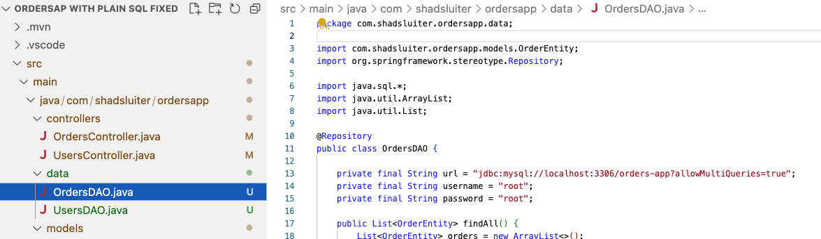
Figure 41 Remove the allMultipleQueries option.

- Modify the Search query in the OrdersDAO, as seen in Figure 42 and Figure 43.
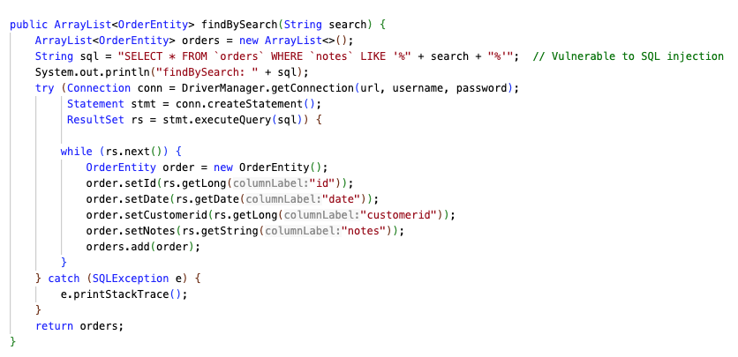
Figure 42 The vulnerable search method.

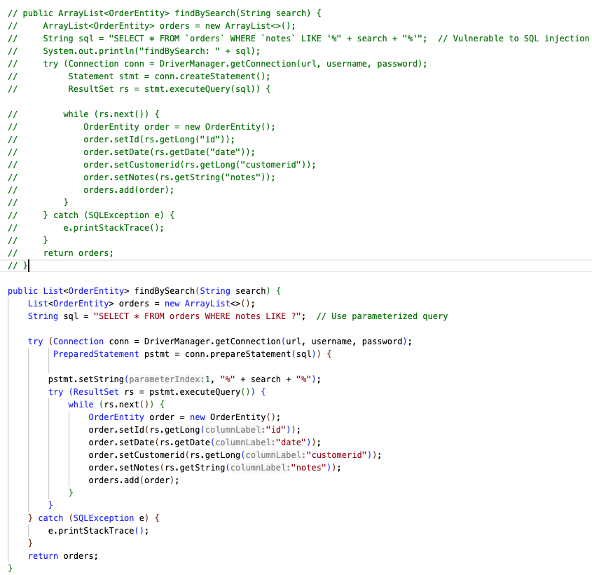
The ? placeholder is calculated as a separate string and inserted as a class called PreparedStatement psstmt
Figure 43 Commented the vulnerable version of the method and replaced it with a parameterized query.

- Attempt to run the SQL injection attack again, shown in Figure 44 and Figure 45.

' UNION SELECT id, '2024-01-01 00:00:00', id, password FROM users WHERE 'a'LIKE'a

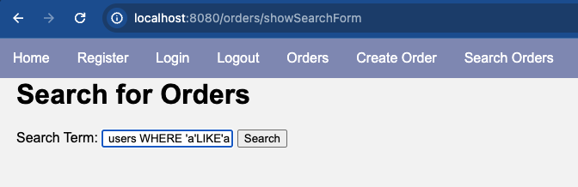
Figure 44 Inserting the SQL injection code.

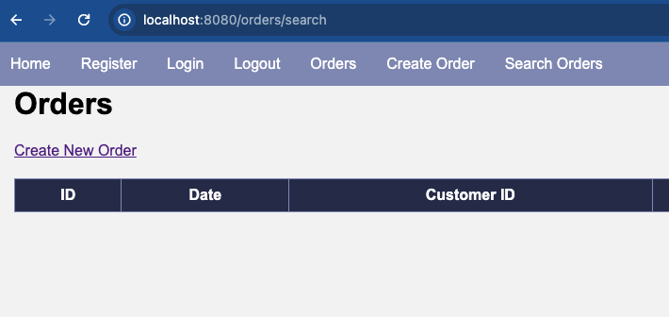
Figure 45 No search results.

- Continue fixing the OrdersController by correcting the findByCustomerId method, seen in Figure 46. It too is vulnerable to SQL injection.
- Use a parameter with ? to identify the Long id value.
- Test the application changes to verify that a) the SQL injection fails and b) the valid SQL statement succeeds.
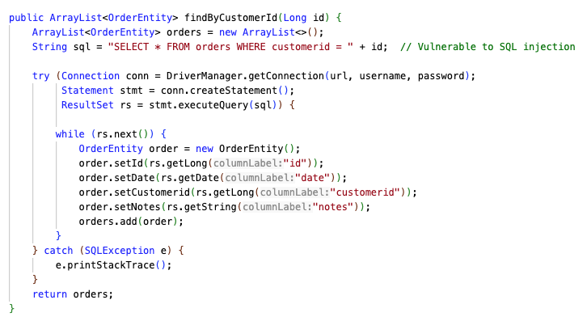
Figure 46 Vulnerable method in OrdersController.

- Fix the delete method. Use a parameter with ? to identify the Long id value, seen in Figure 47.
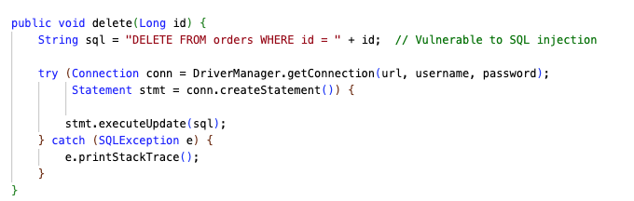
Figure 47 Vulnerable method in OrdersController.

- Fix the update method. Use a parameter with ? to identify the data parameter, seen in Figure 48.
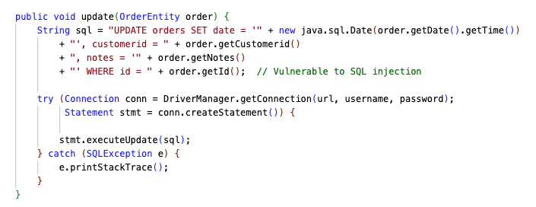
Figure 48 Vulnerable method in OrdersController.

- Fix the save method. This method will require three ? parameters, seen in Figure 49.
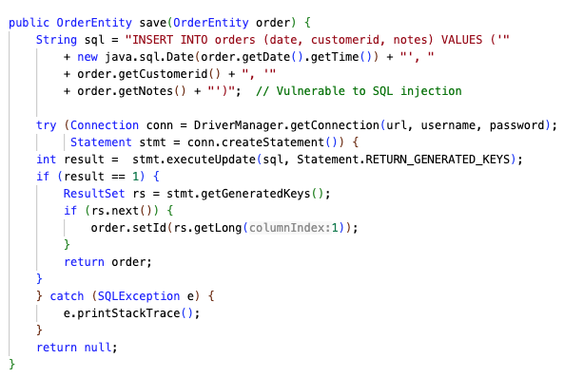
Figure 49 Vulnerable method in OrdersController.

- Fix the findById method. Use a ? parameter for the id value, seen in Figure 50.
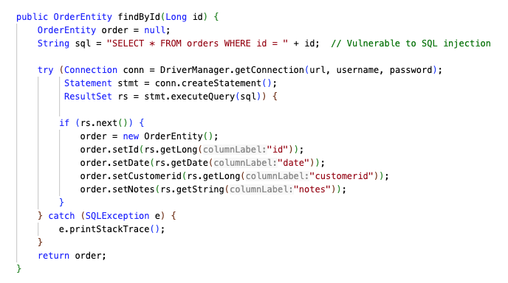
Figure 50 Vulnerable method in OrdersController.

About Sanitize Input

In addition to preventing SQL injection at the DAO level, additional security can be implemented closer to the front end. Follow this rule for effective application security:

“Never trust user input.”

Adding some additional methods in the OrdersController can filter out unwanted characters from user input. While sanitizing input is an important step, it is not a substitute for using parameterized queries or prepared statements. Sanitizing can help defend against other types of attacks including Cross Site Scripting (XSS), Command Injection (using input to run operating system commands), Path Traversal such as ../../Windows/System32 or HTTP header injection.

1. Escape Special Characters
Escape any special characters in the user input to prevent them from being interpreted as part of the SQL command. For example, you can escape single quotes by replacing them with two single quotes (').
public String sanitizeInput(String input) {
if (input == null) {
return null;
}
return input.replaceAll("'", "''");
}

2. Remove Potentially Dangerous Keywords
A list of keywords is replaced by an empty string “” using string matching.
public String sanitizeInput(String input) {
if (input == null) {
return null;
}
String[] keywords = {"--", ";", "/*", "*/", "xp_", "exec", "select", "insert", "update", "delete", "drop", "alter"};
for (String keyword : keywords) {
input = input.replaceAll("(?i)" + keyword, "");
}
return input.replaceAll("'", "''");
}

3. Allow Only Expected Input
Restrict the input to a specific format, such as alphanumeric characters only. The replaceAll method uses regular expressions (regex) to replace substrings.
public String sanitizeInput(String input) {
if (input == null) {
return null;
}
return input.replaceAll("[^a-zA-Z0-9 ]", "");
}

4. Use a Whitelist Approach
Allow only a predefined set of characters using regular expressions.
public String sanitizeInput(String input) {
if (input == null) {
return null;
}
return input.replaceAll("[^a-zA-Z0-9]", "");
}

5. Validate Input Length
Ensure that the input length is within expected bounds. This can prevent certain types of injection attacks where large inputs are used to overflow buffers or cause unexpected behavior.
public String sanitizeInput(String input) {
if (input == null) {
return null;
}
if (input.length() > 100) { // Example length check
throw new IllegalArgumentException("Input too long");
}
return input.replaceAll("[^a-zA-Z0-9 ]", "");
}

Here's an example that combines multiple techniques:

public String sanitizeInput(String input) {
if (input == null) {
return null;
}
// Restrict length
if (input.length() > 100) {
input = input.substring(0, 100);
}
// Escape single quotes
input = input.replaceAll("'", "''");
// Remove potentially dangerous keywords
String[] keywords = {"--", ";", "/\\*", "\\*/", "xp_", "exec", "select", "insert", "update", "delete", "drop", "alter"};
for (String keyword : keywords) {
input = input.replaceAll("(?i)" + keyword, "");
}
// Allow only alphanumeric characters and spaces
return input.replaceAll("[^a-zA-Z0-9 ]", "");
}

Implement Sanitization

- Update the OrdersController to include a sanitize method to clean up user input, shown in Figure 51.
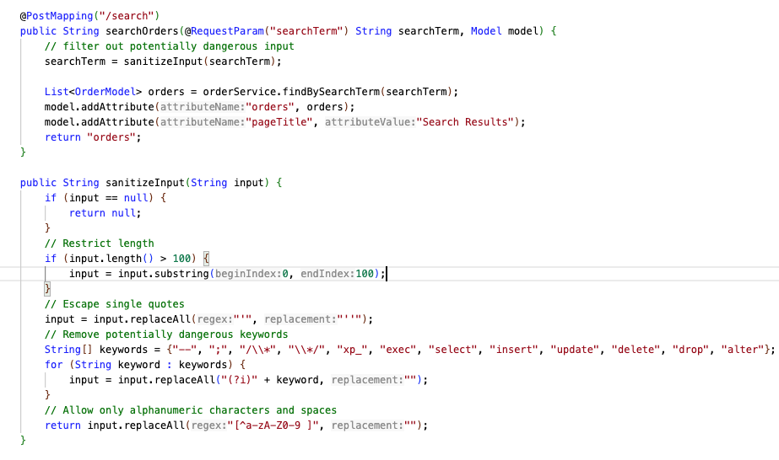
Figure 51 searchTerm is cleaned of potentially dangerous text before being accepted by the program.
- Attempt to run the SQL injection attack again, seen in Figure 52 and Figure 53.

' UNION SELECT id, '2024-01-01 00:00:00', id, password FROM users WHERE 'a'LIKE'a


Figure 52 Inserting the SQL injection code.


Figure 53 No search results.

Additional Techniques

Here are some innovative hacking techniques and fixes.
Time-based Blind SQL Injection: Attackers use time delays to infer the results of their queries. For example we can write a query to determine if the first letter of a user’s password is ‘a’.

' OR IF(SUBSTRING((SELECT password FROM users LIMIT 1), 1, 1) = 'a', SLEEP(5), 0) –

Resulting SQL Query
When the payload is injected into the search field, the resulting SQL query looks like this:

SELECT * FROM `orders` WHERE `notes` LIKE '%' OR IF(SUBSTRING((SELECT password FROM users LIMIT 1), 1, 1) = 'a', SLEEP(5), 0) -- %

SLEEP(5) causes a 5-second delay if the first letter of a is true.
0 does nothing if the condition is false.
By measuring the response time of the web application we can determine:
If the response is delayed by 5 seconds, the first character of the password is 'a'.
If not, the first character is not 'a'.
This process can be repeated character by character to retrieve the entire password.

Parameter Tampering:
Manipulating HTTP parameters can lead to SQL injection vulnerabilities if inputs are not properly validated.

Security Testing Tools:

SQLMap is a tool for automated SQL injection testing.
OWASP ZAP (Zed Attack Proxy) can help find a variety of vulnerabilities, including SQL injection.
w3af (Web Application Attack and Audit Framework) can help in finding and exploiting all web application vulnerabilities.
Arachni is designed to identify security issues within web applications.
BurpSuite is a commercial tool with a wide range of tools to help identify and exploit vulnerabilities in web applications, including SQL injection.

Error Handling:
Don’t allow users to see the generic “White Label” crash reports. Instead, create custom error pages that provide short and safe messages.
Proper error handling and how revealing database errors can give attackers useful information.
Detailed error messages, class names, method names, line numbers, and the sequence of calls leading to the error can reveal the internal structure of the application, making it easier for hackers to understand how the application is built and where potential vulnerabilities might exist.
The type of exception thrown (e.g., NullPointerException, SQLException, IllegalArgumentException) and the associated message indicate the type of errors occurring and suggest potential areas to exploit (e.g., database errors, input validation issues).
Names and versions of frameworks and libraries used (e.g., Spring, Hibernate) can help hackers identify known vulnerabilities associated with those versions.
Details about database schema, table names, and column names can help hackers craft more precise SQL injection attacks.
Configuration file locations, class names, and property value details can lead to further exploitation, such as unauthorized access or privilege escalation.

Least Privilege Principle:

Enforce database user accounts with the least privileges necessary to limit the impact of potential SQL injection, as seen in Figure 54.
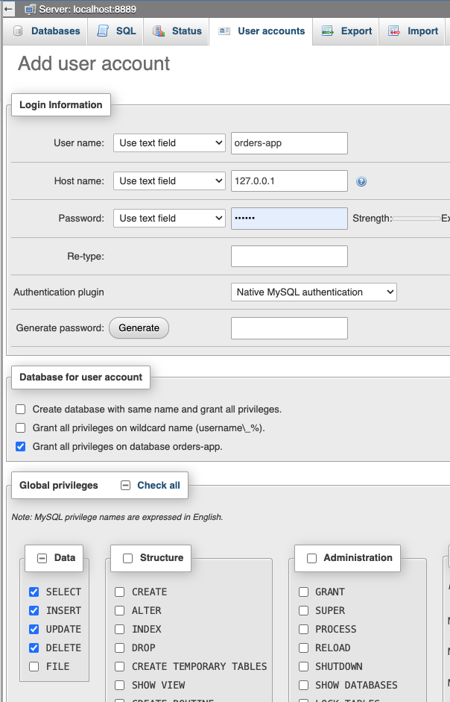
Figure 54 Example of a user account designed to work specifically with the orders-app database. The account has no reason to use the Structure or Administration actions.

Key Takeaways
In this lesson, you learned about the security threat of SQL Injection, how it can be exploited, and how to prevent it. Here are the key points and objectives you should have accomplished:

1. Understand the Basics of SQL Injection
- Definition and Threat: You learned that SQL Injection is a technique where attackers manipulate SQL queries to interfere with the database operations of an application, potentially accessing unauthorized data.
- Attack Techniques: You recognized how attackers can use SQL Injection to perform unauthorized actions like retrieving data, modifying database content, or even deleting data.

2. Identify Vulnerable Code
- Code Vulnerabilities: You identified parts of the code in DAOs, Services, and Controllers that are susceptible to SQL Injection.
  - Example: The findBySearch method in OrdersDAO was initially vulnerable because it directly concatenated user input into the SQL query.
- Role of Components: You understood how DAOs, Services, and Controllers interact to manage data and where vulnerabilities might exist in these interactions.

3. Perform SQL Injection Attacks
- Controlled Environment Attacks: You conducted SQL Injection attacks in a controlled environment to see their potential impact.
  - Example: You used UNION SELECT statements to retrieve unauthorized user data from the database.

4. Implement Prevention Techniques
- Parameterized Queries: You learned to use parameterized queries and prepared statements to mitigate SQL Injection vulnerabilities.
  - Example: Rewriting the findBySearch method to use parameterized queries.
- Input Sanitization and Validation: You implemented input sanitization and validation techniques to ensure user inputs do not contain malicious content.
  - Example: Creating a sanitizeInput method to filter out dangerous characters and keywords.

5. Practice with Security Tools
- Web Application Scanners: You identified various web application scanners that can help find SQL Injection vulnerabilities.
  - Examples: SQLMap, OWASP ZAP, w3af, Arachni, BurpSuite.
- Security Testing: You explained how security testing tools can aid in finding and fixing vulnerabilities.

6. Handle Errors Securely
- Custom Error Pages: You learned why custom error pages are important to avoid exposing sensitive information through error messages.
  - Example: Configuring the application to use custom error pages instead of generic "White Label" error pages.

7. Follow Best Practices
- Least Privilege Principle: You applied the principle of least privilege to database user accounts to limit the impact of potential SQL Injection.
  - Example: Configuring database user accounts with only the necessary permissions for their tasks.
- Related Vulnerabilities: You recognized and addressed other related vulnerabilities such as Cross-Site Scripting (XSS), command injection, and path traversal.

Check for Understanding
Although not graded, these questions will help prepare you for upcoming assessments.
- What is SQL Injection?
- A) A technique used to add new tables to a database.
- B) A method for encrypting database queries.
- C) A security vulnerability that allows attackers to interfere with the queries an application makes to its database.
- D) A way to optimize SQL queries for better performance.
Correct Answer: C) A security vulnerability that allows attackers to interfere with the queries an application makes to its database.
- Which part of the application is most likely to contain SQL Injection vulnerabilities?
- A) Front-end JavaScript code.
- B) Back-end data access code (DAOs, Services, Controllers).
- C) CSS files.
- D) Database configuration files.
Correct Answer: B) Back-end data access code (DAOs, Services, Controllers).
- Which of the following is a safe practice to prevent SQL Injection?
- A) Using string concatenation to build SQL queries.
- B) Using parameterized queries and prepared statements.
- C) Allowing direct user input into SQL queries without validation.
- D) Logging all SQL queries to a public file.
Correct Answer: B) Using parameterized queries and prepared statements.
- What is the purpose of the sanitizeInput method in the context of SQL Injection prevention?
- A) To format SQL queries.
- B) To escape and filter potentially dangerous user input.
- C) To connect to the database.
- D) To log user inputs for auditing.
Correct Answer: B) To escape and filter potentially dangerous user input.
- Which of the following tools can be used to identify SQL Injection vulnerabilities in web applications?
- A) SQLMap
- B) OWASP ZAP
- C) BurpSuite
- D) All of the above.
Correct Answer: D) All of the above.
- What should you do if user input length exceeds the expected bounds during input validation?
- A) Accept the input and log a warning.
- B) Truncate the input to the expected length.
- C) Throw an exception or error.
- D) Store the input as is.
Correct Answer: C) Throw an exception or error.
- What is the principle of least privilege in the context of database security?
- A) Giving all users admin access to the database.
- B) Granting only the necessary permissions to database user accounts.
- C) Allowing users to create and drop tables as needed.
- D) Removing all access controls from the database.
Correct Answer: B) Granting only the necessary permissions to database user accounts.
- Which SQL Injection technique involves using time delays to infer the results of queries?
- A) UNION-based SQL Injection.
- B) Error-based SQL Injection.
- C) Time-based Blind SQL Injection.
- D) Boolean-based Blind SQL Injection.
Correct Answer: C) Time-based Blind SQL Injection.
- What is the role of INFORMATION_SCHEMA in SQL Injection attacks?
- A) It provides detailed error messages to the attacker.
- B) It contains information about the structure of the databases and tables.
- C) It encrypts user passwords.
- D) It optimizes SQL query performance.
Correct Answer: B) It contains information about the structure of the databases and tables.
- Why is it important to use custom error pages instead of generic error messages?
- A) Custom error pages look more professional.
- B) They prevent revealing sensitive information about the application's structure to potential attackers.
- C) They improve the performance of the application.
- D) Custom error pages are easier to maintain.
Correct Answer: B) They prevent revealing sensitive information about the application's structure to potential attackers.

Deliverables:
- Submit a Microsoft Word document with screenshots of the application being run. Show each screen of the output and put a caption under each picture explaining what is being demonstrated.
- In the same document, in one paragraph, write a summary of the key concepts that were demonstrated in this lesson.
- Convert the Word document to PDF.
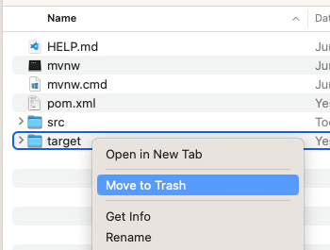
- Submit a ZIP file of the project file. In order to save space, you can delete the target folder of the project. These folders contain the compiled version of the application and are automatically regenerated each time the build or run commands are executed.
- Attach the PDF document separately from the zip file. Multiple files can be uploaded with an assignment.

