Owen Lindsey
Professor Sparks, James
10/20/2024
CST-391
Milestone 3

Aircraft Maintenance Management Application Instructor Feedback:
Milestone 2 feedback:
- Metric type: What is the purpose? The metric seems to be about 3 metrics. I do not see a metric type recorded in the database.

- The sitemap does not distinguish between users and admins, but the wire frames do.

- Overall looks interesting. I'm concerned about its complexity. Do you have time to create the API and two user interfaces?

Revisions of milestone 2 to milestone 3
Project Update | Description
Login Requirement | Removed due to time constraints
User Interfaces | Decision to not create two separate user interfaces due to timeframe limitations.
Design Document | Authentication and login requirements removed from the design document

Aircraft Maintenance Management Application:
Application description:
This application will allow an aircraft maintenance organization manager their fleet. The system provides the following key features.
- Fleet Overview:
- Display a comprehensive list of all aircraft under the organization's responsibility.

- Show each aircraft the most recent maintenance and important details.

- Detailed Maintenance History:
- Access a complete maintenance history for each aircraft

- View all maintenance records, including date, details, and responsible technician.

- Edit existing maintenance entries or add new ones as needed.

- Performance Metrics Dashboard:
- Visualize key performance indicators using various graph types.

- Monitor and analyze metrics such as flight hours, fuel efficiency, and maintenance frequency.

- Input new performance data and generate reports on total flight times, average oil consumption, and other relevant statistics.

Aircraft Maintenance Management Application:
Functionality Requirements (User Story description):
- Aircraft Performance Tracking
- As a User, I want to add and update aircraft performance metrics so I can keep track of each aircraft’s operational efficiency.
2. Maintenance Record Management:
- As a User, I want to select an aircraft and update its maintenance information so that I can keep maintenance records current and accurate.
3. Fleet Expansion:
- As a User, I want to add new aircraft to our hangar spaces whenever a new aircraft is acquired or arrives for maintenance, so that our fleet inventory stays up to date.
4. Visual Analytics:
- As a User, I want to view and interact with graphs that visually display maintenance performance metrics (such as maintenance downtime, flight hours, and engine hours) so that I can quickly assess the status and trends of the fleet.
5. Data Entry and Editing:
- As a User, I want to input new data and edit existing information maintenance records and performance metrics to ensure our database remains accurate and current.
6. Reporting
- As a User, I want to generate basic reports on aircraft performance and maintenance history to support regular operations.

Database Design for Aircraft Maintenance Management Application:
ER diagram -
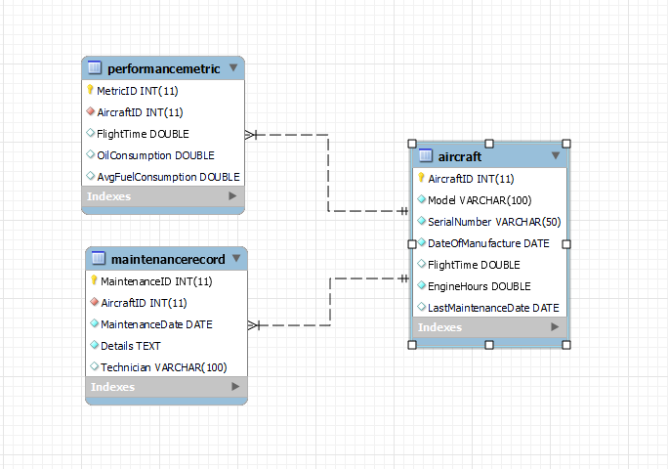

Sitemap for Aircraft Maintenance Management Application:

Sitemap:
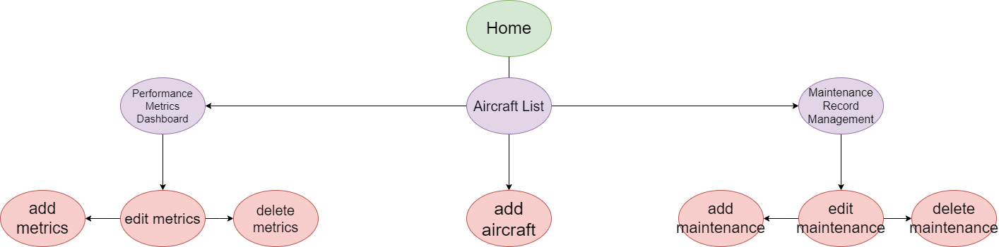

Wireframes for Aircraft Maintenance Management Application:

Page 1: Aircraft List Wireframe:
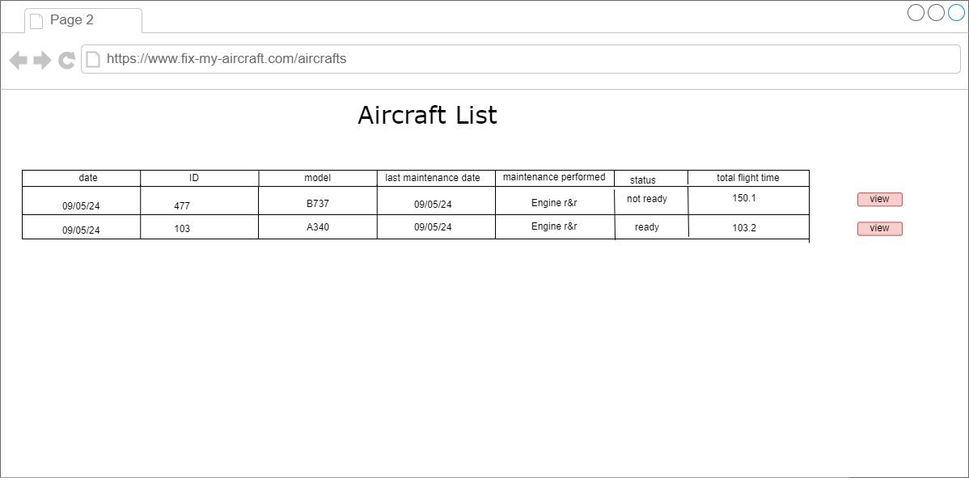

Wireframes for Aircraft Maintenance Management Application:

Page 2: Aircraft Metrics Performance Dashboard Wireframe:
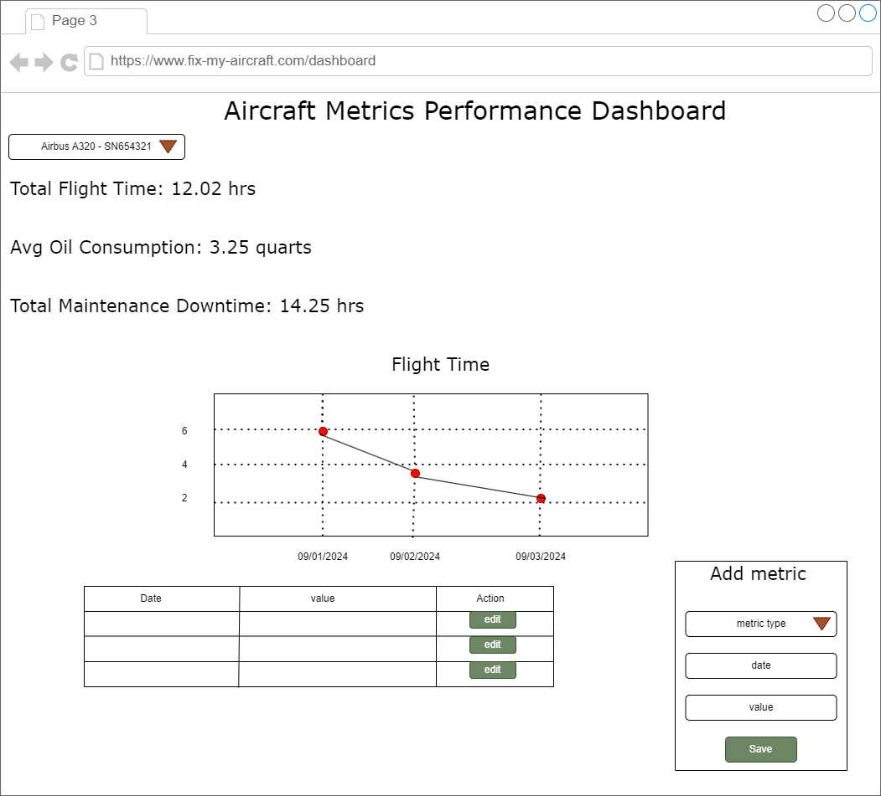

Wireframes for Aircraft Maintenance Management Application:
Page 3: Maintenance Record Management Wireframe:
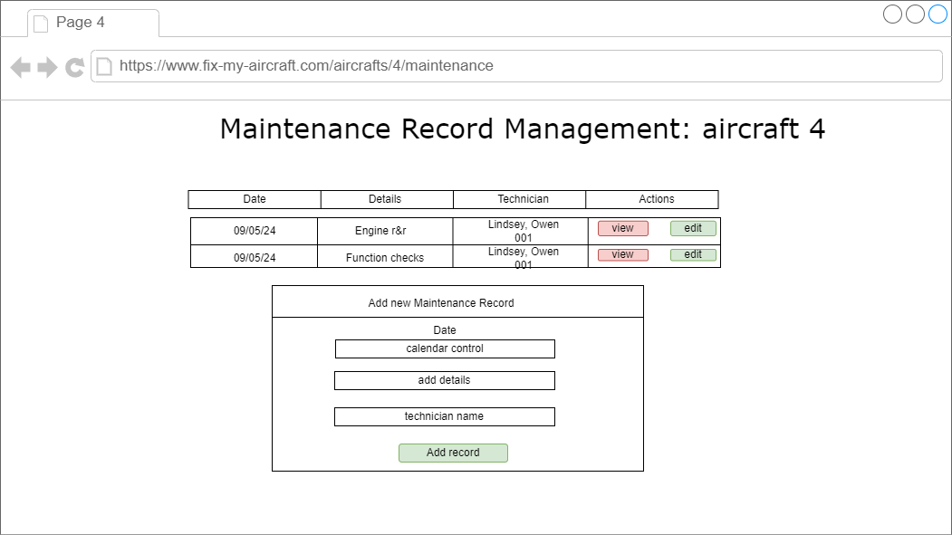

UML classes for Aircraft Maintenance Management Application:
aircraft class:
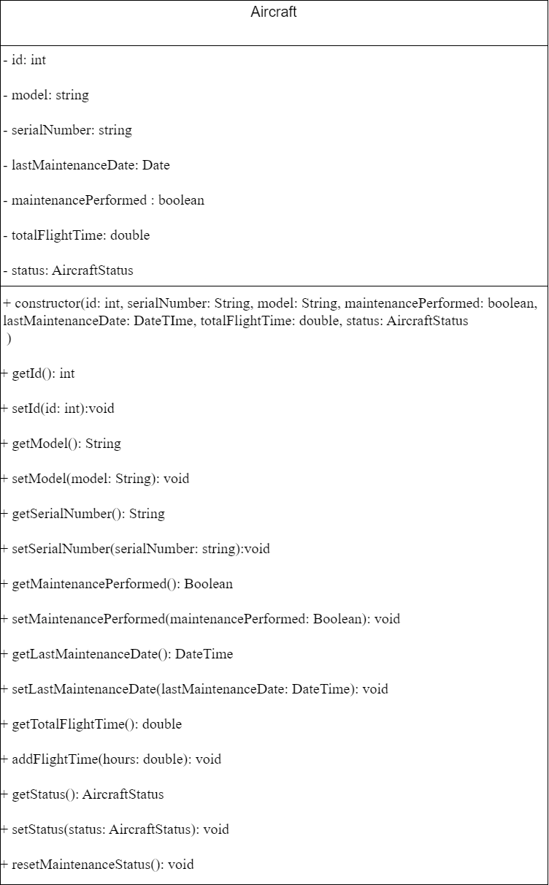

UML classes for Aircraft Maintenance Management Application:

MaintenanceRecord:

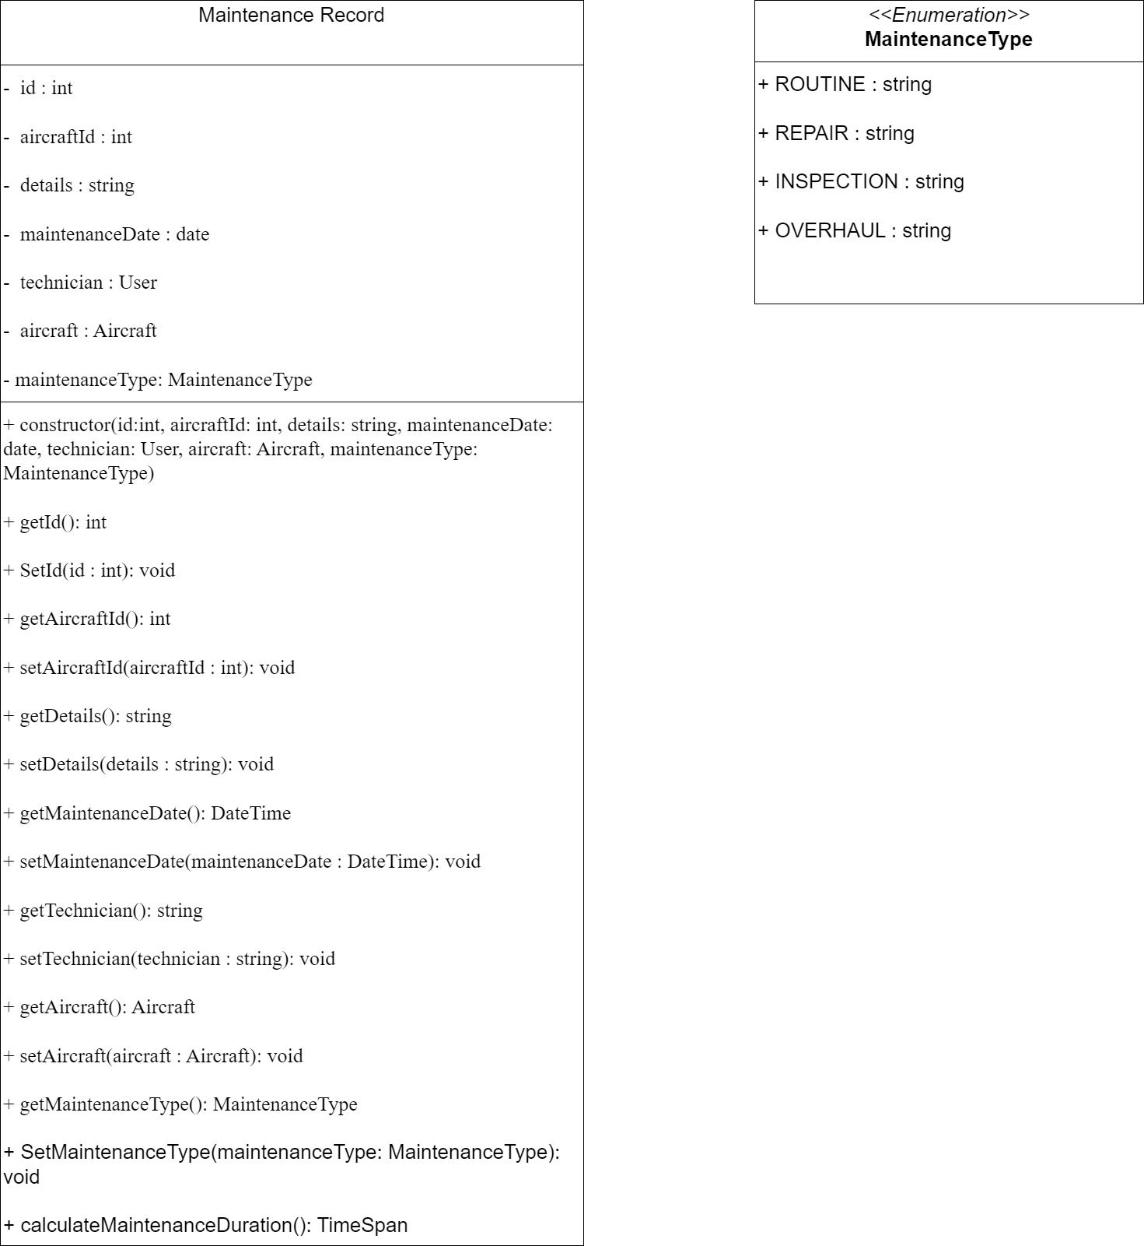

UML classes for Aircraft Maintenance Management Application:
PerformanceMetric:

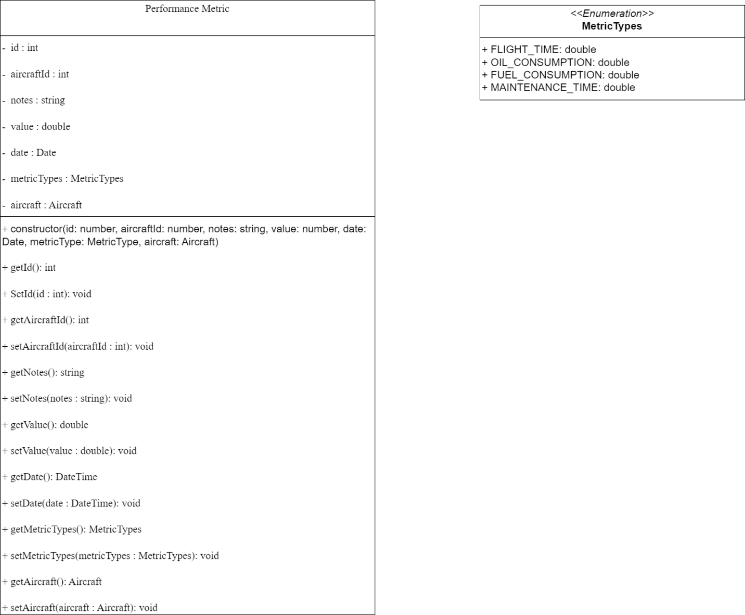

Risks of Aircraft Maintenance Management Application:
1. Security Risks:

1.2 Input Validation:
Risk:

- Vulnerability to basic injection attacks due to improper input handling.

Impact:

- Potential for data corruption or unauthorized access.

Mitigation:

- Implement basic input validation and sanitization for all form fields.

- Use prepared statements for database queries to prevent SQL injection attacks.

Risks of Aircraft Maintenance Management Application:
1. Data Management:

1.1 Data Integrity:
Risk:

- Incorrect data entry or manipulation in maintenance records.

Impact:

- Inaccurate reporting and potential logical errors in the application.

Mitigation:

- Add basic data validation rules to the user interface.

- Implement simple error checking for critical fields (date formats, numeric ranges).

Risks of Aircraft Maintenance Management Application:
2. Project Management:

2.1 Scope and Time Management:
Risk:

- Project scope could become too ambitious for the class time frame.

Impact:

- Incomplete features or rushed implementations.

Mitigation:

- Clearly define core features required for the assignment.

- Prioritize functionality over optimization initially.

- Keep up with an organized timeline.

Risks of Aircraft Maintenance Management Application:
3. Performance Considerations:

3.1 Basic Application Performance:
Risk:

- Inefficient code leads to slow performance, especially for data intensive operations.

Impact:

- Poor user experience and potential issues during project demonstrations.

Mitigation:

- Focus on writing clean, efficient code for core functionalities.

- If time allows, implement basic optimization for data retrieval and display.

Aircraft Maintenance Management Application API:
1. Aircraft endpoints:
- GET: /aircraft

- GET: /aircraft/{id}

- POST: /aircraft

- PUT: /aircraft/{id}

- PUT: /aircraft/{id}

- DELETE: /aircraft/{id}

2. Maintenance endpoints:
- GET: /aircraft/{id}/maintenances

- GET: /aircraft/{id}/maintenances/{maintenanceId}

- POST: /maintenance

- PUT: /aircraft/{id}/maintenances/{maintenanceId}

- DELETE : /aircraft/{id}/maintenances/{maintenanceId}

Aircraft Maintenance Management Application API:
3. Metrics endpoints:
- GET: /aircraft/{id}/metrics

- GET: /aircraft/{id}/metrics/{metricId}

- POST: /aircraft/{id}/metrics

- PUT: /aircraft/{id}/metrics{metricId}

- DELETE: /aircraft/{id}/metrics/{metricId}

Aircraft Maintenance Management Application API:
Postman Documentation

