**If-Else**

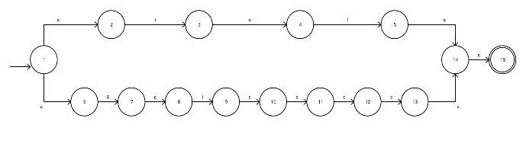

NFA:

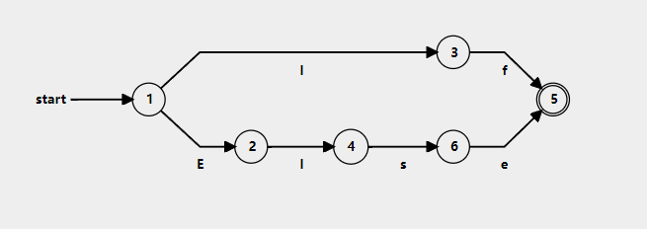

DFA:

**Low**

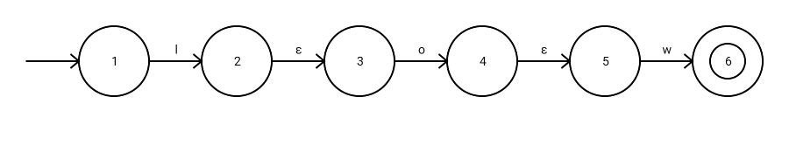

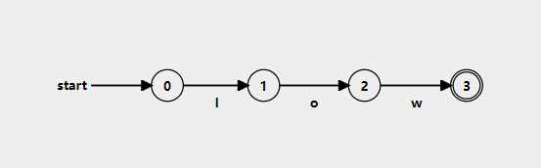NFA:

DFA:

**Slow**

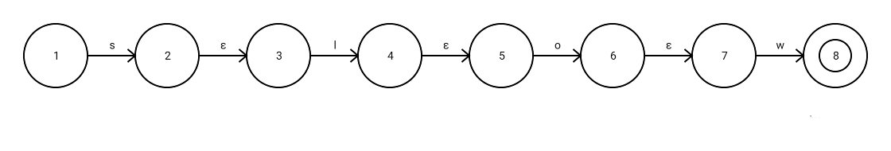

NFA:

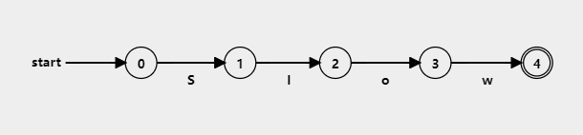

DFA:

**Chlo**

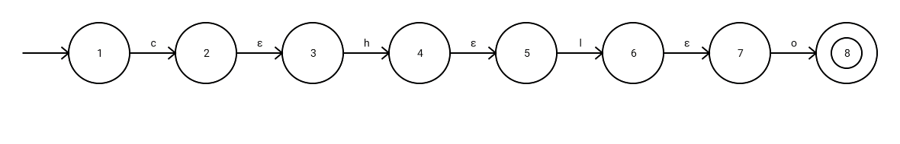

NFA:

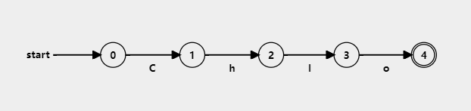

DFA:

**Chain**

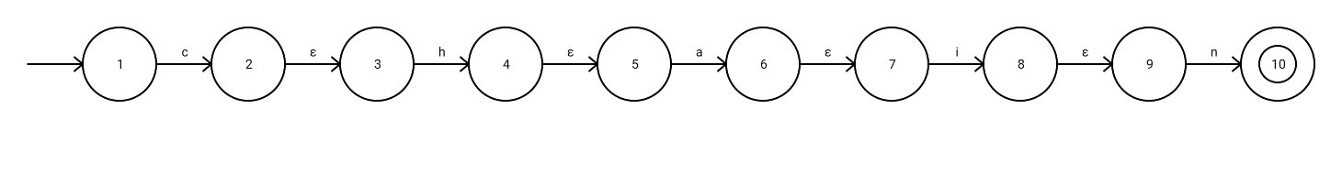

NFA:

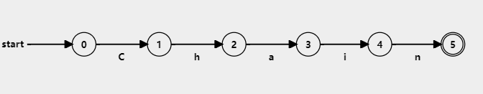DFA:

**Lowf**

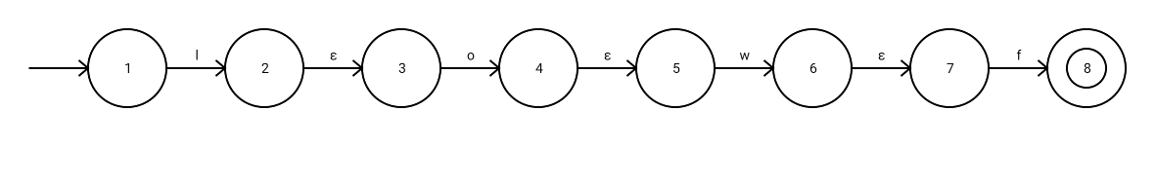

NFA:

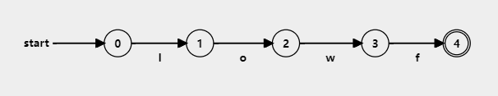

DFA:

**Slowf**

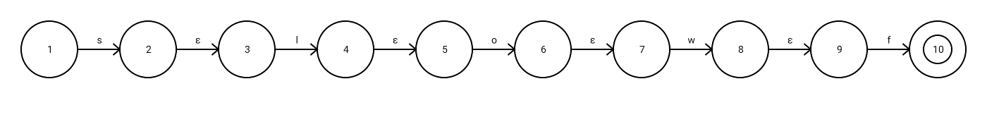

NFA:

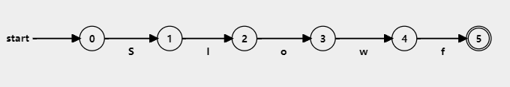DFA:

**Worthless**



NFA:



DFA:

**Loopwhen/Iteratewhen**

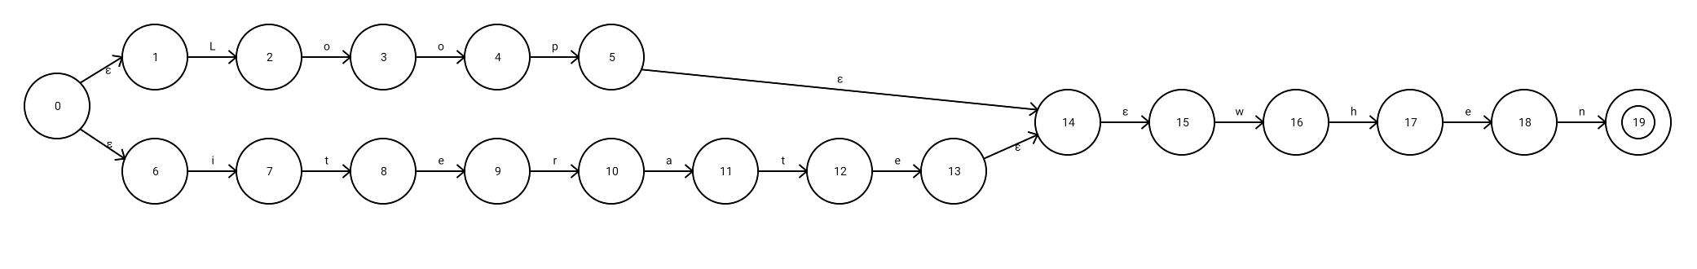NFA:

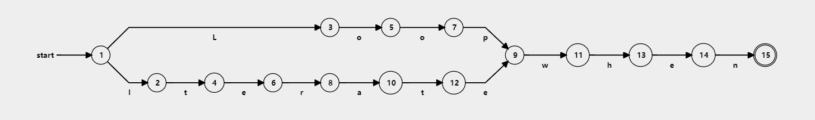DFA:

**Turnback**



NFA:

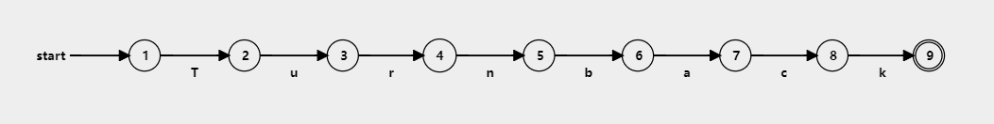

DFA:

**Stop**

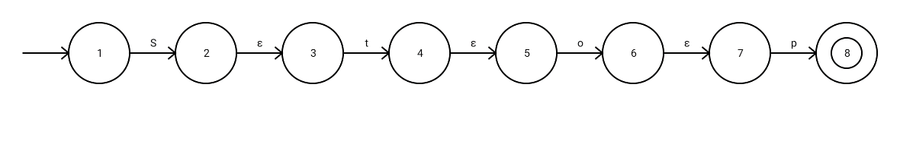

NFA:

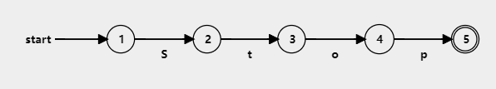

DFA:

**Loli**

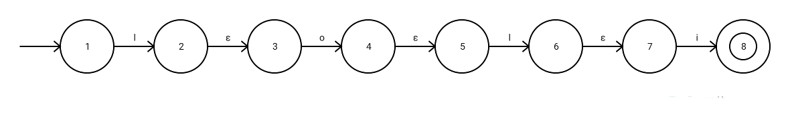

NFA:

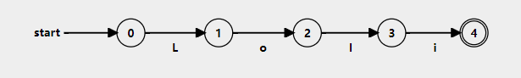

DFA:

**(+,-,*,/)**

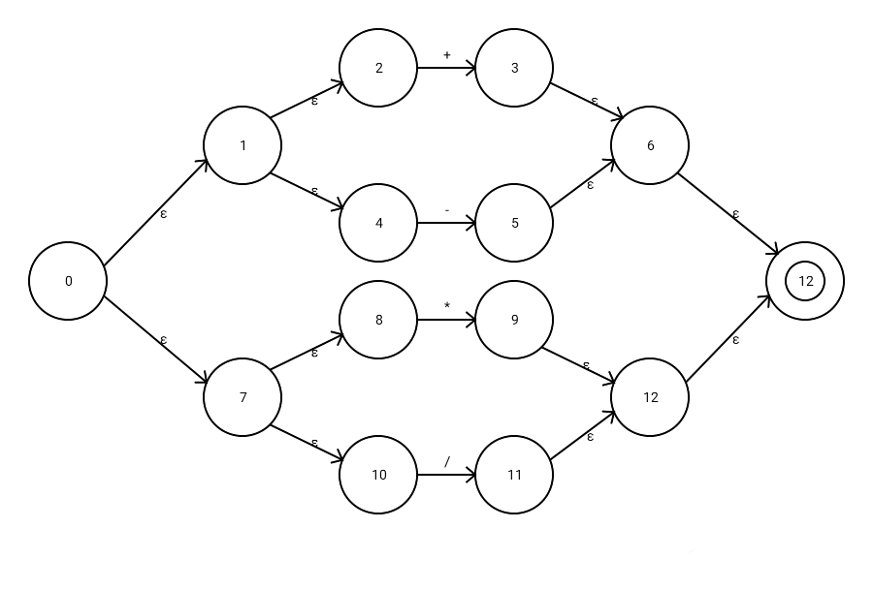

NFA:

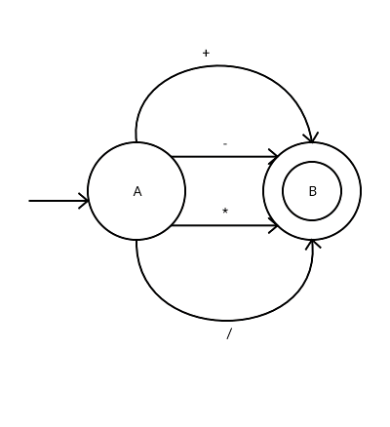

Minimized DFA:

**(&&,||,~)**

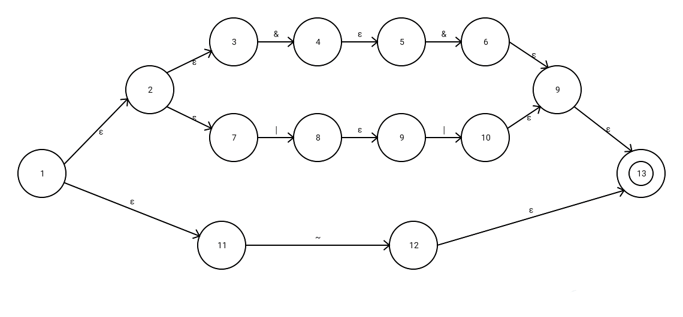NFA:

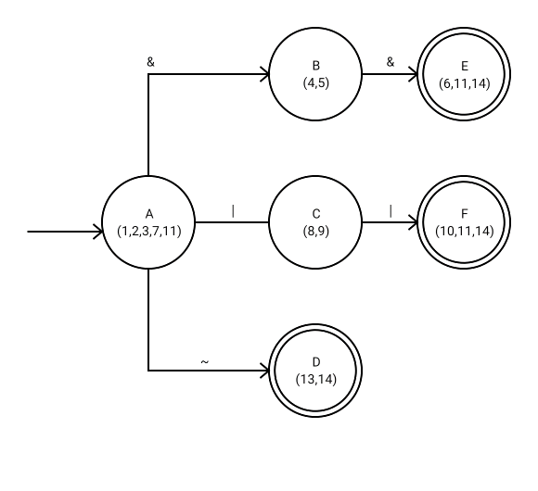

DFA:

**(==,<,>,!=,<=,>=)**

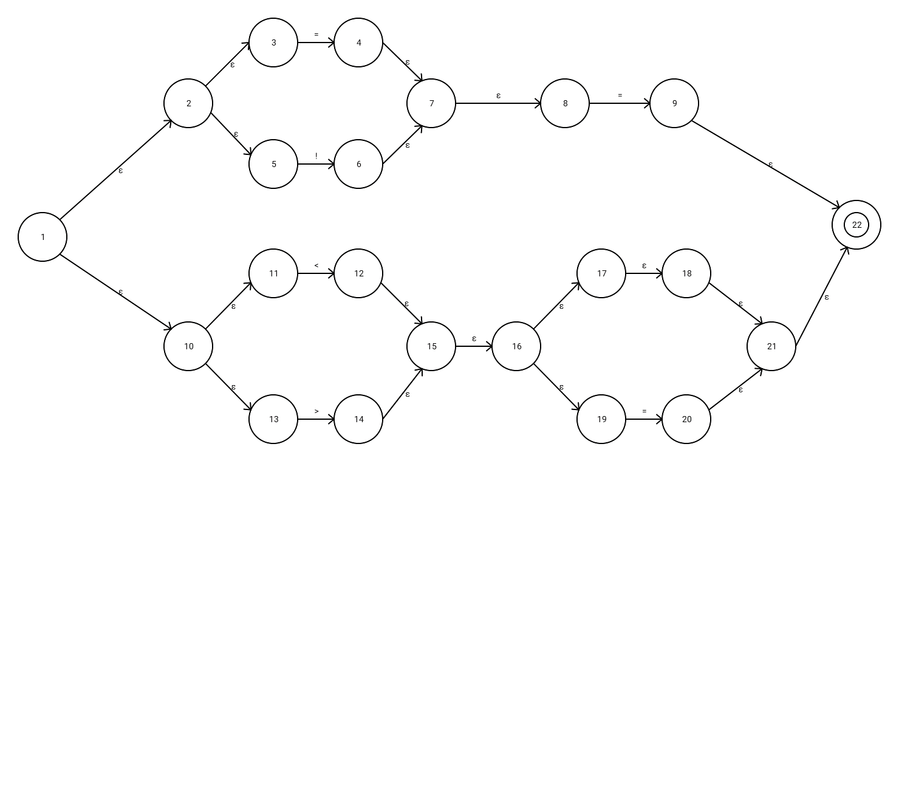

NFA:

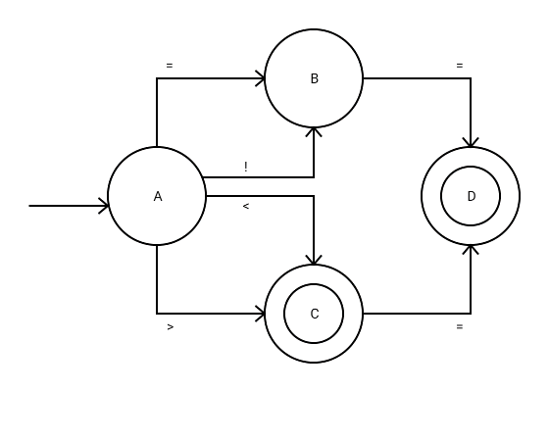

Minimized DFA:

**(=)**

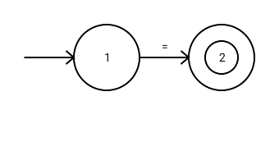

NFA AND DFA:

**(->)**

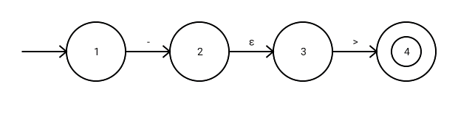

NFA:

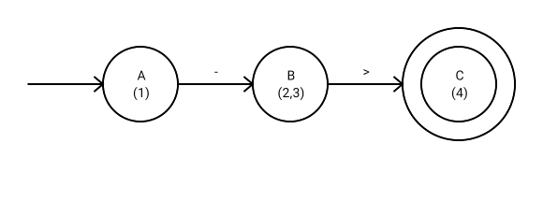

DFA:

**({,},[,])**

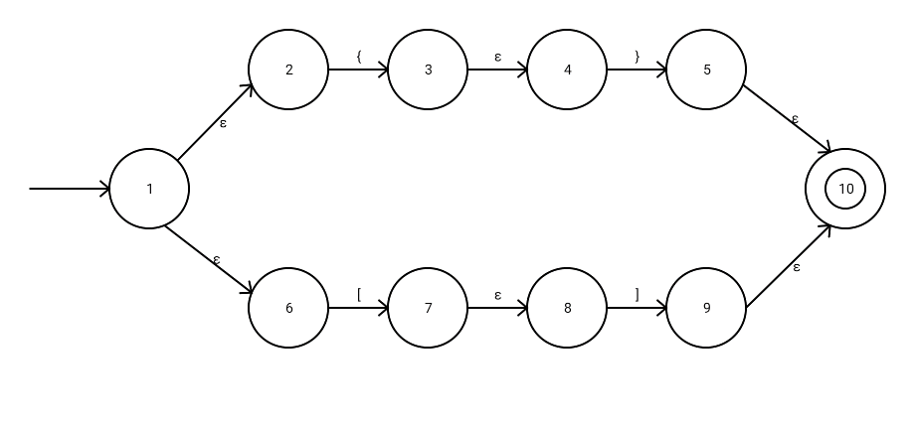

NFA:

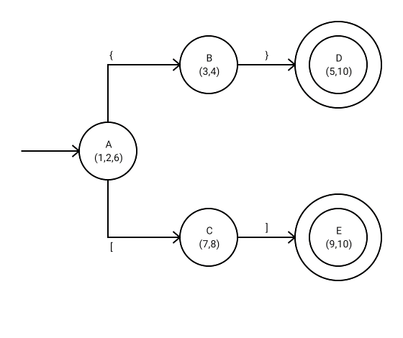

DFA:

**Constant**

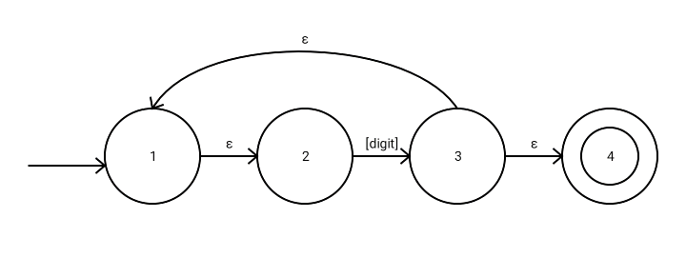

NFA:

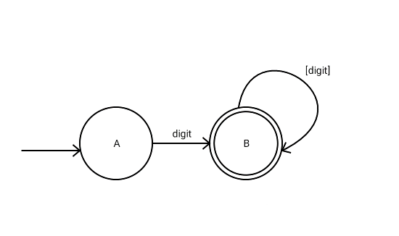

DFA:

**(“,’)**

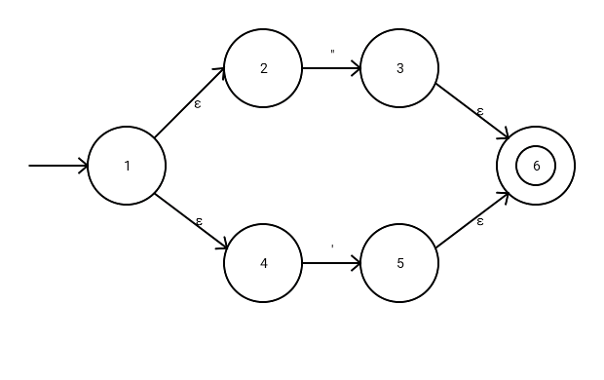

NFA:

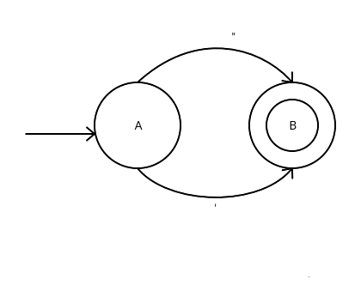

Minimized DFA:

**Include**



NFA:

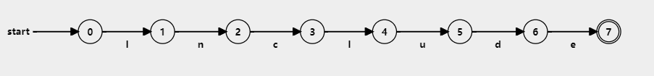

DFA:

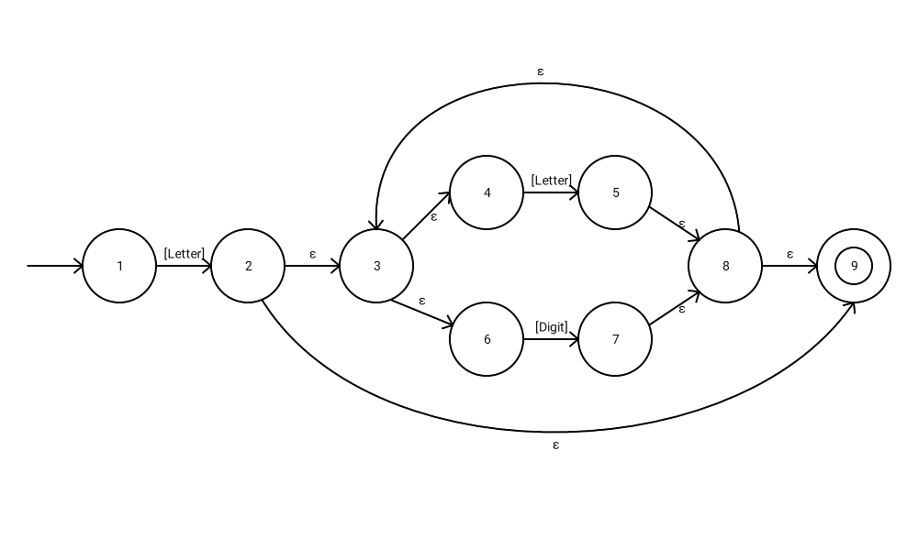**IDINTIFIER**

NFA:

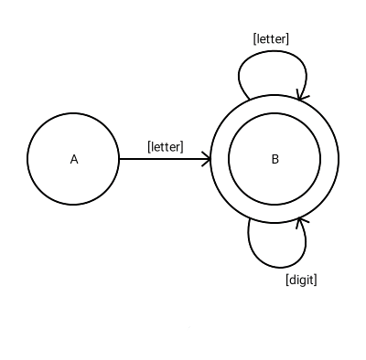

DFA:

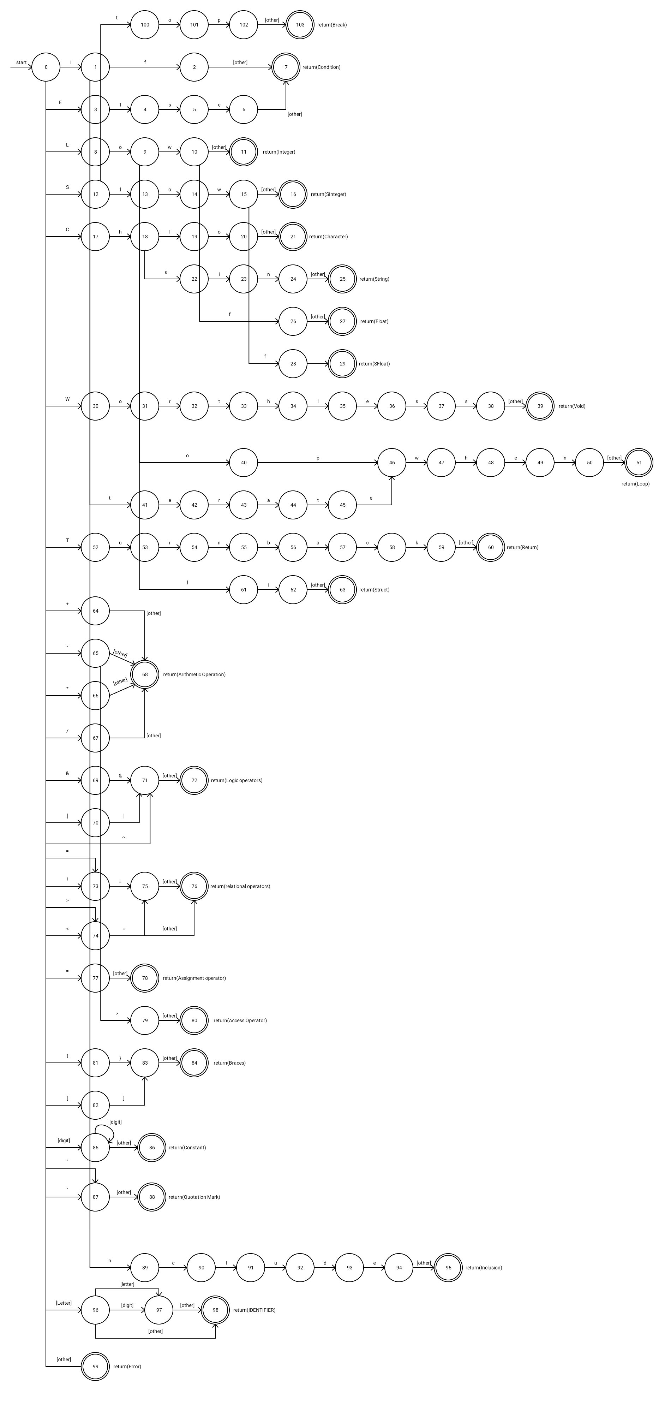**FULL DFA**

**Transition table**

|  |  |  |  |  |  |  |  |  |  |  |  |  |  |  |  |  |  |  |  |  |  |  |  |  |  |  |  |  |  |  |  |  |  |  |  |
| --- | --- | --- | --- | --- | --- | --- | --- | --- | --- | --- | --- | --- | --- | --- | --- | --- | --- | --- | --- | --- | --- | --- | --- | --- | --- | --- | --- | --- | --- | --- | --- | --- | --- | --- | --- |
| Characte - r  State | I | F | E | L | S | O | W | C | H | A | N | R | T | P | U | B | K | D | - | +/* | 0-9 | & | | | ~ | = | ! | < | > | { | } | [ | ] | “’ | A-D | other |
| 0 | 1 |  | 3 | 8 | 12 |  | 30 | 17 |  |  |  |  | 52 |  |  |  |  |  | 65 | 64 | 85 | 69 | 70 | 71 | 73 | 73 | 74 | 74 | 81 |  | 82 |  | 87 | 96 | 99 |
| 1 |  | 2 |  |  |  |  |  |  |  |  | 89 |  | 41 |  |  |  |  |  |  |  |  |  |  |  |  |  |  |  |  |  |  |  |  |  |  |
| 2 |  |  |  |  |  |  |  |  |  |  |  |  |  |  |  |  |  |  |  |  |  |  |  |  |  |  |  |  |  |  |  |  |  |  | 7 |
| 3 |  |  |  | 4 |  |  |  |  |  |  |  |  |  |  |  |  |  |  |  |  |  |  |  |  |  |  |  |  |  |  |  |  |  |  |  |
| 4 |  |  |  |  | 5 |  |  |  |  |  |  |  |  |  |  |  |  |  |  |  |  |  |  |  |  |  |  |  |  |  |  |  |  |  |  |
| 5 |  |  | 6 |  |  |  |  |  |  |  |  |  |  |  |  |  |  |  |  |  |  |  |  |  |  |  |  |  |  |  |  |  |  |  |  |
| 6 |  |  |  |  |  |  |  |  |  |  |  |  |  |  |  |  |  |  |  |  |  |  |  |  |  |  |  |  |  |  |  |  |  |  | 7 |
| 8 |  |  |  |  |  | 9 |  |  |  |  |  |  |  |  |  |  |  |  |  |  |  |  |  |  |  |  |  |  |  |  |  |  |  |  |  |
| 9 |  |  |  | 61 |  | 40 | 10 |  |  |  |  |  |  |  |  |  |  |  |  |  |  |  |  |  |  |  |  |  |  |  |  |  |  |  |  |
| 10 |  | 26 |  |  |  |  |  |  |  |  |  |  |  |  |  |  |  |  |  |  |  |  |  |  |  |  |  |  |  |  |  |  |  |  | 11 |
| 12 |  |  |  | 13 |  |  |  |  |  |  |  |  | 100 |  |  |  |  |  |  |  |  |  |  |  |  |  |  |  |  |  |  |  |  |  |  |
| 13 |  |  |  |  |  | 14 |  |  |  |  |  |  |  |  |  |  |  |  |  |  |  |  |  |  |  |  |  |  |  |  |  |  |  |  |  |
| 14 |  |  |  |  |  |  | 15 |  |  |  |  |  |  |  |  |  |  |  |  |  |  |  |  |  |  |  |  |  |  |  |  |  |  |  |  |
| 15 |  |  |  |  |  |  |  |  |  |  |  |  |  |  |  |  |  |  |  |  |  |  |  |  |  |  |  |  |  |  |  |  |  |  | 16 |
| 17 |  |  |  |  |  |  |  |  | 18 |  |  |  |  |  |  |  |  |  |  |  |  |  |  |  |  |  |  |  |  |  |  |  |  |  |  |
| 18 |  |  |  | 19 |  |  |  |  |  | 22 |  |  |  |  |  |  |  |  |  |  |  |  |  |  |  |  |  |  |  |  |  |  |  |  |  |
| 19 |  |  |  |  |  | 20 |  |  |  |  |  |  |  |  |  |  |  |  |  |  |  |  |  |  |  |  |  |  |  |  |  |  |  |  |  |
| 20 |  |  |  |  |  |  |  |  |  |  |  |  |  |  |  |  |  |  |  |  |  |  |  |  |  |  |  |  |  |  |  |  |  |  | 21 |
| 22 | 23 |  |  |  |  |  |  |  |  |  |  |  |  |  |  |  |  |  |  |  |  |  |  |  |  |  |  |  |  |  |  |  |  |  |  |
| 23 |  |  |  |  |  |  |  |  |  |  | 24 |  |  |  |  |  |  |  |  |  |  |  |  |  |  |  |  |  |  |  |  |  |  |  |  |
| 24 |  |  |  |  |  |  |  |  |  |  |  |  |  |  |  |  |  |  |  |  |  |  |  |  |  |  |  |  |  |  |  |  |  |  | 25 |
| 26 |  |  |  |  |  |  |  |  |  |  |  |  |  |  |  |  |  |  |  |  |  |  |  |  |  |  |  |  |  |  |  |  |  |  | 27 |
| 28 |  |  |  |  |  |  |  |  |  |  |  |  |  |  |  |  |  |  |  |  |  |  |  |  |  |  |  |  |  |  |  |  |  |  | 29 |
| 30 |  |  |  |  |  | 31 |  |  |  |  |  |  |  |  |  |  |  |  |  |  |  |  |  |  |  |  |  |  |  |  |  |  |  |  |  |
| 31 |  |  |  |  |  |  |  |  |  |  |  | 32 |  |  |  |  |  |  |  |  |  |  |  |  |  |  |  |  |  |  |  |  |  |  |  |
| 32 |  |  |  |  |  |  |  |  |  |  |  |  | 33 |  |  |  |  |  |  |  |  |  |  |  |  |  |  |  |  |  |  |  |  |  |  |
| 33 |  |  |  |  |  |  |  |  | 34 |  |  |  |  |  |  |  |  |  |  |  |  |  |  |  |  |  |  |  |  |  |  |  |  |  |  |
| 34 |  |  |  | 35 |  |  |  |  |  |  |  |  |  |  |  |  |  |  |  |  |  |  |  |  |  |  |  |  |  |  |  |  |  |  |  |
| 35 |  |  | 36 |  |  |  |  |  |  |  |  |  |  |  |  |  |  |  |  |  |  |  |  |  |  |  |  |  |  |  |  |  |  |  |  |
| 36 |  |  |  |  | 37 |  |  |  |  |  |  |  |  |  |  |  |  |  |  |  |  |  |  |  |  |  |  |  |  |  |  |  |  |  |  |
| 37 |  |  |  |  | 38 |  |  |  |  |  |  |  |  |  |  |  |  |  |  |  |  |  |  |  |  |  |  |  |  |  |  |  |  |  |  |
| 38 |  |  |  |  |  |  |  |  |  |  |  |  |  |  |  |  |  |  |  |  |  |  |  |  |  |  |  |  |  |  |  |  |  |  | 39 |
| 40 |  |  |  |  |  |  |  |  |  |  |  |  |  | 46 |  |  |  |  |  |  |  |  |  |  |  |  |  |  |  |  |  |  |  |  |  |
| 41 |  |  | 42 |  |  |  |  |  |  |  |  |  |  |  |  |  |  |  |  |  |  |  |  |  |  |  |  |  |  |  |  |  |  |  |  |
| 42 |  |  |  |  |  |  |  |  |  |  |  | 43 |  |  |  |  |  |  |  |  |  |  |  |  |  |  |  |  |  |  |  |  |  |  |  |
| 43 |  |  |  |  |  |  |  |  |  | 44 |  |  |  |  |  |  |  |  |  |  |  |  |  |  |  |  |  |  |  |  |  |  |  |  |  |
| 44 |  |  |  |  |  |  |  |  |  |  |  |  | 45 |  |  |  |  |  |  |  |  |  |  |  |  |  |  |  |  |  |  |  |  |  |  |
| 45 |  |  | 46 |  |  |  |  |  |  |  |  |  |  |  |  |  |  |  |  |  |  |  |  |  |  |  |  |  |  |  |  |  |  |  |  |
| 46 |  |  |  |  |  |  | 47 |  |  |  |  |  |  |  |  |  |  |  |  |  |  |  |  |  |  |  |  |  |  |  |  |  |  |  |  |
| 47 |  |  |  |  |  |  |  |  | 48 |  |  |  |  |  |  |  |  |  |  |  |  |  |  |  |  |  |  |  |  |  |  |  |  |  |  |
| 48 |  |  | 49 |  |  |  |  |  |  |  |  |  |  |  |  |  |  |  |  |  |  |  |  |  |  |  |  |  |  |  |  |  |  |  |  |
| 49 |  |  |  |  |  |  |  |  |  |  | 50 |  |  |  |  |  |  |  |  |  |  |  |  |  |  |  |  |  |  |  |  |  |  |  |  |
| 50 |  |  |  |  |  |  |  |  |  |  |  |  |  |  |  |  |  |  |  |  |  |  |  |  |  |  |  |  |  |  |  |  |  |  | 51 |
| 52 |  |  |  |  |  |  |  |  |  |  |  |  |  |  | 53 |  |  |  |  |  |  |  |  |  |  |  |  |  |  |  |  |  |  |  |  |
| 53 |  |  |  |  |  |  |  |  |  |  |  | 54 |  |  |  |  |  |  |  |  |  |  |  |  |  |  |  |  |  |  |  |  |  |  |  |
| 54 |  |  |  |  |  |  |  |  |  |  | 55 |  |  |  |  |  |  |  |  |  |  |  |  |  |  |  |  |  |  |  |  |  |  |  |  |
| 55 |  |  |  |  |  |  |  |  |  |  |  |  |  |  |  | 56 |  |  |  |  |  |  |  |  |  |  |  |  |  |  |  |  |  |  |  |
| 56 |  |  |  |  |  |  |  |  |  | 57 |  |  |  |  |  |  |  |  |  |  |  |  |  |  |  |  |  |  |  |  |  |  |  |  |  |
| 57 |  |  |  |  |  |  |  | 58 |  |  |  |  |  |  |  |  |  |  |  |  |  |  |  |  |  |  |  |  |  |  |  |  |  |  |  |
| 58 |  |  |  |  |  |  |  |  |  |  |  |  |  |  |  |  | 59 |  |  |  |  |  |  |  |  |  |  |  |  |  |  |  |  |  |  |
| 59 |  |  |  |  |  |  |  |  |  |  |  |  |  |  |  |  |  |  |  |  |  |  |  |  |  |  |  |  |  |  |  |  |  |  | 60 |
| 61 | 62 |  |  |  |  |  |  |  |  |  |  |  |  |  |  |  |  |  |  |  |  |  |  |  |  |  |  |  |  |  |  |  |  |  |  |
| 62 |  |  |  |  |  |  |  |  |  |  |  |  |  |  |  |  |  |  |  |  |  |  |  |  |  |  |  |  |  |  |  |  |  |  | 63 |
| 64 |  |  |  |  |  |  |  |  |  |  |  |  |  |  |  |  |  |  |  |  |  |  |  |  |  |  |  |  |  |  |  |  |  |  | 68 |
| 65 |  |  |  |  |  |  |  |  |  |  |  |  |  |  |  |  |  |  |  |  |  |  |  |  |  |  |  | 79 |  |  |  |  |  |  | 68 |
| 69 |  |  |  |  |  |  |  |  |  |  |  |  |  |  |  |  |  |  |  |  |  | 71 |  |  |  |  |  |  |  |  |  |  |  |  |  |
| 70 |  |  |  |  |  |  |  |  |  |  |  |  |  |  |  |  |  |  |  |  |  |  | 71 |  |  |  |  |  |  |  |  |  |  |  |  |
| 71 |  |  |  |  |  |  |  |  |  |  |  |  |  |  |  |  |  |  |  |  |  |  |  |  |  |  |  |  |  |  |  |  |  |  | 72 |
| 73 |  |  |  |  |  |  |  |  |  |  |  |  |  |  |  |  |  |  |  |  |  |  |  |  | 75 |  |  |  |  |  |  |  |  |  |  |
| 74 |  |  |  |  |  |  |  |  |  |  |  |  |  |  |  |  |  |  |  |  |  |  |  |  | 75 |  |  |  |  |  |  |  |  |  | 76 |
| 75 |  |  |  |  |  |  |  |  |  |  |  |  |  |  |  |  |  |  |  |  |  |  |  |  |  |  |  |  |  |  |  |  |  |  | 76 |
| 77 |  |  |  |  |  |  |  |  |  |  |  |  |  |  |  |  |  |  |  |  |  |  |  |  |  |  |  |  |  |  |  |  |  |  | 78 |
| 79 |  |  |  |  |  |  |  |  |  |  |  |  |  |  |  |  |  |  |  |  |  |  |  |  |  |  |  |  |  |  |  |  |  |  | 80 |
| 81 |  |  |  |  |  |  |  |  |  |  |  |  |  |  |  |  |  |  |  |  |  |  |  |  |  |  |  |  |  | 83 |  |  |  |  |  |
| 82 |  |  |  |  |  |  |  |  |  |  |  |  |  |  |  |  |  |  |  |  |  |  |  |  |  |  |  |  |  |  |  | 83 |  |  |  |
| 83 |  |  |  |  |  |  |  |  |  |  |  |  |  |  |  |  |  |  |  |  |  |  |  |  |  |  |  |  |  |  |  |  |  |  | 84 |
| 85 |  |  |  |  |  |  |  |  |  |  |  |  |  |  |  |  |  |  |  |  | 85 |  |  |  |  |  |  |  |  |  |  |  |  |  | 86 |
| 87 |  |  |  |  |  |  |  |  |  |  |  |  |  |  |  |  |  |  |  |  |  |  |  |  |  |  |  |  |  |  |  |  |  |  | 88 |
| 89 |  |  |  |  |  |  |  | 90 |  |  |  |  |  |  |  |  |  |  |  |  |  |  |  |  |  |  |  |  |  |  |  |  |  |  |  |
| 90 |  |  |  | 91 |  |  |  |  |  |  |  |  |  |  |  |  |  |  |  |  |  |  |  |  |  |  |  |  |  |  |  |  |  |  |  |
| 91 |  |  |  |  |  |  |  |  |  |  |  |  |  |  | 92 |  |  |  |  |  |  |  |  |  |  |  |  |  |  |  |  |  |  |  |  |
| 92 |  |  |  |  |  |  |  |  |  |  |  |  |  |  |  |  |  | 93 |  |  |  |  |  |  |  |  |  |  |  |  |  |  |  |  |  |
| 93 |  |  | 94 |  |  |  |  |  |  |  |  |  |  |  |  |  |  |  |  |  |  |  |  |  |  |  |  |  |  |  |  |  |  |  |  |
| 94 |  |  |  |  |  |  |  |  |  |  |  |  |  |  |  |  |  |  |  |  |  |  |  |  |  |  |  |  |  |  |  |  |  |  | 95 |
| 96 |  |  |  |  |  |  |  |  |  |  |  |  |  |  |  |  |  |  |  |  | 97 |  |  |  |  |  |  |  |  |  |  |  |  | 97 | 98 |
| 97 |  |  |  |  |  |  |  |  |  |  |  |  |  |  |  |  |  |  |  |  |  |  |  |  |  |  |  |  |  |  |  |  |  |  | 98 |
| 100 |  |  |  |  |  | 101 |  |  |  |  |  |  |  |  |  |  |  |  |  |  |  |  |  |  |  |  |  |  |  |  |  |  |  |  |  |
| 101 |  |  |  |  |  |  |  |  |  |  |  |  |  | 102 |  |  |  |  |  |  |  |  |  |  |  |  |  |  |  |  |  |  |  |  |  |
| 102 |  |  |  |  |  |  |  |  |  |  |  |  |  |  |  |  |  |  |  |  |  |  |  |  |  |  |  |  |  |  |  |  |  |  | 103 |