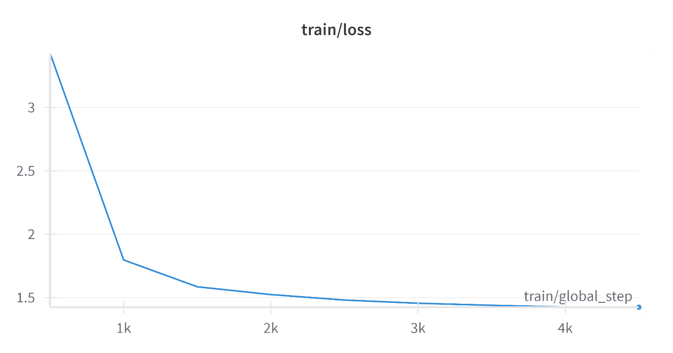

train loss for sbert lora finetuned on 1 million

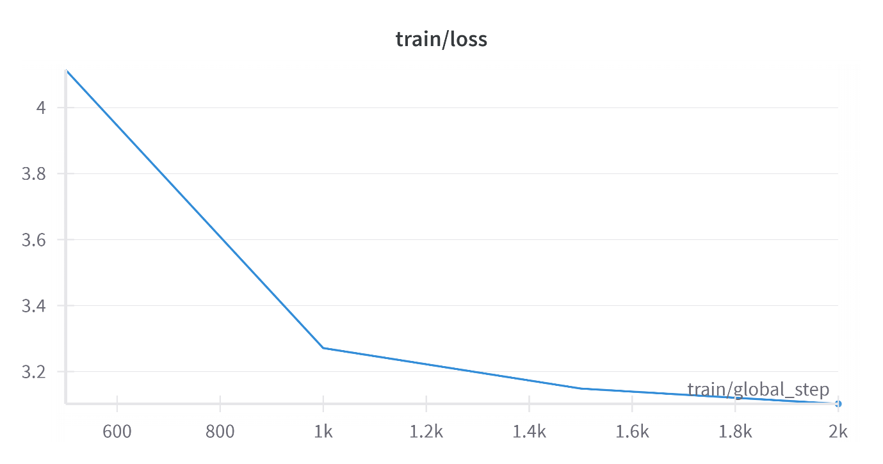

train loss of sbert lora finetuned on hard negatives

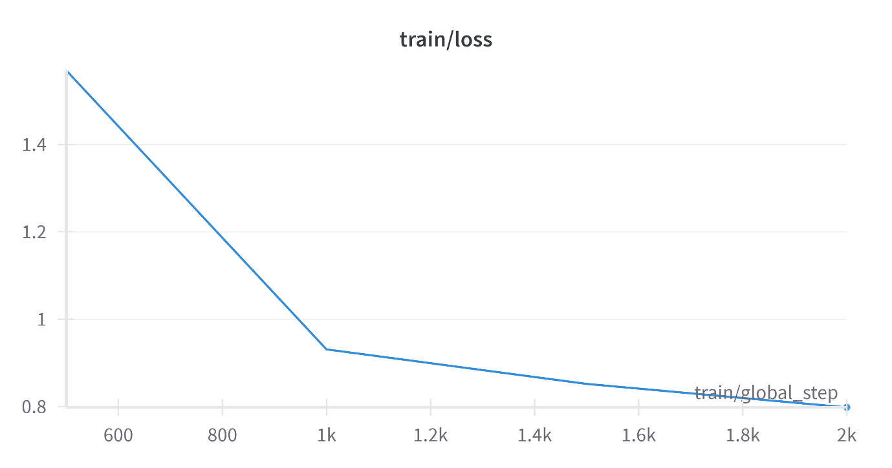

train loss of sbert finetuned on 1 million

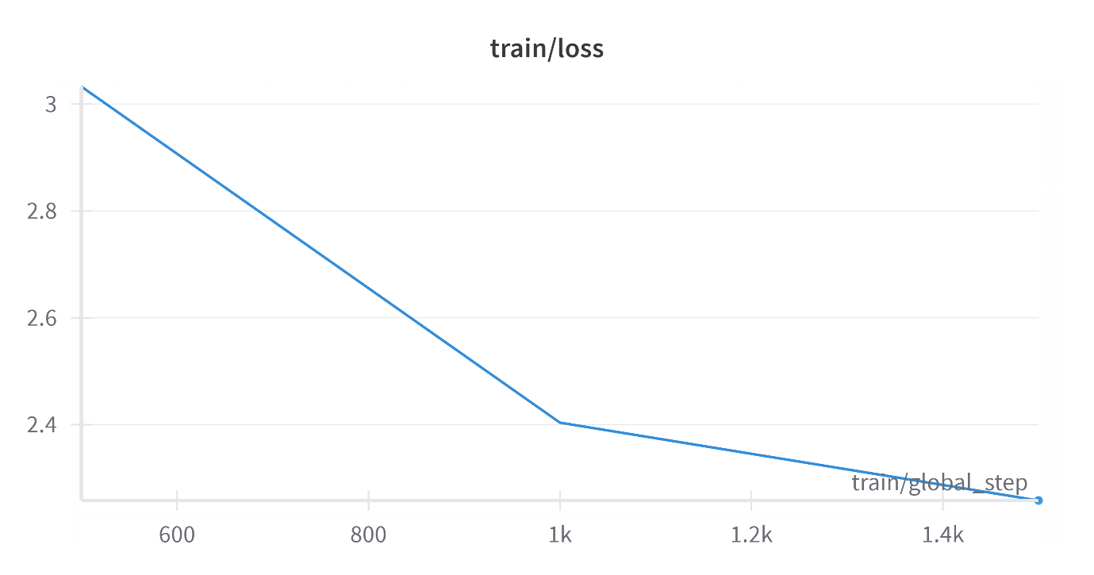

train loss of sbert finetuned on hard negatives