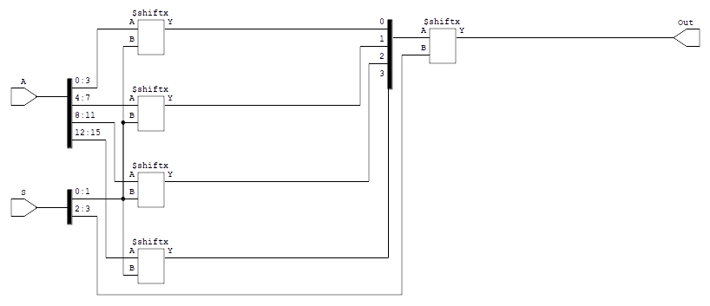

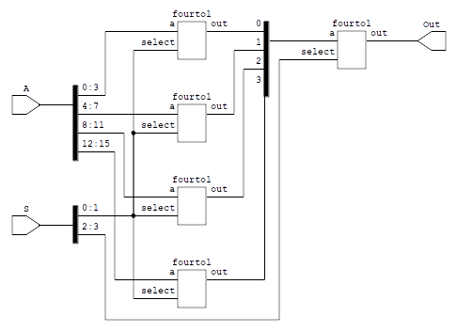

=== sixteento1 ===

Number of wires: 19
Number of wire bits: 60
Number of public wires: 19
Number of public wire bits: 60
Number of memories: 0
Number of memory bits: 0
Number of processes: 0
Number of cells: 5
$shiftx 5

