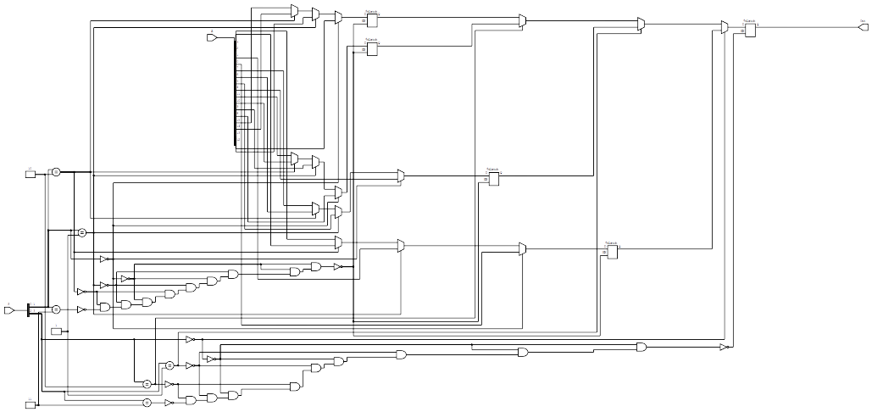

=== sixteento1 ===

Number of wires: 70
Number of wire bits: 111
Number of public wires: 19
Number of public wire bits: 60
Number of memories: 0
Number of memory bits: 0
Number of processes: 0
Number of cells: 56
$and 18
$dlatch 5
$eq 6
$logic_not 2
$mux 15
$not 10

