|  |
| --- |
| ICS2O1 |
| Trio |
| User’s Guide |

|  |
| --- |
| Mohit Patel & Ming Zhou  6/11/2014 |

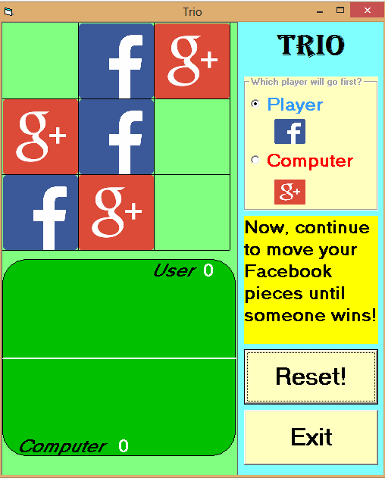

**Table Of Contents:**

The Layout 3

How To Play 4

How To Win 6

Strategy 7

Conclusion 8

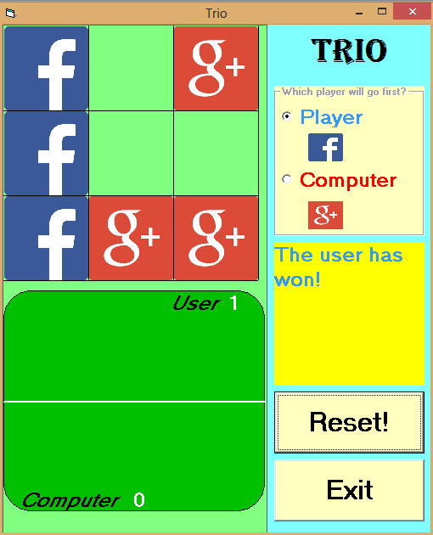

# The Layout

When you start the game, you will be shown the game like this:

1. 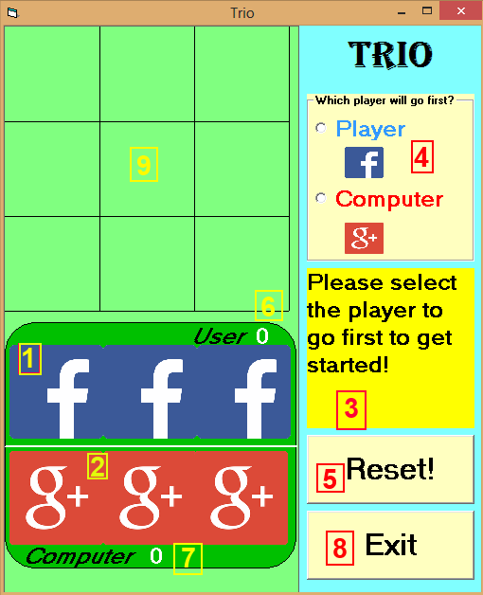**User pieces**; these blue, Facebook pieces are the ones which you will use to play the game.
2. **Computer pieces**; these red, Google Plus pieces are the ones which the computer will use to play the game
3. **Display**; this will show any appropriate messages to help guide you through the game, and display who wins!
4. **Beginning play**; the first play will be done when clicking either option; either you can choose to place your piece first, or you can make the computer make the first move.
5. **Reset**; when the game has ended or you want to prematurely end the game, the reset button can be clicked to clear the playing board.
6. **User score**; every time the user wins, your score increases by one. Essentially, the amount of times you have won the game.
7. **Computer score**; every time the computer wins, the computer score is increases by one. Thus, the computer score is the accumulation of the computer’s wins.
8. **Exit button**; when you are finished playing Trio, this will conveniently end the game.
9. **The playing board**; this is where the pieces will be placed.

# How To Play

To start the game, click on one of the options on the top right corner of the game; this decides who will go first.

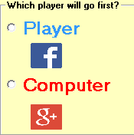

* If you click “**Player**”, you will now be able to drag any one of your pieces onto the playing field.
* If you click “**Computer**”, the computer will automatically place their piece onto the playing field.

After clicking one of these options, you will be able to start playing.

To play, decide which of the three pieces you would like to move.

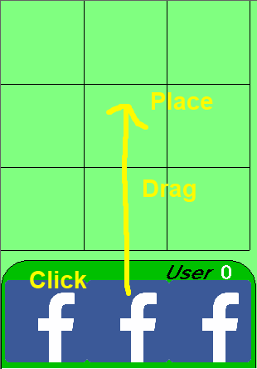

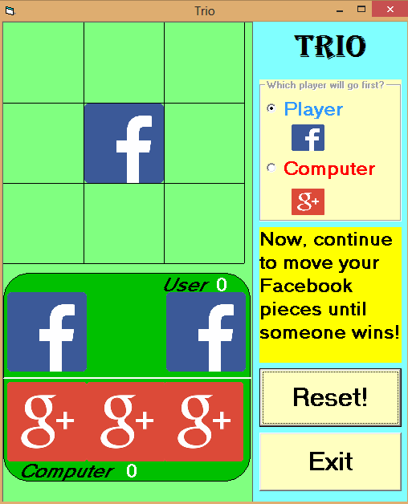One you have decided which piece to move, **click** your mouse on the piece, **drag** it onto an empty square on the playing board, and **place** it. If you move it onto a place with a piece on it already, it will go back to its previous location, which means you will have to move it again.

After making your move, the computer will move one of its pieces on the board as well. The game board may look something like this: (If you let the computer move first, they should have 2 pieces on the board at this point)

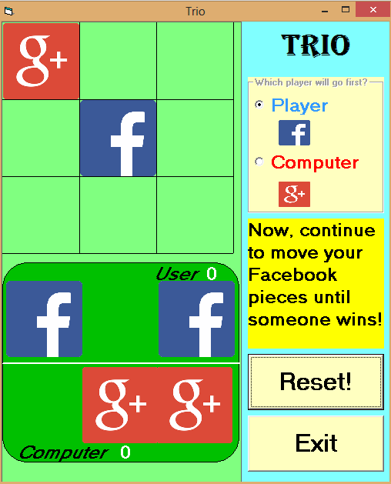

You may now continue to move any of your pieces on any empty free space. You are not restricted to which piece you want to move; you can move any piece at any time, until the game ends.

# How To Win

To win the game, the user or the computer must have **3 of their own pieces in a row.** This can be done:

**Vertically** **Horizontally** **Diagonally**



However, winning may be more difficult than it seems, because

1. The computer will try to block your pieces.

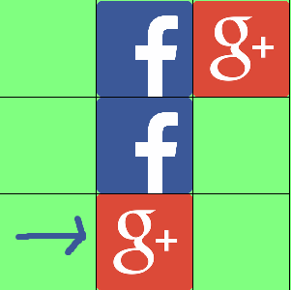

1. The computer will also try to win.

In this scenario, it is the user’s turn to move. The computer is guaranteed to win, because it can move its pieces into any yellow square in order to win. Since it can move to two possible locations, the user will not be able to block its pieces.

To counter this, there are several strategies which can be done in order to win.

# Strategy

1. Block the opponent.



If you see that the opponent has two pieces in a row, it would be senseless to not block them on the same turn, unless you have a winning opportunity. This is because they would immediately win on the next turn. This enables the game to be prolonged, giving you more opportunities to win.

1. 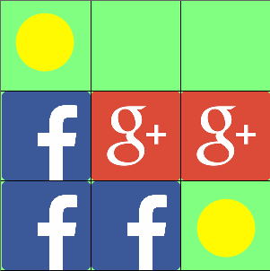Aim for a double win scenario

In this scenario, the user (Facebook pieces) managed to bring himself into a scenario where he has two places to move next turn to win. These scenarios are beneficial because, other than the obvious loss if the computer can get three in a row the next turn, the user will ALWAYS win. Since the computer can only move once per turn, the computer can only block one of these squares, which allows you to select the other square and win!

1. Win whenever you can!

As obvious as this sounds, it is important to grab opportunities whenever you see them; it may be easy to miss a potential diagonal win or a vertical win. Be careful with every move you play.



# Conclusion

Now, after reading all about Trio, you are ready against the computer! Who will dominate social media? Will it be Facebook or Google Plus? Play Trio to find out!