**README**

**Quickbook API as a connector**

Made Quickbook API as a Connector to get data from the different API Endpoints of Quickbook and printing extracted data from API-Endpoints as a Pandas-Data frame and also saving as .csv file

**python-quickbooks 0.9.1(**[**https://pypi.org/project/python-quickbooks/**](https://pypi.org/project/python-quickbooks/)**)**

**pip install python-quickbooks**

A Python 3 library for accessing the Quickbooks API.

**Process Flow**

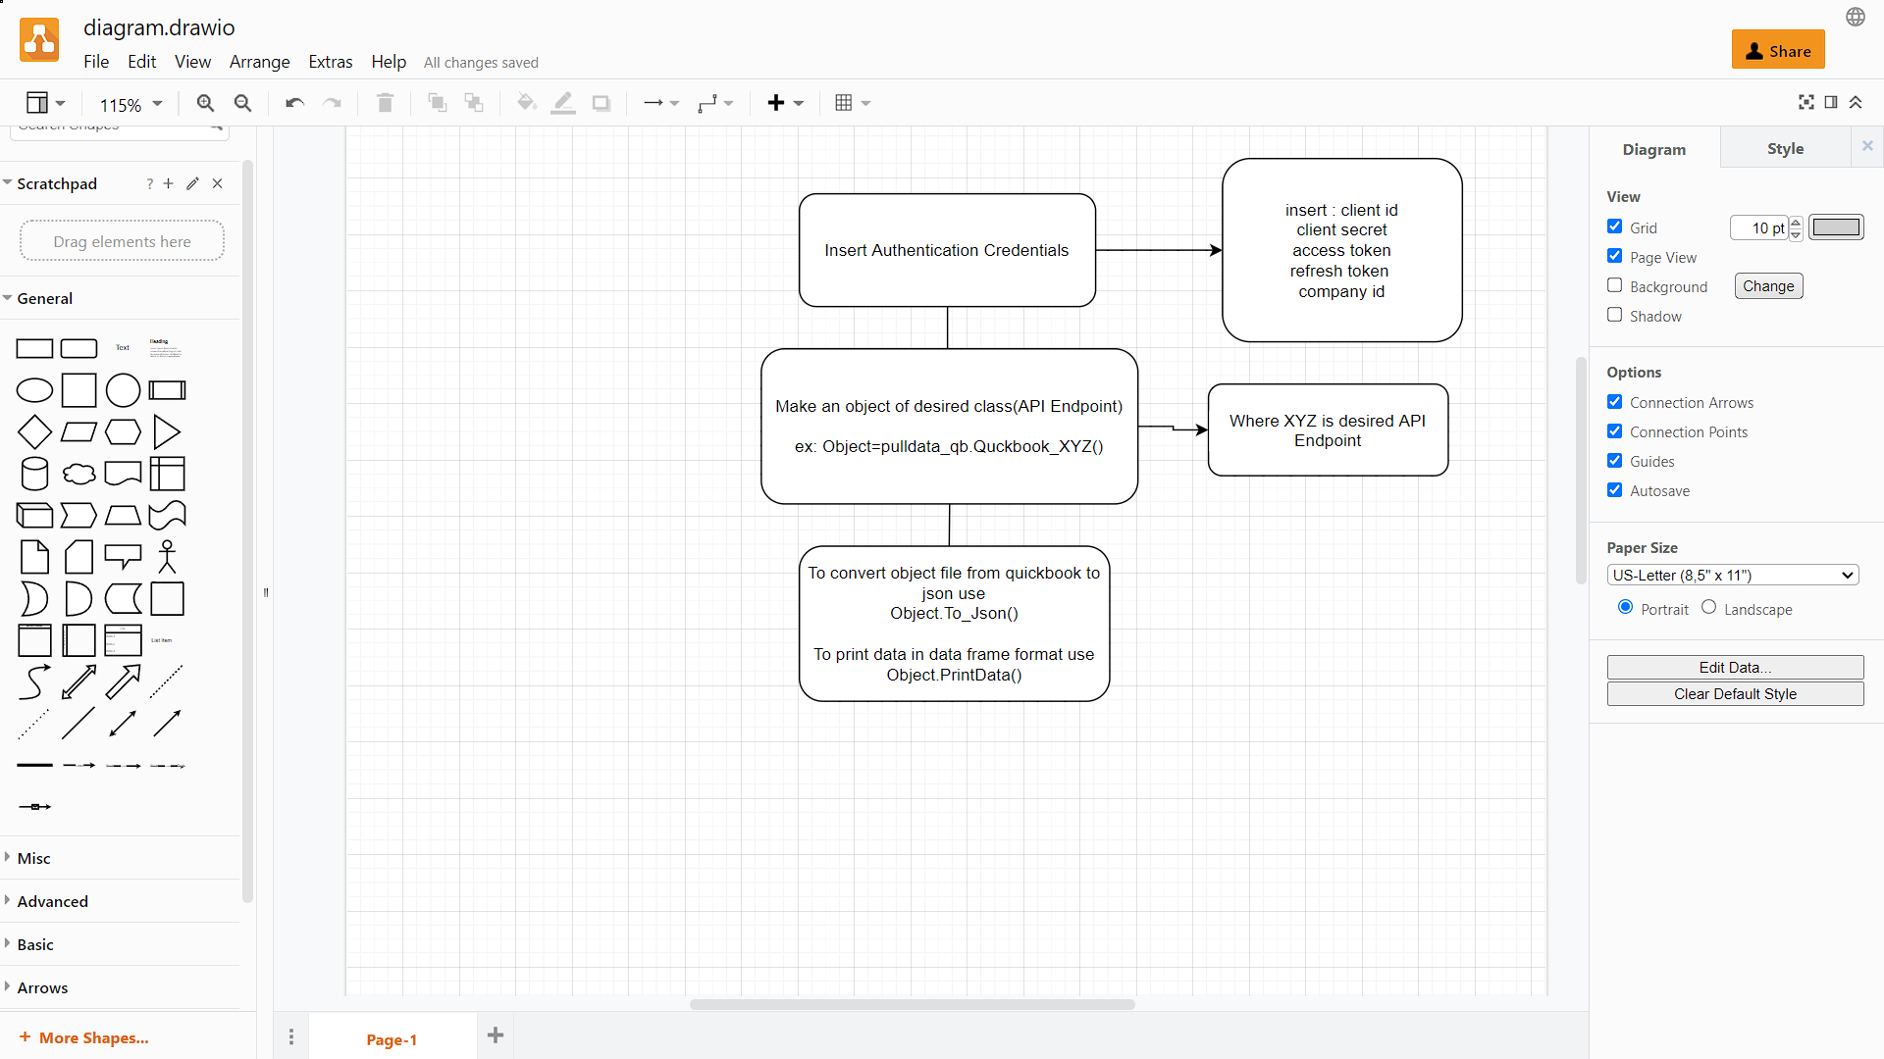

**Output**

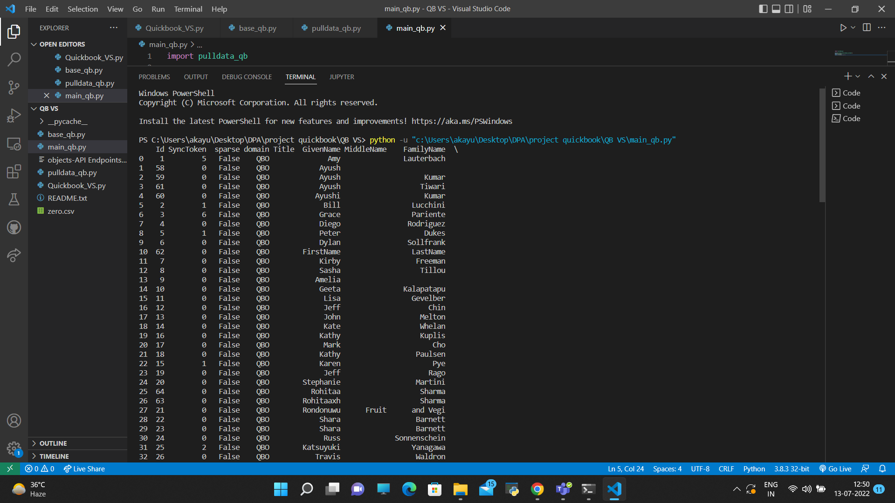

**Sample Example of connector**

**Step 1:** Give credentials

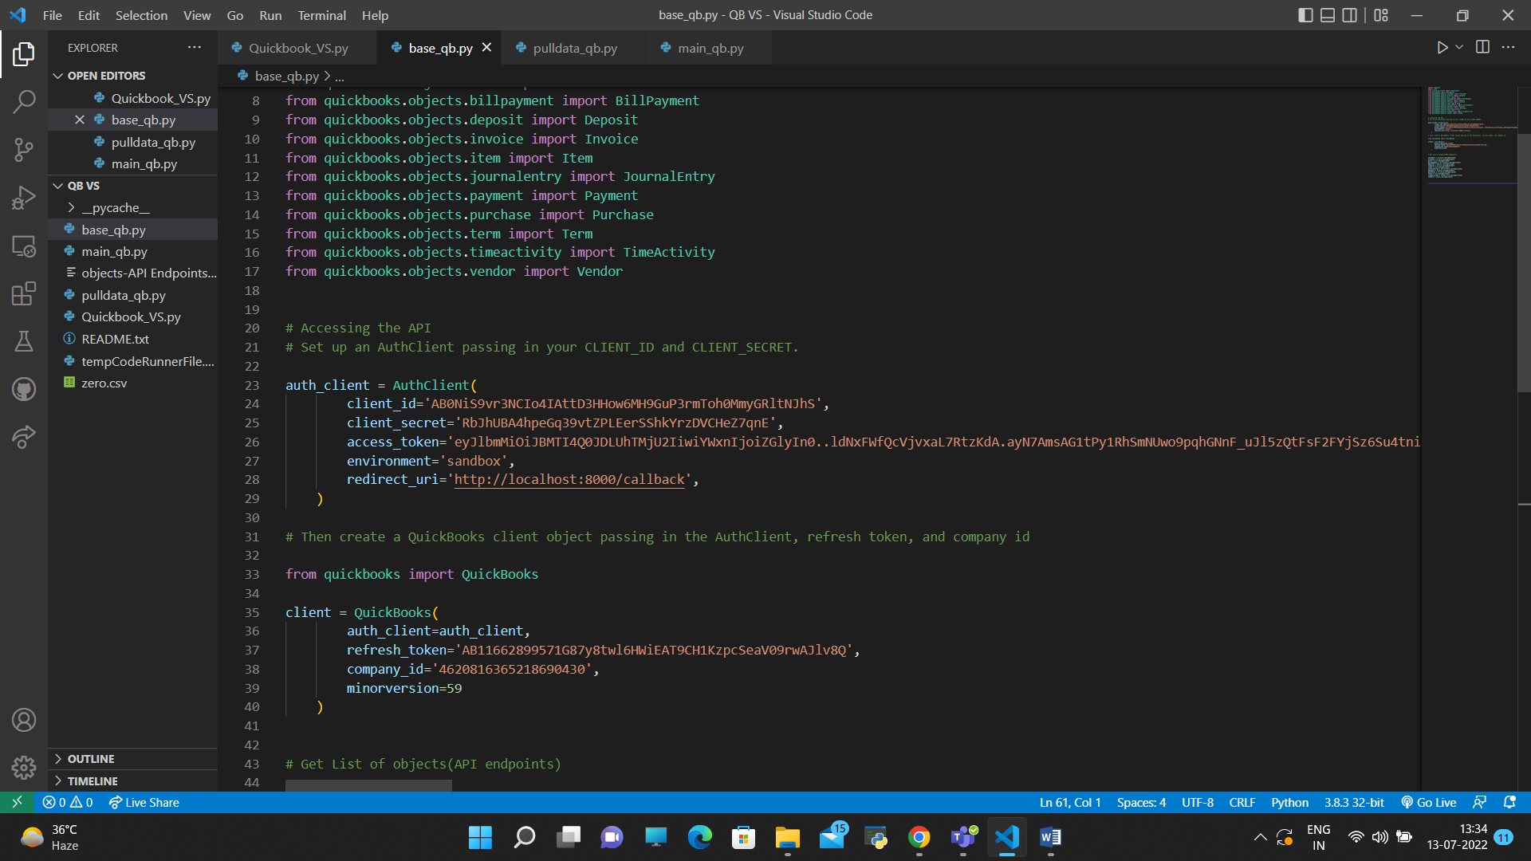

**Step 2:** Define an object of the particular API Endpoint or class you want to call

Ex= for customers endpoint

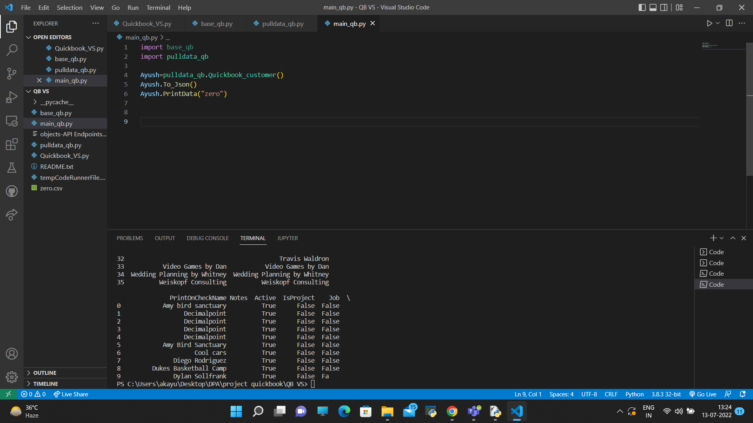

Step 3: Making that Object will call this class and its functions:

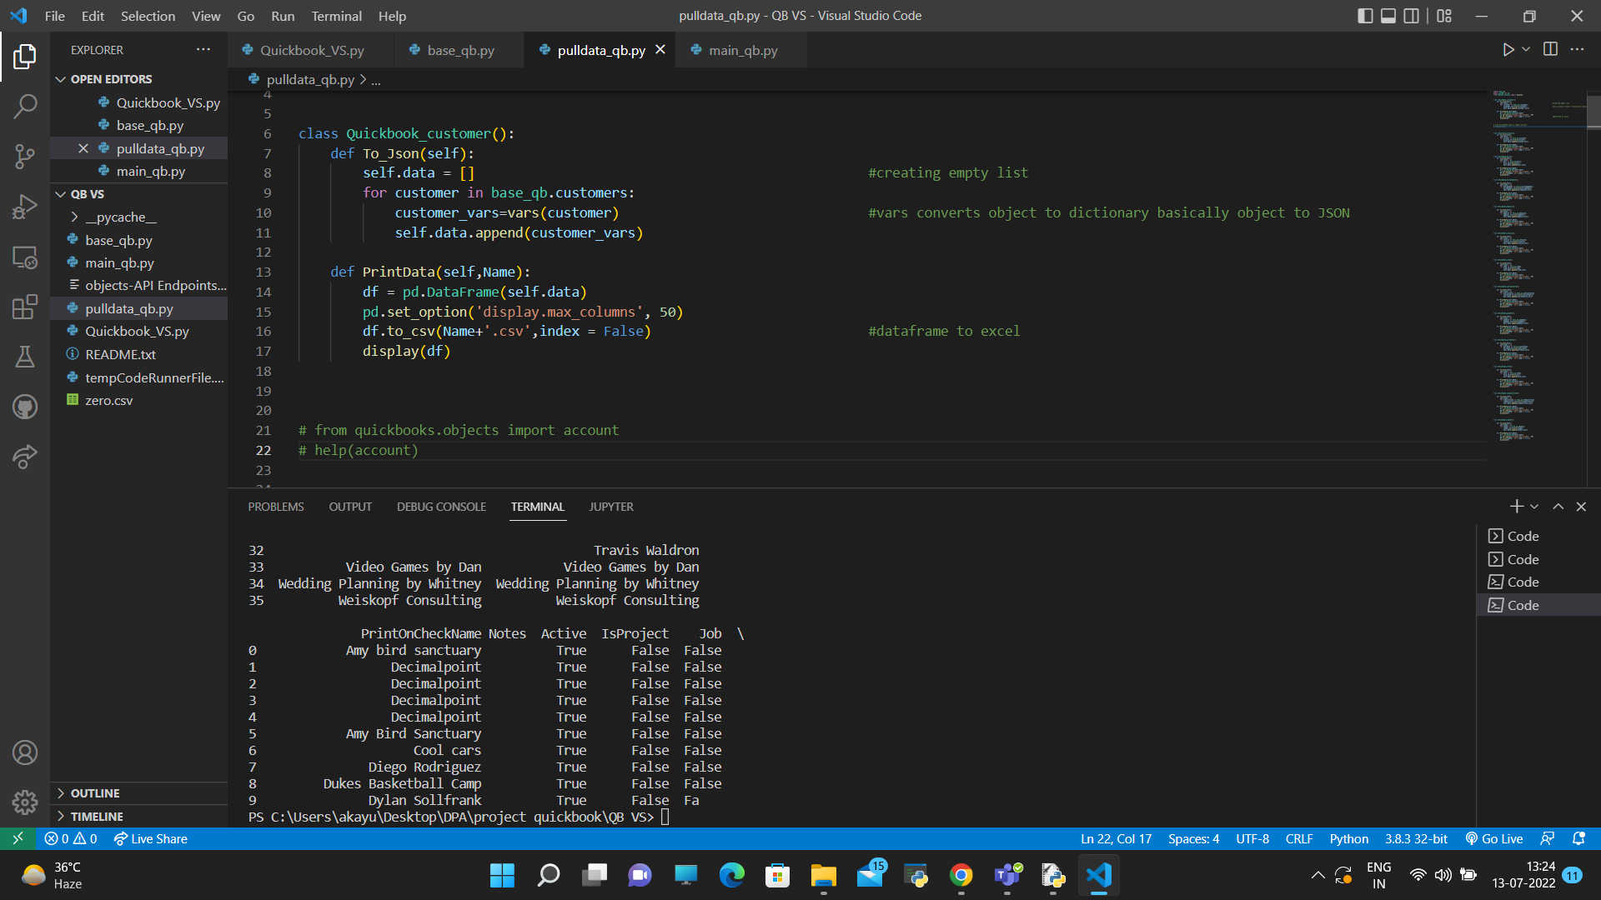

Step 4: You’ll get data in form of data Frame 