## Description: Western Governors University Seal.JPGWeb Development Fundamentals

## Student Project Submission Form

To complete this student project, you need to upload the site you created to a web server. You also need to submit a zipped folder that includes all files used to create your website and a completed copy of this form. You will upload your zipped folder to TaskStream for credit.

**Name: Omar B. Mohamad**

**Date: 07/ 25 /2015**

**Website URL: http://omohama.mystudenthosting.com/index.html**

**Browser/Version Used: Chrome 44.0.2403.89**

## Project Sketch:

A project sketch shows the location of each of the sections of your website and an approximate look of how they fit together. The following are examples of two project sketches.

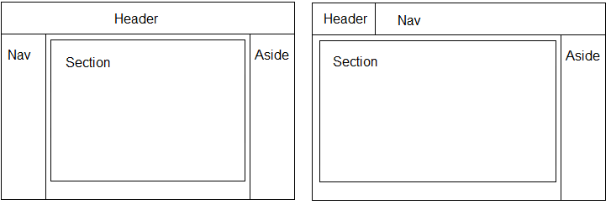

In the space provided below, insert an image of what your project sketch looks like. Make sure to label areas for Nav, Header, Aside, and Section.

Aside

Footer

Header

Article

Nav